Name: Asad Ali
ID: 14875
Department: BS Microbiology 4th semester
Subject: Microbial ecology
Submitted to: Amir Afzal sir
Date: 13, June, 2020
Final term Examination

Q1: Write a detailed note on Roles and regulation of microbes in natural and manmade environment.
Answer: Microorganisms play an important role in the various biogeochemical cycles, as well as being a particularly important component of plant and soil ecosystems. They break down dead plant and animal tissues and make their nutrients, including carbon and nitrogen, available to support plant growth. Following are the two main jobs performed by microbes.
- Bioremediation: The use of biological agents, such as bacteria, fungi, or green plants, to remove or neutralize contaminants, as in polluted soil or water.
Microorganisms are suited to the task of contaminant destruction because they possess enzymes that allow them to use environmental contaminants as a food. ... For bioremediation to be effective, microorganisms must enzymatically attack the pollutants and convert them to harmless products.
Fungi play an important role in organic matter decomposition, and therefore nutrient cycling.
Example: specialized microbial cultures are added (bioaugmentation) to further enhance biodegradation. Some examples of bioremediation related technologies are phytoremediation, mycoremediation, bioventing, bioleaching, landfarming, bioreactor, composting, bioaugmentation, rhizofiltration, and biostimulation

- Plants growth promoters: Rhizosphere bacteria may improve the uptake of nutrients to plants and/or produce plant growth promoting compounds.
They also protect plant root surfaces from colonization by pathogenic microbes through direct competitive effects and production of antimicrobial agents.

Example: Bacteria which have been found to enhance plant growth, include Pseudomonas, Enterobacter, and Arthrobacter.
Bacteria are also cheap and accurate sensors of toxic chemicals
-***-

Q2: Write a detailed note on Microorganisms in Terrestrial Environments.
Answer: Terrestrial environments are dominated by inert solid materials. Organic substances, including microorganisms, are usually a minor part of a soil.
- Soil is the habitat for a variety of organisms which include bacteria, fungi, protozoa, insects, nematodes, worms, and many other animals.
- Viruses also are present in soils.
- This complex biological community contributes to the formation, maintenance, and in some situations, the degradation and disappearance of soils.

Microorganisms in the Soil Environment:
- Most soil bacteria are located on the surfaces of soil particles and require water and nutrients that must be located in their immediate vicinity.
Bacteria are found most frequently on surfaces within smaller soil pores. Here they are probably less liable to be eaten by protozoa.
The gram-positive bacteria, which show varied degrees of branching and mycelial development, are an important and less studied part of the soil microbial community. They include the coryneforms, the nocardioforms, and the true filamentous bacteria or actinomycetes
These bacteria play a major role in the degradation of hydrocarbons, older plant materials, and soil humus. In addition, some members of these groups actively degrade pesticides.

- Terrestrial filamentous fungi bridge across open areas between soil particles or aggregates called peds. These fungi are exposed to high levels of oxygen.
These fungi will tend to darken and form oxygen-impermeable structures including sclerotia and hyphal cords.

- A wide variety of insects and animals also are present in soils, and these often use the fungi and bacteria as food sources, as well as processing plant residues.
The earthworms, with their ability to mix and ingest soils, add bacteria and enzymes from their intestine to their soil casts, a process that has major effects on the soil structure and the soil microbial community.
Earthworms also assist in mixing soil organic materials, creating the deep soils found in grasslands.

Microorganisms and the Formation of Different Soils:
- Once they are formed, most soils are rich sources of nutrients. Nutrients are found in organic matter, microorganisms, soil insects, and other animals.
Plants grow, senesce, and die and at each of these phases, they provide nutrients for soil organisms.
- Soils in cold environments, whether in Arctic, Antarctic, or alpine regions, are of extreme interest because of their wide distribution and impacts on global-level processes.
- The colder mean soil temperatures at these sites decrease the rates of both decomposition and plant growth.
- In these cases soil organic matter accumulates, and plant growth can become limited due to the immobilization of nutrients in soil organic matter.

Soil Microorganisms and Human Health:
- Humans are in constant contact with soils. This occurs directly as when children or adults play in the “dirt,” or even when leafy and root vegetables, covered with soil dust, are eaten. In most cases the contact with soil is harmless.
Organisms such as Acanthamoeba, which can be inhaled from dust, may cause primary amebic meningoencephalitis.
- Mold is a major source of chronic sinus (sinus infection occurs when your nasal cavities become infected, swollen, and inflamed) infections. These molds also have been related to increases in asthma rates.
The major responsible fungi are Stachybotrys chartarum, Eurotium herbariorum, and Aspergillus versicolor. Fungal growth results in a black slime; when this fungal growth dries, a dry dusty layer remains and the spores can be dispersed into the air.
These spores are particularly dangerous for infants, whose lungs are less developed.
-***-

Q3: Write a detailed note on the following.
- Commensalism:
Commensalism [Latin com, together, and mensa, table] is a relationship between individuals of two species in which one species obtains food or other benefits from the other without either harming or benefiting the latter.
- This is a unidirectional process.
- The commensal—the species that benefits from the association may obtain nutrients, shelter, support, or locomotion from the host species, which is unaffected.
- The commensal relation is often between a larger host and a smaller commensal.
- The host organism is essentially unchanged by the interaction, whereas the commensal species may show great morphological adaptation.
- When the commensal is separated from its host experimentally, it can survive without being provided some factor or factors of host origin.
- Commensalistic associations also occur when one microbial group modifies the environment to make it more suited for another organism.
For example, in the intestine the common, nonpathogenic strain of Escherichia coli lives in the human colon, but also grows quite well outside the host, and thus is a typical commensal.
When oxygen is used up by the facultatively anaerobic E. coli, obligate anaerobes such as Bacteroides are able to grow in the colon.
Example: Barnacles attached to a gray whale gain a home and transportation to area of food while leaving whale unaffected.

- Predation:
Predation is a biological interaction where one organism, the predator, kills and eats another organism, its prey.
The prey can be larger or smaller than the predator, and this normally results in the death of the prey.
Example: Some examples of predator and prey are lion and zebra, bear and fish, and fox and rabbit
Several of the best examples are including Bdellovibrio, Vampirococcus, and Daptobacter. Each of these has a unique mode of attack against a susceptible bacterium.
- Bdellovibrio penetrates the cell wall and multiplies between the wall and the plasma membrane, a periplasmic mode of attack, followed by lysis
of the prey and release of progeny.
- Vampirococcus attaches to the surface of the prey (an epibiotic relationship) and then secretes enzymes to release the cell contents.
- Daptobacter penetrates a susceptible host and uses the cytoplasmic contents as a nutrient source.

Beneficial effects of predation:
A surprising finding is that predation has many beneficial effects.
- Simple ingestion and assimilation of a prey bacterium can lead to increased rates of nutrient cycling, critical for the functioning of the microbial loop
In this process, organic matter produced through photosynthetic and chemotrophic activity is mineralized before it reaches the higher consumers, allowing the minerals to be made available to the primary producers, in a “loop.”
- Predators are an important part of a healthy ecosystem. Predators remove vulnerable prey, such as the old, injured, sick, or very young, leaving more food for the survival and success of healthy prey animals. Also, by controlling the size of prey populations, predators help low down the spread of disease
-***-

Q4: Write a detailed note on Microbial habitats and
functions.
Answer: Microbial habitat: it is a place where microorganism live.
Microbial habitats — including soils, rivers, lakes, oceans, on the surface of living and dead things, inside other organisms, on man-made structures, and everything in between , provide nutrients and protect cells from harsh conditions ,Instead of being devoid of life.
These environments are rich in microbial life.

AQUATIC HABITATS:
- Aquatic habitats range from the vast ocean reaches to lakes and ﬂowing bodies of water, such as rivers and streams.
- The size and diversity of aquatic habitats hints at the importance of aquatic habitats for microorganisms.
- Major microbial players in aquatic habitats include phototrophs, which are critical to primary production, and heterotrophs, which participate in the cycling of carbon in aquatic habitats.
Freshwater
The term freshwater habitats generally refers to rivers, streams, lakes, ponds, and groundwater.
- The United States Geological Survey (USGS) deﬁnes freshwater as water that contains less than 1000 mg/L of dissolved solids.
- The phylogenetic diversity of freshwater microorganisms differs substantially from that of marine habitats.
- Pernthaler and Amann (2005) note that typical freshwater bacterial groups include members of the Betaproteobacteria (e.g., relatives of Rhodoferax and Polynucleobacter necessarius), the acI clade of the Actinobacteria, and relatives of Haliscomenobacter hydrossis in the Cytophaga/Flexibacter/Flavobacterium group.

Marine Habitats
In marine water salt concentration is high.
- In terms of sheer volume, the marine environment represents a major portion of the biosphere and contains 97% of the Earth’s water.
- This is one of several environmental parameters that shape the nature of microorganisms inhabiting marine habitats.
- In addition, as you go from the surface to the depths of the ocean, gradients of temperature, light, availability of nutrients, and pressure change.

SOIL HABITATS
- Soils are widespread and important habitats for microorganisms, which play key roles in providing nutrients to plants.
- If you dig a hole in the ground, you’ll notice that there is a structure to the soil, with different levels.
- These include the organic horizon (O horizon) at the top, which includes freshly fallen litter on top through partially decomposed organic matter farther down, followed by the A horizon, which contains a variety of minerals. B horizon where humus, clays, and other transported materials reside, and ﬁnally, the C horizon of weathered parent material.
- Permeability of the soil can affect the degree to which nutrients and microorganisms can move around
- The area around plant roots, the rhizosphere, is a habitat where abundant microbial populations occur
- Microbial abundance in soil varies with physical and chemical characteristics of the microenvironment, including moisture content, abundance of organic matter, and size of soil aggregates.

ATMOSPHERIC HABITATS:
- The microbial community of the atmosphere is potentially a vehicle for pathogen transport, but little research has been carried out on this important habitat.
- It is generally known that bacteria, spores of higher fungi and pollen grains are present among dust particles in the atmosphere near the earth’s surface.
- Dust storms loft desert soil particles, often with attached microorganisms, high into the air.
- Many have thought that ultraviolet light, temperature, and desiccation would kill transported microorganisms, but we are now learning that many bacteria and especially fungal spores are resistant to these stressors.
- Microorganisms survive over long distances and times, to land on distant terrains.

Function of microbes in different habitats: Microorganisms have several vital roles in ecosystems; decomposition, oxygen production, evolution, and symbiotic relationships.

- Decomposition: Many fungi and bacteria are essential for cycling nutrients in ecosystems and for acting as decomposers, breaking down dead organisms and the waste of living things

- Oxygen production: Much of the oxygen released into the atmosphere through photosynthesis comes from algae and blue-green bacteria.

- Symbiotic relationships: Symbiotic bacteria is the one which forms association with either plant, animal or fungus in which bacteria as well as the host, both are benefited.

Example:
- Rhizobium bacteria forms association with the root nodules of higher plants, plant provide shelter to the bacteria and bacteria helps in nitrogen fixation.
- Mutualistic bacteria in the gut that aid digestion in both humans and animals.

-***-

Q5: Define the following terms.

(A). Phytoplankton:
Phytoplankton are microscopic organisms that live in watery environments, both salty and fresh. Some phytoplankton are bacteria, some are protists, and most are single-celled plants.
- They are minute organisms that drift with water currents.
- Like land vegetation, phytoplankton uses carbon dioxide, releases oxygen, and converts minerals to a form animals can use.
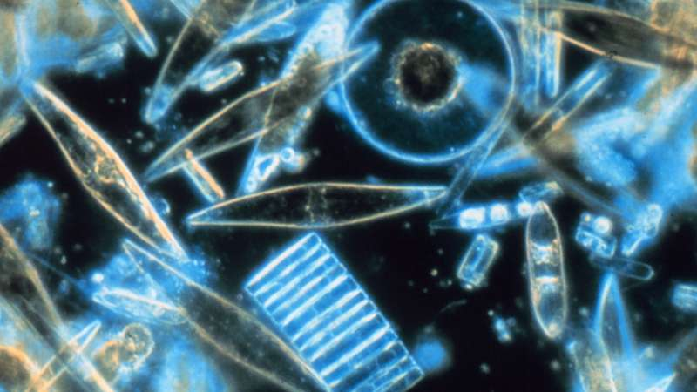

(B). Virioplankton:
Virioplankton are the viruses in aquatic ecosystem.
- Virioplankton are the most abundant plankton class in aquatic environments.
- Virioplankton are an important biological component of marine and freshwater ecosystems. Often overlooked, aquatic viruses play an important role in biogeochemical cycles on a global scale, infecting both autotrophic and heterotrophic microbes.
- They may influence the functioning of the microbial loop.
- Involved in horizontal gene transfer between prokaryotes.
- Control microbial community diversity.

(C). Barophiles:
A barophile is an organism that needs a high-pressure environment in order to grow.
- Barophiles are a type of an extremophile.
An example of a high-pressure habitat is the deep-sea environment, such as ocean floors and dee lakes where the pressure can exceed 380 atm.
There are different type of barophiles depend on pressure.
- Moderate barophiles: It grow optimally at 400 atm, but still grow at 1 atm.
- Extreme barophiles: It can grow only at higher pressures
- Pressure differences influence many biological processes including cell division, flagellar assembly, DNA replication, membrane transport, and protein synthesis.
- Porins, outer membrane proteins that form channels for diffusion of materials into the periplasm, also function most effectively at specific pressures.

(D). Epilimnion:
The epilimnion or surface layer is the top-most layer in a thermally stratified lake (Lake stratification is the separation of lakes into three layers), occurring above the deeper hypolimnion (hypolimnion is the bottom layer of colder water, isolated from the epilimnion by the metalimnion) .
- It is warmer and typically has a higher pH and higher dissolved oxygen concentration than the hypolimnion.

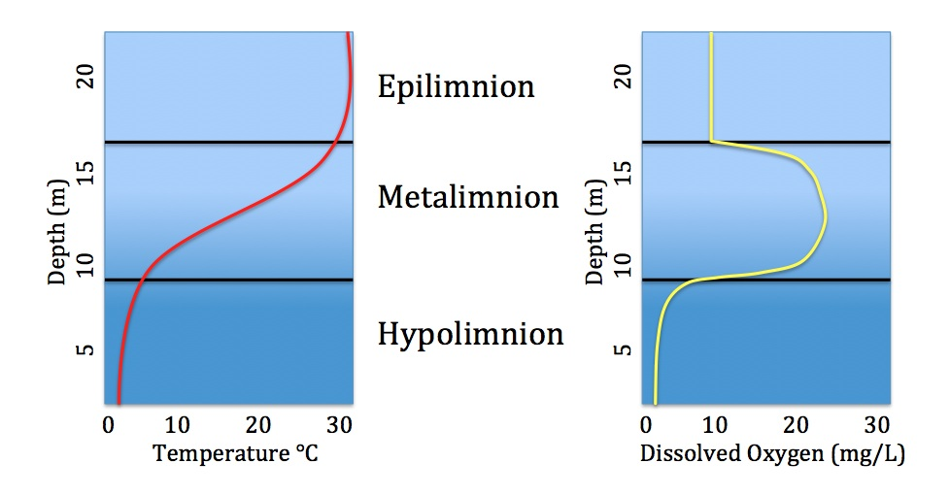

(E). Thermocline:
A thermocline is a thin but distinct layer in a large body of fluid in which temperature changes more rapidly with depth than it does in the layers above or below.
- Formation: A Thermocline is formed by the effect of the sun, which heats the surface of the water and keeps the upper parts of the ocean or water in a lake, warm. Water near the bottom remains colder as sunlight doesn't penetrate enough.
- The thermocline is a layer of water towards the bottom that has no oxygen or very little oxygen. Fish can venture below the thermocline to feed but they can't stay there for extended periods of time.
- Thermoclines play a role in meteorological forecasting. The depth of the thermocline is the measure of the size of the "fuel tank" and helps to predict the risk of hurricane formation.
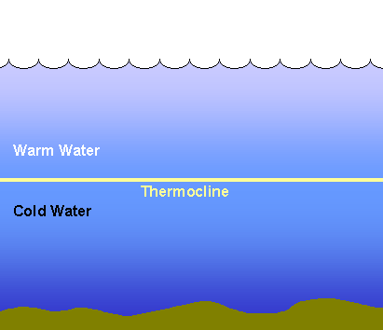
The End

