DPT 4th Semester

Course Title: Exercise Physiology Instructor: Ahmed Hayat
Student Name: wajeeha komal ID: 15118

Final Term Assignment Marks: 50

NOTE: Mention your name and roll number on the assignments.

- If you lifted a 10-kilogram (Kg) weight upward over the distance of 2 meters (m), the work performed would be ? Calculate Work.

- Ans: Work is defined as the product of force multiplied by distance
Work = force X distance
- SI unit for work is joule.
- Power = Work -:- time
- SI unit for power is watt.
It is the work rate or power output that describes the intensity of exercise
So,
Then in this case;
M=10 kg , g=10m/s(square)
S=2m ,
W=PE
PE=mgh
W=mgh
W=(10)(10)(2)
W=200j kgm/s(square)=j
W=200j

- Enlist basic principles of the training.

Ans : In order to obtain the most out of a training, individuals must follow some basic simple training principles.
The four basic principles of training include:
- progression
- specificity
- reversibility
- overload
progression:
- As the body adjusts, training needs to be more progressive so that greater demands are made on it. Once the adaptations of the body have occurred training should become progressively more and more difficult.
- Progression means training gets gradually harder and harder. This does not mean overdoing it as it can lead to injury
Example: marathon runners would gradually run further distance when training to make sure their training gets progressively more difficult.
Overload:
The overload principles says that you have to increase the intensity, duration, type, or time of a workout progressively in order to see adaptations. The adaptations are improvements in endurance, strength, or muscle size.
- Overload states that a system or tissue must be exercised at a level beyond which it is habitualized in order for a training effect to occur.
- The system or tissue gradually normalizes to this overload.
- This order of progressively and systematically overloading a system or tissue as adaptations occur concludes in upgraded function over time

Reversibility:
The Reversibility Principle states that athletes lose the effects of training after they training however the detraining effects can be reversed by resuming the training.
Specificity:
The Specificity Principle is a principle that states that exercising a certain body part, component of the body, or particular skill primarily develops that part or skill.
- If a muscle is engaged in endurance types of exercise, the primary adaptations are in capillary and mitochondria number, which increase the capacity of the muscle to produce energy aerobically.
- If a muscle is engaged in heavy resistance training, the primary adaptation is an increase in the quantity of the contractile proteins; the mitochondrial and capillary densities may actually decrease.
- The training effect is specific to the:
- muscles involved
- fiber types recruited
- the principal energy system involved (aerobic versus anaerobic)
- the velocity of contraction
- the type of muscle contraction (eccentric, concentric, or isometric)
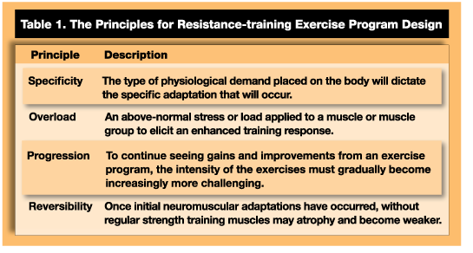

- Describe preload and afterload in simple words.

- PRELOAD: The degree of tension on the muscle when it begins to contract is the preload. It is also known as , also known as ventricular end-diastolic pressure (LVEDP), is the amount of ventricular stretch at the end of diastole the leftthe heart loading up for the next big squeeze of the ventricles during systole.
- Some people remember this by using an analogy of a balloon – blow air into the balloon and it stretches; the more air you blow in, the greater the stretch
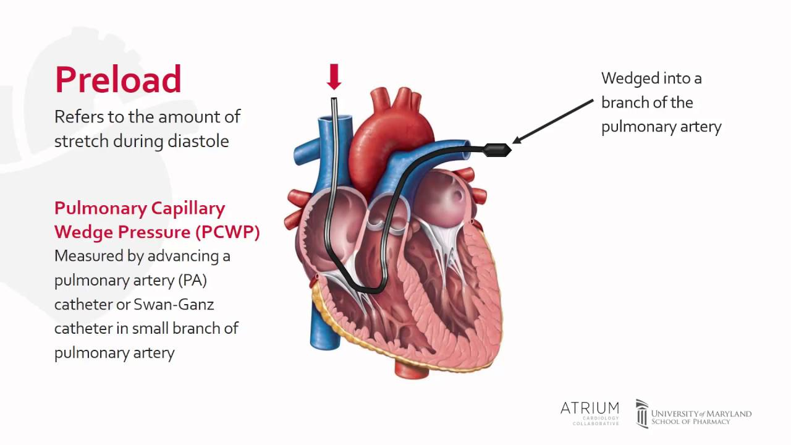
- Rowell raises the question that the increase in stroke volume that occurs with endurance training may simply be due to the chronic stretch of the myocardium at rest because of the increased filling time associated with the slower resting heart rate (bradycardia).​

AFTERLOAD:
Afterload, also known as the systemic vascular resistance (SVR), is the amount of resistance the heart must overcome to open the aortic valve and push the blood volume out into the systemic circulation. If you think about the balloon analogy, afterload is represented by the knot at the end of the balloon. To get the air out, the balloon must work against that knot.
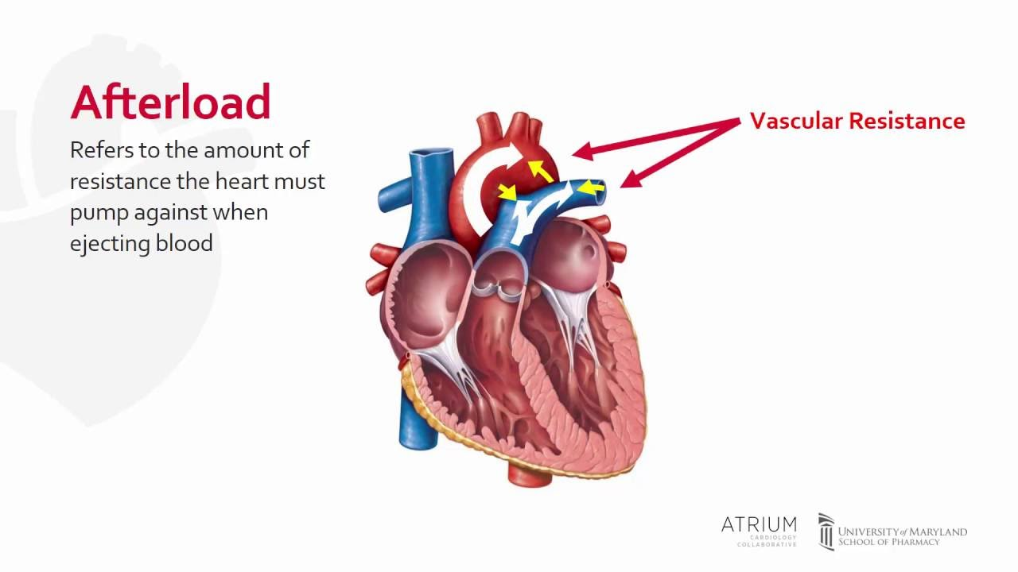
After-load refers to the peripheral resistance against which the ventricle is contracting as it tries to push a portion of the EDV into the aorta.

- What are the factors increasing stroke volume.

Stoke volume: Stroke Volume (SV) is the volume of blood in millilitres ejected from the each ventricle due to the contraction of the heart muscle which compresses these ventricles. SV is the difference between end diastolic volume (EDV) and end systolic volume (ESV)

Stroke volume index is determined by three factors:
Preload: The filling pressure of the heart at the end of diastole. Preload is the filling pressure of the heart at the end of diastole. The left atrial pressure (LAP) at the end of diastole will determine the preload.
The greater the preload, the greater will be the volume of blood in the heart at the end of diastole. (Like blowing up a balloon, the more pressure that is applied, the bigger is will get.

Contractility: The inherent vigor of contraction of the heart muscles during systole. contractility is the inherent strength and vigour of the heart's contraction during systole.
According to Starling's Law, the heart will eject a greater stroke volume at greater filling pressures. For any filling pressure (LAP), the stroke volume will be greater if the contractility of the heart is greater.
The inherent strength and vigour of the heart's contraction during systole may be increased by sympathetic autonomic activity and by pharmacologic agents.

Afterload: The pressure against which the heart must work to eject blood during systole. Afterload is the pressure against which the heart must work to eject blood during systole (systolic pressure). The lower the afterload, the more blood the heart will eject with each contraction.
Like contractility, changes in afterload will raise or lower the Starling curve relating stroke volume index to LAP.
The effect of afterload on stroke colume is due to the fact that the maximum pressure that the heart can develop is smaller at lower ventricular volumes.
Therefore, if the systolic pressure is lower, the heart will be able to contract to a smaller volume at the end of systole. This will result in an improved stroke volume.
Conversely, if the systolic pressure is higher, the heart will be unable to contract to as small a vollume at the end of systole and the stroke volume index will be decreased.

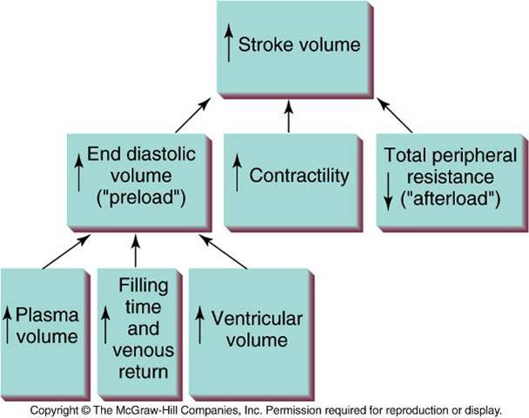

- Differentiate between isometric, isotonic and isokinetic exercises.

- Isometric exercises:
Isometric exercises are contractions of a particular muscle or group of muscles. During isometric exercises, the muscle doesn't noticeably change length and the affected joint doesn't move. Isometric exercises help maintain strength. They can also build strength, but not effectively. isometric exercises are done in one position without movement, they'll improve strength in only one particular position. The term "isometric" combines the Greek words "Isos" (equal) and "metria" (measuring), meaning that in these exercises the length of the muscle and the angle of the joint do not change, though contraction strength may be varied.^{[1]} This is in contrast to isotonic contractions, in which the contraction strength does not change, though the muscle length and joint angle do.
The three main types of isometric exercise are isometric presses, pulls, and holds. They may be included in a strength training regime in order to improve the body’s ability to apply power from a static position or, in the case of isometric holds, improve the body’s ability to maintain a position for a period of time.
Example: The 'plank' is a type of isometric hold which can intensively activate the body's core musculature. It may also be performed by balancing on the forearms
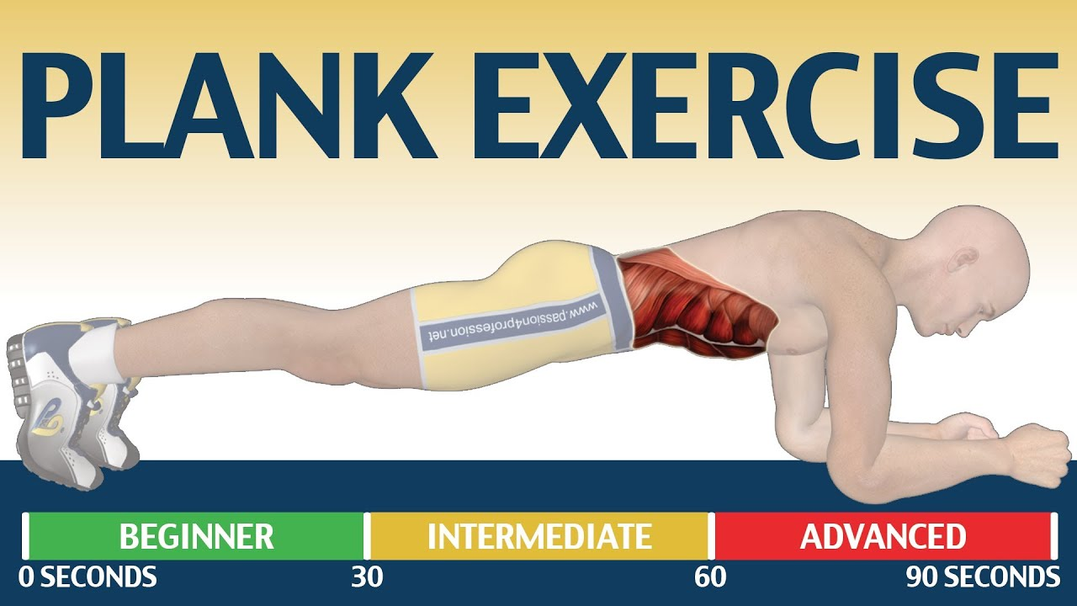
Isotonic exercise:
Isotonic exercise involves putting a constant amount of weight or tension on your muscles while moving your joints through a full range of motion. An example is bench-pressing, as the amount of weight stays the same and your joints bend and straighten all the way. In an isotonic contraction, tension remains the same, whilst the muscle's length changes. Isotonic contractions differ from isokinetic contractions in that in isokinetic contractions the muscle speed remains constant. While superficially identical, as the muscle's force changes via the length-tension relationship during a contraction, an isotonic contraction will keep force constant while velocity changes, but an isokinetic contraction will keep velocity constant while force changes. A near isotonic contraction is known as Auxotonic contraction.
There are two types of isotonic contractions:
(1) concentric
(2) eccentric.
In a concentric contraction, the muscle tension rises to meet the resistance, then remains the same as the muscle shortens.
In eccentric, the muscle lengthens due to the resistance being greater than the force the muscle is producing
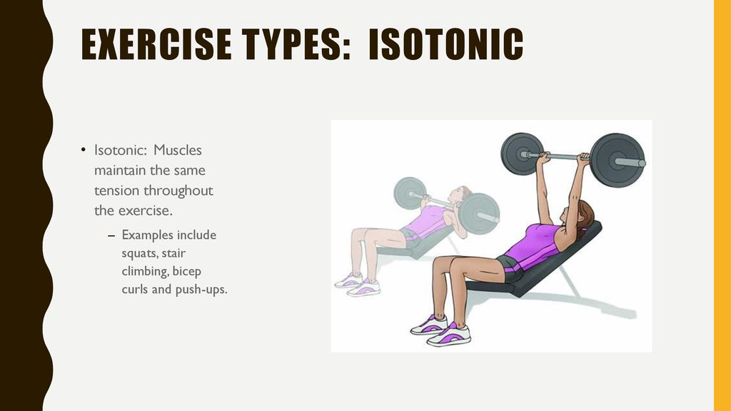

ISOKINETIC EXERCISE:
Isokinetic exercise is a type of strength training. It uses specialized exercise machines that produce a constant speed no matter how much effort you expend. These machines control the pace of an exercise by fluctuating resistance throughout your range of motion
isokinetic exercise refers to movement at a constant speed regardless of the force applied. Muscles contract and shorten at a constant speed in isokinetic contraction. Isokinetic exercise allows muscles to gain strength consistently all through the range of movement. Isokinetic exercises are often used for rehabilitation and recovery since it’s a controlled form of exercise. Physical therapists and occupational therapists use isokinetic machines to help people recover from a stroke, an injury, or a medical procedure. Isokinetic machines can also be used to treat imbalances in the body that have the potential to cause injury.
