Subject: Anatomy-I (theory) Total Marks 50
Final Term Assignment. Note: “Draw a Labeled diagram where necessary” Dr. Attaullah NOUMAN KHAN ID 16457
.
Q:1 Differentiate between artery, vein and capillaries on the basis of structural characteristics.
ANSWER: Arteries, Veins, and Capillaries
Arteries
Arteries carry blood away from the heart. Pulmonary arteries transport blood that has a low oxygen content from the right ventricle to the lungs. Systemic arteries transport oxygenated blood from the left ventricle to the body tissues. Blood is pumped from the ventricles into large elastic arteries that branch repeatedly into smaller and smaller arteries until the branching results in microscopic arteries called arterioles. The arterioles play a key role in regulating blood flow into the tissue capillaries. About 10 percent of the total blood volume is in the systemic arterial system at any given time.

The wall of an artery consists of three layers. The innermost layer, the tunica intima (also called tunica interna), is simple squamous epithelium surrounded by a connective tissue basement membrane with elastic fibers. The middle layer, the tunica media, is primarily smooth muscle and is usually the thickest layer. It not only provides support for the vessel but also changes vessel diameter to regulate blood flow and blood pressure. The outermost layer, which attaches the vessel to the surrounding tissue, is the tunica externa or tunica adventitia. This layer is connective tissue with varying amounts of elastic and collagenous fibers. The connective tissue in this layer is quite dense where it is adjacent to the tunic media, but it changes to loose connective tissue near the periphery of the vessel..
TYPES OF ARTERIES:
Large arteries of elastic type, e.g. aorta and its main branches
(brachiocephalic, common carotid, subclavian and common iliac) and
the pulmonary arteries.

2. Medium and small arteries of muscular type, e.g. temporal, occipital,
radial, popliteal, etc.

3. Smallest arteries of muscular type are called arterioles. They
measure 50-100 micron in diameter.
VEINS:
- Veins. are present throughout the body as tubes that carry blood back to the heart. Veins are classified in a number of ways, including superficial vs. deep, pulmonary vs. systemic, and large vs. small.

Superficial veins are those closer to the surface of the body, and have no corresponding arteries.
Deep veins are deeper in the body and have corresponding arteries.
Perforator veins drain from the superficial to the deep veinsThese are usually referred to in the lower limbs and feet.
Communicating veins are veins that directly connect superficial veins to deep veins.
Pulmonary veins are a set of veins that deliver oxygenated blood from the lungs to the heart.
Systemic veins drain the tissues of the body and deliver deoxygenated blood to the heart.
- Structure of veins consists: Structure of a vein, which consists of three main layers. The outer layer is connective tissue, called tunica adventitia or tunica externa; a middle layer of smooth muscle called the tunica media, and the inner layer lined with endothelial cells called the tunica intima.

CAPILLARIES
A capillary is a microscopic channel that supplies blood to the tissues themselves, a process called perfusion. Exchange of gases and other substances occurs in the capillaries between the blood and the surrounding cells and their tissue fluid (interstitial fluid). The diameter of a capillary lumen ranges from 5–10 micrometers; the smallest are just barely wide enough for an erythrocyte to squeeze through. Flow through capillaries is often described as microcirculation.
The wall of a capillary consists of the endothelial layer surrounded by a basement membrane with occasional smooth muscle fibers. There is some variation in wall structure: In a large capillary, several endothelial cells bordering each other may line the lumen; in a small capillary, there may be only a single cell layer that wraps around to contact itself.
For capillaries to function, their walls must be leaky, allowing substances to pass through.
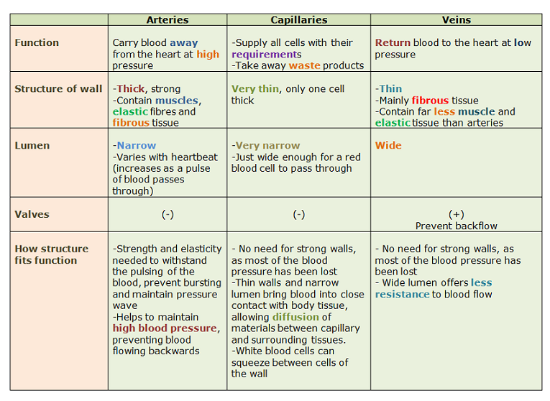

Q:2 Define and explain anastomosis and its different types.
ANSWER:DEFINITION: The term “anastomosis” refers to a connection between two tubes or passages that would usually branch away from each other. Anastomosis is the connection of two things that are normally diverging. In medicine, an anastomosis typically refers to a connection between blood vessels or between two loops of the intestine.
Types
A. Arterial anastomoses is the communication between the arteries, or
branches of arteries. It may be actual or potential.
1. In actual arterial anastomosis the arteries meet end to end. For example,
palmar arches ,plantar arch, circle of Willis, intestinal arcades, labial
branches of facial arteries.
2. In potential arterial anastomoses the communication takes place
between the terminal arterioles.
•
B. Venous anastomoses is the communication between the veins or
tributaries of veins. For example, the dorsal venous arches of the hand and
foot.
C. Arteriovenous anastomosis (shunt) is the communication between an
artery and a vein.

- END-ARTERIES

Arteries which do not anastomose with their neighbors are called end
arteries .
- Examples:
Central artery of retina and labyrinthine artery of internal ear are
the best examples of an absolute end arteries.
Central branches of cerebral arteries and vasa recta of mesenteric
arteries.
. Arteries of spleen, kidney, lungs and metaphyses of long bones.

Q3: Write a detail note on parts of Nervous system
ANSWER: The nervous system is a complex network of nerves and cells that carry messages to and from the brain and spinal cord to various parts of the body.
The nervous system includes both the Central nervous system and Peripheral nervous system. The Central nervous system is made up of the brain and spinal cord and The Peripheral nervous system is made up of the Somatic and the Autonomic nervous systems.
- Parts of Nervous System

The nervous system is broadly divided into central and peripheral parts
which are continuous with each other. Further subdivisions of each
part are given below.
A. Central nervous system (CNS) includes:
1. Brain or encephalon, which occupies cranial cavity, and contains the higher
governing centres.
2. Spinal cord or spinal medulla, which occupies upper twothirds of the
vertebral canal, and contains many reflex centres.

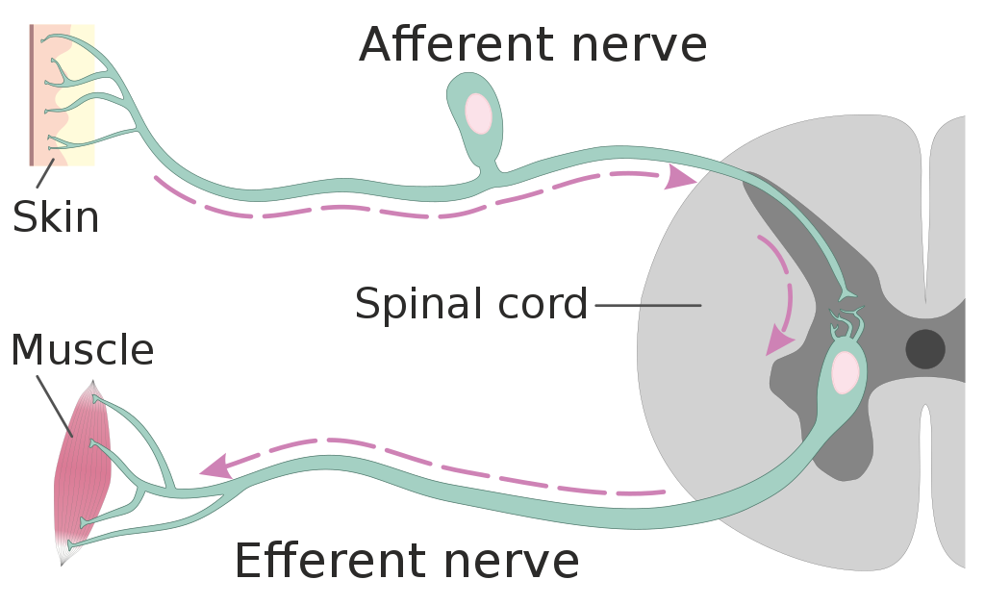

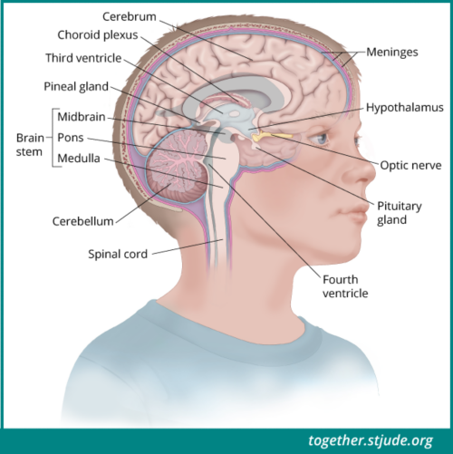
Peripheral nervous system (PNS):
Is subdivided into the following two components.
1 . Cerebrospinal nervous system is the somatic component of the peripheral
nervous system, which includes 12 pairs of cranial nerves and 31 pairs of
spinal nerves. It innervates the somatic structures of the head and neck,
limbs and body wall, and mediates somatic sensory and motor functions.

2. Peripheral autonomic nervous system is the visceral component of the
peripheral nervous system, which includes the visceral or splanchnic nerves
that are connected to the CNS through the somatic nerves. It innervates the
viscera, glands, blood vessels and nonstriated muscles, and mediates the
visceral functions.
CELL TYPES OF NERVOUS SYSTEM:
The nervous tissue is composed of two distinct types of cells
(a) The excitable cells are the nerve cells or neurons and
(b) The non-excitable cells constitute neurogila and ependyma in the CNS and schwann cells in the PNS.
1 Neuron:
Each nerve cells or neuron has
(a) A cell body or perikaryon or somata having a central nucleus and nissl granules in its cytoplasm.
(b) cell processes called neurites which are of two types
Many short afferent processes which are freely branching and varicose are called dendrites.
A single long efferent process called axon arising from axon hillock. It may give off occasional branches and is of unifrom diameter the terminal branches of the axon are called axon terminals.
The cell bodies of neurons form grey matter and nuclei in the CNS and ganglia in the PNS. The cell processes axon form tracts in the cns and nerves in the PNS.

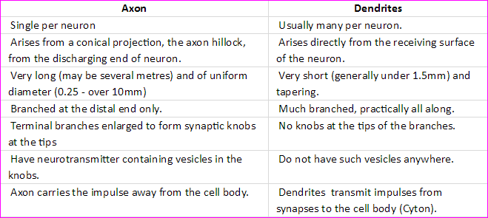
- Types of neurons:
Neurons can be classified in several ways.
I. According to the number of their processes (neurites) they may be:

(a) Unipolar, e.g. mesencephalic nucleus;

(b) Pseudo-unipolar, e.g. sensory ganglia or spinal ganglia
(c) Bipolar, e.g. spiral and vestibular ganglia and bipolar neurons
of retina.

(d) Multipolar, neurons in cerebrum and cerebellum.
II . According to the length of axon, the neurons are classified as

(a) Golgi type I neurons, with a long axon; and

(b) Golgi type II neurons (microneurons), with a short or no axon.

Dynamic polarity:

The neurons show dynamic polarity in their processes. The impulse flows
towards the soma in the dendrites, and away from the soma in the axon
However, in certain microneurons, where the axon is absent,
the impulse can flow in either direction through their dendrites.
- Synapes: In the nervous system, a synapse is a structure that permits a neuron (or nerve cell) to pass an electrical or chemical signal to another neuron or to the target effector cell. Synapses are essential to neuronal function: neurons are cells that are specialized to pass signals to individual target cells, and synapses are the means by which they do so. At a synapse, the plasma membrane of the signal-passing neuron (the presynaptic neuron) comes into close apposition with the membrane of the target (postsynaptic) cell. Both the presynaptic and postsynaptic sites contain extensive arrays of molecular machinery that link the two membranes together and carry out the signaling process. In many synapses, the presynaptic part is located on an axon and the postsynaptic part is located on a dendrite or soma.
- 2. Neuroglia
The non-excitable supporting cells of the nervous system form a major component
of the nervous tissue. These cells include the following.
1. Neuroglial cells, found in the parenchyma of brain and spinal
cord.
2. Ependymal cells lining the internal cavities or ventricles.
3. Capsular or satellite cells, surrounding neurons of the sensory and autonomic
ganglia.
4. Schwann cells, forming sheaths for axons of peripheral nerves.
5. Several types of supporting cells, ensheathing the motor and sensory nerve
terminals, and supporting the sensory epithelia

- REFLEX ARC
A reflex arc is the basic functional unit of the nervous system which can perform an
integrated neural activity. In its simplest form, i.e. mono-synaptic reflex arc, is made
up of:
(a) A receptor, e.g. skin;
(b) A sensory or afferent neuron;
(c) A motor or efferent neuron; and
(d) An effector, e.g. muscle.
The complex forms of reflex arc are polysynaptic due to addition of one or more
internuncial neurons (interneurons) in between the afferent and efferent neurons.
An involuntary motor response of the body is called a reflex action. The stretch
reflexes (tendon jerks) are the examples of monosynaptic reflexes. whereas the
withdrawal reflex (response to a painful stimulus) is a polysynaptic reflex.

- PERIPHERAL NERVES

The nerves are solid white cords composed of bundles (fasciculi) of nerve fibres.
Each nerve fibre is an axon with its coverings.
The nerve fibres are supported and bound together by connective tissue sheaths
at different levels of organization of the nerve.

The whole nerve trunk is ensheathed by epineurium, each fasciculus by
perineurium, and each nerve fiber by a delicate endoneurium.

The toughness of a nerve is due to its fibrous sheaths, otherwise the nerve tissue
itself is very delicate and friable.
- SPINAL NERVES

There are 31 pairs of spinal nerves, including 8 cervical, 12 thoracic,
5 lumbar, 5 sacral, and 1 coccygeal.
Q4: Describe anatomy of pectoral girdle with the help of diagram
ANSWER: The bones that attach each upper limb to the axial skeleton form the pectoral girdle (shoulder girdle). This consists of two bones, the scapula and clavicle. The clavicle (collarbone) is an S-shaped bone located on the anterior side of the shoulder. It is attached on its medial end to the sternum of the thoracic cage, which is part of the axial skeleton. The lateral end of the clavicle articulates (joins) with the scapula just above the shoulder joint.
CLAVICLE
The clavicle is the only long bone that lies in a horizontal position in the body . The clavicle has several important functions. First, anchored by muscles from above, it serves as a strut that extends laterally to support the scapula. This in turn holds the shoulder joint superiorly and laterally from the body trunk, allowing for maximal freedom of motion for the upper limb. The clavicle also transmits forces acting on the upper limb to the sternum and axial skeleton. Finally, it serves to protect the underlying nerves and blood vessels as they pass between the trunk of the body and the upper limb.

The clavicle has three regions: the medial end, the lateral end, and the shaft. The medial end, known as the sternal end of the clavicle, has a triangular shape and articulates with the manubrium portion of the sternum. This forms the sternoclavicular joint, which is the only bony articulation between the pectoral girdle of the upper limb and the axial skeleton. This joint allows considerable mobility, enabling the clavicle and scapula to move in upward/downward and anterior/posterior directions during shoulder movements. The sternoclavicular joint is indirectly supported by the costoclavicular ligament which spans the sternal end of the clavicle and the underlying first rib. The lateral or acromial end of the clavicle articulates with the acromion of the scapula, the portion of the scapula that forms the bony tip of the shoulder. There are some sex differences in the morphology of the clavicle. In women, the clavicle tends to be shorter, thinner, and less curved. In men, the clavicle is heavier and longer, and has a greater curvature and rougher surfaces where muscles attach, features that are more pronounced in manual workers.

The clavicle is the most commonly fractured bone in the body. Such breaks often occur because of the force exerted on the clavicle when a person falls onto his or her outstretched arms, or when the lateral shoulder receives a strong blow. Because the sternoclavicular joint is strong and rarely dislocated, excessive force results in the breaking of the clavicle, usually between the middle and lateral portions of the bone. If the fracture is complete, the shoulder and lateral clavicle fragment will drop due to the weight of the upper limb, causing the person to support the sagging limb with their other hand. Muscles acting across the shoulder will also pull the shoulder and lateral clavicle anteriorly and medially, causing the clavicle fragments to override. The clavicle overlies many important blood vessels and nerves for the upper limb, but fortunately, due to the anterior displacement of a broken clavicle, these structures are rarely affected when the clavicle is fractured.

- SCAPULA
The scapula is also part of the pectoral girdle and thus plays an important role in anchoring the upper limb to the body. The scapula is located on the posterior side of the shoulder. It is surrounded by muscles on both its anterior (deep) and posterior (superficial) sides, and thus does not articulate with the ribs of the thoracic cage.

The scapula has several important landmarks The three margins or borders of the scapula, named for their positions within the body, are the superior border of the scapula, the medial border of the scapula, and the lateral border of the scapula. The suprascapular notch is located lateral to the midpoint of the superior border. The corners of the triangular scapula, at either end of the medial border, are the superior angle of the scapula, located between the medial and superior borders, and the inferior angle of the scapula, located between the medial and lateral borders. The inferior angle is the most inferior portion of the scapula, and is particularly important because it serves as the attachment point for several powerful muscles involved in shoulder and upper limb movements. The remaining corner of the scapula, between the superior and lateral borders, is the location of the glenoid cavity (glenoid fossa). This shallow depression articulates with the humerus bone of the arm to form the glenohumeral joint (shoulder joint). The small bony bumps located immediately above and below the glenoid cavity are the supraglenoid tubercle and the infraglenoid tubercle, respectively. These provide attachments for muscles of the arm

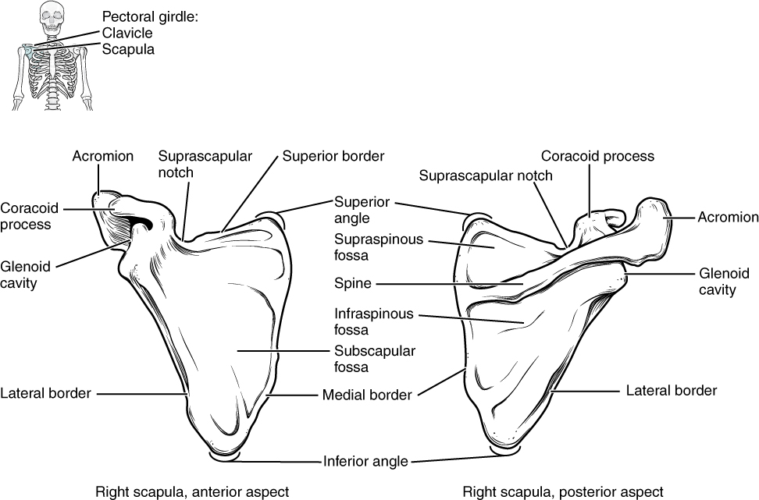

The scapula also has two prominent projections. Toward the lateral end of the superior border, between the suprascapular notch and glenoid cavity, is the hook-like coracoid process.This process projects anteriorly and curves laterally. At the shoulder, the coracoid process is located inferior to the lateral end of the clavicle. It is anchored to the clavicle by a strong ligament, and serves as the attachment site for muscles of the anterior chest and arm. On the posterior aspect, the spine of the scapula is a long and prominent ridge that runs across its upper portion. Extending laterally from the spine is a flattened and expanded region called the acromion or acromial process. The acromion forms the bony tip of the superior shoulder region and articulates with the lateral end of the clavicle, forming the acromioclavicular joint ). Together, the clavicle, acromion, and spine of the scapula form a V-shaped bony line that provides for the attachment of neck and back muscles that act on the shoulder, as well as muscles that pass across the shoulder joint to act on the arm.
The scapula has three depressions, each of which is called a fossa. Two of these are found on the posterior scapula, above and below the scapular spine. Superior to the spine is the narrow supraspinous fossa, and inferior to the spine is the broad infraspinous fossa. The anterior (deep) surface of the scapula forms the broad subscapular fossa. All of these fossae provide large surface areas for the attachment of muscles that cross the shoulder joint to act on the humerus.
The acromioclavicular joint transmits forces from the upper limb to the clavicle. The ligaments around this joint are relatively weak. A hard fall onto the elbow or outstretched hand can stretch or tear the acromioclavicular ligaments, resulting in a moderate injury to the joint. However, the primary support for the acromioclavicular joint comes from a very strong ligament called the coracoclavicular ligament. This connective tissue band anchors the coracoid process of the scapula to the inferior surface of the acromial end of the clavicle and thus provides important indirect support for the acromioclavicular joint. Following a strong blow to the lateral shoulder, such as when a hockey player is driven into the boards, a complete dislocation of the acromioclavicular joint can result. In this case, the acromion is thrust under the acromial end of the clavicle, resulting in ruptures of both the acromioclavicular and coracoclavicular ligaments. The scapula then separates from the clavicle, with the weight of the upper limb pulling the shoulder downward. This dislocation injury of the acromioclavicular joint is known as a “shoulder separation” and is common in contact sports such as hockey, football, or martial arts.

Q5: Write down proximal bony landmarks and articulation of Ulna.
ANSWER: The ulna is a long bone in the forearm. It lies medially and parallel to the radius, the second of the forearm bones. The ulna acts as the stabilising bone, with the radius pivoting to produce movement.

Proximally, the ulna articulates with the humerus at the elbow joint. Distally, the ulna articulates with the radius, forming the distal radio-ulnar joint.
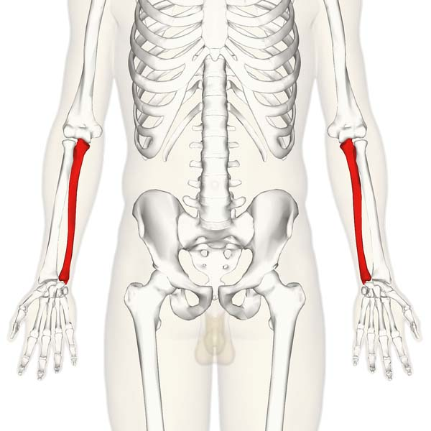

Important landmarks of the proximal ulna are the olecranon, coronoid process, trochlear notch, radial notch and the tuberosity of ulna:

Olecranon – a large projection of bone that extends proximally, forming part of trochlear notch. It can be palpated as the ‘tip’ of the elbow. The triceps brachii muscle attaches to its superior surface.
Coronoid process – this ridge of bone projects outwards anteriorly, forming part of the trochlear notch.
Trochlear notch – formed by the olecranon and coronoid process. It is wrench shaped, and articulates with the trochlea of the humerus.
Radial notch – located on the lateral surface of the trochlear notch, this area articulates with the head of the radius.
Tuberosity of ulna – a roughening immediately distal to the coronoid process. It is where the brachialis muscle attaches.
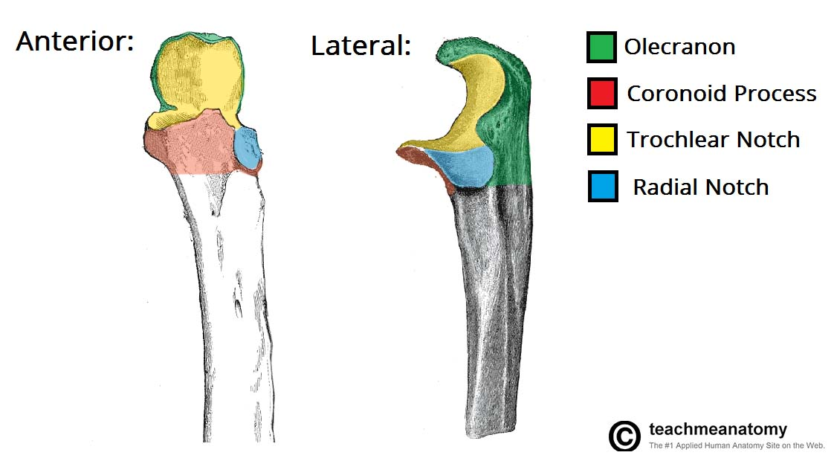
- Shaft of the Ulna
The ulnar shaft is triangular in shape, with three borders and three surfaces. As it moves distally, it decreases in width.

The three surfaces:

Anterior – site of attachment for the pronator quadratus muscle distally.
Posterior – site of attachment for many muscles.
Medial – unremarkable.
The three borders:

Posterior – palpable along the entire length of the forearm posteriorly
Interosseous – site of attachment for the interosseous membrane, which spans the distance between the two forearm bones.
Anterior – unremarkable.
Distal Osteology and Articulations
The distal end of the ulna is much smaller in diameter than the proximal end. It is mostly unremarkable, terminating in a rounded head, with distal projection – the ulnar styloid process.

The head articulates with the ulnar notch of the radius to form the distal radio-ulnar joint.
RADIUS:
The radius is a long bone in the forearm. It lies laterally and parallel to ulna,
the second of the forearm bones. The radius pivots around the ulna to
produce movement at the proximal and distal radio-ulnar joints.
• The radius articulates in four places:
• Elbow joint – Partly formed by an articulation between the head of the
radius, and the capitulum of the humerus.
• Proximal radioulnar joint – An articulation between the radial head, and
the radial notch of the ulna.
• Wrist joint – An articulation between the distal end of the radius and the
carpal bones.
• Distal radioulnar joint – An articulation between the ulnar notch and the
head of the ulna. The proximal end of the radius articulates in both the elbow and proximal
radioulnar joints.
• Important bony landmarks include the head, neck and radial tuberosity:
• Head of radius – A disk shaped structure, with a concave articulating
surface. It is thicker medially, where it takes part in the proximal radioulnar
joint.
• Neck – A narrow area of bone, which lies between the radial head and
radial tuberosity.
• Radial tuberosity – A bony projection, which serves as the place of
attachment of the biceps brachii muscle.
- SHAFT OF RADIUS: The radial shaft expands in diameter as it moves distally. Much like
the ulna, it is triangular in shape, with three borders and three
surfaces.
• In the middle of the lateral surface, there is a small roughening for the
attachment of the pronator teres muscle.
- DISTAL REGION OF RADIUS:
In the distal region, the radial shaft expands to form a rectangular
end. The lateral side projects distally as the styloid process. In the
medial surface, there is a concavity, called the ulnar notch, which
articulates with the head of ulna, forming the distal radioulnar joint.
• The distal surface of the radius has two facets, for articulation with
the scaphoid and lunatecarpal bones. This makes up the wrist joint.

