NAME: FAIZ UR REHMAN
STDENT ID: 14623
SUBJECT: PROGRAMMING FUNDAMENTALS
INSTRUCTOR: MUHAMMAD WAQAS
DATE: 22ND AUG, 2020

Question 2
- Write a program (starting from #include) that asks the user for numbers 10 times, after the numbers have been entered, PRODUCT of all the numbers should be displayed. During the program if a positive number is entered it should continue and ask for another number, if a negative number is entered the program should end and output the PRODUCT of all the positive entries. A sample run should appear on the screen like the text below. (12 Marks)
Enter a number: 3
Enter a number: 10
Enter a number: 2
Enter a number: -213
The product of all your positive numbers is 60
Answer:
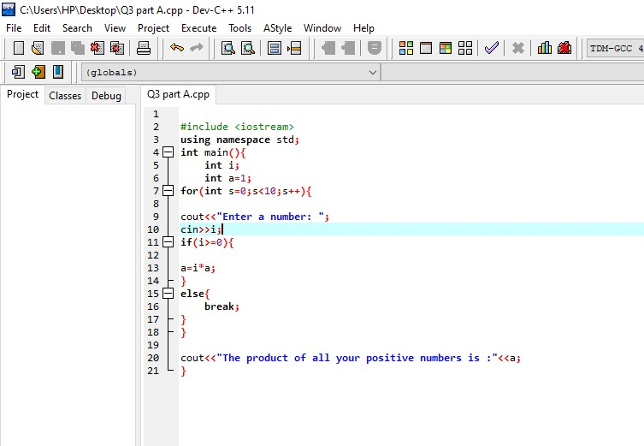
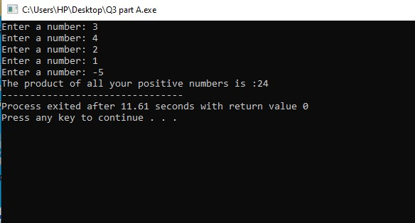

Question 3
- The program below is supposed to compute the average of two numbers. The program compiles without error, but does not correctly compute the average. (5 Marks)
#include <iostream>  using namespace std;  void main() {  int total=0;  cout<<”Enter a number: “;  int a;  cin>>a;  total = total + a;  cout<<”Enter another number: “;  int b;  cin>>b;  total = total + a;  double average = total / 2;  cout<<”The average is “<<average<<”\n”;  } | b) What is the output of the following code? (5 Marks)  #include <iostream>  using namespace std;  void main(){  int I = 0;  for(i=1; i<19; i++){  for(int j=1; j<2; j++){  i = i-3;  cout<<i<<endl;  }  }  cout<<”Final Answer is = “<<i<<endl;  }

Answer:
Part A:
The problem is with the code of the programme as we can see that after cin>>b;
The total=total+a; in here the code doesn’t add the number we entered for the integer b earlier in the result average does not have the value of the b which leads us towards incorrect output

Answer:
Part B:
The above code won’t give us any result because the C++ language is case sensitive, As we can see that int I has a capital I while the loop contain a small i so the code won’t run and will give us a error.

Question 1
Give 3 reasons why it’s important to comment your code. What are the 2 different ways to comment code in C++ and how are they different?
Answer:
Commenting is very in programming, As there are a lot of different ways to do a same task in a programming language so it is difficult to understand sometimes the codes of other people without comments.
C++ comments come in two flavors: single-line comments and multiline comments. Single-line comments are accomplished using a double slash (//). The double slash tells the compiler to ignore everything that follows, until the end of the line.

Multiline comments are started by using a forward slash followed by an asterisk (/*). This “slash-star” comment mark tells the compiler to ignore everything that follows until it finds a “star-slash” (*/) comment mark. These marks can be on the same line or they can have one or more lines between them; however, every /* must be matched with a closing */.

What are the two different commands used to output a new line in C++?
Answer:
There are two different commands in c++ to output a new line;
The first one is the “\n” command
The second one is the endl command
Both of the upper commands are very easy to use and are used equally.

Show the difference between IF-ELSE and nested IF condition?
Answer:
Nested If Statement:
When an if statement appears inside the other it is called nesting of if statements. Nesting of if statements is very helpful when you have something to do by following more than one decision.
The if-else Statement:
Use the if statement to specify a block of C++ code to be executed if a condition is true.
The else statement is used when we’re giving the compiler an option that if this isn’t true then run this one.

What is a nested loop? Give a nested FOR loop example and the exact number of times the loop will run?
Answer:
A nested loop is something when we use a loop inside a loop.
A nested for loop will be when we use a for loop inside a for loop
For example:
for(int i=0;i<5;i++){
cin>>i;
if(i<=0){

for(int j=0;j<5;j++){
}
}
}
Int the above code if i is 0 or a negative number then the loop of I will run 5 times from 0-4 while the j loop will also run 5 times from 0-4.
So the total will be 10.

