{ Assignment for Mid-Term }
………………………………………………

Name ___ Mohammad Basir
ID ___ 13142
Program ___ Bscs (8th semester)
Subject ___ HUMAN COMPUTER INTERACTION

Q1__ (a)__ What is the main aim of the Don Norman’s Book (The Design of Everyday things)?
Answer :
The Design of Everyday Things is a book about how design serves as the communication between object and user, and how to optimise that conduit of communication in order to make the experience of using the object pleasurable ..
The goal: guide the user effortlessly to the right action on the right control at the right time. In this entertaining and insightful analysis, cognitive scientist Don Norman hails excellence of design as the most important key to regaining the competitive edge in influencing consumer behavior .
……………………………………………..
(b)__
Explain Deductive and Abductive reasoning with examples ?

ANSWER : Deductive Reasoning

Deduction is generally defined as "the deriving of a conclusion by reasoning." Its specific meaning in logic is "inference in which the conclusion about particulars follows necessarily from general or universal premises." Simply put, deduction—or the process of deducing—is the formation of a conclusion based on generally accepted statements or facts. It occurs when you are planning out trips, for instance. Say you have a 10 o'clock appointment with the dentist and you know that it takes 30 minutes to drive from your house to the dentist's. From those two facts, you deduce that you will have to leave your house at 9:30, at the latest, to be at the dentist's on time.
………………………
Examples :
- All men are mortal. (First premise)
- Socrates is a man. (Second premise)
- Therefore, Socrates is mortal. (Conclusion
……………….

Abductive Reasoning

The third method of reasoning, abduction, is defined as "a syllogism in which the major premise is evident but the minor premise and therefore the conclusion only probable." Basically, it involves forming a conclusion from the information that is known. A familiar example of abduction is a detective's identification of a criminal by piecing together evidence at a crime scene. In an everyday scenario, you may be puzzled by a half-eaten sandwich on the kitchen counter. Abduction will lead you to the best explanation. Your reasoning might be that your teenage son made the sandwich and then saw that he was late for work. In a rush, he put the sandwich on the counter and left.
Jury duty decisions are one example of abductive reasoning .

Q__2__
Analyze the following scenario and write down seven stages of action for given particular
scenario for solution.
Scenario is:
Suppose I want to go to University, but the tyre of my car got punctured. Now I have to repair it.
You are required to write the seven stages of Gulf of Execution and Evaluation to solve the scenario?
ANSWER : before getting to the solution we may understand the basic about these concern then we can easily solve the scenario …
With a foot in psychology, Norman explains the user’s cognitive process as she/he interacts with technology in daily life using, among others, a model called seven stages of action to explain how human beings interact with the physical world.
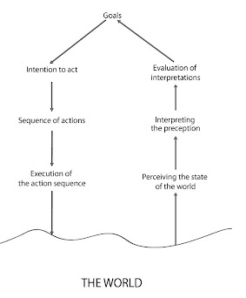
The identified steps are:
- Forming the goal
- Forming the intention
- Specifying an action
- Executing the action
- Perceiving the state of the world
- Interpreting the state of the world
- Evaluating the outcome

This model has several implications. First of all, it implies a goal-oriented design, which is very different from the task-oriented approach. Norman points out the difference between goals and tasks, which is often neglected by experts.

So, from here we can solve the it successfully …..
_______________________________________________

Q3___(a)___ Differentiate slip and mistake?
ANSWER :
Mistakes are errors in choosing an objective or specifying a method of achieving it whereas slips are errors in carrying out an intended method for reaching an objective (Sternberg 1996). ... If the intention is not appropriate, this is a mistake. If the action is not what was intended, this is a slip.
…………………..
(b)___ Explain self perception and object perception?
ANSWER :
Self-perception theory posits that people determine their attitudes and preferences by interpreting the meaning of their own behavior. Critcher and Gilovich looked at whether people also rely on the unobservable behavior that is their mindwandering when making inferences about their attitudes and preferences.
Object perception does accord with principles governing the motions of material bodies: Infants divide perceptual arrays into units that move as connected wholes, that move separately from one another, that tend to maintain their size and shape over motion, and that tend to act upon each other only on contact.
Q4___(a)__ Write the steps involved in perceptual process ?
ANSWER : The perceptual process consists of six steps: the presence of objects, observation, selection, organization, interpretation, and response. Perceptual selection is driven by internal (personality, motivation ) and external (contrast, repetition) factors.
…………………………………..
(b)___ Differentiate between perception and recognition?
ANSWER: perception: It basically means the way in which something is regarded, understood, or interpreted. Since, images are perceived by humans, therefore it varies from human to human.
Recognition: In image processing object recognition is a method which helps to identify objects which are present in an image. It categorizes the objects, e.g. a dog present in an image can be recognized as a dog only ___________________________________________

Q ___5___(b)___
A graphic designer, wants to design a 3d shape using Adobe Illustrator, he select a
shape, apply some gradient on it and then apply drop shadow effect.
In the given scenario in the light of interaction identify the Goal, Problem domain and the task?

ANSWER : before having the answer we should understand the concern steps of the topic than it can be done successfully with the help of these terms and process : - - -
A Goal can be defined as something the user wished to achieve. Goal can be for example: write a letter - make an order - deposit money. To reach a goal the user usually needs a plan which involves a set of tasks to be performed in order to reach the goal
A Task is the series of activities or actions required to achieve a goal. A task is a structured set of activities. The task can involve problem solving or selecting between alternative actions (or sub tasks)

An Action is a 'simple task' which requires no problem solving. An action has no structure

The tasks can be described as hierarchies. For example the use of a word processing system can be described as a hierarchy of subtasks which can be taken alternatively or after each others in order to reach the overall goal
……………………………………..
Task analysis steps
Goal -> What to do
Select the Device or Method -> Determines the task in concrete terms
Task -> activities to achieve the goals using the device
Subtask - components of a task
Actions - simple tasks
…………………………….

The method
- Action = elementary task, can not be partitioned in subtasks
  - Described as text (UPPER CASE) or a symbol (mouse click, move cursor, point,...)
- Task = sequence of actions or tasks (subtasks)
  - Described as a rule.
  - Task has a name <taskA> , <taskB> written in brackets.
…………………..
A HTA can be described in three steps: Starting - progressing - finalizing
- Starting the analysis
  - Specify the main task
  - Break down into 4 - 8 subtasks. Tha subtasks should be desribed as objectives - Should cover the whole main task
  - Draw subtasks as a layer. Make a plan how subtasks are connected.
- Progressing the analysis
  - Decide on the level of detail (detailed: keystroke-level - higher: general tasks)
  - Decide for each task if the analysis should be continued
  - Number boxes according levels
- Finalize the analysis
  - Check decompositions - all alternatives covered
  - Show the decomposition to an expert (evaluation - assessment)
(b)___ Explain Gulf of Execution and Gulf of Evaluation?
ANSWER :

Gulf of execution
Gulf of execution is the degree of ease with which a user can understand the current state of a system. It is the difference between the intentions of the users and what the system allows them to do.
For example, a person can look at a light switch and easily tell what the current state of the system is (i.e., whether the light is on or off) and how to operate the switch. This means that the gulf of execution is small. Norman states that, in order to design the best interfaces, the gulf must be kept as small as possible .
……………………………..
The terms gulf of execution and gulf of evaluation were introduced by usability researcher Donald Norman. They are concepts that are essential to understanding the interaction between humans and computers. The two gulfs are closely related to Norman’s Seven Stages of Action; the first four stages make up the gulf of execution, while the next three stages make up the gulf of evaluation. Consider the diagram below:

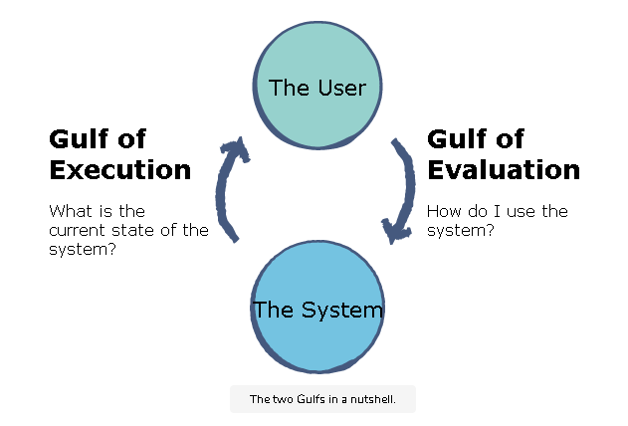
________________________________________
***
(THE END) .

