ASSIGNMENT/QUIZ

NAME: ZOHAIB KHAN

ID: 14821

DEPARMENT: B-TECH (CIVIL)

SUBJECT: QUANTITY SURVEY & CONTRACT DOCUMENTS
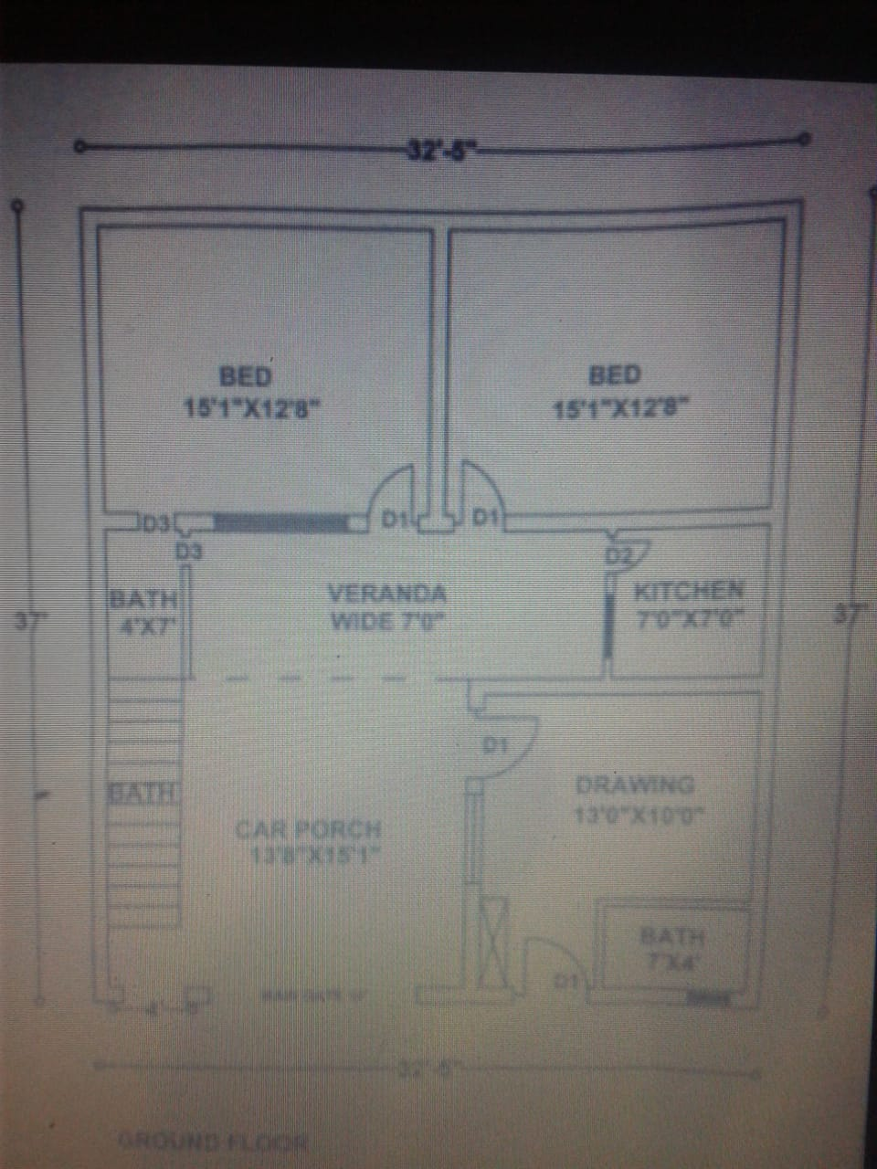

2 bed room + veranda + kitchen + side both, (slab)
L* W *H/D
21.16* 32.41* 0.5=342.89 cft
Drawing hall + both , (slab)
L * W * H/D
14.5* 15.875 * 0.5 = 115.09 cft
Net qty
=342.89 + 115.09
=457.98 cft
457.98* 1.54 = 705.28 cft
Ratio = 1 : 2 : 4 (sum = 7)
For cement = 1/7 * 705.28
=100.75/1.25
=81 bags
For sand = 2/7 * 705.28
= 201.50/100
= 2 sykra
For crush = 4/7* 705.28
=403.01/100
=4 sykra
Ratio = 1 : 2 : 4 ( sum 1 + 2 + 4 = 7)
16.875 * 1.54 = 25.98 cft
For cement = 1/7 * 25.98 = 3.71 / 1.25
=3 bags
For sand = 2 /7* 25.98 =7.42/100
=0.07 sykra
For crush = 4/7* 25.98 = 14.84/100
= 0.14 sykra
Bed of stairs = L * W * H/D
= 11.25 * 4 * 0.5
= 22.5 cft
For cement = 1/7 * 22.5
= 3.21/1.25
= 3 bags
For sand = 2/7 * 22.5
= 6.42/100
= 0.06 sykra
For crush= 4/7 * 22.5
= 12.85/100
= 0.12 sykra
Net qty = total qty – deduction qty
= 1752.75 – 221.805
Net qty = 1530.945 cft

For bricks = 1530.945 * 30%
= 20667 bricks
For masonry = 1530.945 * 30%
= 459.28 cft
Ratio = 1 : 4 ( sum of ratio = 1 + 4 = 5 )
For cement = 459.28 * 1/5 = 91.856/1.25
= 74 bags required
For sand = 459.28 * 4/5 = 367.42/100
= 3.6 sykra sand required
For stair = 1 step L * W * H/D = 4 * 0.75 * 0.75 = 2.25/2
1 step qty = 1.125 cft
15 * 1.125 = 16.875 cft
Required bricks = 20667 no.s
Cement bags = 74 + 3 + 3 +81= 161 bags
Crush = 0.14 + 0.12 + 4 = 5 sykra
Sand = 3.6 + 0.07 + 0.06 + 2 = 6 sykra
M.B 0F BUILDING
NO | DESCRIPTION | L | H./D | W | QTY | REMARKS
1 | Back wall | 32.41 | # | 0.75 | 267.38
2 | Sides wall | 35.5 | # | 0.75 | 585.75 | 37-0.75-0.75=35.5
3 | Drawing f/b wall | 13.75 | # | 0.75 | 226.875 | 13+0.75=13.75
4 | D.inner/s wall | 10 | # | 0.75 | 82.5
5 | Bed front wall | 30.91 | # | 0.75 | 255 | 32.41-0.75-0.75=30.91
6 | Bed/ mid wall | 12.66 | # | 0.75 | 104.445
7 | Main gate/fw | 17.91 | 9 | 0.75 | 120.89 | 32.41-1.5-13=17.91
8 | Kitchen wall | 7 | 11 | 0.375 | 28.875
9 | v/b both front | 7 | 8 | 0.375 | 21
 | back | 4.375 | 8 | 0.375 | 13.125 | 4+0.375=4.375
10 | Drawing both 1st | 7 | 11 | 0.375 | 28.875
 | 2nd side | 4.375 | 11 | 0.375 | 18.04 | 4+0.375=4.375

Total qty=1752.755 cft

Deduction of doors and windows
 | NO | L (ft) | H/D (ft) | W (ft) | QTY(cft)
D 1 | 4 | 3.5 | 7 | 0.75 | 73.5
D 2 | 1 | 3 | 7 | 0.375 | 7.875
D 3 | 3 | 2.5 | 7 | 0.375 | 19.68
Front gate | 1 | 4 | 9 | 0.75 | 27
Main gate | 1 | 10 | 9 | 0.75 | 67.5
Window of d/b | 2 | 3.5 | 5 | 0.75 | 26.25
Total qty =221.805 cft

