2) Criticism of Heckscher-Ohlin Theory:
No doubt, the Hexcher – Ohlin theory has been found to be more accurate, precise, scientifically and analytically superior to the earlier approach to the theory of international trade, yet it has some shortcomings for which it has been criticized by many authors is.
(i) Partial Equilibrium Analysis:
Although Heberler recognized Ohlin's theory as less abstract, it has failed to develop a general equilibrium concept. It is a part of partial equilibrium analysis, and is made up of large. This theory only seeks to interpret trade patterns based on factor ratios and factor intensities, while ignoring many other effects such as transportation costs, economies of scale, external economies, etc., which also greatly influence the cost of production. .In such a situation, Ellsworth states that "with many factors working together at a cost, it becomes a matter of adding all the cost-reducing and increasing power effects to arrive at a net result."
(ii) Oversimplifying Assumptions:
This theory is based on highly-simplified assumptions of perfect competition, full employment of resources, equal production work, constant returns to scale, absence of transportation costs and absence of product differentiation. Given this set of assumptions, the whole model becomes quite unrealistic.
(iii) Static Analysis:
The Heckscher – Ohlin model assumes a fixed quantity of factors of production, given production functions, income, and cost. This means that the theory examines the pattern of international trade in a stable setting. The conclusions drawn from such analysis are not relevant for a dynamic economic system.
(iv) Identical Factors:
This theory suggests that there is no qualitative difference between the factors and that these factors are capable of accurate measurement so that the factor endowment ratio can be calculated. In the real world, however, qualitative factor differences exist. In addition, there is more than one type of each factor. This creates serious complications in the measurement and comparison of costs and the determination of business patterns.

(v) Neglect of Product Differentiation:
The theory ignores the role played by product differentiation in international trade. Even when production agents are similar in the two countries, international trade can still be due to product differentiation. For example, Japanese machines are sold in the US and American machines are sold in Japan. In this context, Vizinesines believes that factor prices do not determine costs. These are commodity prices that determine commodity prices.The prices of goods are determined by their utility (strength of demand) for buyers and the prices of factors such as raw materials, labor, etc. are ultimately dependent on the demand and prices of the final goods because the demand for them is derived demand. Hence Viznaimes states that "prices are the only things we can accept as data. Everything else has to be derived from there." He considers both the Ricardian theory and the Hexcher-Ohlin theory to be faulty because they factor prices. Ignoring the costs related to and the impact of product discrimination on international trade.
(vi) Factor Proportions and Specialisation:
The H-O theory states that relative factor ratios (or factor endowments) determine expertise in exports to different countries. Capital-rich countries export capital-intensive goods and labor-rich countries export labor-intensive goods. This implies that there will not be trade between such countries or regions, as there are similar relative factor ratios. But this is not true.A large proportion of world trade is between the countries of the U.S.A. and Western Europe, despite the fact that they all have a large capital — the abundance and scarcity of labor. The H-O theory cannot provide a complete and satisfactory explanation of business in such cases. In fact, specialization is controlled not only by factor ratios, but also by many other factors such as cost and price differences, transportation costs, economies of scale, external economies and so on. The H-O theory was clearly wrong in ignoring these factors.

(vii) Neglect of Factor Demand:
The H-O theory assumes that factor prices are determined by the relative factor settlement of a country. This means that the rate of interest should be relatively low and wage rates should be relatively high in a capital-rich but labor-intensive country. On this basis, the United States should have a lower interest rate structure but it is actually higher because even in that capital-surplus country, the demand for capital is very strong. In fact, relative factor prices are influenced not only by their supply, but also by demand for them. The H-O theory failed to take into account the effect of demand for factors on their prices.

(viii) Factor Mobility:
This theory assumes that international mobility of factors is lacking. This assumption is not valid. Authors such as Williams and Levine have pointed out that the international mobility of factors is actually higher than inter-regional mobility within similar countries. This is evident from the international capital inflows of LDCs from advanced countries like petroleum, minerals, plantations etc. to such export areas.

Similarly, large-scale labor from third world countries to advanced countries has helped the latter in increasing its production and exports. Therefore, it is clear that the H-O theory takes an unrealistic assumption of international stagnation of factors.

(ix) Neglect of Technological Change:
The H – O model assumes the same production function. This means that technical conditions in a country remain unchanged. This assumption is again invalid. Production techniques have steadily improved in both advanced and less developed countries. Neglect of technological change in H-O theory makes this model quite incompatible with actual reality.

(x) Factor-Intensity:
This theory gives great prominence to the concept of factor intensity. In this model it is assumed that one is good capital-intensive and the other is labor-intensive. Good capital-intensive, capital-intensive in both countries and labor-intensive in both countries. This means that there can be no reversal of factor-intensity, that is, capital-intensive is good in one country while labor-intensive in another. The empirical evidence on this issue is conflicting. However, if the factor-intensity inversion occurs, the entire structure of the H-O theory will collapse.

(xi) Neglect of By-Products:
Sometimes byproducts are also more important than the main product. The Heckcher – Ohlin theorem, however, provides no explanation as to how the terms of trade are determined in the case of by-products.
(xii) Possibility of Trade Even under Identical Proportions:
The factor ratio theory implies that there can be no possibility of international trade if the factor ratios between two countries are the same. Exactly equal factor ratios cannot close the possibility of trading if customer’s preferences are not identical due to differences in income distribution in two DEFFERENT NATIONS.

4) Spillover which effect Pakistan Economy:
These points are given below

- Spillover to the travel industry:
Pakistan has been ranked as one of the most beautiful tourist destinations in the world by major travel websites and various media outlets. The country has great potential to come up with more promising tourism opportunities. The tourism industry not only contributes a huge amount to Pakistan's growing economy, but portrays the country's soft image around the world.According to the Travel and Tourism Competitiveness Report 2017 released by the World Economic Forum, travel and tourism's direct contribution to Pakistan's GDP in 2015 was US $ 328.3 million, with 2.8% of total GDP. According to the World Travel and Tourism Council, travel and tourism's direct contribution to Pakistan's GDP in 2016 was US $ 7.6 billion (PKR 793.0 billion), with 2.7% of total GDP. By 2025, the government predicts that tourism will contribute tr1 trillion (US $ 7.1 billion) to Pakistan's economyDomestic as well as one of the most visited areas in Gilgit Baltistan, discredited by foreign tourists. It is located in the north of Pakistan. It is the summit of snow covered peaks in some of the 3 largest mountain ranges, some of the tallest plateaus in the world, for a rare habitat of flora and fauna with a society of diverse cultural backgrounds and rich traditions. A promising land for the tourism industry in Pakistan. With progress across the country, travel restrictions and various industries closing with the private sector on the verge of recession, it presents a dangerous situation for GB residents, as most people are dependent on tourism.
Also the Pakistan transport industry also effect due to coronavirus.

Spillover to the hospitality industry:
Pakistan has changed hundreds of hotels into temporary quarantine centers, many necessary steps to make sure a traditionally prepared PHC system can deal with the coronavirus epidemic. The All Pakistan Restaurants Association on Friday warned the government that if they were not allowed to resume work by May 30, they would open eateries across the country.In a press conference, members of the Association's Joint Action Committee (JAC) said that by June 1, about 100,000 restaurants across the country would reopen.
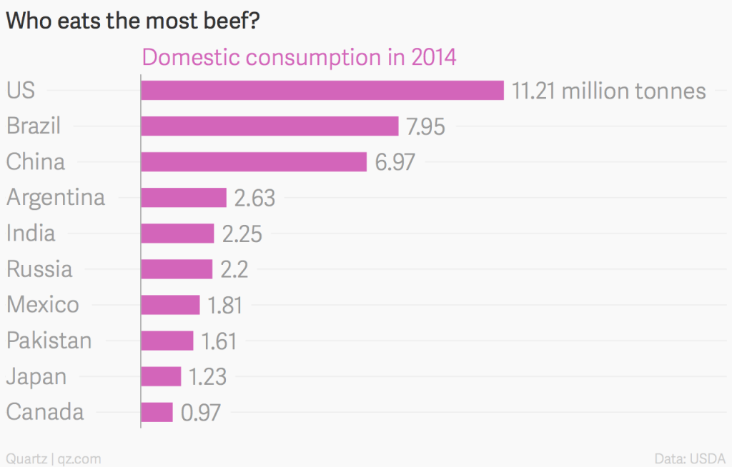
So this graph that this pandemic effect badly Pakistan hospitality industry.

Spillover to import-dependent countries:
As we know that Pakistan import many product and services from all our the world as given below,
Trade deficit, including services, widened to USD 32.6 billion in 2018 (WTO) as imports grew much faster than exports. The imports of goods reached USD 60.5 billion in 2018, while the exports were only USD 23.5 billion.
Here I will share my personal life example yesterday I want to shop, to assemble an air cooler for myself than I found that import of many parts of air cooler have stopped due to covid-19 pandemic.
Spillover to the financial Market:
As we know that covid-19 effect globle economy very badly like the most visible result of the COVID-19 crisis on financial markets was the impact in the global stock market. According to the S&P Dow Jones Index, global stock markets lost $ 6 trillion in value in six days from February 23 to 28. Between February 20 and March 19, the S&P 500 index fell 28% (from 3,373 to 2,409), the FTSE 250 index fell 41.3% (from 21,866 to 12,830), and the Nikkei fell by 29% (from 23,479 to 16,552). . Over the same period, large international banks saw their share price fall, for example, Citigroup's share price fell 49% (from US $ 78.22 to US $ 39.64), JPMorgan Chase's share price fell 38% ( Fell from US $ 137.49 to US $ 85.30), and Barclays' share price fell by 52% (from £ 181.32 to £ 86.45).
As many of business are closed in Pakistan due to this pandemic Pakistan has sufferd 2.3t lose in covid-19 period.
The Karachi Stock Exchange took a plunge of 1,100 points following a slump in international stock markets.
Spillover to the health sector:
With the surge in hospitals and a sharp increase in the number of deaths, Pakistan's fragile health system hangs on to the adjacent peak of coronovirus.
The number here has already crossed China, the origin of the novel virus.
Government officials claim that the situation is "under control", but health officials believe the already dispersed health system is unable to handle the flames of COVID-19 patients.
In the country's two most populous cities, Karachi and Lahore, hospitals are already struggling due to a sharp increase in COVID-19 patients in recent weeks.
Some major private hospitals are removing patients due to lack of beds. In Karachi, home to over 15 million people, and the epicenter of Pakistan's COVID-19 epidemic, 15 government, private and charitable hospitals are dealing with coronovirus patients.
According to official figures, the number of ventilators in those hospitals is 136.
According to Health Minister Yasmin Rashid of the Northeast Punjab Province, Lahore has only 539 beds and 200 ventilators available for coronovirus patients, of which Lahore is the capital.
Punjab and southern Sindh provinces, which account for more than 70,100 of the country's 94,000 cases, have more than 14,000 beds for coronovirus patients in state-run and private hospitals.

Spillover to the education sector:
The relevance of the plague amidst the epidemics of modern times is surprising as the world is at a close halt. From the everyday activities of a common man to the functioning of governments, COVID-19 has led to disintegration and deaths not from war but from a disease that has shaken nations to their core.In addition, the rapid and undetermined transfer of COVID-19 to China and its vicinity alerted Pakistan over time. Earlier, Pakistan's Foreign Ministry and HEC faced criticism over the reluctant response to Pakistani students present in China as a result of the outbreak of COVID-19 in the province, making them the first students to be affected by the new epidemic.
Furthermore, with the proliferation of COVID-19 in Pakistan, educational institutions across the country were ordered to immediately suspend their regular academic activities keeping in mind the safety of students.
Furthermore, as the country entered educational institutions in about a month of complete lockdown and partial to total suspension, it would have faced an unprecedented challenge to face with re-adjusting its academic year is. However, Pakistan is not the only country facing the staggering impact of COVID-19 on education. According to the latest figures released by UNESCO, an estimated 87% of the student population in 165 countries are closed schools and universities. In addition, approximately 1.5 billion students in the world are unable to attend educational institutions due to measures taken to prevent the spread of COVID-19.

3) CPEC Infrastructure Development

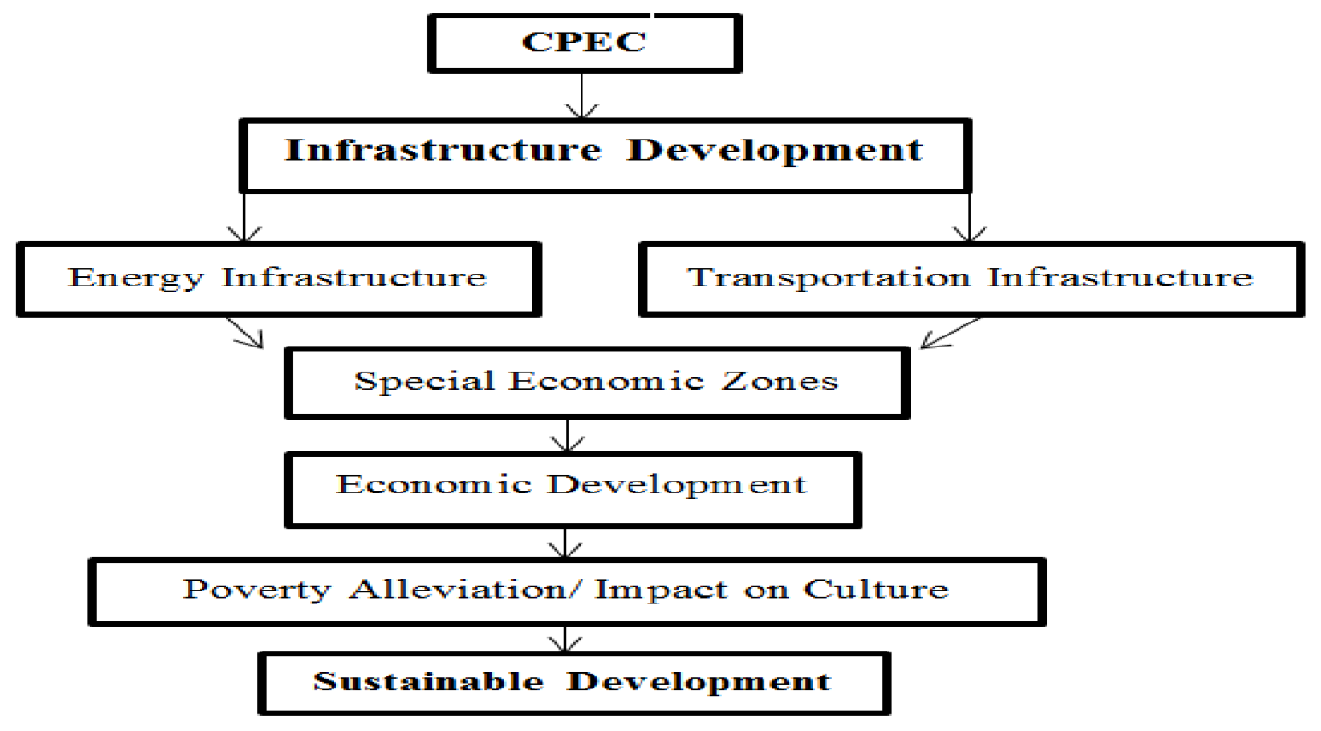

Energy Infrastructure Development

Under CPEC investment, about 34 billion USD is going to be invested in Pakistan's energy sector through development and installment of resources for power generation through coal and gas. In addition, approximately US $ 2.5 billion has been allocated for the construction of ﬁ ednaturalgas (LNG) pipelines. Thelique l ednaturalgas (LNG) willbetransportedfromIranto the energy requirement of both the provinces of Balochistan (Gwadar) and Sindh (Nawabshah) ful ces ll.
In addition, aprojectgasandoilpipelinebetweenPakistanandIranwillalsosatisfytheenergyneedsof one of both China and Pakistan. The suggested gas and oil pipelines under the CPEC project can be converted into oil and gas pipelines of China, Pakistan and Iran. The components of energy projects under CPEC will not have a symbolic effect on Pakistan's economy. These energy projects will meet the energy needs of the industrial sector of Pakistan and improve the economic conditions. Pakistan's GDP growth has been shifted to around 2% -2.5% due to energy shortage in the industrial sector. Electric power projects will be executed on priority basis throughout Pakistan to meet the power shortage in Pakistan. About 21,000 MGW of power is expected to be generated upon completion of the power projects under CPEC.
Transportation Infrastructure Developmen:
Pakistan's transportation and infrastructure development is the second component of CPEC and has been allocated approximately USD 12 billion with a 46 billion USD CPEC investment.Under the CPEC project, China is building new infrastructure and upgrading the already existing transportation system in Pakistan. The Industrial Commercial Bank of China (ICBC), China Exim Bank and China Development Bank (CDB) are agencies providing in nance in transportation and infrastructure development projects.According to CPEC routes new and upgrade of existing railway and high way network will be constructed all over Pakistan. A motorway of about 1100 km would be built to connect Karachi to Lahore, and this motorway would play a significant role in internal connections and economic development. In addition, the Karakoram Highway (KKH) will be extended to other cities in Pakistan. A railway network will also be constructed between Peshawar and Karachi.
Special Economic Zones
In the process of industrialization, SEZs and industrial clusters play an important role. In di have erent cities of Pakistan, SEZ is proposed under the CPEC project, which will accelerate the process of industrialization in Pakistan [81]. Several SEZs are going to be developed under the CPEC project in Pakistan, and the Chinese government has also created a special economic zone in the historic city of Xinjiang, named Kashghar. Kashghar is located near the border area between Pakistan and China. In addition, Kashgarvillipansentialrointellificationpecificationhefkin Pakistan [82]. The approach of Special Economic Zones (SEZs) is considered as the e एक्टिव ective way to increase economic growth and trade within a country. As per the observation of International Labor Organization (ILO) in 47 states, 176 Special Economic Zones were established in the year 1986. In addition, the erstwhile NetworkPhyshexologicZonadicin increased to 6200, and in13500SEZsareworking in130countries. InChina, Attheprovinciallevel, 750specialeconomiczoneshavebeenestablished, and these SEZs contribute to national GDP - around 22%, exports around 60%, and FDI around 46%. Prior to the SEZ strategy, industrial estates were established in Pakistan to enhance economic growth, but these did not yield satisfactory results. There is a continuous decrease in the Chineseintoistosting institute ﬁ rstSEZ in Gwadar, anditisexpectedthatthecostofshippingwill signi decrease. Habib Bank Limited Pakistan (HBL) and Industrial and Commercial Bank of China (ICBC) are providing funds for the establishment of SEZ in Balochistan and Punjab. The SEZ will be declared tax free by the Government of Pakistan for ten years. 27SEZshavebeplannedunderthe CP agshipofthe CPEC to increase local economic status and business, according to Ministry of Planning, Development and Reforms. The suggested SEZ would be around 1 trillion rupees with 2,000,000 job opportunities through turnover.

Economic Development
The reference is stated. The CPEC will have a significant role in the enhancement of Pakistan's economic situation, and further,
It will improve infrastructure and social development. However, CPEC will also increase China's trade with Pakistan and other counties of the world as CPEC will provide a safe and cost-saving shipment route to China. The context assessed that China is growing as a world economic power, and that intelligence is playing an important role in strengthening relations between Pakistan and China. Economic relations between Pakistan and china are about to mature, and CPECwill further improve the socio-economic relationship of both countries and promote cooperation in various sectors such as building infrastructure, building power and energy generation units (both strategic and digital). The reference stated that CPEC under BREC. Provithewariouskindsophoparityandbin for ts for Pakistan from socio-Economic development to improve security across the country. In short, CPEC will improve governance in Pakistan, help alleviate poverty and attract foreign investment.

Poverty Alleviation and Social Development
The reference stated that the local people of Pakistan will get many employment and business opportunities on the EC erent routes of CPEC, which will further increase their income level. Furthermore, in rural areas of Pakistan, CPEC will create drastic changes and bring about structural development and prosperity. The context assessed that CPEC will uplift Pakistan's social development through the implementation of di ent erent projects such as energy production, infrastructure development, and the establishment of new industries. These projects under CPEC will create new employment opportunities for Pakistani youth and will help in poverty alleviation. Rural, remote areas will connect with cities. In addition, technical and commercial centers will also improve social conditional Pheistanisocietybyprovidingtrainingaboutnewmoderntechnologythatwilltransfer in Pakistan under CPEC.

Sustainable Development
The Sustainable Development Goals (SDGs) have become a central focus worldwide due to their favorable outcomes in health, environment, sustainability, quality of life, and economic development . Necessary facilities can be easily accessed in remote areas of Pakistan through CPEC through education, transport, market and banking. Health and education are important factors in symbolic and sustainable development, and improvements in these two factors lead to an improved standard. TheresultsofthebinarylogisticregressionshowedthatCPECwillbehelpful in socio-economic development in the study area, and the mainstay of socio-economic development is undivided development. Accordingly, cultural communication, technology transfer, and interconnection are likely to increase in the region under the BRI. Under CPEC, the transformation of human capital knowledge and technology will play an important role in the development of Pakistan. Industrial capitalization is expected to improve the urban sector, which is will further stabilize the economy of Pakistan. Infrastructure-leadership-development is the foundation of socio-economic development. There are plans to use natural resources and social infrastructure as e एक्ट ects under the CPEC. The results of this study are supported by theories of development, theories of globalization and infrastructure development. Pakistan has introduced several institutional reforms in the industrial sector to improve domestic economic development. Additionally, CPEC has become a source of FDI, which will play a catalytic role in the stabilization of Pakistan's shaking economy. CPEC is a multidisciplinary project under the umbrella of BRI, the leading development process in Pakistan for sustainable development. Infrastructure development will be helpful in socio-economic development, poverty alleviation and improvement in the standard of living of people. In addition, it will also be helpful in reducing the development gap between the ﬀ erent regions. The goal of sustainable development can only be achieved through a multidisciplinary development project.

The 4 Possible Scenarios for Economic Recovery After the Pandemic:
Economists analyze the current scenario of COVID-19 and possibly predict four economic recovery models:

V-shape, meaning when imprisonment ends and a quick return to economic normality. This option is possible, but it is difficult to realize, because as mentioned earlier, the world will not return to the same economic landscape before the epidemic. Security measures, limited capacity, closed borders and fear of contagion against this option.

Dhara Ranasinghe, Ritwik Carvalho (2020) [iv] reported that the V-shaped recovery model is the best result. Similarly, a rapid rebound is accompanied by a decline in production. "The April-June GDP contraction will likely occur on a scale not seen for decades. But fiscal and monetary stimulus - $ 10 trillion and counting - could aid an equally rapid rebound."

Ross Walker, co-head of NatWest Markets' global economics, forecasts economic downturns in this quarter "business is open again in Q3 and Q4."
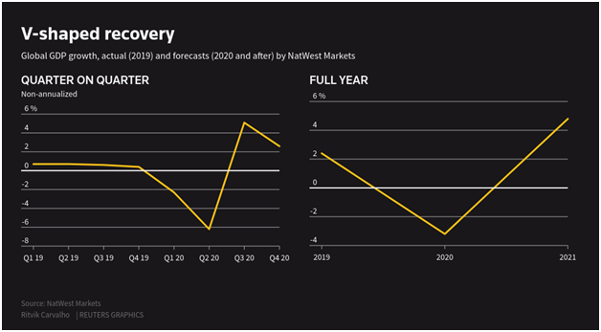

U-shape, this option means that it will take longer to return to economic normality. This form of retrieval seems more in line with the situation we will find after imprisonment, as the opening will be progressive and the situation will be different before the coronovirus appears.

Ranashighe and Carvalho (2020) [v] argued, "Economies have experienced recession more rapidly and deeper than in 2008–09. Given this situation, they speculated that this may be the most likely outcome. "

Although almost all organisms agree that U-shaped recovery is most likely, some warn of a more unfavorable scenario.

U-shape is the base case for ING's Brozsky, which will last for some time after noting the effect of the lockdown. "The loosening of the lockdown measures will be gradual, social disturbances will continue and the tourism industry will likely be harmed," Brejski said.
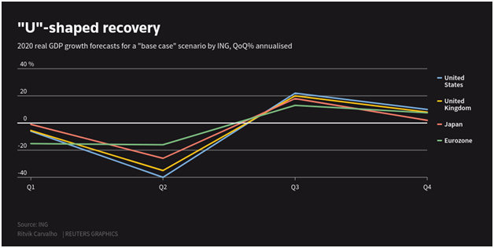

A W-shape or double-dip means that, after a short recovery, there will be a further decline and then a final economic recovery. This option corresponds to a flare or disappearance of the initial effects of monetary and fiscal measures imposed to combat coronovirus.

According to Ranasinghe and Carvalho (2020) [vi] if the relaxation of lockdown restrictions initially promotes activity, the effects of unemployment and corporate insolvency will begin to filter.
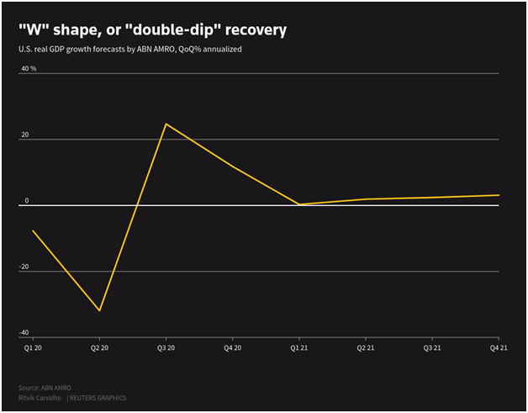

L-shape, this is the worst option we can face. This would mean that we would go through a major crisis, which would take a long time to recover. This is the weakest economic scenario and will lead to strong economic and social changes, which always occur when major economic collapse occurs.

Accordingly, Ranasinghe and Carvalho (2020) [vii] explained, "L-shaped results can be a risk to emerging markets that are able to engage large incentives and o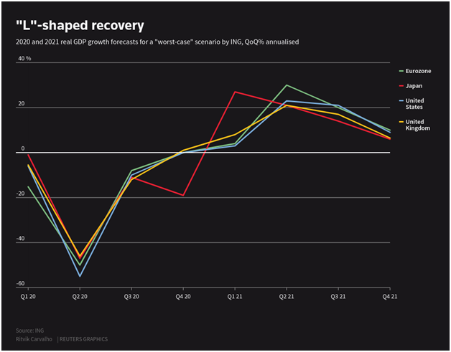ften rely on commodity exports."

1)Exploitation of natrul resorses:
Earth's natural resources are important for the survival and development of human populations. However, these resources are limited by Earth's ability to renew them. Freshwater, forests and harvesting products are renewable, provided that the exploitation does not exceed regeneration. Fossil fuels and metal ores are non-renewable. Although many of the effects of overexploitation are felt locally, the increasing dependence of nations and international trade in natural resources make their demand and sustainable management a global issue. This chapter focuses on major developments in the use of renewable and non-renewable resources in Europe in the context of global trends. Statistics available to monitor changes in the use of natural resources globally
renewable resources

Food, water, forests and wildlife are all renewable resources. To be sustainable for resource use, the rate of consumption must be maintained within the capacity of natural systems. Current rates of depletion of Earth's shares of renewable resources and the level of pressure exerted on their regenerative capacity through production and consumption may already be beyond this limit in some cases.

Non-renewable resources

Minerals, oil, gas, and coal are non-renewable resources: their use as material and energy sources reduces Earth's reserves. However, the period during which reserves may become available may be increased by improving recycling or utilization efficiency. Ultimately, to the extent that more efficient processes can expand the use of shares of non-renewable resources, renewable resources and restrictions are required, along with existing ones, that can be sustained by existing stocks.

Eamples:
As we know that that Russia and Arabia are in oil war in international market they make there revenue from this natural source.how ever saudia Arabia use oil for making electric city and much more.
Ever since oil was discovered in the Arabian Desert in 1938, Saudi Arabia has been a major power within the organization of the world's major petro-state and petroleum exporting countries.

Along with oil revenues, the country has neither income taxes nor corporate taxes due to heavy subsidies for food and fuel. And the royal family has built huge palaces in the house while buying houses abroad in London and in places like boats in the south of France.

But now the oil-rich state wants to look beyond oil. The crash in crude oil prices that began in 2014 has left the country with a huge budget deficit. And while oil prices have plummeted, climate activists have tried to bring the end of the hydrocarbon era closer and many analysts have predicted a "peak demand" approach that marks the end of a long climb in global oil consumption Will mark

The 31-year-old deputy crown prince, Mohammed bin Salman, the king's son, has worked to strengthen the Saudi economy by the year 2030. His plan, called Vision 2030, will promote new private businesses, improve and trim education. Budget reduction by introducing subsidy reductions and 5 percent value-added tax.

Most shocking: The government has proposed to sell a portion of its crown jewel, the state-run oil company Saudi Aramco. The company, which had been in the hands of four large oil companies in the US for decades and whose nationalization had become a powerful political symbol, is widely believed to be valued at $ 1 trillion to $ 2 trillion; Its stake offer may be the largest in history. And many analysts believe the secret giant holds closely guarded secrets such as the true cost of a soldier barrel and the size of payments made to the royal family.

