Name: Haseena Kausar
ID: 16468
Department: microbiology second semester
Assignment: computer

Transmission Media
- Magnetic Media. One of the most convenient way to transfer data from one computer to another, even before the birth of networking, was to save it on some storage media ...
- Twisted Pair Cable. A twisted pair cable is made of two plastic insulated copper wires twisted together to form a single media.
Transmission Media & Types
In network communications, a transmission medium is a physical connection or an interface between the transmitter and the receiver. There are two major categories of transmission media, namely guided and wireless (or unguided). For any networking to be effective, raw stream of data is to be transported from one device to other over some medium. Various transmission media can be used for transfer of data.
These transmission media may be of two types −
- Guided − In guided media, transmitted data travels through cabling system that has a fixed path. For example, copper wires, fibre optic wires, etc.
- Unguided − In unguided media, transmitted data travels through free space in form of electromagnetic signal. For example, radio waves, lasers, etc.
Each transmission media has its own advantages and disadvantages in terms of bandwidth, speed, delay, cost per bit, ease of installation and maintenance.
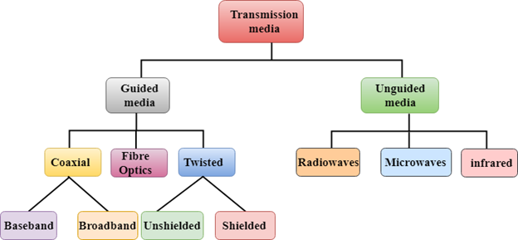

Types and Characteristics of Transmission Media
Transmission media refers to the physical means by which information is transferred. It does not include books, compact disks, tapes, floppy disks, photographs and slides which are themselves moved from one site to another. Transmission media, then, includes electrical wires, coaxial cables, optical fibres and electromagnetic waves. Besides microwaves, there are two other commonly used wireless media, namely radio and infra-red optical systems.

1. Twisted Pair Cable
Twisted pair cables have been around for a long time. They were mainly invented for voice transmissions. Twisted pair is a widely used medium in networking because it's lighter, cheaper, more flexible, easy to install, and provides greater speeds than coaxial cables. There are two types of twisted pair cables: the unshielded twisted pair (UTP) and the shielded twisted pair (STP). Let's take a closer look at each of them.
The unshielded twisted pair cable has 4 pairs of copper wires that are present inside a plastic sheath. These wires are twisted to protect them from interference. The only protection available for a UTP cable is a plastic sheath that is thin in size.
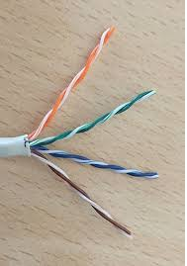
Optical Fiber Transmission in the Form of Light Waves

The shielded twisted pair cable is widely used in high-speed networks. The major difference between UTP and shielded twisted pair is that STP makes use of a metallic shield to wrap the wires. This metallic shield prevents interference to a better extent than UTP. These STP cables come with numbering; the higher the numbering, the better the interference prevention. As an example: most computer networks must go with CAT 3 or CAT 5, and nothing less than this.
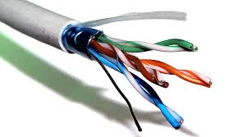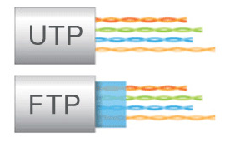
Shielded Twisted Pair Cable UTP and STP Difference

2. Coaxial Cables
The coaxial cables have a central copper conductor, surrounded by an insulating layer, a conducting shield, and the outermost plastic sheath. Thus, there are three insulation layers for the inner copper cable. There are two basic modes of data transmission in coaxial cables: baseband mode that has dedicated bandwidth, and broadband mode that has distributed cable bandwidth.
Cable TV and analog televisions mainly use coaxial cables. Coaxial cables have better resistance to cross talk than twisted pair cables. The coaxial cables are used for long distance communication. The most widely used types of coaxial cables are RG-59 and RG-6 (RG stands for 'radio guide'). RG-59 has lesser shielding and is suitable for short cable lengths and cable TV connections.
RG-6 has better insulation than RG-59 and is used for satellite TV and digital signal transmissions for better strength and longer distances.
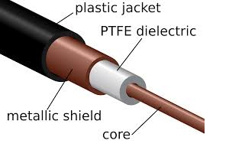
Coaxial Cable
There are many advantages to coaxial cables, including the following:
- High bandwidth
- Easy and cheap installation
- Better immunity from noise
- Better scaling
However, there are also a number of disadvantages to coaxial cables, which include the following:
- They're more prone to lightning strikes.
- They cover less distance than fiber optic cables.
- They carry less bandwidth than both fiber optic and twisted pair cables.
Now let's move onto a different type of guided transmission media.

3. Optical Fibers
Optical fibers use light waves for transmission. Crosstalk, EMI, and attenuation aren't issues with optical fibers. These cables are well-suited for voice, data, and video transmissions. Optical fibers are the most secure of all the cable media. Installation and maintenance are difficult and costly. Fiber optic cables have greater transmission speed, high bandwidth, and the signal can travel longer distances when compared to coaxial and twisted pair cables. Though the cost of optical fiber cable is less compared to co-axial and twisted pair cables, the additional optical components needed for installation make fiber optic the costliest of all the cables.
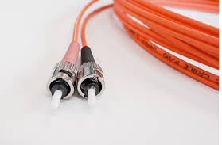
Optical Fiber Cable
The advantages of optical fibers include the following:
- There is zero interference and covers major cities and countries.
- They have high speed and high bandwidth.
- They're highly secure.
There also are a number of disadvantages, including the following:
- Installation and maintenance are difficult.
- Cabling is costly.
- Retrofitting an existing network is difficult, since optical fibers are incompatible with many types of electronic networking equipment.
There are two modes of operation for optical fibers. First there's single-mode fiber, which uses a single beam of light and allows communication over great distances with better transfer speed. Then there is multimode fiber, which uses multiple light beams inside a single fiber cable, has a reduced length and travel speed, and has a larger bandwidth, but signal strength is weakened.
Optical Fiber Transmission in the Form of Light Waves

4. Wireless or Unguided Transmission Media
The features of wireless/unguided transmission media are that the signal gets broadcast without any guided medium through the air and is less secure. There are three types of wireless transmission media:
- Radio wave
- Infrared
- Microwave
The advantages of unguided transmission media include the following:
- They are useful in wireless remote accessing methods.
- Networks can be expanded without disturbing the current users.
The disadvantages include:
- Potential security issues.
- They have limited speed compared to guided transmission media

Radio Wave Links
Electromagnetic waves in the frequency range of 3 kHz to 1 GHz are commonly known as radio waves. There are basically two types of configuration for electromagnetic wave transmission and reception, directional and omni-directional. In directional configuration, an antenna radiates electromagnetic energy as a focused beam in a particular direction. The receiving antenna should be aligned in that direction for receiving the signals. In omni-directional configuration, an antenna radiates electromagnetic energy equally in all directions. This implies that transmitting antenna and receiving antenna do not have to be aligned as in directional configuration. Also here electromagnetic waves from a transmitting antenna can be received by many users.
Radio waves are basically omni-directional in nature. They use omni-directional antennas for transmission and reception of electromagnetic signals. Radio waves are used in AM and FM broadcast systems, television, cordless phones, paging and a wide variety of other multi-casting applications.

Terrestrial Microwave Links
Frequencies in the range of about 1 GHz to 300 GHz are commonly known as microwaves. Microwaves are narrow beams and hence they are directional in nature. Microwaves are usually transmitted through air between two stations. Thus in microwave systems, the transmitting antenna and receiving antenna should be aligned. Microwave propagation is also termed as line-of-sight propagation. This is because transmitting and receiving antenna should be in visible contact with each other. Terrestrial microwave communication is commonly used in situations where cables are difficult to install. Such situations include communication across sea, mountains, large buildings and remote areas. Microwaves are widely used in point-to-point communication systems such as mobile communication, satellite systems and wireless LANs.

Infrared Links
Frequencies in the range from 300 GHz to 400 THz are the infrared waves. They are used for short-range communications such as data transfer between two cell phones in one room, TV remote control operation and data transfer between a computer and a cell phone that resides in the same closed area. Line-of-sight propagation mode is employed in all applications of infrared waves. That means, transmitter and receiver must be aligned with respect to each other so that nothing obstructs the path of infrared wave

