Name: Shah fahad
Id: 16172
Section: (A)
Programe: SE

-: FINAL TERM LAB:-

Q1. How to check Even and Odd numbers in java using object oriented approach?

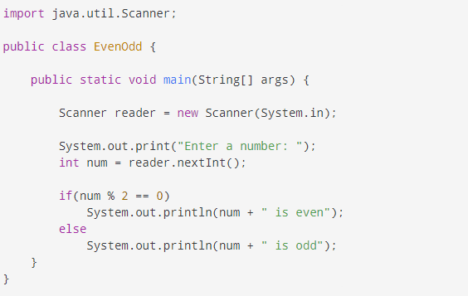

OUTPUT:-
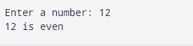

Q2. How to add 2 complex numbers in java using object oriented approach?

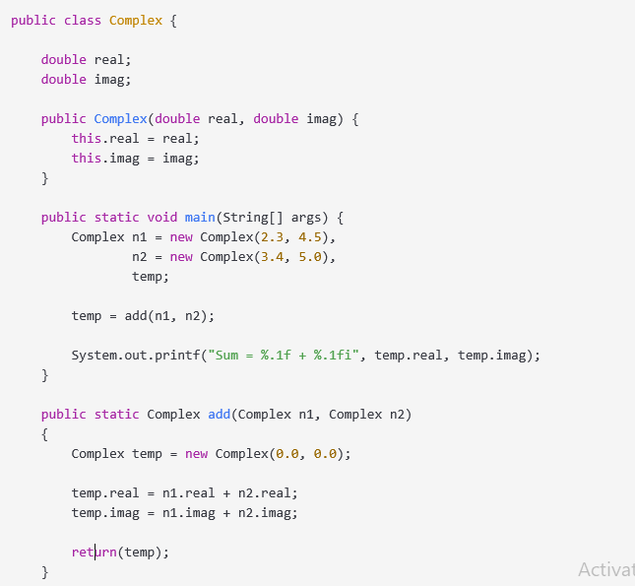

OUTPUT:-

Q3. How to check Leap year in java using object oriented approach?

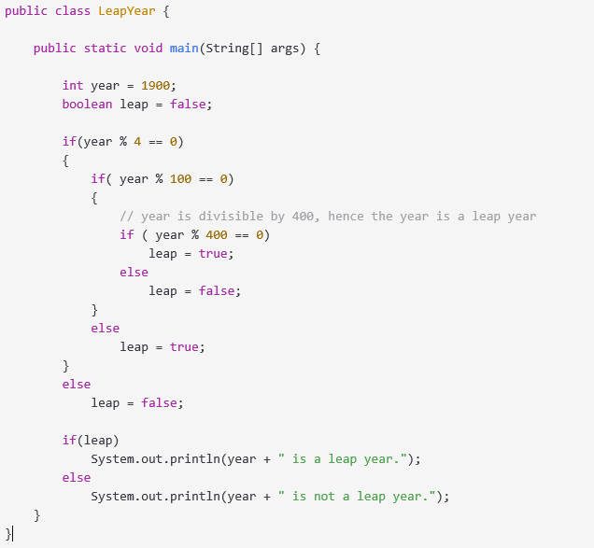

OUTPUT:-
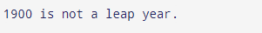

Q4. How to check that the input from the user is the vowel or not in java using object oriented approach?

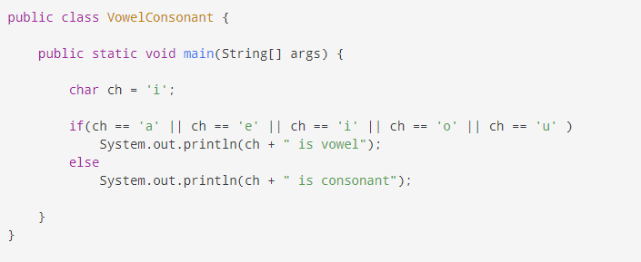

OUTPUT:-

Q5. How to use power of a number in java using object oriented approach?
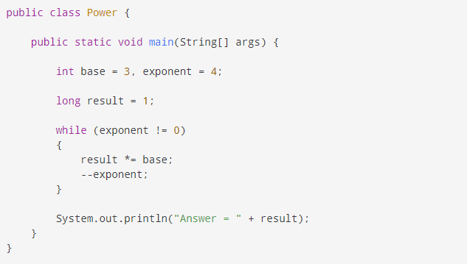

OUTPUT:-

