Syed Tufail Jan
Id 15371
Q.1
ANSWER
Iodinated contrast is the main type of radiocontrast used for intravenous administration
The iodinated contrast are differentiated in Ionic monomer
Ionic dimer (HOCM)
Non-ionic contrast agent
Non-ionic dimer (LOCM)
Non-ionic monomer (LOCM)
Ideal administration for IV contrast

Q.2
ANSWER
Venography (also called phlebography or ascending phlebography) is a procedure in which an x-ray of the veins a venogram is taken after a special dye is injected into the bone marrow or veins The dye has to be injected constantly via a catheter, making it an invasive procedure.
Contrast venography is the gold standard for judging diagnostic imaging methods for deep venous thrombosis although because of its cost invasiveness the increased sensitivity of sonography to demonstrate pathology and other limitations this test is rarely performed.
Specific venographic procedure
Venography can be divided into following sections.
Peripheral venography
Lower limb venography
Upper limb venography
Peripheral venography

Q.3
ANSWER
loopogram is a diagnostic test that is performed on the section of bowel that functions in place of the urinary bladder.
Patients who do not have a bladder or have a malfunctioning bladder may undergo a surgical procedure called a urinary diversion to reroute the flow of urine through an opening in the abdomen
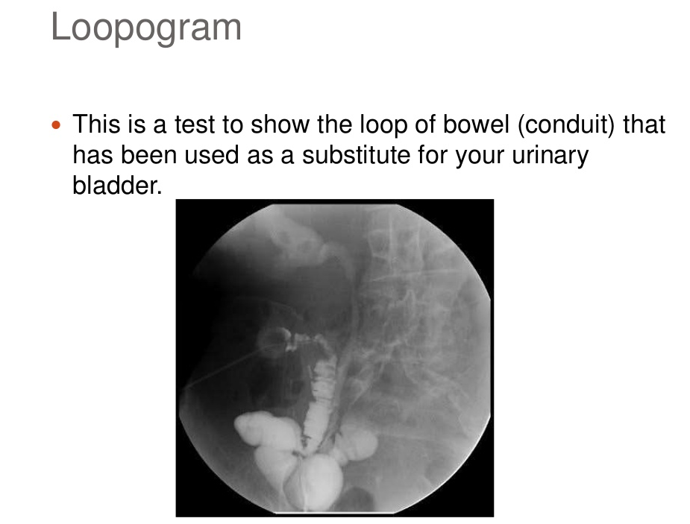

Q.4
ANSWER
Radiologist technologists perform the following tasks including.
- Explaining procedures to patients and answering every questions
- Preparing equipment for use as needed
- Preparing examination rooms for the patient exams
- Positioning patients for imaging exams
- Documenting information with computers
- Reporting important information to the physician
- Ensuring safety of patient during exams
- Producing diagnostic images of soft tissues
- Using sound waves to obtain images of organ and tissue in the body

Q.5
ANSWER
Catheters and Wires
Guidewires:
- Guidewires (solid wires navigated within the vascular system / extravascular tract) act as a lead point for catheters, allowing operators to traverse along a given vessel / track.

Types of Guidewires:
- Starting guidewires ‐ used for catheter introduction and some procedures.
- Selective guidewires ‐ used to cannulate side branches or cross critical lesions.
- Exchange guidewires ‐ are stiffer and used to secure position as devices are passed over the wire.

Catheters:
Angiographic catheters:
•Used for diagnostic and therapeutic invasive intra‐vascular procedures.
•Are of various shapes and tip
configurations
•Usually have one end‐hole for selective injections
•Usual size: 2Fr – 8Fr

Drainage catheters:
•Used for percutaneous drainage of fluid/collections
•Usual shape is straight tip or
“pigtail” or a mushroom
(Malecot).
Angiographic catheters:
- usually made of plastic (polyurethane, polyethylene, Teflon, or nylon)
- exact catheter material, construction, coatings, inner diameter, outer diameter, length, tip shape, side‐hole pattern, and end‐hole dimensions are determined by the intended use
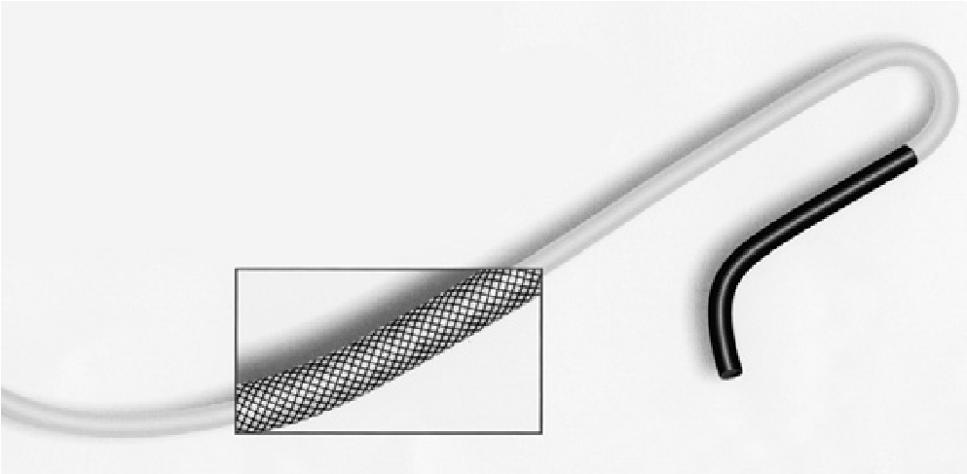
- Diameter is outer size described in French gauge (3F = 1 mm) and inner
lumen is in hundredth of an inch
- Length described in centimeters (usually between 65 and 100 cm)

