Name: imran khan
Id : 15963
ASSIGNMENT FOR VIVA.
Class: Dental sec (b) 2nd semester

Q1. (i) Write a note on cardiovascular system?
(ii) what are the symptoms of high and low blood pressure?
(iii) what is the treatment of high and low blood pressure?

QUSTION 1.

The cardiovascular system ;
Organ system that distribute blood to all parts of the body.
MAJOR FUNCTION.Transportation ,using blood as the transport as the transport vehical.
This system carries oxygen, nutrients ,cell wastes.hormones and other substance vital for body homeostasis to all from cell.
The force to move blood around blood the body is provided by the pumping heart and blood pressure.
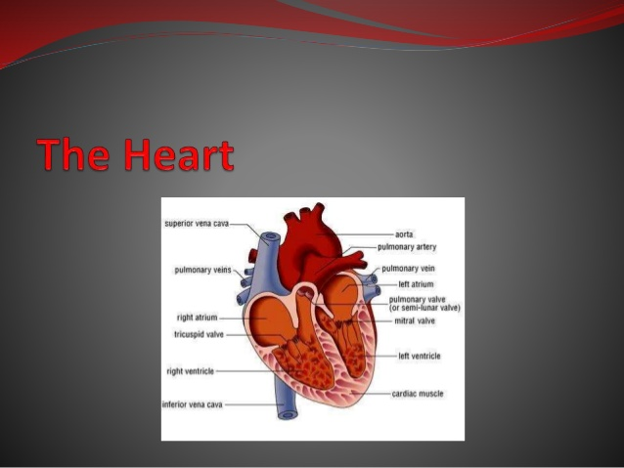
The human heart is approximatly the size of a first and weighs less than a pound.
Its is enclosed within the inferior mediastinum,the medial cavity of the thorax,and flanked on each side by the lungs
The pointed aspect ,or base shoulder and lies beneath the second rib.
The heart is inclosed by a double membran walled sac called pericardium.
The superficaial loosely fitted part is caled fibrus periardum.
The cardiovascular system also have bloods vessles.
ARTERIES.
CAPILLARIES.
VEINS.

ARTERIES AND arteriols take blood away from the heart.
The largest artery as (aortA)
Arterioles can contrict or dilate ,changing blood pressure.
CAPILLARIES…
Have walls only one cell thick to allow exchange of gases and nutrients with tissue fulide.
Capillary beds are present in all regin of the body but not all capillary beds are open at the same time.
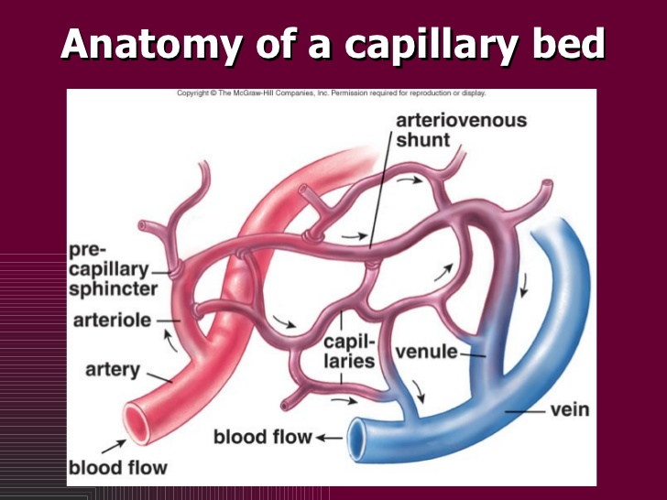
THE VEINS.
Venuls drin blood capillary,then join to from venis that take blood to hert .
Veni have much less smooth muscle and connective tissus than arteries.
Venis carry about 70%of the body blood and act as a reservoir during hemorrhage.

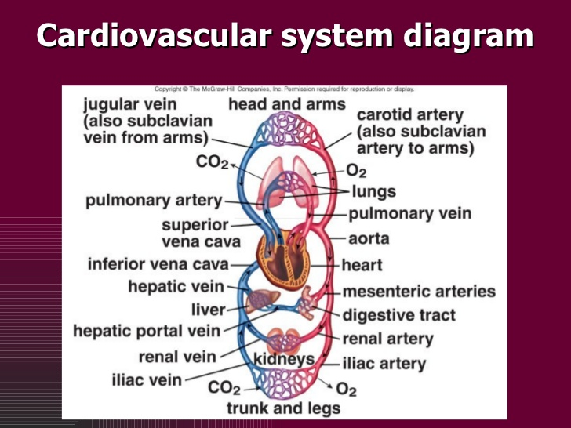

*******************************
QUSTION 2
BLOOD PRESSURE.
SYMPTOM OF LOW BLOOD PRESSURE.
- FAINTING( SYNCOPE).
- DIZZINESS.
- A FEELING OF LIGHTHEDEDNESS.
- CHEST PAIN.
- BLURRED VISSION.
- INCREASED THRIST.
- NAUSEA

SYMPTOM OF HIGH BLOOD PRESSURE..
Most people who have high blood pressure do not have symptom .in some case people with high blood pressure may have a pounding feeling in their head or chest a feeling of lighteadedness or dizziness,or other sings,
Like.
Nose bleeds .fits. Black-outs. Trouble breathing.etc
*************************
QUSTION 3
TREATMENT OF LOW BLOOD PRESSURE.
- EAT SALTY FOODS..
- DRINK CAFFEINE..
- BOOST YOUR B12 INTAKE
- FILL UP ON FOLATE..
- CUT BACK ON CARBS..
- REDUCED MEAL SIZE.
- EASY ON THE ALCOHOL..
TREATMENT OF HIGH BLOOD P.
- LOSE EXTRA POUNDS AND WATCH YOUR WAISTLINE.
- EXERCISE REGULARLY.
- EAT A HEALTY DIET.
- REDUCE SODIUM IN YOUR DIET.
- LIMIT THE AMOUNT OF ALCOHOL YOU DRINK.
- QUITE SMOKING.
- CUT BACK ON CAFFINE..
- REDUCED YOUR STRESS..

