NAME: MASOOD KHAN.
ID NO: 14530
DEGREE: DPT 4th
PAPER: BIOCHEMISTRY
SUBMITTED TO: MAM KULSOOM
DATE: JUNE 25, 2020.

QNO. 1. WRITE BRIEF NOTES ON:
Sterile Hormone,
Glucocorticoids,
Mineralocorticoids,
Insulin,
Insulin problems,
Glucagon,
The Role of Glucagon in the Body,
Steroid Hormone Synthesis,
Functions of Steroid Hormone.

Answer:
Sterile Hormone.
Answer: Any of group of hormones that belong to the class of chemical compound known as steroid, they are secreted by three steroid glands. Adrenal cortex, testes and ovaries and during pregnancy, by the placenta. All steroid hormones are derived from cholesterol. They are transported through the blood streams to the cell of various target organ where they carry out the regulation of wide range of physiological functions.

Glucocorticoids:-
Such as cortisol, control many metabolic process including the formation of glucose from amino acid and fatty acid and the deposition of glycogen in the liver. Glucocorticoid also help maintains normal blood pressure.

Mineralocorticoids:-
Such as aldosterone help maintain the balance between water and salt in the body.

Insulin:-
Insulin is a chemical messenger that allow cell to absorb glucose, a sugar from the blood.
The higher level of glucose, the more insulin goes into the production to balance sugar level in the blood. Insulin also assists and breakdown fats or proteins for energy.

Insulin problems:-
In some people, the immunity system attacks the islets, and they cease to produce insulin are do not produce enough.
When this occurs, blood glucose stay in the blood and cell cannot absorb them to convert the sugar into energy.

Glucagon:-
Glucagon is a hormone that is produce by cell of the pancreas known as the islet of Langerhans.

The Role of Glucagon in the Body:-
Glucagon play an activity role in allowing the body to regulate the utilisation of glucose and fats.
When glucagon is released, it can perform the following tasks:
Stimulation the liver to breakdown glycogen to the released in the blood as glucose.
Activating gluconeogenesis the conversion of amino acid into glucose.
Breakdown stored fat into fatty acids for use as fuel by cell.

Steroid Hormone Synthesis:-
The cholesterol precursor cone from cholesterol synthesise with in the cell from acetate from cholesterol ester store in intracellular lipids, droplets or from uptake of cholesterol containing low density lipoprotein.

Lipoprotein taken up from plasma are most important when steroidogenic cell are chronically stimulated.
The rate limiting step in this process is the transport of free cholesterol from cytoplasm into mitochondria. This step is carried out by the steroidogenic Acute Regulatory Protein.

Functions of Steroid Hormone:-
Steroid hormone play an important role in carbohydrates regulations, mineral balances, reproductive functions.
Steroid also play role in inflammatory response stress response, bone metabolism, cardiovascular and mood.

QNO 2. WHAT IS DEAMINATION AND TRANSAMINATION?
Answer:-
Deamination:-
Deamination is the removal of the amine group as ammonia (NH3), as shown below.
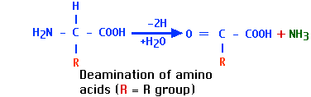
this ammonia (NH3) is toxic for human body so it is converted to urea through enzymes and finally urea is excreted out through the body.
Oxidative deamination is the liberation of free ammonia from the amino group of amino acid coupled with oxidation.
Site: Mostly in the liver and kidney.
Oxidative deamination is to provide NH3 for urea synthesis and alpha keto acids for a variety of reactions, including energy generation.
Only liver mitochondria contains glutamate dehydrogenase which deaminates glutamate to alpha keteglutarate and ammonia.
It needs NAD + as co-enzyme.
It is activated by ADP and inhibited by GTP.

Transamination
Transamination is the transfer of an amine group from an amino acid to a keto acid (amino acid without an amine group), thus creating a new amino acid and keto acid as shown below.
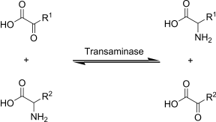

Transamination is the exchange of amino group between amino acid and another keto-acid forming a new alpha amino acid.
The enzyme catalysing the reaction is a group known as transaminase.
These enzymes have pyridoxal phosphate as prosthetic group.
The reaction is readily reversible.

Biological significance of transamination:-

First step of catabolism:
1. Ammonia is removed and rest of the amino acid is entering into catabolic pathway.

2. Synthesis of non-essential amino acids:
By means of transamination, all non-essential could be synthesized by the body from keto-acid available for other source.

Clinical significance of Transamination:-
Aspartate aminotransferase (AST) is increased in myocardial infarction and alanine amino transferase (ALT) in liver diseases.

QNO 3. WRITE DOWN METABOLISM OF PROTEIN.
Answer:-
Metabolism of protein:-
- Dietary proteins are very large complex molecules that cannot be absorbed from the intestine.
- To be absorbed, dietary proteins must be digested to small simple molecules (amino acids), which are easily
- absorbed from the intestine.
I- Digestion in the stomach
Protein digestion begins in the stomach by gastric juice, pepsin and rennin are the enzymes present in stomach.
II- Digestion in the small intestine
- Digestion of proteins is completed in the small intestine by proteolytic enzymes present in pancreatic and intestinal juices.
In Pancreatic Juice trypsin, chymotrypsin, elastase, Carboxypeptidase enzymes are present and
In Intestinal Juice Aminopeptidase, Tripeptidase, Dipeptidase enzymes are present
The end products of protein digestion in the small intestine are amino acids.

Protein Absorption
- It is an active process that needs energy.
- It occurs in small intestine.
- Absorption of amino acids is rapid in the duodenum and jejunum, but slow in the ileum.
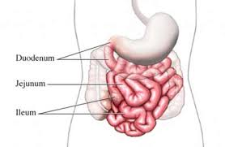

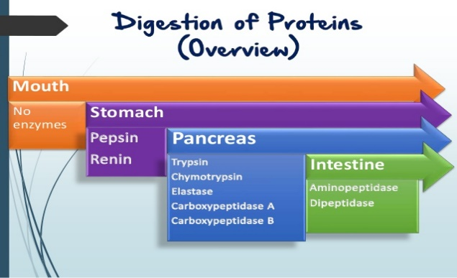

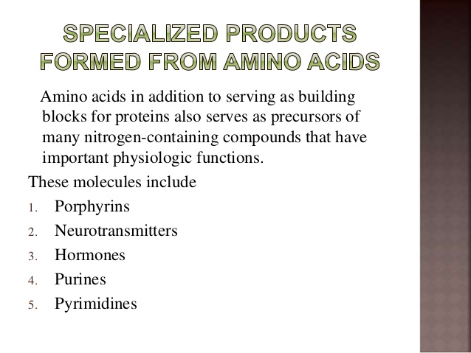

Pancreatic digestion of protein:
The optimum pH for the activity of pancreatic enzyme (pH 8) is provided by the alkaline bile and pancreatic juice.
The secretion of pancreatic juice is stimulated by the peptide hormone, cholecystokinin and pancreozymin.

Gastric digestion of proteins:
In the stomach, hydrochloric acid is secreted. It makes the pH optimum for the action of pepsin and also activates pepsin.
The acid also denatures the proteins. But hydrochloric acid at body temperature could not break the peptide bonds.
Thus in the stomach, HCl alone will not able to digest proteins; it need enzymes.

QNO 4. EXPLAIN BRIEFLY TRANSLATION OF DNA IN EUKARYOTES.
Answer:-
TRANSLATION OF DNA IN EUKARYOTES:-
Translation is the process by which the sequence of nucleotide in a messenger RNA molecule directs the incorporation of amino acid into protein is called translation.

TRANSLATION PROCESS:-
- In a eukaryotes cell, translation occurs in the cytoplasm.
- Translation involves three major steps:
- INITIATION
- ELONGATION
- TERMINATION

- INITIATION:-
The initiation of translation of DNA in eukaryotes is complex, involving at least 10 eukaryotic initiation factors (elFs) & divided into 4 steps:

- Ribosomal dissociation.
- Formation of 43s preinitiation complex.
- Formation of 48s initiation complex.
- Formation of 80s initiation complex.

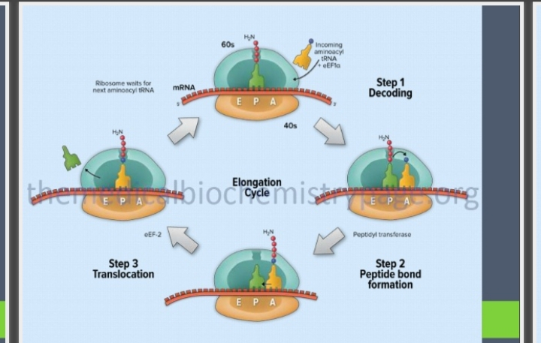
- ELEMINITION:-
- Ribosomes elongate the polypeptide chain by a sequential addition of amino acids.
- The amino acid sequence is determined by the arder of codons in the specific mRNA.
- Elongation, a cyclic process involving certain elongation factors.
- Elongation may be divided into three steps.
- Binding of aminoacyle t- RNA to A-site.
- Peptide bond formation.
- Translation.

- TERMINATION:-
- One of the stop or termination signal (UAA, UAG AND UGA) terminates the growing polypeptide.
- When the ribosomes encounters a stop codon, there is no tRNA available to bind to the A site of the ribosome,
-instead a release factor binds to it.
- In eukaryotes, a single release factor- eukaryotic release factors 1 (eRF1) - recognizes all three stop codons, and eRF3 stimulates the termination events.
- Once release factors binds, the ribosomes unit falls aparts,
-releasing the large and small subunits,
-the tRNA carrying the polypeptide is also released,
Freeing up the polypeptide product.
- Ribosome recycling occurs in eukaryotes.

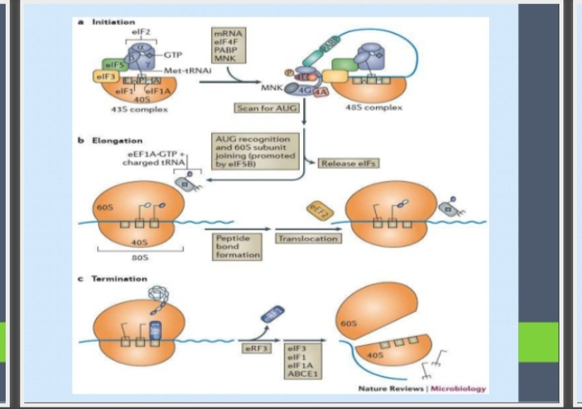

QNO 5. WRITE DOWN CLINICAL SIGNIFICANCE OF CHOLESTEROL?
Answer:-
CLINICAL SIGNIFICANCE OF CHOLESTROLE:-
Normal RANGE; 150-200 mg /dl
Hypercholesterolemia associated with;
- Diabetes Mellitus (increase availability of acetyle CoA due to unavailability of oxaloacetate).
- Nephrotic syndrome (increase globulins & increase in plasma lipoproteins).
- Hypothyroid/ myxedema (associated decrease HDL receptors on hepatocytes).
- Obstructive jaundice (obstruction in excretion of cholesterol through bile).

HYPOTHYROIDISM (Is a condition in which your thyroid gland doesn’t produce enough of certain crucial hormones).
Jaundice
Hyperlipidemia (high level of cholesterol or try glyceride in your body)
Atherosclerosis (buildup of fats, cholesterol and other substances in and on your artery walls (plaque), which can restrict blood flow).
Addition factors for coronary artery disease include – lifestyle
Cigarette smoking, coffe drinking, Emotional Stress, obesity, Lack of exercise , High blood pressure etc.

THE END

