Subject : Basic Mathematics
Instructor : Raza Ahmed Khan
E.mail : raza.ahmed@inu.edu.pk
Assigning Date : 14th September , 2020
End Date: 20th September, 2020 Attempt all the questions, each question having (5) marks
Q1. Transpose to make 𝒙 the subject:
- 𝑦 = 3𝑥
Sol: y=3x
3x+y=0
xy= 3
X= 3y ans

- 𝑦 = 1/𝑥
Sol: y=1/x
Xy=1
X=1y ans

c. 𝑦= 7𝑥 – 5
sol: y=7x-5
x=2y ans
D.𝑦 = 1/2 𝑥 – 7
Sol: y=1/2x -7
X=1/2-7y
X=2/6y ans
Q2. Solve the followings
2: a. ½ x 3/2 (x-4) = 6
-21x +12 = -6-3x

Sol:
- 2 x 1/2 x + 3/2 (x-4) ^{x2} =6x2
-21x +12 = -6 -3x
- 1x + 3x -12=12
=21x+3x=-6-12
- 4x = 12 +12
-18 = -18
- X = 24 ⁶/4 ¹
X = -18 ¹/-18 ¹
- x= 6
x=1 ans
b: 4x ½ (2x-4) = 18
-1-7m = -8m+7
Sol:
- 2 x 4x +1/2 (2x-4) = 18x2
-1-7m = -8m+7
- 8x +1 (2x – 4)= 36
-7m + 8m =7+1
- 10x = 36+4
1m = 8
- 10x = 40
1m = 8
- X = 40/10
M = 8
- X = 4
M = 8 ans
Q3:
Sol: (i) 2x + y =2
3x + 7y= 14
2 1  3 7 |  | X  y |  | 2  14
A xB
X = B ⁻¹ B
2 1
3 7
A =(2x7)(3x1) = 14 + 3 = 17 not equal to 0
A ⁻¹ = 1/17
[A]
7 - 1
-3 2

A ⁻¹= 1/17

7 - 1  -3 2 | 2  14

A ⁻¹= 1/17 [ (7x2)(-1x14)]
[(-3x2)(2x14 ]
A ⁻¹= 1/17
[14 -14]
[-6 28]
A ⁻¹= 1/17 =

0
22

A ⁻¹ =
0/17  22/17 | X  y
ans
(ii)
Sol:
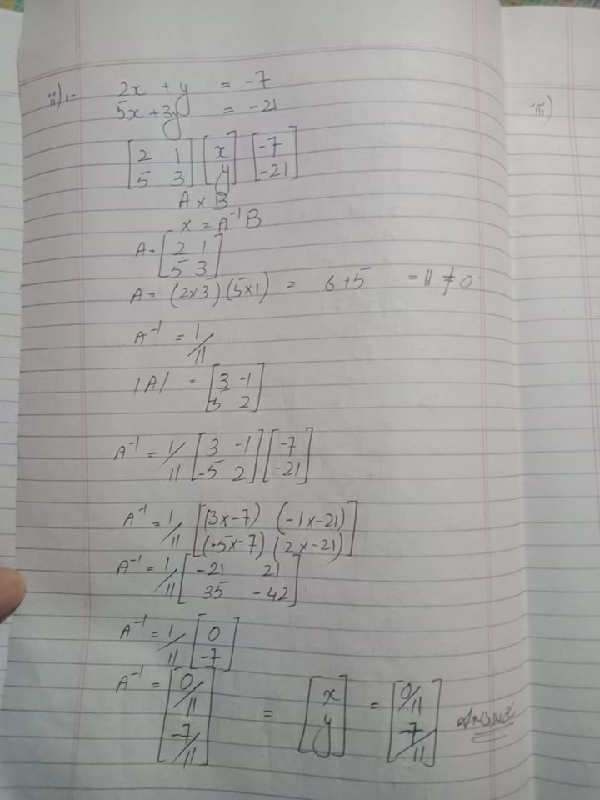
(iii)
Sol:

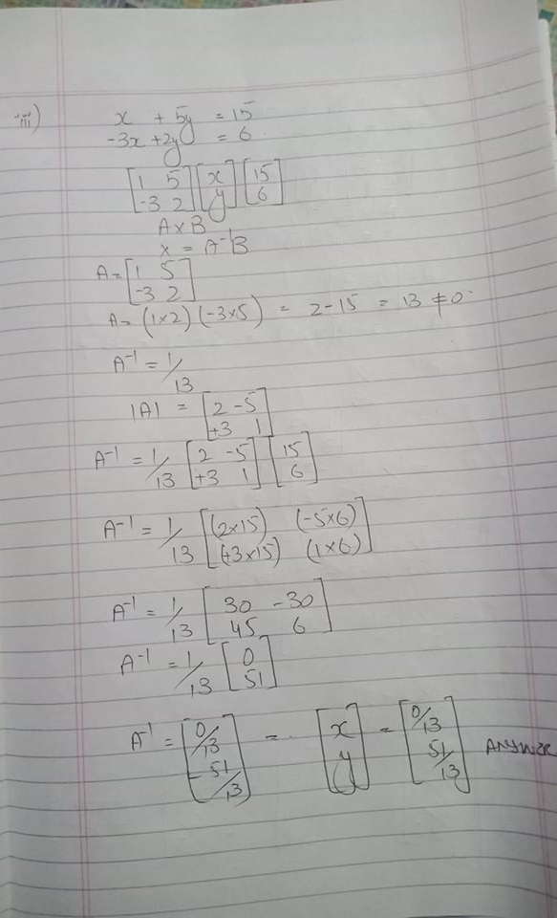
(iv)
Sol:
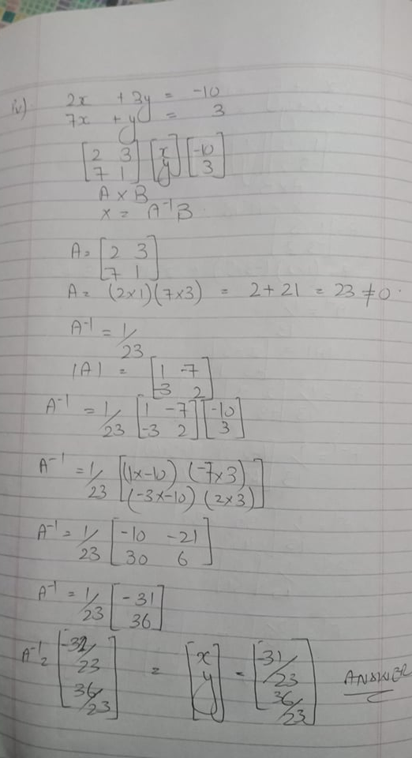

Question # 4
If A = [ 3 1] then find [A]
[-2 3]
sol:
If A = [ 3 1] then find [A]
[-2 3]
A= = [ 3 1]
[-2 3]
A=(3x3)(-2x1)
9-2#0
A ⁻¹ = 1/7
[A] = [ 3 -1]
[+2 3] ans
Question#5
Write each product as single matrix
1)
1 -1
- 2
1 0

[3 1 -1]
[0 -1 2]

Sol:

1 -1
- 2
1 0

[3 1 -1]
[0 -1 2]

[(3x1)(1x0)(1x1)]
[(3x-1)(1x2)(-1x0)]

[3 0 -1]
[-0 -2 0] ans

1
2
-2
Ii) [3 -2 2]

Sol:

1
2
-2
[3 -2 2]

[(3x1)(-2x2)(2x-2)]
[3 -4 -4] ans
2 -2 -1  1 1 -2  1 0 -1 | 1 -2 5  -1 - 1 3  -1 -2 4
(iii)

Sol:
2 -2 -1  1 1 -2  1 0 -1 | 1 -2 5  -1 - 1 3  -1 -2 4

(2x-1) (-2x-1) (-1x-1)
(1x-2) (1x-1) (-2x-2)
(1x5) (0x3) (-1x4)

-2 +2 +1
-2 -1 +4
5 0 -4

Ans
(iv)
-1 -2 5
-1 -1 3
-1 -2 4
2 -2 - 1
1 1 -2
1 0 -1

Sol:
-1 -2 5
-1 -1 3
-1 -2 4
2 -2 - 1
1 1 -2
1 0 -1

=

(-1x2) (-2x1) ( 5x1)
-1x-2) (-1x1) (3x0)
(-1x1) (-2x-2) (4x-1)

-2 -2 5
+2 -1 0
+1 +4 -4

Question #6

If A [1 4] B=[-3 2] c=[1 0]
[2 1] [4 0[ [0 2]
Sol:
A = [1 4] B=[-3 2] c=[1 0]
[2 1] [4 0[ [0 2]
Find A ² +BC
A= [1 4] x A= [1 4]
[2 1] [2 1]
(1x1) 4x2)
(2x4) (1x1)

A ²=

1 8
8 1

B=[-3 2] x c= [1 0]
[4 0] [0 2]
(-3x1) (2x0)
(4x0) (0x2)

BC

-3 0
0 0

BC
1 8
8 1
-3 0
0 0

A² + BC =

A² + BC
ans

question 7

