Assignment
Name: Abeer Ahmad Khan
Section: (A)
Semester: (Second)
Department: (BBA)
Roll Number: 15721
Dated: 23 june 2020
Submitted to: Shahzeb Anwar

Q1) what is swot analysis? Why companies use it? Develop swot analysis for Iqra national university.
Swot analysis:
Swot analysis is a frame work used to evaluate a company’s competitive positions and to develop strategic planning. Swot analysis consist of strength, weakness, opportunities and threats. It tells us about the internal and external factors of the company’s as well as current and futures affairs. It is very useful for the companies for previous review and future planning.
- Strengths: characteristics of the business or project that give it an advantage over others.
- Weaknesses: characteristics of the business that place the business or project at a disadvantage relative to others.
- Opportunities: elements in the environment that the business or project could exploit to its advantage.
- Threats: elements in the environment that could cause trouble for the business or project.

Why companies use swot analysis:
We use swot analysis to study the internal and external environments of the company and organization. Through the analysis of (strength, weakness, opportunities threats) of the company. Swot analysis is very useful to identify the functioning factors for giving a useful information about the Company or organization for strategic planning. Swot analysis give us the information about internal and external factors of the organization.
Swot analysis of iqra national university:
Strength:
1)The most famous departments of iqra national university are fashion designing and business administration because of which most of the people select iqra national university for their further studies.
2)The functions/events of iqra national university are very famous.
3)Iqra university has well qualified teachers.
4) GYM of Iqra national university has a great impression on students because of good and modified machineries.
Weakness:
1)They should increase the car parking area in order to facilitate university students and the visitors in order to have a good impression.
2)They should arrange study tour for students.
3)They should announce competition of university with national and international universities.
Opportunities:
1)They can avail online class by good video quality apps.
2)They can announce sports competition with other universities.
3)They can avail good Marketing at social and electronic media.
Threats:
1)They should focus on their play grounds.
2)They should focus on their library.
3)they should focus on their class room furniture.

Q2) Discuss the product development process and drawn its model.
Product development process:
The company start a new product development process according to society around them. First of all they analyse the thinking of new generation and society Because every generation has its own perspective and different way of thinking. To facilitate the society they make hundreds of ideas that how can they modify their product according to new generation. To get a good one at the end.
There are two ways to get idea about your new product:
- We can arrange a meeting with our organization talented employee. Which we know that they can give us good advises. We should give them chance while communication in meeting to give their opinion about the production of the product. That how can it survive in the market.
- Other method is to make some samples of the product and spread it into the market (distributers, shopkeeper and customers etc) to take their opinion about the product and by collecting good point of review of the customers to make our product more batter in market then our competition
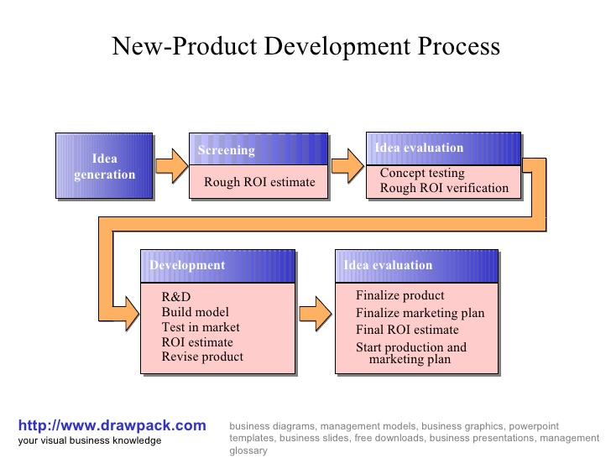

Q3) Write briefly about product life cycle and draw its model.
Definition of product life cycle:
The product life cycle is broken into four stages: introduction, growth, maturity, and decline. This concept is used by management and by marketing professionals as a factor in deciding when it is appropriate to increase advertising, reduce prices, expand to new markets, or redesign packaging.

Explanation:
Product life cycle and its own great importance in marketing. It describes all the stages ap the life cycle of the product. From first day at market till the end when it was finally removed from the market. Not all products reach the final stage. Some start growth and some rises and then fall.
1)Research and development
2)introduction
3)Growth
4)Maturity
5)Decline
1)Research and development:
The researching and development of the product that are before it is available for customers in market. For collecting positive points for the modification in production.
2)Introduction:
To launch a product first time in the market after production of the product to the customers to make its market value.
3)Growth:
When the sale of the product is increasing at the highest rate. This took the product to peek of the success and make it famous.

4)Maturity:
The sale of the product is highest but the growth is very slow because of competitors in market. Because every product have a high number of competitors in market.
5) Decline:
It is the final stage of cycle of the product. When the number of the high sale of the product falls. So it is the last stage of the product in the market.
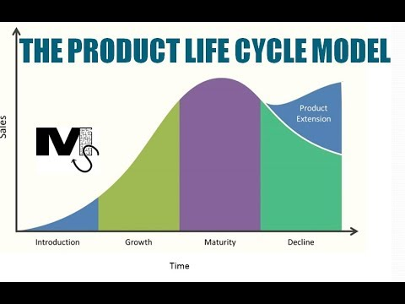

Q4) Write briefly about Branding along with examples?
Branding:
The marketing practice of creating a brand name, symbol or design that can differentiate between the product from other products.
Explanation:
Branding is absolutely critical to a business because of the overall impact it makes on your company. Branding can change how people perceive your brand, it can drive new business and increase brand awareness.
1)Branding Recognition:
Branding is very important for a business to become welknown to the consumers. Logo is very important for the brand face the company of the brand. Logo is very useful for remembering the product and it give a good impression on the customer at first sight.
2)Branding increase business value:
Branding take the business towards success. Branding is important to generate future business. Strongly establish brand can increase the busing by its high sale. It gives a business high hold in the market. By branding if business increases so the investment will all be increased.
3)Branding increase new customers:
Strong branding basically means that company has a good impression on a consumer and they are likely to do business with you because of the familiarity and assumed dependability of using a name they can trust. Once the company get well established, so it become a word of mouth of the consumer it is a effective technique of advertisement.

4)Improves Employee Pride and Satisfaction:
When the employee works for a high branding company so it feels satisfaction and pride, they will stand behind the product all the time. They will be more satisfied from their job. High branding increases the interest of the employee in their work. While working in branded office it also increases the interest and satisfaction of the employee.
5)Branding Supports Advertising
Advertising is another component to branding, and advertising strategies will directly reflect the brand and its desired portrayal. Advertising techniques such as the use of promotional products from trusted companies such a outstanding branding make it easy to create a cohesive and appealing advertising strategy that plays well into your branding goals.
Example:
1)Pepsi
2)Coca Cola
3)Lipton tea
4)Nokia
5)Samsung
6)Prince biscuit

