***IQRA NATIONAL UNIVERSITY***

**Project Report Of Power Electronics**

**Group Members**

**Name ID**

**1)Raheel Ahmad 11437**

***Supervised by***

***Engnr Shayan Tari******Q***

***Department of Electrical Engineering***

***IQRA NATIONAL UNIVERSITY HAYAT ABAD PHASE-II, PESHAWAR, PAKISTAN***

***SESSION (2016-2020)***

**BjTransistor**

The transistor is a two junction, three terminal semiconductor device which has three regions namely the emitter region, the base region, and the collector region. There are two types of transistors. An npn transistor has an n type emitter, a p type base and an n type collector while a pnp transistor has a p type emitter, an n type base and a p type collector. The emitter is heavily doped, base region is thin and lightly doped and collector is moderately doped and is the largest. The current conduction in transistors takes place due to both charge carriers- that is electrons and holes and hence they are named Bipolar Junction Transistors (BJT).



**Figure 1 npn and pnp transistor regions and symbol**

Depending upon the biasing of the two junctions, emitter-base (EB) junction and collector-base(CB) the transistor is said to be in one of the four modes of operation.

|  |  |  |  |  |  |
| --- | --- | --- | --- | --- | --- |
| |  | | --- | | **E B Junction** | | |  | | --- | | **CB Junction** | | |  | | --- | | **Mode** | |
| |  | | --- | | Reverse biased | | |  | | --- | | Reverse biased | | |  | | --- | | Cut-off | |
| |  | | --- | | Forward biased | | |  | | --- | | Reverse biased | | |  | | --- | | Active | |
| |  | | --- | | Forward biased | | |  | | --- | | Forward biased | | |  | | --- | | Saturation | |
| |  | | --- | | Reverse biased | | |  | | --- | | Forward biased | | |  | | --- | | Reverse Active | |

**Figure 2 Transistor modes of operation**

The transistor is used as a switch in Cut-off (OFF) and Saturation (ON) regions and as an amplifier in Active region. Reverse Active mode is rarely used (it is used as input stage in TTL gates in digital circuits).

The transistor can be considered as a two port network. Three configurations are possible depending upon which terminal acts as input port, output port, and the common terminal. They are common base, common emitter, and common collector configuration. In this experiment we will consider common emitter configuration in which the input is applied between base and emitter, and the output taken at collector with respect to emitter. This is the most popular configuration used in both switches and amplifiers.

**Operation of transistor in active mode:**

We consider here the active mode of operation, by forward biasing the base-emitter junction and reverse biasing the base-collector junction as shown in Fig 3. Electrons diffuse from the emitter into the base and holes diffuse from the base into the emitter. The electrons diffused into based region become minority carriers in base. Since the base region is lightly doped and thin, very few electrons will recombine with the holes in the base region and contribute to base current and majority of the electrons arrive at the base-collector depletion region and are swept through the depletion layer due to the electric field. These electrons contribute to the collector current. The direction of motion of electrons is shown by the arrows in red colour in Fig 3.



**Figure 3 Operation of a transistor**

**CE input characteristics**:

The input characteristics are obtained as family of IB -VBE curves at constant VCE. Since the base emitter junction is forward biased, the IB -VBE (Fig.4) characteristics resemble that of a forward biased junction diode. The increase in VCE causes increase in reverse bias to C-B junction. This causes the depletion region to widen and penetrate into the base region more reducing effective base width. This results in less base current to flow and hence increase in VCE causes the characteristics to shift to the right as shown in Fig. 5.

The reciprocal of the slope of the linear part of the characteristic gives the dynamic input resistance of the transistor.

**Figure 4**



**Figure 4 CE characteristics**



**Figure 5 Family of input characteristics**

**Output Characteristics**

These characteristics are obtained as family of IC-VCE at different values of IB. At small values of VCE, the collector voltage is less than that of base causing CB junction to get forward biased. This causes the transistor to enter saturation region where both the junctions are forward biased. For a given base bias, increase in VCE reduces the forward bias and eventually reverse bias the CB junction. This now results in narrowing the base width and thereby reducing base current. This makes the collector current to slightly increase at higher values of VCE causing the characteristics to exhibit some slope. This is Early effect. The collector current is given by

Ic=Ise VBE/VT(1+VCE/VA)

where, VA is Early voltage

.

One can estimate Early voltage by extending the linear portion of Ic curves in the second quadrant. All these curves are found to meet at VA. See Fig. 6.



**Figure 6 Output characteristics**

One can find output conductance from the slope of the linear portion of the characteristic curves and also find β=delta IC/delta IB to be defined at a given value of VCE.

**2)**

**Merits of** **Bjts**

The bipolar junction transistor (BJT) has a large gain bandwidth.

The BJT shows better performance at high frequency.

The BJT has a better voltage gain.

The BJT can be operated in low or high power applications.

The BJT has high current density.

There is low forward voltage drop.

**De merits of Bjts**

The bipolar junction transistor (BJT) more noise produced.

The BJT are more effect by radiation.

BJT has a low thermal stability.

The switching frequency of BJT is low.

It has a very complex base control. So it may lead to confusion and requires a skilful handling.

**Bjts vs power diode**

The diode is a semiconductor device which allows the current to flow only in one direction, whereas the transistor transfers the resistance from the low resistance region to high resistance region.

The diode is used for converting the AC to DC or for rectifications whereas the transistor is mainly used for amplification and as a regulator.

The diode has two terminals namely anode and cathode.The anode is the positive terminal, and the cathode is the negative terminal of the diode. The transistor has three terminals; they are the emitter, collector and base.

The diode is a type of uncontrolled switch whereas the transistor is a controlled switch.

The BJT uses both the electrons and hole as a charge carrier, and the FET is a unipolar transistor.

The diode has only one depletion layer between P – type and N – type whereas the transistor has two depletion layer, one is between emitter and base region, and the other is between the base and collector region

**Bjts vs thyristor**

A transistor can only withstand small output power hence it is rated in watts. While a thyristor exhibits better ability to manage large power than a transistor thus it is rated in Kilowatts.

A transistor is composed of 3 layers namely npn or pnp while a thyristor is composed of 4 layers i.e., pnpn.

When power transistors are employed in the electronic circuits then it reduces the overall cost of the system. Whereas the use of thyristor in circuits increases the cost. Thereby making it expensive.

Transistor does not exhibits surge current capacity characteristic thus is able to handle the only small rate of change of current. As against, a thyristor exhibits surge current characteristic and hence can bear a comparatively high rate of change of current than a transistor.

A transistor switches on fast, thus it exhibits faster turn-on time than that of the thyristor.

Transistor circuit does not require commutation circuit. However, in the case of thyristor commutation circuit is needed.

The internal power losses in case the transistor is high as compared to the thyristor.

Transistors are suitable for high-frequency applications but not for high power applications. As against, thyristors are suitable for high power applications but not for high-frequency applications.

**Bjts vs mosfet**

A transistor can only withstand small output power hence it is rated in watts. While a thyristor exhibits better ability to manage large power than a transistor thus it is rated in Kilowatts.

A transistor is composed of 3 layers namely npn or pnp while a thyristor is composed of 4 layers i.e., pnpn.

When power transistors are employed in the electronic circuits then it reduces the overall cost of the system. Whereas the use of thyristor in circuits increases the cost. Thereby making it expensive.

A transistor switches on fast, thus it exhibits faster turn-on time than that of the thyristor.

Transistor circuit does not require commutation circuit. However, in the case of thyristor commutation circuit is needed.

The internal power losses in case the transistor is high as compared to the thyristor.

Transistors are suitable for high-frequency applications but not for high power applications. As against, thyristors are suitable for high power applications but not for high-frequency applications.

**IGBts vs Bjts**

IGBT is driven by the gate voltage whereas BJT is a current-driven device.

BJT is made of an emitter, base, and collector three-terminal device whereas IGBT are known as emitter, collector and base.

IGBTs are better in power handling to compare to BJT.

IGBT can be considered as a combination of BJT and FET device.

IGBT has a complex device structure than BJT.

BJT has a long history as compare to IGBT.

3)

**Bjts as an inverter**

The BJT inverter displayed below contains a DC voltage source input, varying from 0V to 5V, connected to a 10KO resistor set on the base of the BJT. A 5V Voltage source connected to a 1O resistor is on the collector of the BJT, while the emitter of the BJT is connected to the ground. The voltage output is located in between the collector and the 1kO resistor at voltage node V(4).

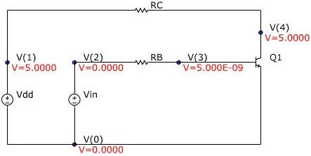

A circuit simulation program, was used to analyze the characteristics of the BJT inverter with the given properties. The information received from the PSpice analysis gave the various critical voltage points of the BJT inverter, the said points being the output voltage high, Voh, the input voltage low, Vil, the input voltage high, Vih, the output voltage low, Vol and the voltage where the output and input are equal, Vm. The information output was taken and then inputted into for graphical analysis. was then used to determine the BJT's modes of operation at varying input voltages.

**Definitions:**

VOH: The maximum voltage that occurs on the output.

VOL: The minimum voltage that occurs on the output.

VIL: The voltage that occurs when the slope of the VTC equals -1 and the BJT is on the Edge of Conduction.

VIH: The voltage when the slope of the VTC equals -1 and the BJT is on the Edge of Saturation. VM: Voltage point on the VTC where the input voltage is equal to the output voltage.

Voltage Transfer Characteristics(VTC): A graph of the input voltage versus the output voltage.

Cut-off: BJT mode where the input voltage is smaller than cut-in voltage.

Forward Active: BJT mode where the input voltage is larger than the cut-in voltage and the collector voltage is larger than 0.1V.

Saturation: BJT mode in which the voltage input is higher than the cut-in voltage and the collector voltage is equal to 0.1V.

Noise Margins:

The noise margins of a circuit give the amount of sensitivity the circuit has in input fluctuations. The two noise margins define where the logic high, NMh, and logic low, NMl, occur. NMH is calculated by: NMH = VOH - VIH. NML is calculated by: NML = VIL - VOL.

The BJT circuit defined here has the Noise margins of:

NMH: 5V - 0.775V = 4.225V

NML: 0.551V – 0.0195V = 0.5315V

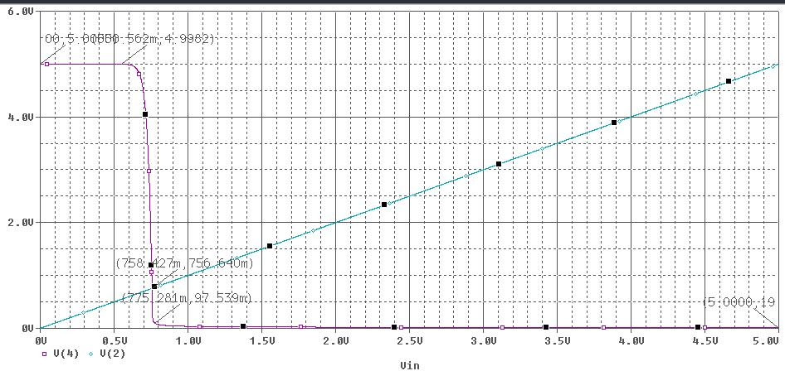

VTC with markings of Voh, Vil, Vm, Vih, Vol

**Comments:**

Varying various components and characteristics of the BJT inverter can adversely change the voltage transfer characteristics. The resistor values of RB and RC change both the slope of the VTC and the ending VOL. Increasing RB’s value decreases the slope of the VTC and increases the VOL, whereas decreasing RB increases the slope of the VTC and decreases VOL. Increasing RC does the opposite of increasing RB, it increases the slope and lowers the VOL, decreasing RC does the opposite. Decreasing the ßF alters the slope of the VTC only by decreasing it, while an increase makes the VTC drop faster.

**Conclusion:**

In conclusion the BJT inverter is a very stable inverter and adjusting its VTC is fairly easy. By simply changing the resistor values, one can attain a desired VTC and obtain desired critical voltages. The BJT’s modes of operation are also easily found due to the fact that it can only be in three modes, cut-off, forward active and saturated. These two factors of easy modifiability and easy steps to find its mode of operation make the BJT a very useful inverter.

4)

Bipolar junction transistors (Also known as BJTs) can be used as an amplifier, filter,rectifier, oscillator, or even a switch, which we cover an example in the first section. The transistor will operate as an amplifier or other linear circuit if the transistor is biased into the linear region. The transistor can be used as a switch if biased in the saturation and cut-off regions. This allows current to flow (or not) in other parts of a circuit.

Because [transistor](https://www.allaboutcircuits.com/textbook/semiconductors/chpt-4/bipolar-junction-transistors-bjt/)’s collector current is proportionally limited by its base current, it can be used as a sort of current-controlled switch. A relatively small flow of electrons sent through the base of the transistor has the ability to exert control over a much larger flow of electrons through the collector.

**Using a BJT as a Switch:**

Suppose we had a lamp that we wanted to turn on and off with a switch. Such a circuit would be extremely simple, as in the figure below (a).

For the sake of illustration, let’s insert a transistor in place of the switch to show how it can control the flow of electrons through the lamp. Remember that the controlled current through a transistor must go between collector and emitter.

Since it is the current through the lamp that we want to control, we must position the collector and emitter of our transistor where the two contacts of the switch were. We must also make sure that the lamp’s current will move *against* the direction of the emitter arrow symbol to ensure that the transistor’s junction bias will be correct as in the figure below (b).

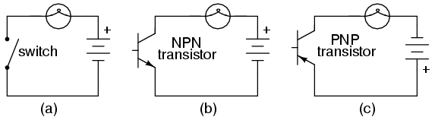

***(a) mechanical switch, (b) NPN transistor switch, (c) PNP transistor switch.***

A PNP transistor could also have been chosen for the job. Its application is shown in the figure above (c).

The choice between NPN and PNP is really arbitrary. All that matters is that the proper current directions are maintained for the sake of correct junction biasing (electron flow going *against* the transistor symbol’s arrow).

In the above figures, the base of either BJT  is not connected to a suitable voltage, and no current is flowing through the base. Consequently, the transistor cannot turn on. Perhaps, the simplest thing to do would be to connect a switch between the base and collector wires of the transistor as in figure (a) below.

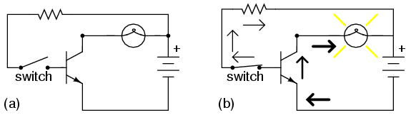

***Transistor: (a) cutoff, lamp off; (b) saturated, lamp on.***

**Cutoff vs Saturated Transistors**

If the switch is open as in figure (a), the base wire of the transistor will be left “floating” (not connected to anything) and there will be no current through it. In this state, the transistor is said to be ***cutoff***.

If the switch is closed as in figure (b), current will be able to flow from the base to the emitter of the transistor through the switch. This base current will enable a much larger current flow from the collector to the emitter, thus lighting up the lamp. In this state of maximum circuit current, the transistor is said to be ***saturated***.

Of course, it may seem pointless to use a transistor in this capacity to control the lamp. A regular switch will suffice the function instead of a transistor.

**Transistor to Control Current**

Two points can be made here. First is the fact that when used in this manner, the switch contacts need only handle what little base current is necessary to turn the transistor on; the transistor itself handles most of the lamp’s current. This may be an important advantage if the switch has a low current rating: a small switch may be used to control a relatively high-current load.

More importantly, the current-controlling behavior of the transistor enables us to use something completely different to turn the lamp on or off. Consider the figure below, where a pair of solar cells provides 1 V to overcome the 0.7 V base-emitter voltage of the transistor to cause base current flow, which in turn controls the lamp.

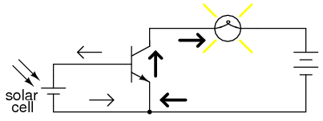

***Solar cell serves as light sensor.***

Or, we could use a thermocouple (many connected in series) to provide the necessary base current to turn the transistor on in the figure below.

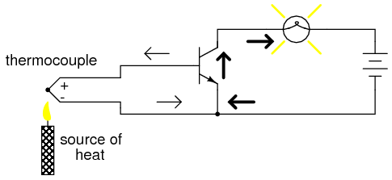

***A single thermocouple provides less than 40 mV. Many in series could produce in excess of the 0.7 V transistor VBE to cause base current flow and consequent collector current to the lamp.***

Even a microphone (see the figure below) with enough voltage and current (from an amplifier) output could turn the transistor on, provided its output is rectified from AC to DC so that the emitter-base PN junction within the transistor will always be forward-biased:

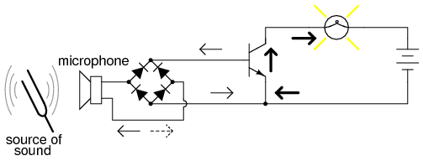

***Amplified microphone signal is rectified to DC to bias the base of the transistor providing a larger collector current.***

The point should be quite apparent by now. Any sufficient source of DC current may be used to turn the transistor on, and that source of current need only be a fraction of the current needed to energize the lamp.

Here we see the transistor functioning not only as a switch, but as a true amplifier: using a relatively low-power signal to control a relatively large amount of power**.** Please note that the actual power for lighting up the lamp comes from the battery to the right of the schematic. It is not as though the small signal current from the solar cell, thermocouple, or microphone is being magically transformed into a greater amount of power. Rather, those small power sources are simply controlling the battery’s power to light up the lamp.

**The BJT as Switch REVIEW:**

* Transistors may be used as switching elements to control DC power to a load. The switched (controlled) current goes between emitter and collector; the controlling current goes between emitter and base.
* When a transistor has zero current through it, it is said to be in a state of *cutoff* (fully nonconducting).
* When a transistor has maximum current through it, it is said to be in a state of *saturation* (fully conducting).

9)

**Smlation Procedures:**

One can in general use the component toolbar for finding components. For this tuorial, let us use the virtual component toolbar.

Let us now place a few components so that we can simulate the **output curves** of a bipolar transistor.

1. Place a virtual NPN transistor as follows:



1. Place a DC current source which we will use to supply base current as follows

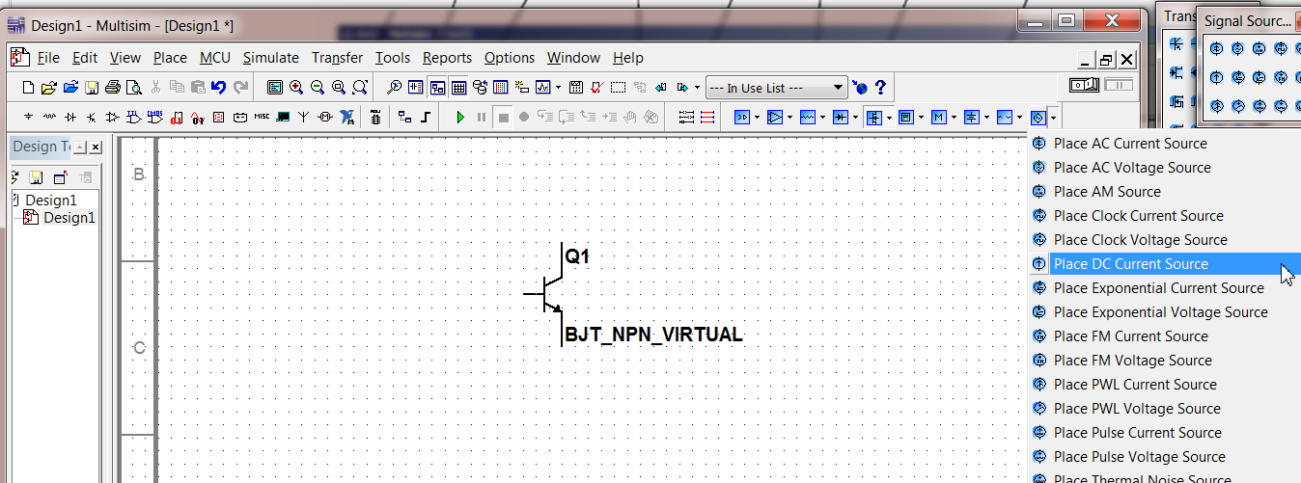

Three) Place a DC voltage source, which we will use to set the collector-to-emitter voltage VCE, as follows:



4) Last but not least, **place ground** as follows:



5) • Select and move around your components to your liking.

1. Click a single compoent to select it. Esc to deselect it.
2. Hold Shift, then click to select multiple components.

Wiring:

Wiring is both particularly simple and particularly difficult in Multisim. The chance is that you will first find the wiring simple or simpler than other programs you used before, at least for simple circuits. When the cursor is close to the unconnected end of any component, it will change into a small black connection dot and crosshair. A click on the end of the component starts the wiring. Move the cursor to where you want it to be connected. The routing of the wire is by default automatic, but manual adjustment is possible.

A very important limitation is that **one of the two pins or component ends you are trying to wire together must be unconncted**. If both pins are connected, which can easily occur, you will encounter problem of existing connections being broken as new wiring is added.

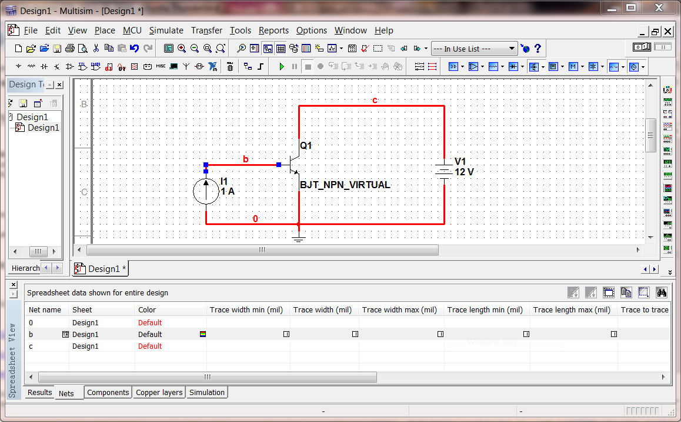

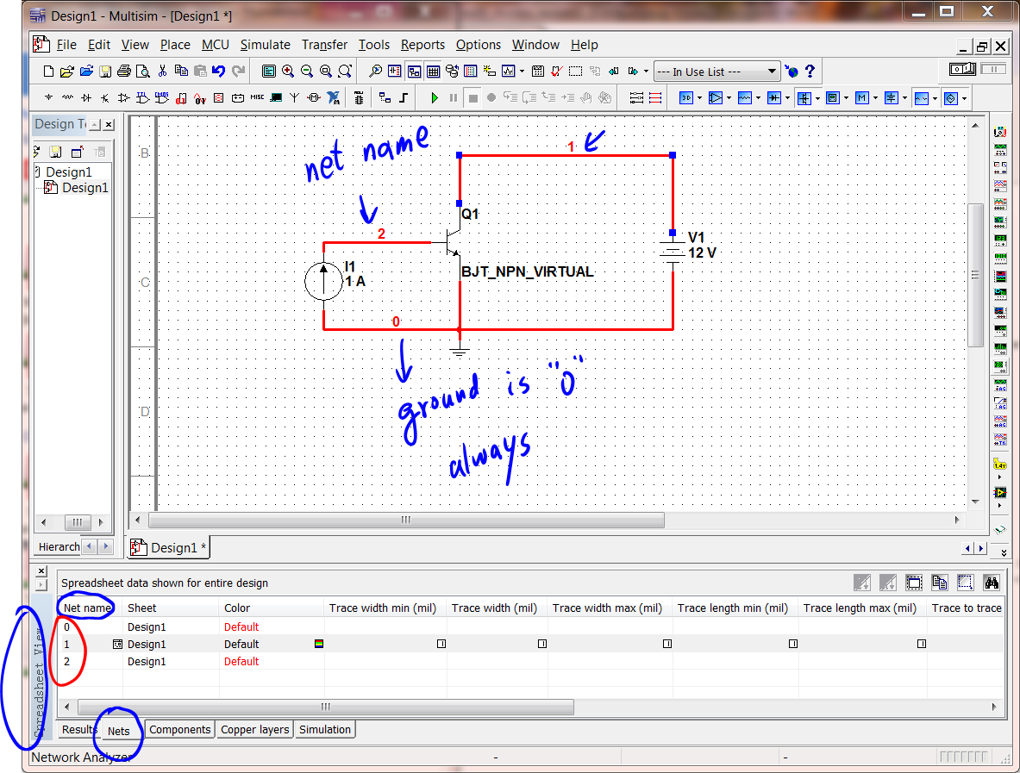

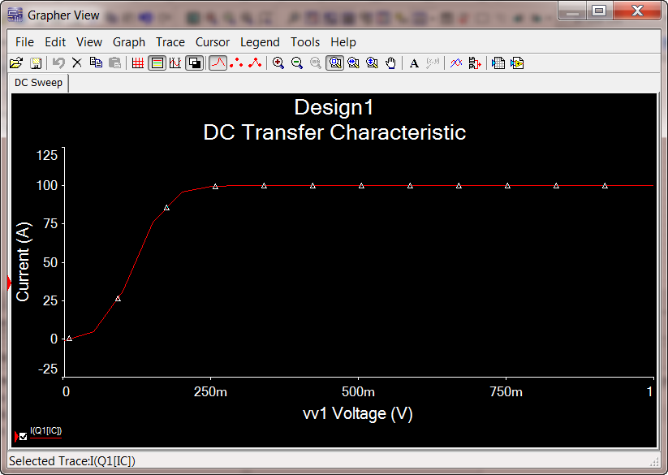

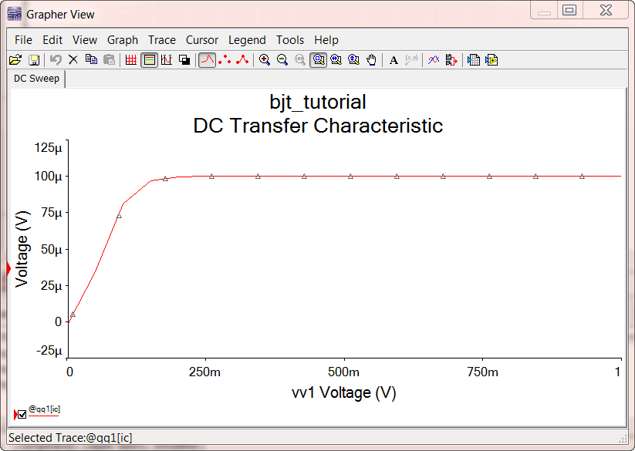

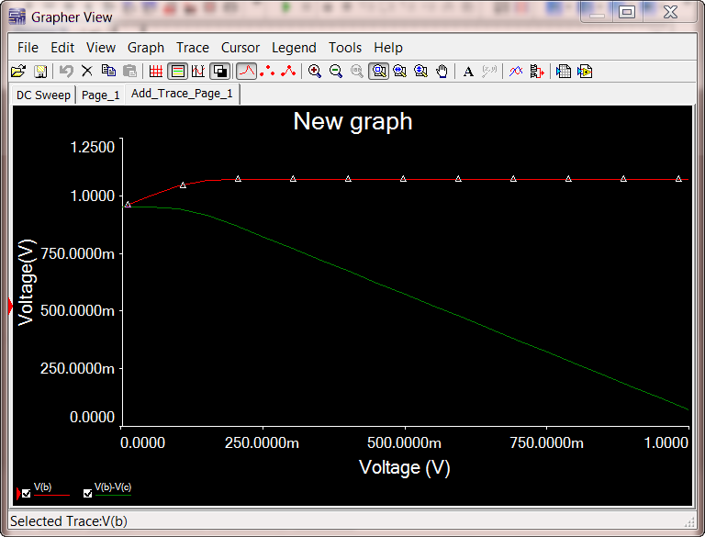

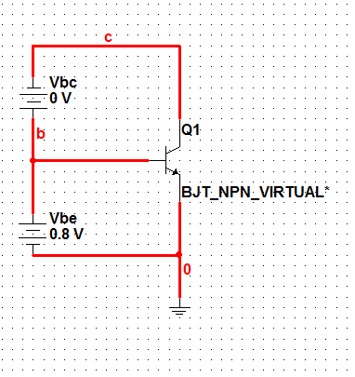

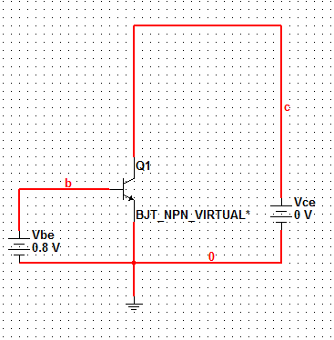

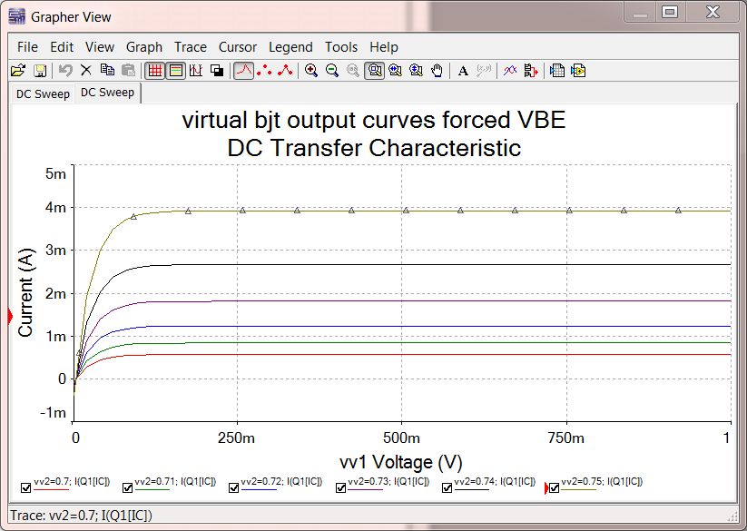

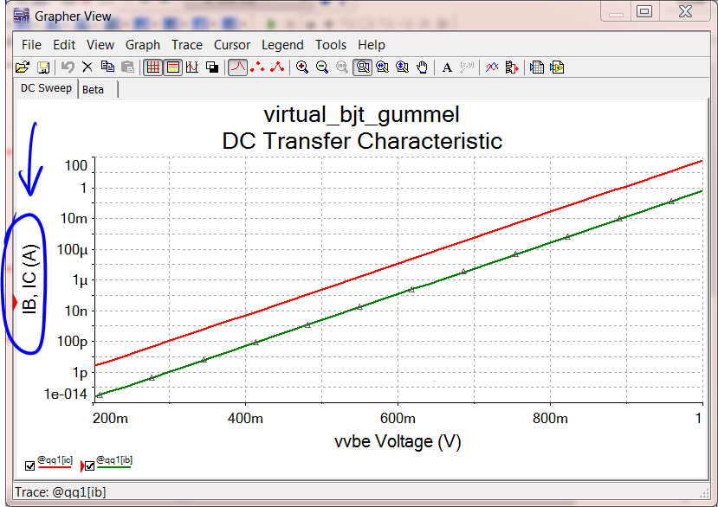

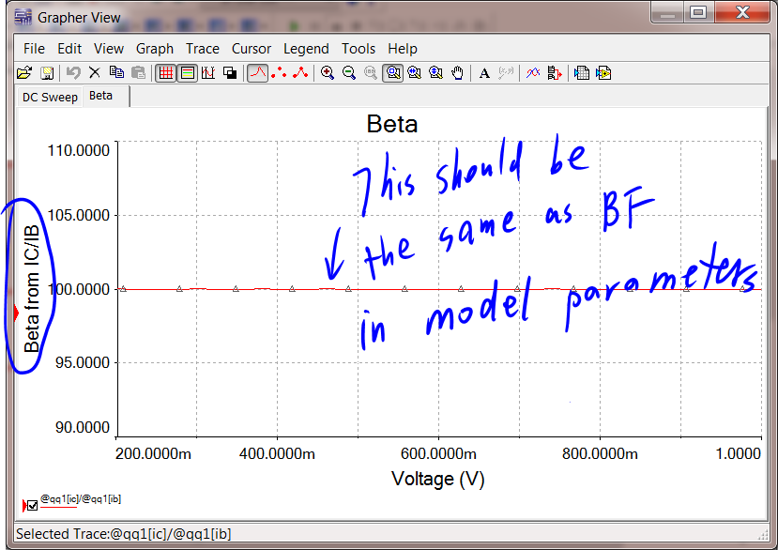

10)

Conclsion: