DPT 4th
Course Title: Pharmacology I
Student Name: Noor islam
Student ID: 14777

- Explain the detailed neurotransmission process
Answer :
The brain and nervous system are made of billions of nerve cells, called neurons. Neurons have three main parts:
cell body, dendrites, and axon. The axon is covered by the myelin sheath

>Dendrites receive messages from other neurons.
>Cell Body is in charge of the neuron’s activities.
>Myelin Sheath covers the axon to protect it and help messages travel faster and
>Axon sends messages from the cell body to the dendrites of other neurons.

The transfer of information between neurons is called neurotransmission.
This is how neurotransmission works:
1. A message travels from the dendrites through the cell body and to the end of the axon.
2. The message causes the chemicals, called neurotransmitters, to be released from the end of the axon
into the synapse. The neurotransmitters carry the message with them into the synapse. The synapse is the space between the axon of one neuron and the dendrites of another neuron.
3. The neurotransmitters then travel across the synapse to special places on the dendrites of the next
neuron, called receptors. The neurotransmitters fit into the receptors like keys in locks.
4. Once the neurotransmitter has attached to the receptors of the second neuron, the message is passed on.
5. The neurotransmitters are released from the receptors and are either broken down or go back into the axon of the first neuron.

Answer Key
1. The number of neurons in the brain is about 100 billion.
2. The parts of neurons that send messages are the axons, and the parts of neurons that receive messages are the dendrites.
3. The space between the dendrites of one neuron and the axon of another neuron is called the synapse.
4. The nucleus of a neuron is where genetic material is stored.
5. Neurons that send information from sensory organs, such as the skin or eyes, to the central nervous system are called sensory (or afferent) neurons.
6. Neurons that send information from the central nervous system to muscles or glands are called motor (or efferent) neurons.
7. Poisons that affect neurotransmission are called neurotoxins.
8. In the year 1921, a man named Otto Loewi first discovered neurotransmitters during an experiment with two frog hearts.
9. Glial cells are brain cells that do many important things that help neurons, including bringing nutrients to neurons, insulating parts of neurons, and digesting parts of dead neurons

Q.No.2What does direct and indirect cholinergic agent means? Explain therapeutic application and adverse effects of cholinergic agents in detail.
Answer:
Direct-Acting Cholinergic Drugs:
• Direct-acting cholinergic drugs are similar to Acetylcholine (ACH) and stimulate receptors like Acetylcholine (ACH)
• Direct-acting drugs have longer durations of action than Acetylcholine (ACH) and are clinically useful
• These drugs are used in ophthalmology as miotics and in the treatment of glaucoma
• Bethanechol stimulates urinary bladder contraction and is taken orally to treat non obstructive urinary retention

Indirect-Acting Cholinergic Drugs:

• Indirect-acting drugs increase ACH levels at receptors by inhibiting the enzyme acetyl cholinesterase.
• These drugs primarily increase ACH at cholinergic and nicotinic-muscle receptors
• Drugs classified as reversible inhibitors of acetyl cholinesterase are the most widely used.
• These drugs are also referred to as anticholinesterase drugs.
Drug Effects of Cholinergic Agents:
• Cardiovascular effects:
Decreased heart rate( Bradycardia) –
Vasodilation (NO mediated)
• Stimulate intestine and bladder
Increased gastric secretions
Increased gastrointestinal motility
Increased urinary frequency
• Stimulate pupil:
Constriction (miosis), Spasm of accommodation
Reduced intraocular pressure (increased outflow)
• Respiratory effects:
Bronchial constriction, narrowed airways
• Increased salivation and sweating
Acetylcholine:
• One of the main neurotransmitters of the ANS is acetylcholine •
• Acetylcholine is released at preganglionic fibers of both the sympathetic and parasympathetic nervous system
• Also released from postganglionic sympathetic neurons that innervate the sweat glands and from motor neurons that innervate the skeletal muscles
• It is a quaternary ammonium compound so cannot penetrate the membrane. Do not have any therapeutic importance, because rapid inactivation by acetylcholinesterases.
• It has both Muscarinic & Nicotinic actions.
Bethanechol:
• Not hydrolyzed by acetylcholinesterases
Mode of Actions:
• Directly stimulates M receptors causing increased intestinal motility & tone, It stimulates detrusor muscle of the bladder while trigone & sphincters are relaxed causing expulsion of urine
Therapeutic Uses:
• Paralytic ileus
• Urinary retentions •
• Helpful for postsurgical atony of the bladder and GI tract
Pilocarpine:
• An alkaloid, lipid soluble & is stable to hydrolysis by cholinsterases.
Mod of Actions:
• When applied locally to cornea Produces rapid miosis & contraction of ciliary muscle produces spasm of accommodation & vision is fixed at particular distance making it impossible to focus for far situated objects
Therapeutic Use:
• In Glaucoma it opens trabecular meshwork around schlemm’s canal causes drainage of aqueous humor
• IOP immediately decreases.
Uses of Indirect Cholinergic agonists:
• Cobra bite: edrophonium (prevent respiratory paralysis.
• Atropine poisoning: – Physostigmine (antogonizes both central and peripheral effects).
• Alzheimer’s Disease: – Donepezil, galantamine, tacrine, rivastigmine.
• TCA, Phenothiazines, overdose: Physostigmine.
Cholinergic Agents: Side Effects:
• Effects Side effects are a result of overstimulation of the PSNS
• Cardiovascular: – Bradycardia, hypotension, conduction abnormalities (AV block and cardiac arrest)
• CNS: – Headache, dizziness, convulsions
• Gastrointestinal: – Abdominal cramps, increased secretions, nausea, vomiting
• Side Effects • Respiratory: –Increased bronchial secretions, bronchospasms
• Other: –Lacrimation, sweating, salivation, loss of binocular accommodation, miosis

Q3.
- Explain the effects and adverse effects of organic nitrates in angina pectoris.
- Write down the treatment algorithm for improving symptoms of stable angina.
Answer:
PART B:
STABLE ANGINA
The most common (90 persent )
It chestpain caused by temporary inadequacy of blood flow to the myocardium ,the underlying cause is usually occlusion of the coronary arteries by atherosclerosis
Usually lasts 1-15 minutes and is provoked by exercise , stress , extreme cold or heart heavy meals , alcohol , or smoking.
Rx : promptly relived by rest or nitroglycerin ( a vasodilator).

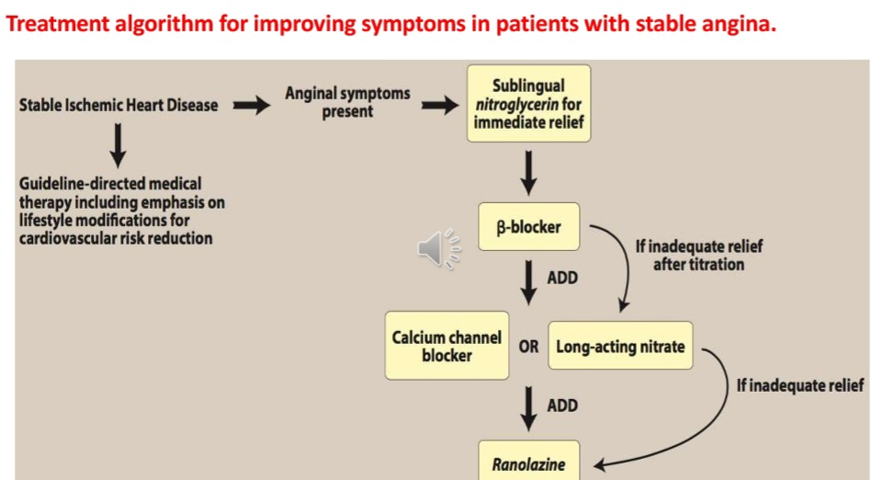

PART A :
ORGANIC NITRATES
ORGANIC nitrates and (nitritis) are simple nitric and nitrous acid asters of alcohols. They differ in their volatility ; for example ,isosorbide dinitrate is solid at room temperature ,nitroglycerin is only moderately volatile , whereas amyl nitrates is extremely volatile .these compounds caused a rapid reduction in mycocardial oxygen demand followed by rapid relief of symptoms. They are effective in stable and unstable angina as well as prinzmetal’s or variant angina pectoris
EFFECT OF ORGANIC NITRATE IN ANGINA PACTORIS
At therspeutic doses , nitro –glycerin has to major effects .first, it caused dilation of the large veins, resulting in pooling of blood in the veins.This diminishes preload (venous return to the heart ) . Seconds nitroglycerin, dilates the coronary vasculature ,providing increased blood supply to the heart muscle .Nitroglycerin causes a decrease in myocardial oxygen consumption because of decrease cardiac work.
ADVERSE EFFECT OF ORGANIC NITRATES IN ANGINA PACTORIS
The most common adverse effect of nitroglycerin ,as well as the other nitrates ,is headache.Thirty to sixty parcent of patients reciving intermittent nitrate therapy with long – acting agents develop headaches. High doses of organic nitrates can also caused postural hypotension ,facial flushing , and tachycardia.

Q4.
- Differentiate between primary and secondary hypertension
- Explain the effect of renin on hypertension
- What is the importance of pharmacological treatment of hypertension

Answer:
PART A:

DIFFERENTIATION BETWEEN PRIMARY AND SECONDRY HYPERTENSION
Although hypertension may occurs secondry to other disease processes, more than 90 percent of patients have essential hypertension a disorder of unknown origin affecting the blood pressure –regulating mechanisms .A family history of hypertension increase the likelihood that an individual will develop hypertension disease . Essential hypertension occurs four times more frequently among blacks than among whites , and it occur more often among middle- aged males than among middle – aged females .Enviromental factor such as a stressful lifestyle, high dietary intake of sodium , obesity , and smoking all further predispose an individual to the occurrence of hypertension .summarizes the drugs used to treat hypertension [note:Nonsteroidalanti –inflammatory drugs(NSAID)Interfere with the hypertensive action of many antihypertensives.

PART B :
EFFECT OF RENIN ON HYPERTENSION
The kidney provides for the long –term control of blood pressure by altering the blood volume.Baroreceptors in the kidney respond to reduced arterial pressure (and to sympathetic atimulation of beta adrenoceptors0 by releasing the enzyme renin. This peptidase converts angiotensinogen to angiotensin 1, which is in turn converted to angiotensin 2 in the presence of angiotensin converting enzyme antiotensin 2 in the body’s most response of the automatic ,nervous system and the renin –angiotensin- aldosterone system to a decrease in the blood.
Protent circulating vasoconstrictor , causing an increase in the blood pressure. Furthermore , angiotensin 2 stimulates aldosterone secretion ,leading to increased renal sodium resorption and an increase in blood volume ,which contributes to a further increase in the blood pressure.

PART c:
ANTIHYPERTENSIVE DRUGS :
BUMENTANIDE
FUROSEMIDE
Hydrochlorothizide
Spironoiactone
Triamterene
BETA BLOCKERS
Atenolol
Labetalol
Metoprolol
Propranolol
Timolol
ACE INHIBITORS
BENAZEPRIL
CAPTOPRIL
Enalapril
Fosinopril
Lisinopril
Moexipril
Quinapril
Ramipril
ANGIOTENSIN 2 ANTAGONIST
LOSARTAN
CA ++ CHANNEL BLOCKERS
Amiodipine
Diltiazem
Feiodipine
Laradipine
Nicardipine
Nifedifine
Verapamil
ALPHA BLOCKER
Doxazosin
Prazosin
Terazosin
OTHER
Clonidine
Diazoxide
Hydralazine
Alpha methyldopa
Minoxidil
Sodium nitroprusside

Q5.
- Differentiate between right heart failure and left heart failure
- Summarize the pharmacotherapy of heart failure
Answer:
PERT A:
RIGHT HEART FAILURE
In right heart failure ,the right atrium and ventricle are unable to handle blood returning from the systemic circulation .This caused fluid to accumulate in the peripheral tissue and ankle edema and and organ congestion (liver , spleen ) are typically manifestations.
LEFT HEART FAILURE
The left atrium and ventricle are unable to adequately handle the blood returning from lungs .This causes pressure to build up in the pulmonary veins, and fluid accumulates in the lungs .Consequently , left heart failure is associated with pulmonary edema.

PART B:
PHARMACOTHERAPY OF HEART FAILURE
Basic goals is congestive heart failure is to improve the heart pumping ability
Strateges:
rimary drugs used to exert a positive inotropic effect of the cardiac glycosides
Decrease workload through an effect on the heart of peripheral vasculature , or by controlling fluid volume , are recognized as benefical in congestive heart failure .angiotensin converting enzyme inhibitors , beta blockers ,diuretics , and vasodilators

