Iqra National University
Course Title: | Introduction to Financial Accounting |  | Instructor: | Mr. Naveed Azeem Khattak
Name : | Ijaz khan (16710) |  | MBA (1.5)
School of Management and Social Sciences (Dept. of Business administration).

Ans 1:

Bad debt definition
A bad debt is a receivable that a customer will not pay. Bad debts are possible whenever credit is extended to customers. They arise under the following circumstances:

- When a company extends too much credit to a customer that is incapable of paying back the debt, resulting in either a delayed, reduced, or missing payment.
- When a customer misrepresents itself in obtaining a sale on credit, and has no intent of ever paying the seller.
The first situation is caused by bad internal processes or changes in the ability of a customer to pay. The second situation is caused by a customer intentionally engaging in fraud.

There are two ways to record a bad debt, which are:
- Direct write-off method. If you only reduce accounts receivable when there is a specific, recognizable bad debt, then debit the Bad Debt expense for the amount of the write off, and credit the accounts receivable asset account for the same amount.
- Allowance method. If you charge an estimated amount of accounts receivable to bad debt expense in the same period when you record related revenue, then debit the Bad Debt expense for the amount of the estimated write-off, and credit the Allowance for Doubtful Accounts contra account for the same amount.

The direct write-off method is not the best approach, because the charge to expense may occur several months after you recorded the related revenue, so there is no matching of revenue and expense within the same period (the matching principle).The allowance method has the advantage of matching expected bad debts to revenues, even if you don't know exactly which accounts receivable will not be collectible.
It is not entirely true that a bad debt will never be collected. It is possible that a customer will pay extremely late, in which case the original write off of the related receivable should be reversed, and the payment charged against it. Do not create new revenue to reflect the receipt of a late cash payment on a written-off receivable, since doing so would overstate revenue.
Example 1:
To illustrate a receivables write-off, assume that the fi nancial vice president of Hampson Furniture authorizes a write-off of the $500 balance owed by R. A. Ware on March 1, 2018. The entry to record the write-off is as follows.
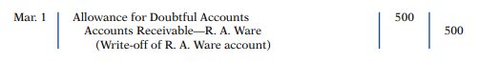
, the entry to record the write-off of an uncollectible account reduces both Accounts Receivable and Allowance for Doubtful Accounts. After posting, the general ledger accounts appear as shown in Illustration 9-4
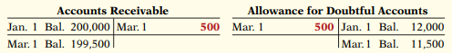
A write-off affects only balance sheet accounts—not income statement accounts. The write-off of the account reduces both Accounts Receivable and Allowance for Doubtful Accounts. Cash realizable value in the balance sheet, therefore, remains the same, as Illustration 9-5 shows.
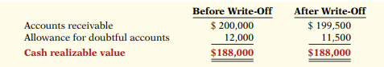
To illustrate, assume that Gonzalez Company elects to use the percentage-of-sales basis. It concludes that 1% of net credit sales will become uncollectible. If net credit sales for 2017 are $800,000, the estimated bad debt expense is $8,000 (1% 3 $800,000). The adjusting entry is as follows.
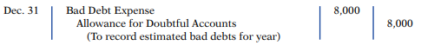
After the adjusting entry is posted, assuming the allowance account already has a credit balance of $1,723, the accounts of Gonzalez Company will show the following.
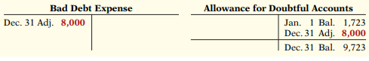
Example 2
Brule Co. has been in business fi ve years. The unadjusted trial balance at the end of the current year shows:
Accounts Receivable $30,000 Dr.
Sales Revenue $180,000 Cr.
Allowance for Doubtful Accounts $2,000 Dr.
Brule estimates bad debts to be 10% of receivables. Prepare the entry necessary to adjust Allowance for Doubtful Accounts.
Solution:
The following entry should be made to bring the balance in Allowance for Doubtful Accounts up to a normal credit balance of $3,000 (10% 3 $30,000):
Bad Debt Expense [(10% 3 $30,000)+ $2,000] | $5000
Allowance for Doubtful Accounts  (To record estimate of uncollectible accounts) |  | $5000

Ans2:

Solution:
Sr.Num | Date | Account title | Dr | Cr
1 (a) | 31-Dec | Bad Debt Expense | 2900
 |  | Accounts Receivable—Willie’s |  | 2900
b (1) | 31-Dec | Bad Debt Expense | 17400
 |  | [($1,800,000 2 $60,000) 3 1%]
 |  | Allowance for Doubtful Accounts |  | 17400
b (2) |  | Bad Debt Expense | 13700
 |  | Allowance for Doubtful
 |  | Accounts [($180,000 3 10%) 2 $4,300] |  | 13700
C (1) | 31-Dec | Bad Debt Expense | 13,050
 |  | [($1,800,000 2 $60,000) 3 0.75%]
 |  | Allowance for Doubtful Accounts |  | 13,050
C (2) | 31-Dec | Bad Debt Expense | 11,210
 |  | Allowance for Doubtful
 |  | Accounts [($180,000 3 6%) 1 $410] |  | 11,210

Ans 3:

Accounting Equation
The accounting equation is considered to be the foundation of the double-entry accounting system. The accounting equation shows on a company's balance sheet whereby the total of all the company's assets equals the sum of the company's liabilities and shareholders' equity.
Based on this double-entry system, the accounting equation ensures that the balance sheet remains “balanced,” and each entry made on the debit side should have a corresponding entry (or coverage) on the credit side.

Accounting Equation Formula
Assets= (Liabilities + Owner’s Equity)
For Example:
A sole proprietorship business owes $12,000 and you, the owner personally invested $100,000 of your own cash into the business. The assets owned by the business will then be calculated as:
$12,000 (what it owes) + $100,000 (what you invested) = $112,000 (what the company has in assets)

Assets
Assets include cash and cash equivalents or liquid assets, which may include Treasury bills and certificates of deposit. Accounts receivables are the amount of money owed to the company by its customers for the sale of its product and service. Inventory is also considered an asset.

Liabilities are what a company typically owes or needs to pay to keep the company running. Debt including long-term debt are liabilities as well as rent, taxes, utilities, salaries, and wages as well as dividends payable.
Shareholders' equity is a company's total assets minus its total liabilities. Shareholders' equity represents the amount of money that would be returned to shareholders if all of the assets were liquidated and all of the company's debt was paid off.

Retained earnings are part of shareholders' equity and are equal to the percentage of net earnings that were not paid to shareholders as dividends. Think of retained earnings as savings since it represents a cumulative total of profits that have been saved and put aside or retained for future use.

The Double-Entry System
The accounting equation forms the foundation of the double-entry accounting and is a concise representation of a concept that expands into the complex, expanded, and multi-item display of a balance sheet. The balance sheet is based on the double-entry accounting system where total assets of a company are equal to the total of liabilities and shareholder equity.
Essentially, the representation equates all uses of capital (assets) to all sources of capital, where debt capital leads to liabilities and equity capital leads to shareholders' equity.

Cash Flow vs. Balance Sheet
The cash flow statement shows the amount of cash and cash equivalents entering and leaving a company. The cash flow statement (CFS) measures how well a company manages and generates cash to pay its debt obligations and fund operating expenses.
A balance sheet is a summary of the financial balances of a company, while a cash flow statement shows how the changes in the balance sheet accounts and income on the income statement affect a company's cash position. In essence, a company's cash flow statement measures the flow of cash in and out of a business, while a company's balance sheet measures its assets, liabilities, and owners' equity.

Limits of the Accounting Equation
Although the balance sheet always balances out, the accounting equation doesn't provide investors as to how well a company is performing. Instead, investors must interpret the numbers and decide for themselves whether the company has too many or too few liabilities, not enough assets or perhaps too many assets, or is financing the company properly to ensure long term growth.

Real-World Example
For every transaction, both sides of this equation must have an equal net effect. Below are some examples of transactions and how they affect the accounting equation.

1. Purchasing a Machine with Cash
Company XYZ wishes to purchase a $500 machine using only cash. This transaction would result in a credit to Equipment (+$500) and a debit to Cash (-$500). The net effect on the accounting equation would be as follows:
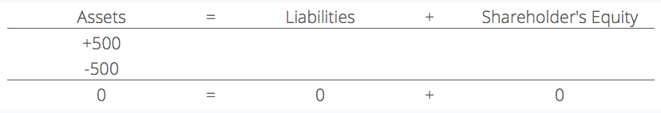
This transaction affects only the assets of the equation; therefore there is no corresponding effect in liabilities or shareholder’s equity on the right side of the equation.

2. Purchasing a Machine with Cash and Credit
Company XYZ wishes to purchase a $500 machine but it only has $250 of cash in its holdings. The company is allowed to purchase this machine with an initial payment of $250 but it owes the manufacturer the remaining amount. This would result in a credit to Equipment (+$500), a credit to Accounts Payable (+$250) and a debit to Cash (-$250). The net effect on the accounting equation would be as follows:
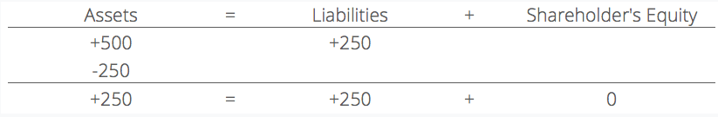

This transaction affects both sides of the accounting equation; both the left and right sides of the equation increase by +$250.

