IQRA NATIONAL UNIVERSITY
DEPARTMENT OF ALLIED HEALTH SCIENCES
Final-Term Examination(Summer-20) (BS. MLT)
Course Title: Human Anatomy-l Instructor: Ms. Maria Feroze
Time: 4 hours Max Marks: 50

Name Zawar Hussain
ID # 16581
Department MLT

QUESTION # 1
Explain the mechanism of breathing.
ANSWER
BREATHING
DEFINITION
The process in which air moves in and out of the lungs is known as breathing. This is carried out through various respiratory organs. In other words, breathing is a simple give and take process.
EXPLANATION
When we breathe, we take in air rich in oxygen from the atmosphere, in return of which, we give out carbon dioxide-rich in the atmosphere which is utilized by the plants for photosynthesis.
This is a continuous process and goes on throughout the life of an organism.
The process of taking in oxygen-rich air is called inhalation. On the contrary, the process of giving out air that is rich in carbon dioxide is known as exhalation.
In a day, a person breathes several times. One breath comprises one inhalation and one exhalation. In a minute, the number of times a person breathes is termed as his/her breathing rate. By calculating the breathing rate, we can know the number of times we breathed in a day.
However, the breathing rate varies which is dependant upon a person’s activity. It raises when a person is brisk walking, running or after a heavy exercise; similarly, decreases when a person is calm.
The breathing rate of an adult is 15-18 times per minute. However, during heavy exercise, breathing rate exceeds 25 times per minute.
Mechanism Of Breathing
The air which we breathe in and out of the lungs varies in its pressure. So basically when there is a fall in air pressure the alveolar spaces falls and the air enters the lungs (inspiration) and as the pressure of the alveoli within exceeds the atmospheric pressure, the air is blown from the lungs (expiration). The flow rate of air is in proportion to the magnitude of the pressure difference.
The breathing mechanism involves two processes:
- Inspiration
- Expiration

Inspiration
In the process of inspiration, there would be a contraction of muscles attached to the ribs on the outer side which pulls out the ribs and results in the expansion of the chest cavity.
Later, the diaphragm, contracts, moves downwards and expands the chest cavity resulting in the contraction of the abdominal muscles.
The expansion of the chest cavity produces a partial vacuum which sucks air into the lungs and fills the expanded alveoli.

Mechanism Of Inspiration
- The process of intake of atmospheric air is known as inspiration. It is an active process.
- When the volume of the thoracic cavity increases and the air pressure decreases, inspiration takes place.
- Contraction of external intercostal muscles increases the volume of the thoracic cavity.
- Contraction of the diaphragm further increases the size of the thoracic activity. Simultaneously, the lungs expand.
- With the expansion of the lungs, the air pressure inside the lungs decreases.
- The pressure equalizes and the atmospheric air rushes inside the lungs.

Expiration
The expiration process is considered once after the gaseous exchange occurs in the lungs and the air is expelled out. This expulsion of air is called expiration.
During this process, muscles attached to the ribs contract, the muscles of the diaphragm and the abdomen relax which leads to a decrease in the volume of the chest cavity and increases the pressure of the lungs, causing the air in the lungs to be pushed out through the nose.

Mechanism Of Expiration
- The process of exhaling carbon dioxide is called expiration. It is a passive process.
- It occurs when the size of the thoracic activity decreases and the air pressure outside increases.
- Now the external intercostal muscles relax and the internal intercostal muscles contract.
- As a result, the ribs are pulled inwards and the size of the thoracic cavity is reduced.
- The diaphragm is relaxed and the lungs get compressed.
- Consequently, the pressure increases and the air is forced outside.

Key Points On Mechanism of Breathing
- Breathing is the physical process of inhaling oxygen and exhaling carbon dioxide.
- The mechanism of breathing involves two main processes: inspiration and expiration.
- Inspiration occurs when the diaphragm and the external intercostal muscles contract.
- Expiration occurs when the diaphragm and the intercostal muscles relax.
- The contraction or relaxation of muscles around the lungs changes the entire volume of air inside the lungs, and so does the pressure.
- If the pressure inside the lungs is more than the outside, the air rushes out. If the opposite happens, the air rushes in.
- Due to the high elasticity of the lung tissue and low surface tension of moisture in the lungs, the lungs have higher compliance.

QUESTION # 2
What do you know about the origin of diaphragm?
ANSWER
DIAPHRAGM
The diaphragm is an unpaired, dome shaped skeletal muscle that is located in the trunk. It separates the thoracic and abdominal cavities from each other by closing the inferior thoracic aperture. The diaphragm is the primary muscle that is active in inspiration. Contraction of the muscle facilitates expansion of the thoracic cavity. This increases volume of the the cavity, which in turn decreases the intrathoracic pressure allowing the lungs to expand and inspiration to occur.
Key facts about the diaphragm

Origin | Sternal part:  Posterior aspect of xiphoid process  Costal part:  Internal surfaces of lower costal cartilages and ribs 7-12  Lumbar part:  Medial and lateral arcuate ligaments (lumbocostal arches), bodies of vertebrae L1-L3 (+intervertebral discs), anterior longitudinal ligament
Insertion | Central tendon of diaphragm
Relations | Pleural cavities, pericardial sac, liver, right kidney, right suprarenal gland, stomach, spleen, left kidney, left suprarenal gland
Openings | Aortic hiatus (aorta, azygos vein, thoracic duct), esophageal hiatus (esophagus, vagus nerve), caval hiatus (inferior vena cava)  Mnemonic: I 8 10 EGGS AT 12  Greater, lesser, least splanchnic nerves, superior epigastric vessels
Innervation | Phrenic nerves (C3-C5) (sensory innervation of peripheries via 6th-11th intercostal nerves)  Mnemonic: C3, 4, 5 keeps the diaphragm alive!
Blood supply | Subcostal and lowest 5 intercostal arteries, inferior phrenic arteries, superior phrenic arteries
Functions | Depresses costal cartilages, primary muscle of breathing (inspiration).

Origin and insertion
The diaphragm is a musculotendinous structure with a peripheral attachment to a number of bony structures. It is attached anteriorly to the xiphoid process and costal margin, laterally to the 11th and 12th ribs, and posteriorly to the lumbar vertebrae. The posterior attachment to the vertebrae is by tendinous bands called crura. The crura are attached to the anterior aspect of the bodies of the 1st, 2nd and 3rd lumbar vertebrae. The muscle fibres, extending from their bony attachments, converge on a central tendon.

QUESTION # 3
What do you know about the general features of first rib?
ANSWER
Description
The first rib is the most curved and usually the shortest of all the ribs; it is broad and flat, its surfaces looking upward and downward, and its borders inward and outward.
The head is small, rounded, and possesses only a single articular facet, for articulation with the body of the first thoracic vertebra. The neck is narrow and rounded. The tubercle, thick and prominent, is placed on the outer border. There is no angle, but at the tubercle the rib is slightly bent, with the convexity upward, so that the head of the bone is directed downward. The upper surface of the body is marked by two shallow grooves, separated from each other by a slight ridge prolonged internally into a tubercle, the scalene tubercle, for the attachment of the Scalenus anterior; the anterior groove transmits the subclavian vein, the posterior the subclavian artery and the lowest trunk of the brachial plexus. Behind the posterior groove is a rough area for the attachment of the Scalenus medius. The under surface is smooth, and destitute of a costal groove. The outer borderis convex, thick, and rounded, and at its posterior part gives attachment to the first digitation of the Serratus anterior; the inner border is concave, thin, and sharp, and marked about its center by the scalene tubercle. The anterior extremity is larger and thicker than that of any of the other ribs.
The first rib is the most superior within the thoracic cavity. It is atypical in structure:
- head:
  - single articular facet for synovial joint with upper hemifacet on lateral body of T1
  - relatively small
  - reinforced by typical radiate ligament
- neck:
  - slopes superiorly and slightly posteriorly to join the shaft
  - relations:
    - anterior ramus of eighth cervical nerve on superior surface
    - anterior ramus of first thoracic nerve on inferior surface
    - posterior to anterior on thoracic surface: stellate ganglion or sympathetic chain, supreme intercostal vein, superior intercostal artery. These structures are in contact with the apposing cervical pleura.
- tubercle:
  - in anatomical position, most posterior point of rib
  - medial facet for synovial joint articulation with first thoracic vertebra transverse process
  - laterally provides attachment for;
    - lateral costotransverse ligament
    - costalis muscle
    - longissimus muscle
- angle:
there is no angle as it has effectively fused with the tubercle
- shaft:
see submenu
- general points:
  - the first rib is bent into a very tight curve to turn 180 degrees from vertebra to sternum
  - in the anatomical position, the rib is inclined 45 degrees to the horizontal.

QUESTION # 4
Classify the ribs according to their attachments to the sternum.
ANSWER

Introduction
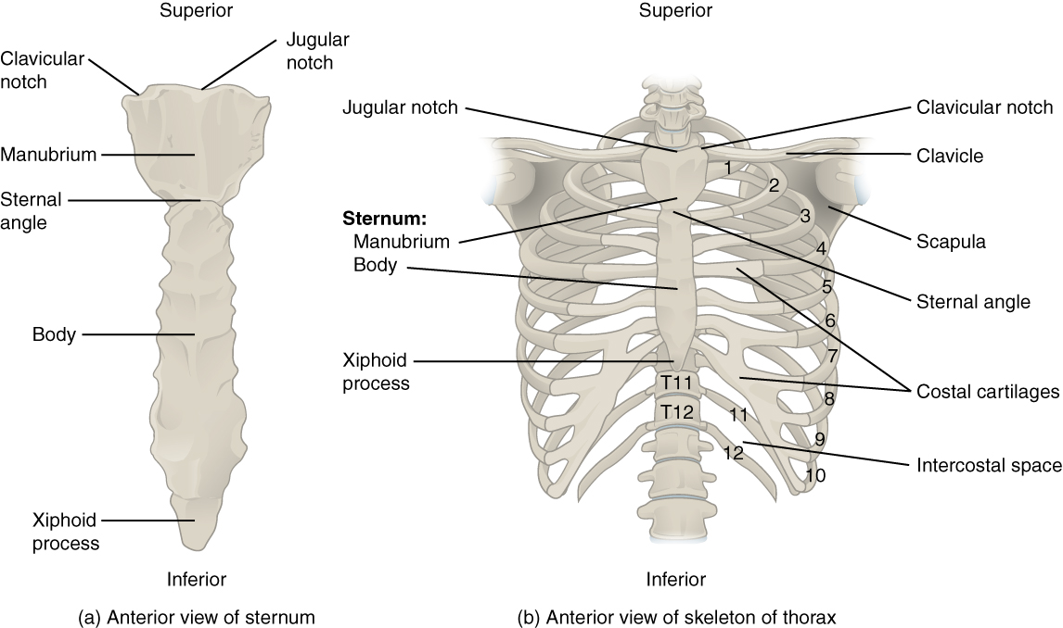

The ribs are classified into three groups based on their relationship to the sternum.
Ribs 1–7 are classified as true ribs (vertebrosternal ribs). The costal cartilage from each of these ribs attaches directly to the sternum. Ribs 8–12 are called false ribs (vertebrochondral ribs). The costal cartilages from these ribs do not attach directly to the sternum. For ribs 8–10, the costal cartilages are attached to the cartilage of the next higher rib. Thus, the cartilage of rib 10 attaches to the cartilage of rib 9, rib 9 then attaches to rib 8, and rib 8 is attached to rib 7. The last two false ribs (11–12) are also called floating ribs (vertebral ribs). These are short ribs that do not attach to the sternum at all. Instead, their small costal cartilages terminate within the musculature of the lateral abdominal wall.

The ribs are the bony framework of the thoracic cavity.
- The ribs form the main structure of the thoracic cage protecting the thoracic organs, however their main function is to aid respiration.
- There are twelve pairs of ribs.
- Each rib articulates posteriorly with two thoracic vertebrae by the costovertebral joint. An exception to this rule is that the first rib articulates with the first thoracic vertebra only.
According to their attachment to the sternum, the ribs are classified into 3 groups: true, false, and floating ribs.
- The true ribs are the ribs that directly articulate with the sternum with their costal cartilages - ribs 1-7. They articulate with the sternum by the sternocostal joints. The first rib is an exception to that rule; it is a synarthrosis and the first rib could uniquely articulate with the clavicle by the costoclavicular joint
- The false ribs (8,9,10) are the ribs that indirectly articulate with the sternum, as their costal cartilages connect with the seventh costal cartilag by the costochondral joint.
- The floating ribs (11,12) do not articulate with the sternum at all (distal two ribs).
Typically, the ribs have the following anatomical components:
- Head with two articular facets
- Tubercle
- Neck
- Shaft
- Costal groove
Most of the ribs are typical ribs ie they have all these features. The atypical ribs which do not have all these features are:
- First rib (wide and short, has two costal grooves, and one articular facet)
- Second rib (thin, long, and has a tuberosity on its superior surface for the attachment of the serratus anterior muscle)
- Tenth rib (only one articular facet)
- Eleventh rib, Twelfth rib (one articular facet with no neck)
The functions of the ribs are critical, as they
- protect the contents of the thoracic cavity and mediastinum
- move superiorly, inferiorly, anteriorly and posteriorly to facilitate breathing (their flexibility in their movement increases/decreases the size of the thoracic cavity; assisting the lungs in respiration. Control of these movements is via the diaphragm, external intercostals, and the intercartilaginous portion of the internal intercostals).
- provide a place where some muscles originate or attach
- play a role in erythropoiesis during development (at birth, the erythropoiesis sites change, it recedes in long bones and persists in flat bones, like ribs.

Muscle Attachments
There are a number of muscles related to ribs.
- intercostal muscles: situated in the intercostal spaces.
- diaphragm: arises from the inner surfaces of the costal cartilages on the sixth rib
- serratus anterior: originates anterolaterally from the 1st to 8th ribs
- pectoralis major and minor muscles arise from superior anterior ribs
- latissimus dorsi: originates from the 9th to 12th ribs
- scalenus anterior, posterior and medius muscles have attachments on the first and second ribs
- rectus abdominis: inserts at the xiphisternum and the 5th to 7th costal cartilages.

Structure and Function
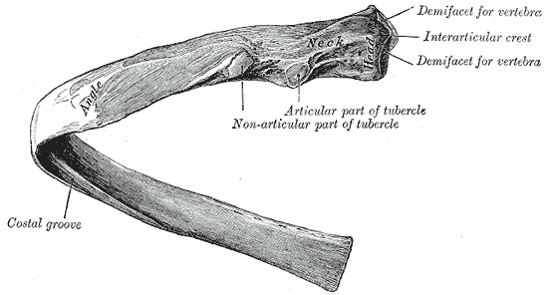

QUESTION # 5
How is the mediastinum divided?
ANSWER
MEDIASTINUM
- The mediastinum is an area found in the midline of the thoracic cavity, that is surrounded by the left and right pleural sacs. It is divided into the superior and inferior mediastinum, of which the latter is larger.
- Anatomically the mediastinum is divided into two parts by an imaginary line that runs from the sternal angle ( the angle formed by the junction of the sternal body and manubrium ) to the T4 vertebrea.
- The inferior mediastinum is further divided into the anterior, middle and posterior mediastinum. Every compartment of the mediastinum contains many vital organs, vascular and neural structures that are closely related one to another.
- The mediastinum, or mediastinal cavity, is a visceral compartment of the thoracic cavity. It completely separates the two pleural cavities by being placed longitudinally between them in a median sagittal position. It extends superoinferiorly from the superior thoracic aperture to the diaphragm, anteroposteriorly from the sternum to the bodies of thoracic vertebrae, and laterally from the mediastinal pleura of the adjacent pleural cavities. The main mediastinal contents are the heart, esophagus, trachea, thoracic nerves and systemic blood vessels.
DIVISION OF MEDIASTINIUM
Mediastinum is divided by;
Superior mediastinum | Borders: first rib (superior) - T4 (inferior)  Content: thymus, trachea, esophagus, thoracic duct, aortic arch, veins (superior vena cava, brachiocephalic, left superior intercostal), nerves (vagus, phrenic, left recurrent laryngeal), lymphatics, other small arteries and veins  Mnemonic: Try To Eat Toast And Vitamins Now Little Oliver
Anterior inferior mediastinum | Borders: T4 (superior) - T9 (inferior); sternum (anterior) - pericardium (posterior)  Content: remnants of the thymus, lymph nodes
Middle inferior mediastinum | Borders: T4 (superior) - T9 (inferior); anterior aspect of pericardium (anterior) - posterior aspect of pericardium  Content: phrenic nerve, heart, pericardium, ascending aorta, pulmonary trunk, superior vena cava, pericardiacophrenic artery
Posterior inferior mediastinum | Borders: T4 (superior) - T12 (inferior); posterior aspect of pericardium (anterior) - spine (posterior)  Content: descending thoracic aorta, azygos veins, hemiazygos veins, accessory hemiazygos veins, thoracic duct, cisterna chyli, esophagus, esophageal plexus, vagus nerve, greater, lesser and least splanchnic nerves, lymphatics  Mnemonic: on the DATE Vivian Slapped Larry.

Superior mediastinum
- The superior mediastinum is a space bounded anteriorly by the manubrium of the sternum, and posteriorly by the bodies of T1-T4 vertebrae. Its superior border is an oblique plane extending from the jugular notch of the manubrium to the superior border of T1 vertebra. Whilst the inferior border is a transverse plane extending from the sternal angle to the T4-T5 intervertebral disc.

Inferior mediastinum
- The inferior mediastinum extends from the inferior border of the superior mediastinum to the diaphragm. It is subdivided anterior-to-posterior into three spaces:
- Anterior mediastinum - posterior to the body of the sternum and anterior to the pericardium
- Middle mediastinum - bounded by the pericardium, which encloses the heart and origins of the great vessels
- Posterior mediastinum - posterior to the pericardium and anterior to the vertebrae

QUESTION # 6
Briefly discuss the structure of lungs.
ANSWER
LUNGS
INTRODUCTION
- The lungs are the major organs of respiration. They are located in the chest either side of the mediastinum.
- The lungs are the primary organs of the respiratory system in humans and many other animals including a few fish and some snails. In mammals and most other vertebrates, two lungs are located near the backbone on either side of the heart.
- Their function in the respiratory system is to extract oxygen from the atmosphere and transfer it into the bloodstream, and to release carbon dioxide from the bloodstream into the atmosphere, in a process of gas exchange. Respiration is driven by different muscular systems in different species. Mammals, reptiles and birds use their different muscles to support and foster breathing.
- In early tetrapods, air was driven into the lungs by the pharyngeal muscles via buccal pumping, a mechanism still seen in amphibians. In humans, the main muscle of respiration that drives breathing is the diaphragm. The lungs also provide airflow that makes vocal sounds including human speech possible.
- Humans have two lungs, a right lung, and a left lung. They are situated within the thoracic cavity of the chest. The right lung is bigger than the left, which shares space in the chest with the heart. The lungs together weigh approximately 1.3 kilograms (2.9 lb), and the right is heavier. The lungs are part of the lower respiratory tract that begins at the trachea and branches into the bronchi and bronchioles, and which receive air breathed in via the conducting zone. The conducting zone ends at the terminal bronchioles. These divide into the respiratory bronchioles of the respiratory zone which divide into alveolar ducts that give rise to the alveolar sacs that contain the alveoli, where gas exchange takes place. Alveoli are also sparsely present on the walls of the respiratory bronchioles and alveolar ducts. Together, the lungs contain approximately 2,400 kilometres (1,500 mi) of airways and 300 to 500 million alveoli. Each lung is enclosed within a pleural sac that contains pleural fluid, which allows the inner and outer walls to slide over each other whilst breathing takes place, without much friction. This sac also divides each lung into sections called lobes. The right lung has three lobes and the left has two. The lobes are further divided into bronchopulmonary segments and pulmonary lobules. The lungs have a unique blood supply, receiving deoxygenated blood from the heart in the pulmonary circulation for the purposes of receiving oxygen and releasing carbon dioxide, and a separate supply of oxygenated blood to the tissue of the lungs, in the bronchial circulation.
- The tissue of the lungs can be affected by a number of respiratory diseases, including pneumonia and lung cancer. Chronic obstructive pulmonary disease includes chronic bronchitis and emphysema, and can be related to smoking or exposure to harmful substances. A number of occupational lung diseases can be caused by substances such as coal dust, asbestos fibres, and crystalline silica dust. Diseases such as bronchitis can also affect the respiratory tract. Medical terms related to the lung often begin with pulmo-, from the Latin pulmonarius (of the lungs) as in pulmonology, or with pneumo- (from Greek πνεύμων "lung") as in pneumonia.
- In embryonic development, the lungs begin to develop as an outpouching of the foregut, a tube which goes on to form the upper part of the digestive system. When the lungs are formed the fetus is held in the fluid-filled amniotic sac and so they do not function to breathe. Blood is also diverted from the lungs through the ductus arteriosus. At birth however, air begins to pass through the lungs, and the diversionary duct closes, so that the lungs can begin to respire. The lungs only fully develop in early childhood.

STRUCTURE OF LUNGS
The lungs are located in the chest on either side of the heart in the rib cage. They are conical in shape with a narrow rounded apex at the top, and a broad concave base that rests on the convex surface of the diaphragm. The apex of the lung extends into the root of the neck, reaching shortly above the level of the sternal end of the first rib. The lungs stretch from close to the backbone in the rib cage to the front of the chest and downwards from the lower part of the trachea to the diaphragm. The left lung shares space with the heart, and has an indentation in its border called the cardiac notch of the left lung to accommodate this. The front and outer sides of the lungs face the ribs, which make light indentations on their surfaces. The medial surfaces of the lungs face towards the centre of the chest, and lie against the heart, great vessels, and the carina where the trachea divides into the two main bronchi. The cardiac impression is an indentation formed on the surfaces of the lungs where they rest against the heart.
Both lungs have a central recession called the hilum at the root of the lung, where the blood vessels and airways pass into the lungs. There are also bronchopulmonary lymph nodes on the hilum.
The lungs are surrounded by the pulmonary pleurae. The pleurae are two serous membranes; the outer parietal pleura lines the inner wall of the rib cage and the inner visceral pleura directly lines the surface of the lungs. Between the pleurae is a potential space called the pleural cavity containing a thin layer of lubricating pleural fluid.

Lobes and segments
Lobes and bronchopulmonary segments
Right lung | Left lung
Upper  - Apical  - Anterior  - Posterior  Middle  - Medial  - Lateral  Lower  - Apical  - Anterior basal  - Posterior basal  - Medial basal  - Lateral basal | Upper  - Anterior  - Apical  - posterior  Lower  - Apical  - Anterior basal  - Posterior basal  - Medial basal  - Lateral basal  Lingula  - Superior  - Inferior
Each lung is divided into lobes by the infoldings of the pleura as fissures. The fissures are double folds of pleura that section the lungs and help in their expansion.
The main or primary bronchi enter the lungs at the hilum and initially branch into secondary bronchi also known as lobar bronchi that supply air to each lobe of the lung. The lobar bronchi branch into tertiary bronchi also known as segmental bronchi and these supply air to the further divisions of the lobes known as bronchopulmonary segments. Each bronchopulmonary segment has its own (segmental) bronchus and arterial supply. Segments for the left and right lung are shown in the table. The segmental anatomy is useful clinically for localising disease processes in the lungs. A segment is a discrete unit that can be surgically removed without seriously affecting surrounding tissue.
- The lung are roughly cone shaped with an apex base three surfaces and three borders. The left lung is slightly smaller than the right this is due to presence of heart.
- Each lung consist of;
- APEX
The blunt superior end of the lung. It projects upward above the level of the 1st rib and into the floor of the neck.
- BASE
The inferior surface of the lung. Which sits on the diaphargm.
- LOBES
( two or three ) these are separated by fissures with in the lung.
LOBES
- The right and left lung do not have an identical lobular structure.
- The right lung has three lobes ( Superior , middle , and inferior ) the lobes are divided from each other by two fissures.
- The left lung has two lobes the lobes are divided from each other by oblique fissures.
- There are two parts of lungs

Right lung
The right lung has both more lobes and segments than the left. It is divided into three lobes, an upper, middle, and a lower lobe by two fissures, one oblique and one horizontal. The upper, horizontal fissure, separates the upper from the middle lobe. It begins in the lower oblique fissure near the posterior border of the lung, and, running horizontally forward, cuts the anterior border on a level with the sternal end of the fourth costal cartilage; on the mediastinal surface it may be traced back to the hilum.
The lower, oblique fissure, separates the lower from the middle and upper lobes and is closely aligned with the oblique fissure in the left lung.
The mediastinal surface of the right lung is indented by a number of nearby structures. The heart sits in an impression called the cardiac impression. Above the hilum of the lung is an arched groove for the azygos vein, and above this is a wide groove for the superior vena cava and right brachiocephalic vein; behind this, and close to the top of the lung is a groove for the brachiocephalic artery. There is a groove for the esophagus behind the hilum and the pulmonary ligament, and near the lower part of the esophageal groove is a deeper groove for the inferior vena cava before it enters the heart.
The weight of the right lung varies between individuals, with a standard reference range in men of 155–720 g (0.342–1.587 lb) and in women of 100–590 g (0.22–1.30 lb).

Left lung
The left lung is divided into two lobes, an upper and a lower lobe, by the oblique fissure, which extends from the costal to the mediastinal surface of the lung both above and below the hilum. The left lung, unlike the right, does not have a middle lobe, though it does have a homologous feature, a projection of the upper lobe termed the lingula. Its name means "little tongue". The lingula on the left lung serves as an anatomic parallel to the middle lobe on the right lung, with both areas being predisposed to similar infections and anatomic complications. There are two bronchopulmonary segments of the lingula: superior and inferior.
The mediastinal surface of the left lung has a large cardiac impression where the heart sits. This is deeper and larger than that on the right lung, at which level the heart projects to the left.
On the same surface, immediately above the hilum, is a well-marked curved groove for the aortic arch, and a groove below it for the descending aorta. The left subclavian artery, a branch off the aortic arch, sits in a groove from the arch to near the apex of the lung. A shallower groove in front of the artery and near the edge of the lung, lodges the left brachiocephalic vein. The esophagus may sit in a wider shallow impression at the base of the lung.
The weight of the left lung, by standard reference range, in men is 110–675 g (0.243–1.488 lb) in women 105–515 g (0.231–1.135 lb).

FUNCTION OF LUNGS
The function of lungs is to oxygenated blood . they achieve this by bringing inspired air into close contact with oxygen poor blood in the pulmonary capillaries.
Diagram
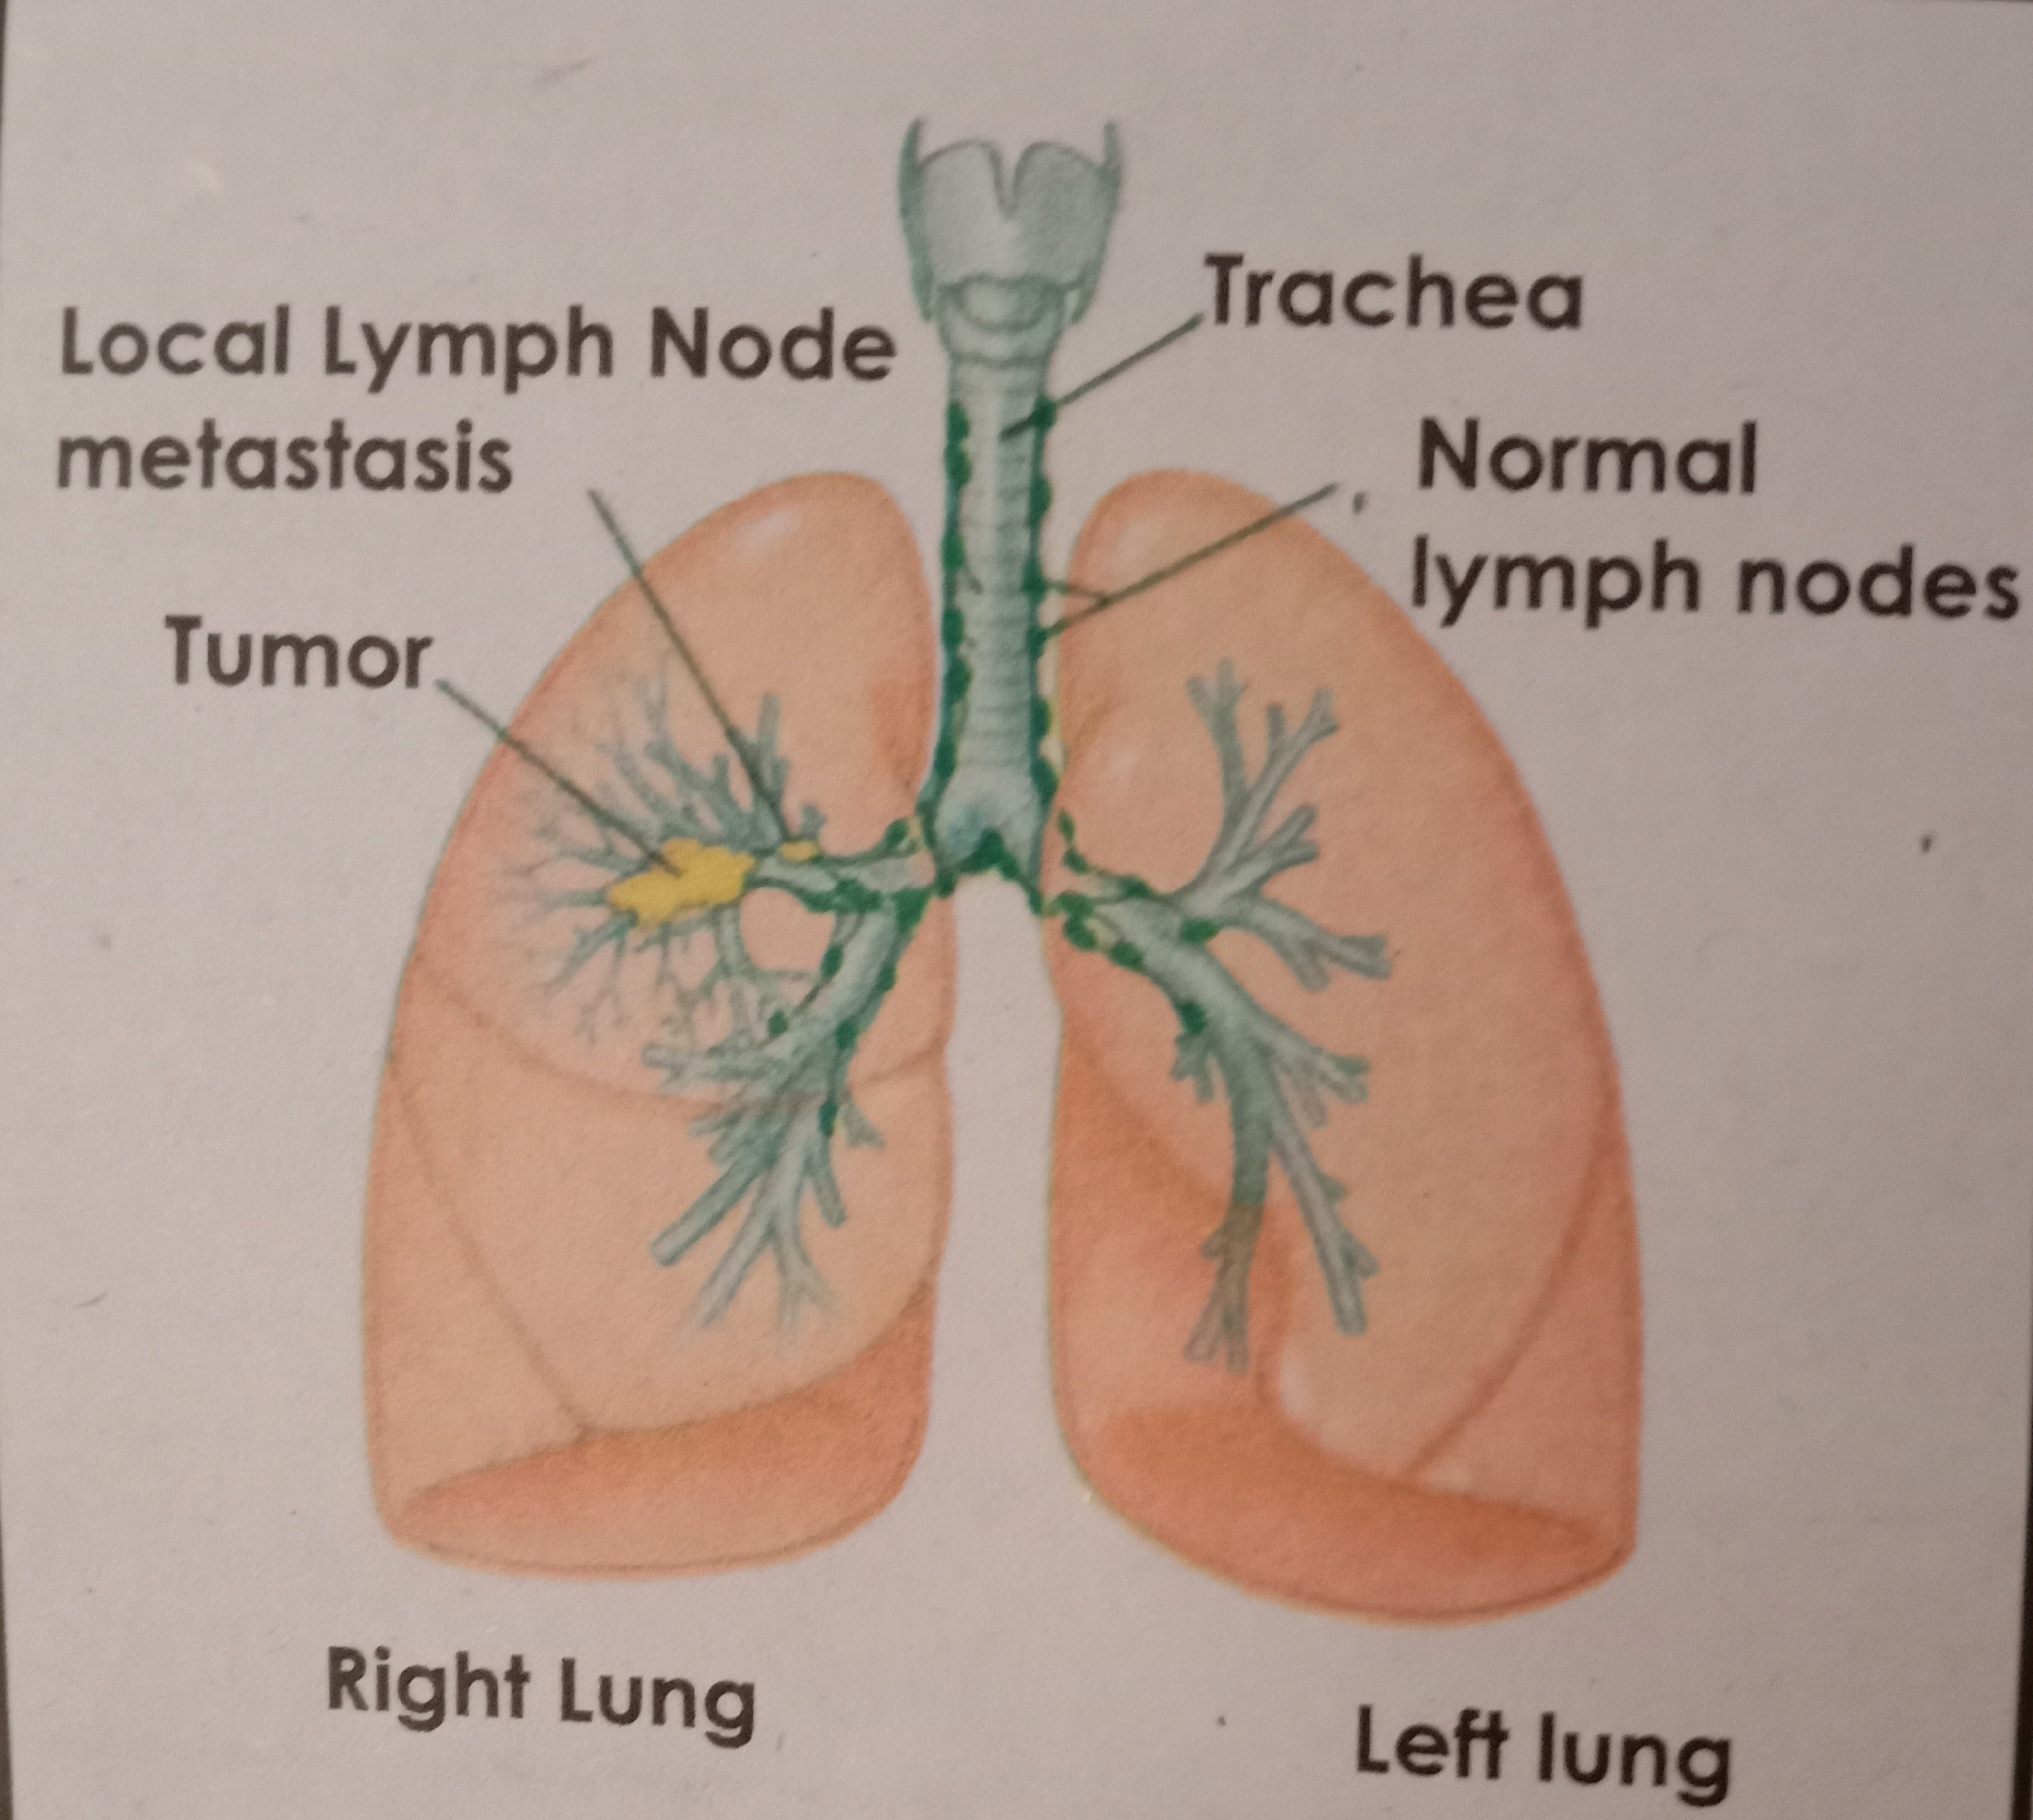

Thank you

