Paper :surgery
DEPARTMENT :DPT
Sarosh gohar
Id#13436
Question#1
Hydrocephalus :
Definition :
Hydrocephalus is a condition in which an accumulation of cerebrospinal fluid (CSF) occurs within the brain.[1] This typically causes increased pressure inside the skull. Older people may have headaches, double vision, poor balance, urinary incontinence, personality changes, or mental impairment. In babies, it may be seen as a rapid increase in head size. Other symptoms may include vomiting, sleepiness, seizures.
Two types:
Communicating hydrocephalus is the build-up of pressure from too much CSF that is not being properly absorbed.
Non-communicating hydrocephalus is the build-up of pressure from CSF when a blockage occurs within the brain.
Differentiate between communicating and non communicating hydrocephalus :
Benign External Hydrocephalus (Communicating)
Benign external hydrocephalus (also referred to as external hydrocephalus) occurs when an accumulation of CSF is found outside the brain, which usually presents itself at birth or soon thereafter. This condition usually corrects itself within 18 months of age.
Normal Pressure Hydrocephalus (Non-Communicating)
Can happen to people at any age, but it is most common among the elderly. It may result from a subarachnoid haemorrhage, head trauma, infection, tumour, or complications of surgery.
However, many people develop normal pressure hydrocephalus even when none of these factors.
Also called Obstructive hydrocephalus.

Communicating:
Communicating hydrocephalus, also known as nonobstructive hydrocephalus, is caused by impaired CSF reabsorption in the absence of any obstruction of CSF flow between the ventricles and subarachnoid space. This may be due to functional impairment of the arachnoidal granulations (also called arachnoid granulations or Pacchioni’s granulations), which are located along the superior sagittal sinus, and is the site of CSF reabsorption back into the venous system. Various neurologic conditions may result in communicating hydrocephalus, including subarachnoid/intraventricular hemorrhage, meningitis, and congenital absence of arachnoid villi. Scarring and fibrosis of the subarachnoid space following infectious, inflammatory, or hemorrhagic events can also prevent resorption of CSF, causing diffuse ventricular dilatation.
Non-communicating
Noncommunicating hydrocephalus, or obstructive hydrocephalus, is caused by a CSF-flow obstruction.
Foramen of Monro obstruction may lead to dilation of one, or if large enough (e.g., in colloid cyst), both lateral ventricles.
The aqueduct of Sylvius, normally narrow, may be obstructed by a number of genetic or acquired lesions (e.g., atresia, ependymitis, hemorrhage, or tumor) and lead to dilation of both lateral ventricles, as well as the third ventricle.
Fourth ventricle obstruction leads to dilatation of the aqueduct, as well as the lateral and third ventricles (e.g., Chiari malformation).
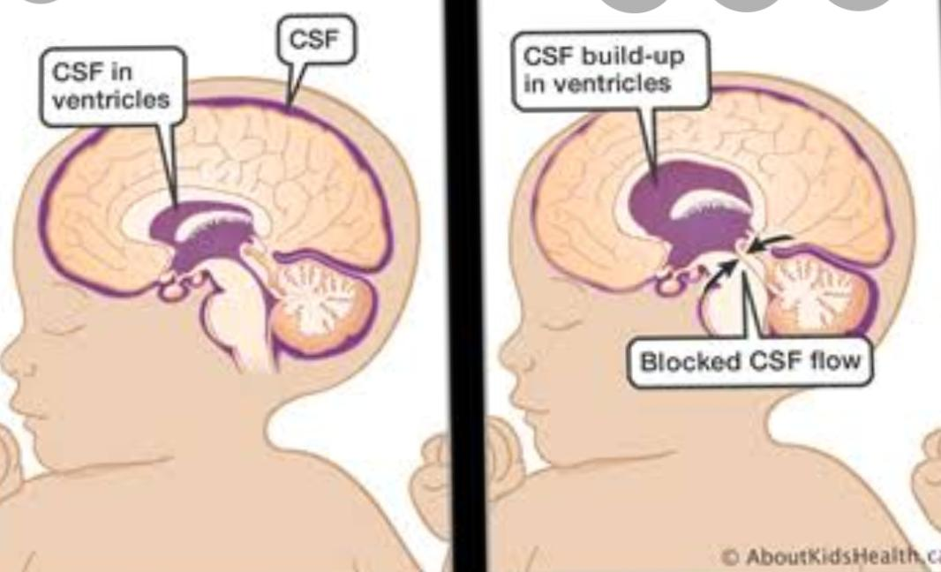
The foramina of Luschka and foramen of Magendie may be obstructed due to congenital malformation

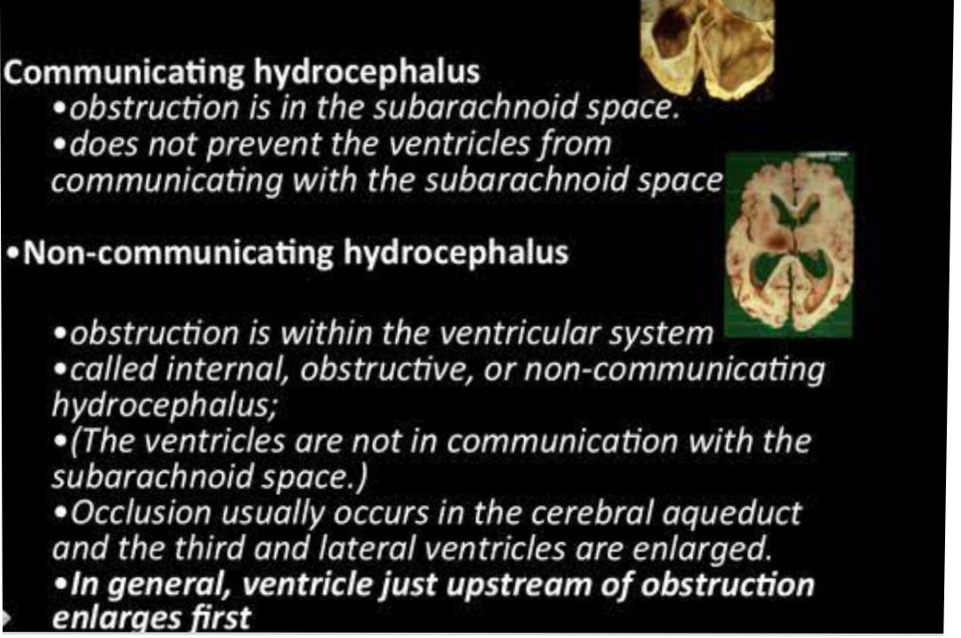
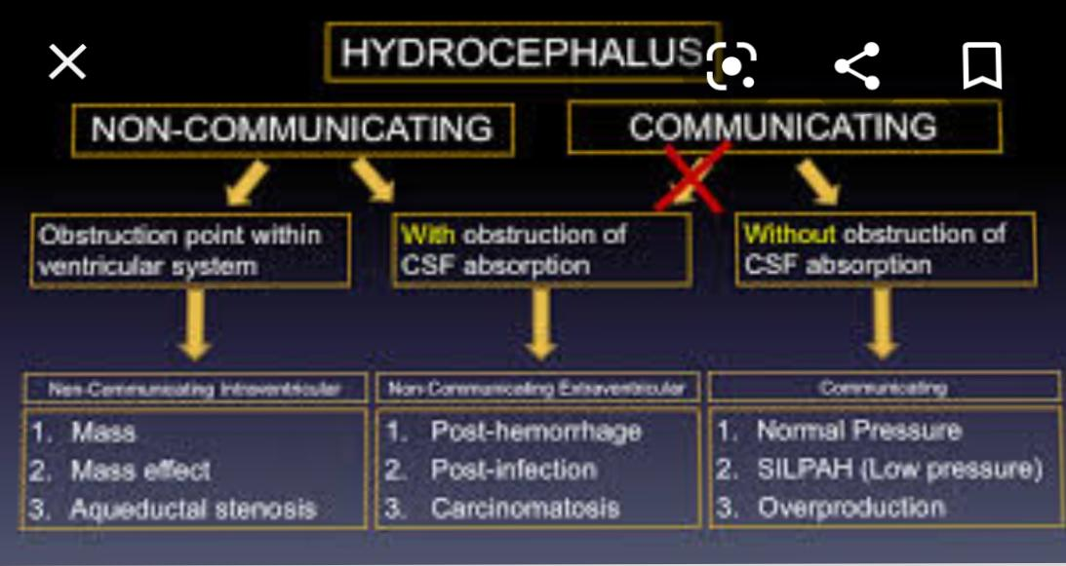
Diffrences:
Prognosis of hydrocephalus:
The prognosis for hydrocephalus depends on the cause, the extent of symptoms and the timeliness of diagnosis and treatment. Some patients show a dramatic improvement with treatment, while others do not. In some instances of normal pressure hydrocephalus, dementia can be reversed by shunt placement.
Failure to catch hydrocephalus on time and treat it accordingly may lead to long-term neurological deficits that require multidisciplinary medical teams to assist patients with developmental and lasting cognitive impairment. Neurological damage that may have occurred prior to treatment is unfortunately irreversible and can have a significant impact on functional social outcomes such as social integration, schooling, and marriage.
:Increase risk for developmental disabilities.
:Abnormalities in memory.
:Some patients show aggressive.
They need for additional surgery occurred in 22%.
Permanent Neurologic deficit or death was 6%
END….. First question…
Questions #2
Nephrolithiasis
Definition:
Nephrolithiasis (kidney stones) is a disease affecting the urinary tract. Kidney stones are small deposits that build up in the kidneys, made of calcium, phosphate and other components of foods. They are a common cause of blood in urine.

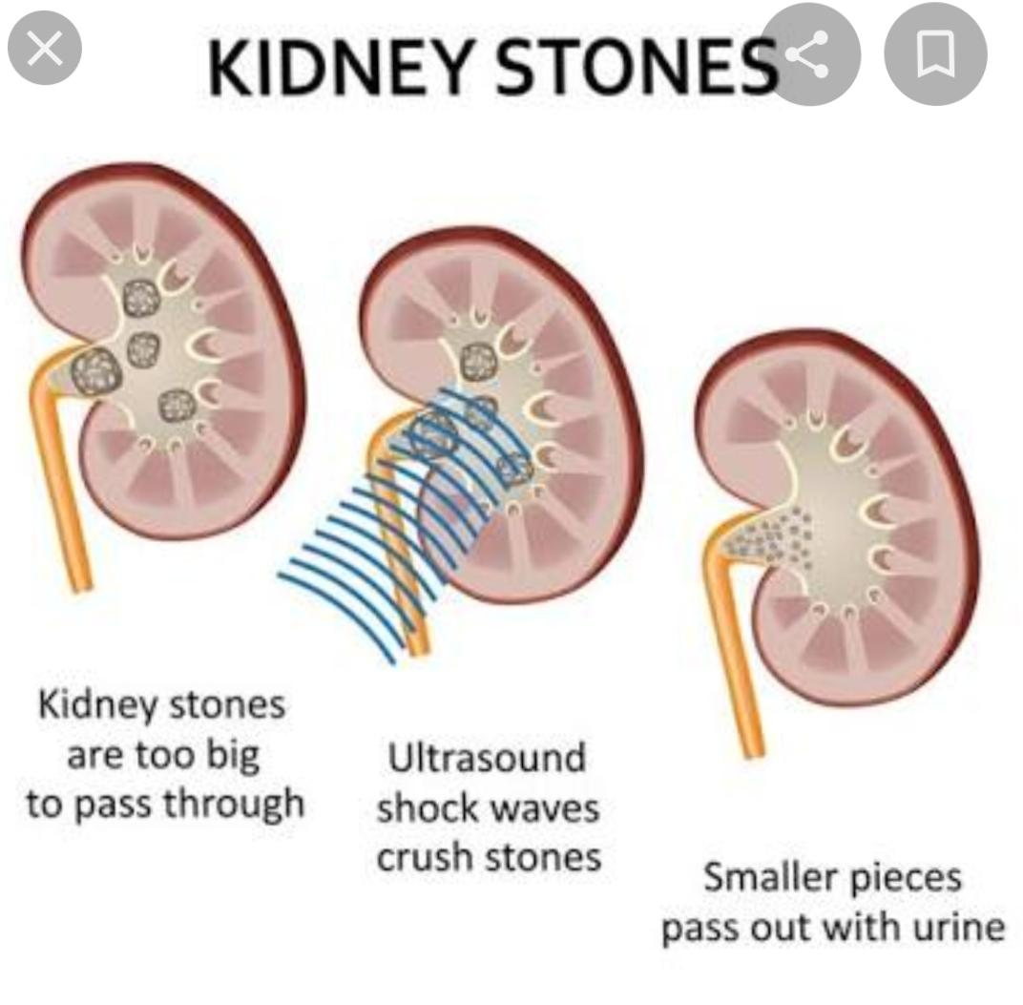

Signs and symptoms :
Kidney stones form in your kidneys. As stones move into your ureters — the thin tubes that allow urine to pass from your kidneys to your bladder — signs and symptoms can result. Signs and symptoms of kidney stones can include severe pain, nausea, vomiting, fever, chills and blood in your urine.
Population at risk :
The lifetime risk of kidney stones is about 19% in men and 9% in women. In men, the first episode is most likely to occur after age 30, but it can occur earlier. Other diseases such as high blood pressure, diabetes, and obesity may increase the risk for kidney stones.
Anyone can get a kidney stone, but some people are more likely than others to have them. Men get kidney stones more often than women do. Kidney stones are also more common in non-Hispanic white people than in people of other ethnicities. You may also be more likely to have kidney stones if:

You have had kidney stones before.
Someone in your family has had kidney stones.
You don’t drink enough water.
You follow a diet high in protein, sodium and/or sugar.
You are overweight or obese.
You have had gastric bypass surgery or another intestinal surgery.
You have polycystic kidney disease or another cystic kidney disease.
You have a certain condition that causes your urine to contain high levels of cystine, oxalate, uric acid or calcium.
You have a condition that causes swelling or irritation in your bowel or your joints.
You take certain medicines, such as diuretics (water pills) or calcium-based antacids

Medical conditions such as Crohn’s disease, urinary tract infections, renal tubular acidosis, hyperparathyroidism, medullary sponge kidney, and Dent’s disease increase the risk of kidney stones.

Risk factors
Kidney stones are more common among males than females. Most people who experience kidney stones do so between the ages of 30 and 50 years. A family history of kidney stones also increases one’s chances of developing them.

Similarly, a previous kidney stone occurrence increases the risk that a person will develop subsequent stones in the future if preventative action is not taken.

Certain medications can increase the risk of developing kidney stones. Scientists found that topiramate (Topamax), a drug commonly prescribed to treat seizures and migraine headaches, can increase the likelihood of kidney stones developing.

Additionally, it is possible that long-term use of vitamin D and calcium supplements cause high calcium levels, which can contribute to kidney stones.

Additional risk factors for kidney stones include diets that are high in protein and sodium but low in calcium, a sedentary lifestyle, obesity, high blood pressure, and conditions that affect how calcium is absorbed in the body such as gastric bypass surgery, inflammatory bowel disease, and chronic diarrhea.

Surgical management of kidney stones
Types of Kidney Stone Procedures and Surgeries
Shock wave lithotripsy. Ureteroscopy. Percutaneous nephrolithotomy or percutaneous nephrolithotripsy
Small kidney stones of size 5 mm also do not require surgery for removal, until and unless they come down and get stuck in the tube (Ureter). Larger stones in the ureter causing swelling of the kidney or infection require immediate removal by ureteroscopy and Holmium LASER.
The treatment options for kidney stones 5-20mm are:
Extracorporeal Shockwave Lithotripsy (ESWL).
Ureteropyeloscopy.
IoPercutaneous Nephrolithotomy – usually for larger stones.
Observation – if the patient is too frail for an operation.
Types of Kidney Stone Procedures and Surgeries
These four treatments can be used on your kidney stones:
Shock wave lithotripsy
Ureteroscopy
Percutaneous nephrolithotomy or percutaneous nephrolithotripsy
Shock Wave Lithotripsy
SWL is the most common kidney stone treatment. It works best for small or medium stones. It’s noninvasive, which means no cuts are made in your skin.
Ureteroscopy
This procedure treats stones in the kidneys and ureters. Your doctor uses a thin, flexible scope to find and remove stones. No cuts are made in your skin. You’ll sleep through this procedure.
Nephrolithotomy: Your surgeon removes the stone through a tube

Nephrolithotripsy: Your surgeon uses sound waves or a laser to break up the stone and then vacuums up the pieces with a suction machine

Open surgery
The surgeon uses an incision in the person’s abdomen or side to reach the kidney and remove the stones
Percutaneous Nephrolithotomy
It is the preferred technique for treating larger kidney stones (over 2cm in diameter) located within the kidney. It involves keyhole surgery that is performed through a 1cm incision in the skin
Physical therapist role
Sedentry life style is a risk factor
Exercise
Women who exercised had up to a 31 percent lower risk of kidney stones
Questions #3
Intestinal obstruction:
Definition:
Bowel obstruction, also known as intestinal obstruction, is a mechanical or functional obstruction of the intestines which prevents the normal movement of the products of digestion. Either the small bowel or large bowel may be affected. Signs and symptoms include abdominal pain, vomiting, bloating and
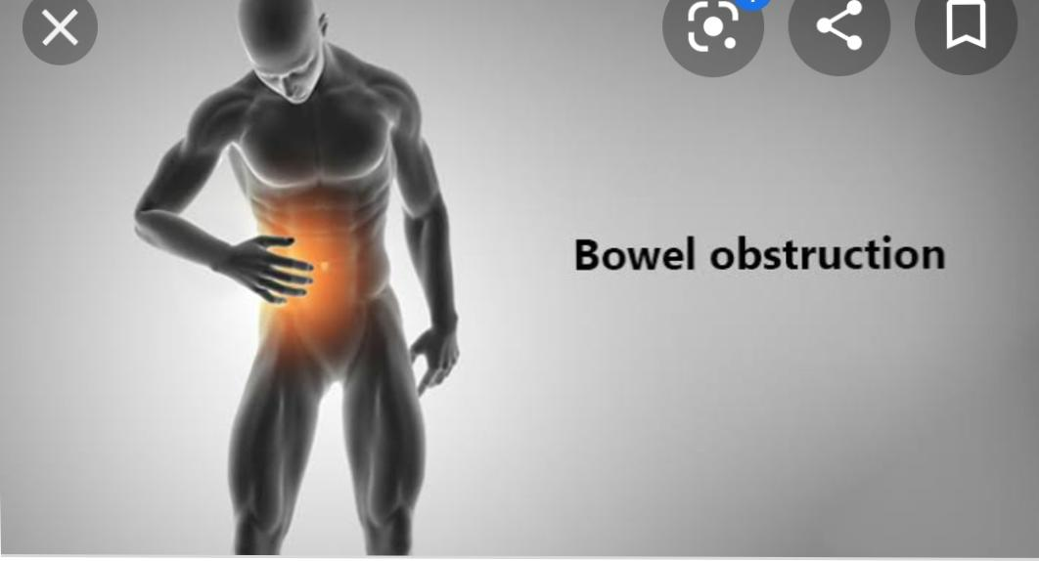
not passing gas.

Mechanical causes of intestinal obstruction may include:
Adhesions or scar tissue that forms after surgery.
Foreign bodies (objects that are swallowed and block the intestines)
Gallstones (rare)
Hernias.
Impacted stool.
Intussusception (telescoping of one segment of bowel into another)
Tumors blocking the intestines
Lab test indicated :
If the diagnosis is unclear, admission and observation are warranted to detect early obstructions. Essential laboratory tests are needed, including the following:
Serum chemistries: Results are usually normal or mildly elevated; abnomal results early in the disease are generally due to vomiting or dehydration
Blood urea nitrogen (BUN)/creatinine levels: May be increased due to a decreased volume state (eg, dehydration)
Complete blood cell (CBC) count: The white blood cell (WBC) count may be elevated with a left shift in simple or strangulated obstructions; increased hematocrit is an indicator of volume state (ie, dehydration)
Serum lactate levels: Increased levels are suggestive of dehydration or tissue underperfusion
Lactate dehydrogenase studies
UrinalysisLo
Type and crossmatch as well as prothrombin time (PT), international normalized ratio (INR), and partial thromboplastin time (PTT): These are adjunctive laboratory tests used in the evaluation of SBO; the patient may require surgical intervention
LAB:
FBC
ABGs
BUSE
ESR & CRP are optional
Group and save
Clotting profile

RADIOLOGICAL:
AXR➡ air fluid level & masses
Shadow
CT ➡ level , extent & cause of
Obstruction
Colonoscopy & endoscopy are optional.
Uss
Doppler
Mesenteric vasculture solid organs
Plain abdominal x rays
Multiple air fluid levels, more evident based on upright position;

Dilatation of intestinal segments proximal the obstacle and collapse in distal bowel.
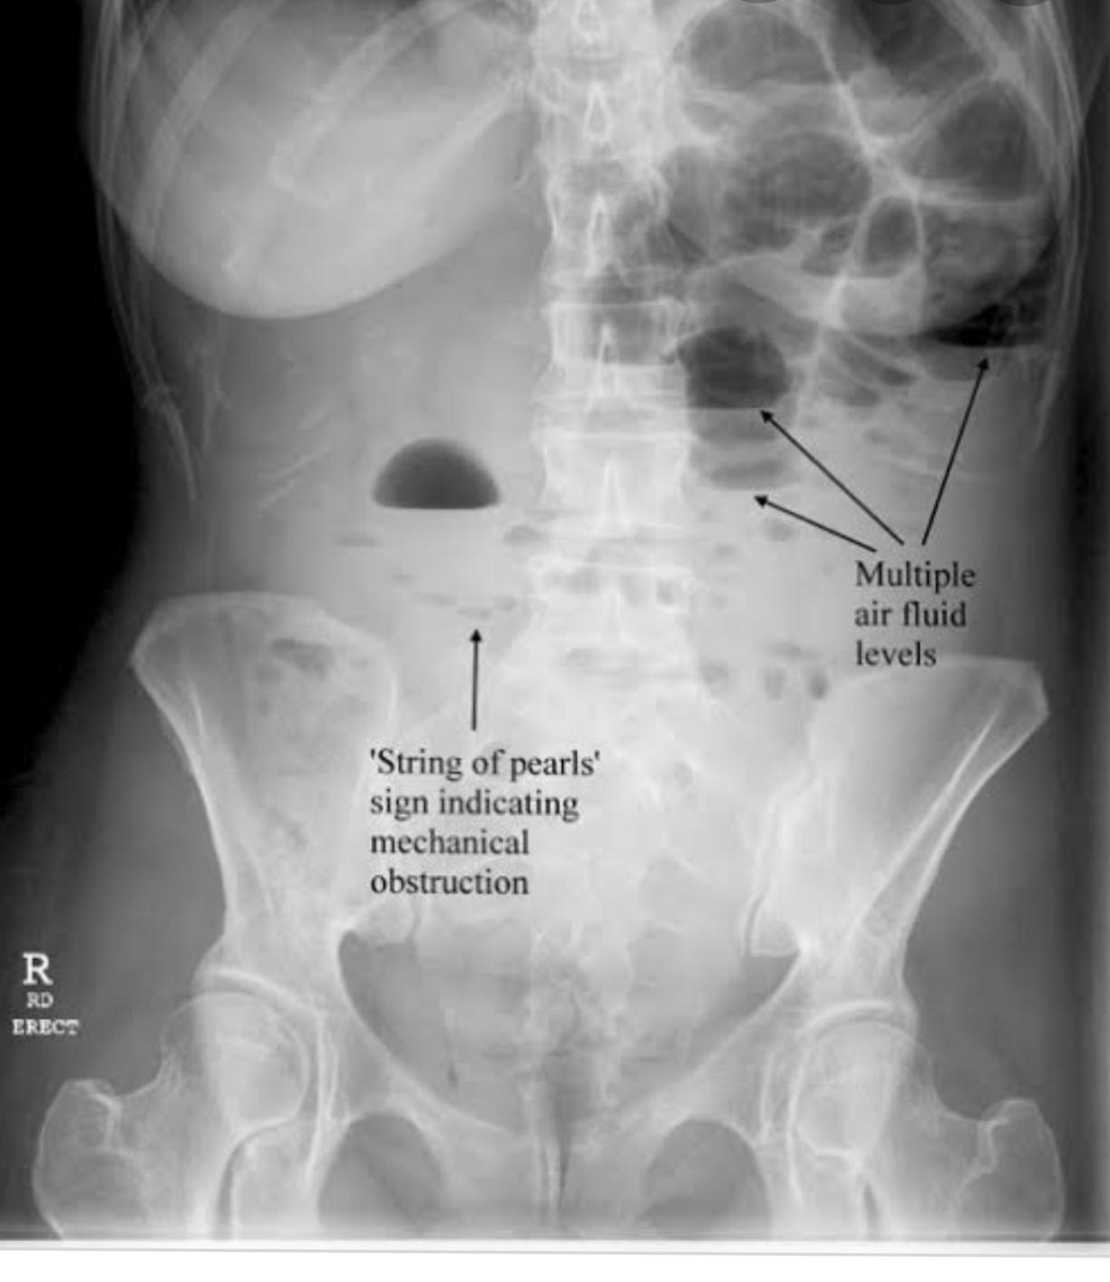

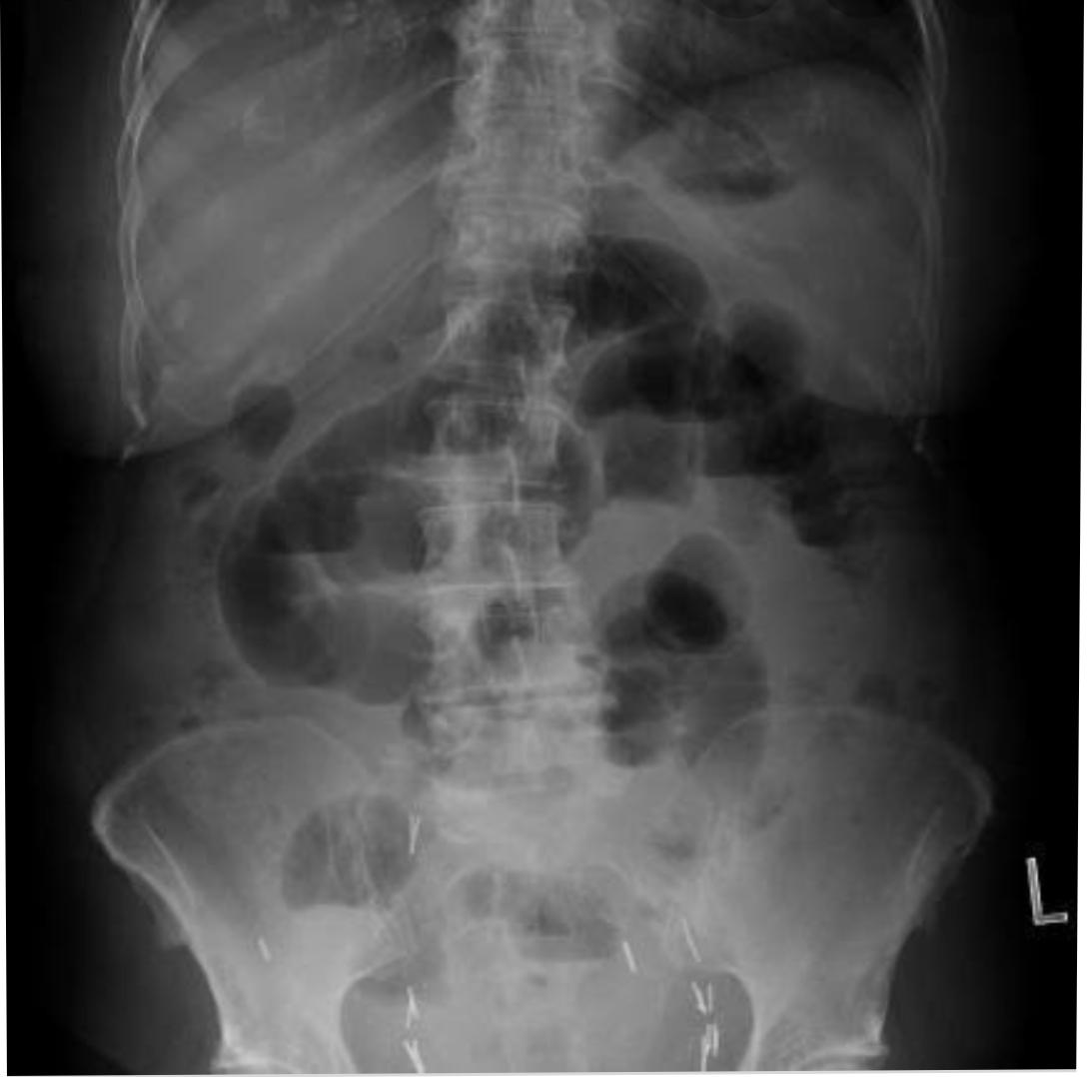
Surgical management of intestinal obstruction :
Surgical intervention is indicated if nasogastric decompression fails or if re-obstruction develops after removal of nasogastric tube. Selection of surgical procedure, resection, bypass, gastrostomy, or tube jejunostomy is based on extent of the disease.
All obstructions will be treated with IV fluids and electrolyte correction. Occasionally, a nasogastric tube is placed to remove fluid and gas backing up in the upper digestive tract. Medications are used to help with nausea and severe pain. A complete obstruction may require surgery or stenting.
Divide the Causative Adhesions
Repair serosal tears, areas of doubtful viability
Laparoscopic, Adhesiolysis in expert surgeon’s hand.

Three criteria guide this therapeutic choice:

Degree of impairment of general conditions due to complications: intestinal ischemia, necrosis, perforation, and peritonitis;

Etiology of obstructive syndrome (hypothesized or confirmed);

Type of intestinal obstruction diagnosed (hypothesized or confirmed):

Complete versus incomplete

Small or large bowel obstacle site

Strangulation occlusion
Conservative
1-NASOGASTRIC TUBE
To decompress dilated bowel
Aspirate it with a 20/50 ml syringe half hourly
2-IV FLUIDS
Normal saline/ringer lactate for intravascular volume depletion(dehydration)
3-ELECTROLYTES CORRECTION
Guided by test results
4-ANALGESICS
For pain relief
5-ANTIBIOTICS
If bowel ischemia/infarction is suspected
Operative:
Repair of hernias
Removal of foreign bodies
Lysis of offending adhesions
Resection
Colostomy.
End….
Questions #4
Subarachnoid hemorrhage:
Definition:
Overview. Subarachnoid hemorrhage (SAH) is a life-threatening type of stroke caused by bleeding into the space surrounding the brain. SAH can be caused by a ruptured aneurysm, AVM, or head injury. One-third of patients will survive with good recovery; one-third will survive with a disability; and one-third will die.
Subarachnoid hemorrhage (SAH) is a type of stroke. Head trauma is the most common cause. In patients without head trauma, SAH is most commonly caused by a brain aneurysm.
There are four major complications to subarachnoid hemorrhage. Those complications are vasospasm, hydrocephalus, seizures, and rebleeding.
Cognitive dysfunction is a common complication of a subarachnoid haemorrhage, affecting most people to some degree. Cognitive dysfunction can take a number of forms, such as: problems with memory – memories before the haemorrhage are normally not affected, but you may have problems remembering new information or facts.

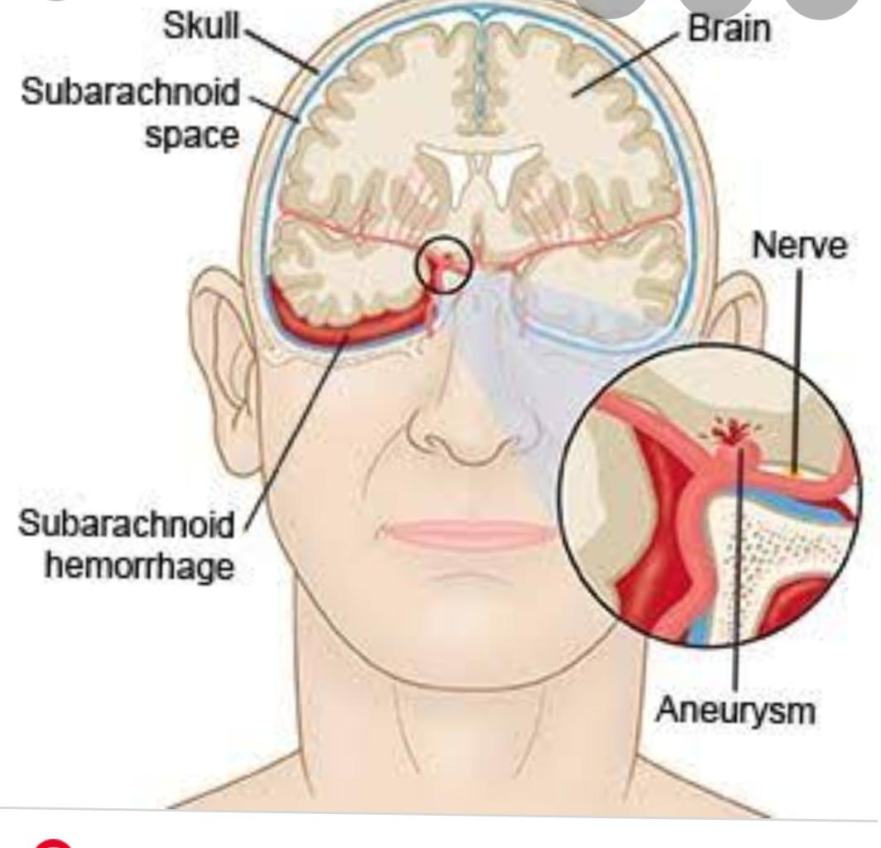

Clinical manifestations of subarachnoid hemorrhage:
Healthy tissues die
Vasospasm(nimodipine)
Hydrocephalus
Sudden onset of a severe headache (often described as “the worst headache of my life”)
Nausea and vomiting.
.Rebleeding.
Delayed cerebral ischemia from vasospasm.
Intracerebral hemorrhage.
Intraventricular hemorrhage.
Left ventricular systolic dysfunction.
Subdural hematoma.
Stiff neck.
Sensitivity to light (photophobia)
Blurred
Loss of consciousness.
Neck pain
Numbness throughout your body
Shoulder pain
Seizures
Confusion
Irritability
Sensitivity to light
Decreased vision
Double vision
Clinical Features
SAH will classically presents with a severe headache, sudden onset (within seconds to minutes), typically in the occipital region (often termed “thunderclap” headaches).

Other features include nausea and vomiting, reduced consciousness, collapse, or seizures, or evidence of meningism (including photophobia, stiff neck, pain on neck flexion, or positive Kernig’s sign).

Examination may reveal focal neurology or evidence of meningism, however may be otherwise unremarkable.

Investigations
Investigations for a suspected SAH should aim to initially confirm the presence of subarachnoid haemorrhage and then to localise the source of any potential bleeding to decide on a management plan

Initial Investigations
An initial urgent non-contrast CT head scan is typically warranted for assessment for SAH (Fig. 4), with a sensitivity of 98% within 12 hours (however small SAH may not be picked up). Hyperattenuating material is seen within the subarachnoid space, most apparent typically around the circle of Willis* or in the Sylvian fissure.

In cases where the initial CT is negative however clinical history is suggestive of SAH, then a lumbar puncture (LP) may be warranted. CSF spectrophotometric analysis following LP will reveal elevated levels of oxyhaemoglobin and bilirubin, in cases of SAH.
INVESTIGATIONS
> CT SCAN
>MRI
>Cerebral Angiography uses an X-ray and injected dye …..
>Lumbar puncture
GCS:

The Fisher grading system is used to classify SAH, as follows: ... Grade 2 - Diffuse or vertical layers of SAH less than 1 mm thick. Grade 3 - Diffuse clot and/or vertical layer greater than 1 mm thick. Grade 4 - Intracerebral or intraventricular clot with diffuse or no subarachnoid blood

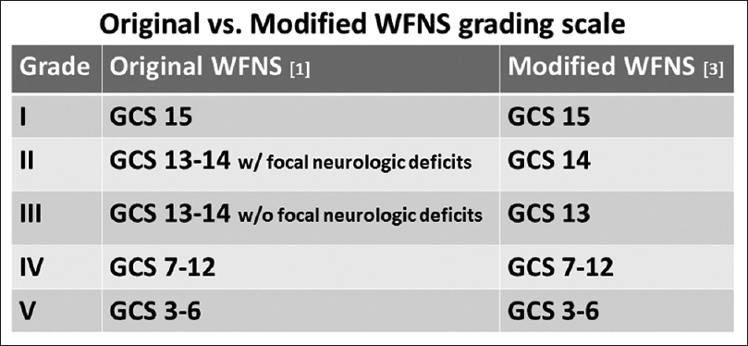

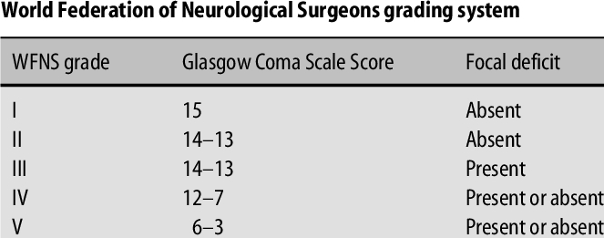
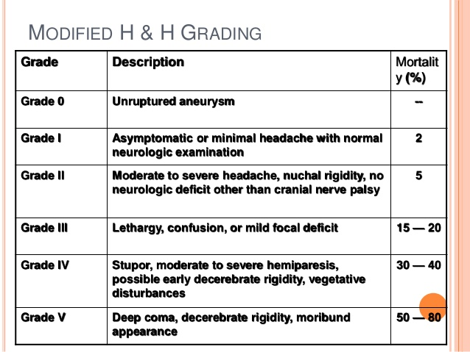
END…. .
Questions #5
Appendicitis:
Definition :
Appendicitis is an inflammation of the appendix, a finger-shaped pouch that projects from your colon on the lower right side of your abdomen. Appendicitis causes pain in your lower right abdomen. However, in most people, pain begins around the navel and then moves.
How to check if appendicitis:
Tests and procedures used to diagnose appendicitis include:
Physical exam to assess your pain. Your doctor may apply gentle pressure on the painful area. …
Blood test. This allows your doctor to check for a high white blood cell count, which may indicate an infection.
Urine test. …
Imaging tests.
Pain feel like:
Abdominal pain
Appendicitis usually involves a gradual onset of dull, cramping, or aching pain throughout the abdomen. As the appendix becomes more swollen and inflamed, it will irritate the lining of the abdominal wall, known as the peritoneum. This causes localized, sharp pain in the right lower part of the abdomen.
Cause:
Appendicitis happens when the appendix gets blocked, often by poop, a foreign body (something inside you that isn’t supposed to be there), or cancer. Blockage may also result from infection, since the appendix can swell in response to any infection in the body.
Clinical sign of appendicitis :
Signs and symptoms of appendicitis may include:
Sudden pain that begins on the right side of the lower abdomen.
Sudden pain that begins around your navel and often shifts to your lower right abdomen.
Pain that worsens if you cough, walk or make other jarring movements.
Nausea and vomiting.
Loss of appetite.
Rovsing’s sign:
, named after the Danish surgeon Niels Thorkild Rovsing (1862–1927), is a sign of appendicitis. If palpation of the left lower quadrant of a person’s abdomen increases the pain felt in the right lower quadrant, the patient is said to have a positive Rovsing’s sign and may have appendicitis.
Mcburney’s point :
Deep tenderness at McBurney’s point, known as McBurney’s sign, is a sign of acute appendicitis. The clinical sign of referred pain in the epigastrium when pressure is applied is also known as Aaron’s sign. … Thus, this sign is highly useful but neither necessary nor sufficient to make a diagnosis of acute appendicitis.
Blumberg’s sign :
Blumberg’s sign (also referred to as rebound tenderness, Shyotkin-Blumberg sign) is a clinical sign that is elicited during physical examination of a patient’s abdomen by a doctor or other health care provider. It is indicative of peritonitis
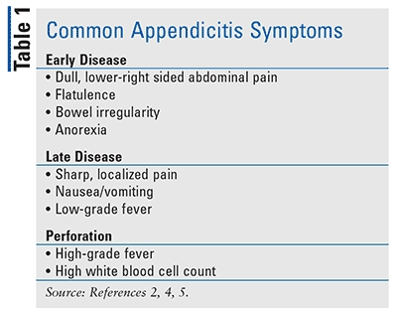
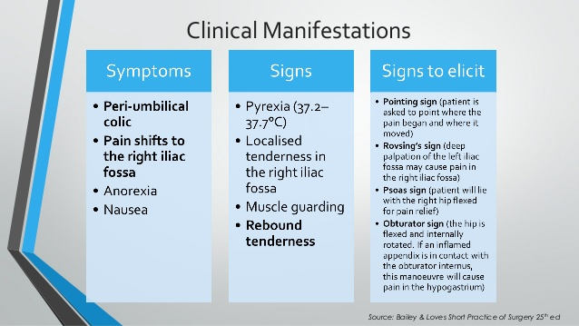
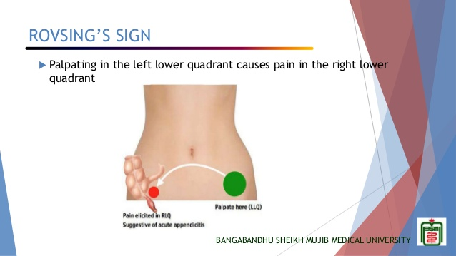

Manage a patient with acute appendicitis:
Recommended first-line imaging consists of point-of-care or formal ultrasonography. Appendectomy via open laparotomy or laparoscopy is the standard treatment for acute appendicitis. However, intravenous antibiotics may be considered first-line therapy in selected patients
Depending on your condition, your doctor’s recommended treatment plan for appendicitis may include one or more of the following:
Surgery to remove your appendix.
Needle drainage or surgery to drain an abscess.
Antibiotics.
Pain relievers.
IV fluids.
Liquid diet
Management :
Resuscitate the patient
- Intravenous fluid
- Antibiotics
- Opiate analgesia
Appendicectomy – treatment of choice
Antibiotics prophylaxis –
Preoperatively
Operation – peritonitis –continue antibiotics therapy
Mrtarnidozole
Gentamycin

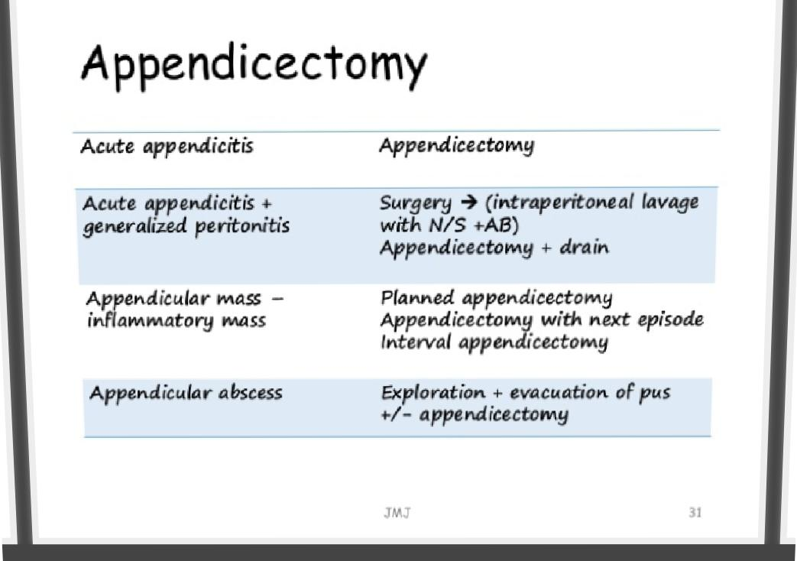

END………

