Subject: Human Anatomy II
Instructor: Dr. Arooba.
Section: B
June 22nd, 2020. Name :Mohammad Ayub
ROLL NO …16801 Total marks: 50
Attempt the following questions. Add diagrams where needed.
Each carries 10 marks.

1: What are the major features of intracranial fossae of the skull? ANS:The floor of the cranial cavity is divided into three distinct depressions. They are known as the anterior cranial fossa, middle cranial fossa and posterior cranial fossa. Each fossa accommodates a different part of the brain.
The anterior cranial fossa is the most shallow and superior of the three cranial fossae. It lies superiorly over the nasal and orbital cavities. The fossa accommodates the anteroinferior portions of the frontal lobes of the brain.
.
Borders
The anterior cranial fossa consists of three bones: the frontal bone, ethmoid bone and sphenoid bone.
It is bounded as follows:
Anteriorly and laterally it is bounded by the inner surface of the frontal bone.
Posteriorly and medially it is bounded by the limbus of the sphenoid bone. The limbus is a bony ridge that forms the anterior border of the prechiasmatic sulcus (a groove running between the right and left optic canals).
Posteriorly and laterally it is bounded by the lesser wings of the sphenoid bone (these are two triangular projections of bone that arise from the central sphenoid body).
The floor consists of the frontal bone, ethmoid bone and the anterior aspects of the body and lesser wings of the sphenoid bone
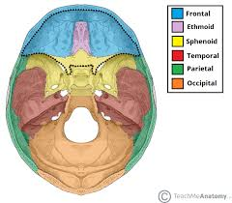
2:Write note on the cranial nerves. ANS Cranial nerves are those nerves which arise from the brain and brain stem rather than the spinal cord. Nerves arising from the spinal cord are the spinal nerves. There are 12 pairs of cranial nerves and these pairs of nerves passage through foramina in the skull, either individually or in groups. Cranial nerves are traditionally referred to by Roman numerals and these numerals begin cranially and run caudally.
The most cranial nerve is the Olfactory nerve (I) which runs from the nasal cavity through to the olfactory bulb. The next most cranial is the Optic nerve (II) which runs from the eyes to the thalamus. Cranial nerves III to XII all exit from the brain stem and innervate the head, neck and organs in the thorax and abdomen. In order of most cranial to caudal, these include the Oculomotor nerve (III), the Trochlear nerve (IV), the Trigeminal nerve (V), the Abducens nerve (VI), the Facial nerve (VII), the Vestibulocochlear nerve (VIII), the Glossopharyngeal nerve (IX), the Vagus nerve (X), the Accessory nerve (XI) and the Hypoglossal nerve (XII).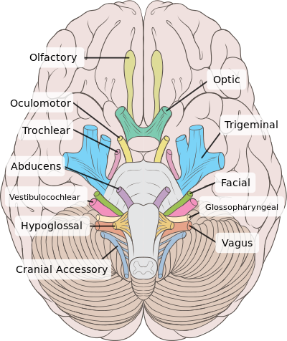 3.Write note on the salient features of norma frontalis and norma occipitalis of skull. AnsNormal frontalis; the most charatrstic feature of the minatogawa skull from frontal aspect are the around contour of the skull vault with its narrow forhead well develped supraorbits ridge flate and boardface
Norma acciptal ;
Is a cranial dermalbone and the main bone of the occiput back and lower part of skull it is trapgoud in sfaped 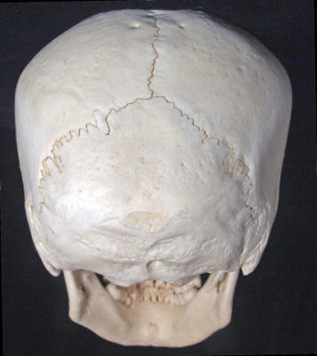
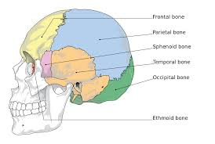 4.What do you know about the muscles of hip and knee? Ansthe muscles of the hip joint are those muscles that cause movement in the hip. Most modern anatomists define 17 of these muscles, although some additional muscles may sometimes be considered. These are often divided into four groups according to their orientation around the hip joint: the gluteal group; the lateral rotator group; the adductor group; and the iliopsoas group. 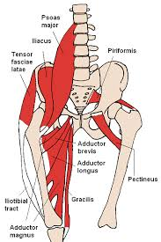 . The muscles responsible for the movement of the knee joint belong to either the anterior, medial or posterior compartment of the thigh. The extensors generally belong to the anterior compartment and the flexors to the posterior.Muscles. The muscles responsible for the movement of the knee joint belong to either the anterior, medial or posterior compartment of the thigh. The extensors generally belong to the anterior compartment and the flexors to the ior. 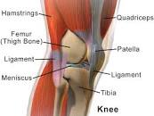 5..write a comprehensive note on the femoral trianglev . ANS The femoral triangle is a wedge-shaped area formed by a depression between the muscles of the thigh. It is located on the medial aspect of the proximal thigh. It is the region of the passage of the main blood vessels between the pelvis and the lower limb, as well as a large nerve supplying the thigh  

