Mid-Term Assignment (spring-20)

Course Title: WBCs and Platelets disorders (MLT 4TH ) Instructor: Saima hadi

Marks: 30

Attempt all questions .Each question carry 5 marks.
Q1.What is leucopoiesis , and also explain its types ?
Q2.Compare all phases (Chronic ,Accelerated, Blast )of CML?
Q3. Explain Leukemia and its causes ?
Q4 .Differentiate between Acute and Chronic leukemia?
Q5. Discuss Rai Classification of chronic lymphocytic leukemia?
Q6.Explain chronic myeloid leukemia causes and symptoms?

***************************************************************************
Name. Safi ur rahman Exam .Midterm Subject. WBC and Platelet Disorder
ID.14659 INU BS MLT 4TH
==========================================================
Q1. ANSWER
Leucopoiesis
It is the termed of haematopoiesis in which leukocytes are formed in the bone marrow and as located in the bones an adults body and haematopoiesis organs present in the fetus.
OR
It is shaped like hematopoiesis ,which presents or passed through bone marrow or and locates as in adults bones with WBC in the fetus.
OR,
It is form of hemopoiesis which is possible for the formation of wbc.

- Causes,
Anemia (normocytic or normochromic anemia)
Irom difficency
Blood lose

- Simptoms
*Fever
*Bruising
*Weakness
*Weight would be lost and poor of appetite.

Types of Leucopoiesis
There are tow types of leucopoiesis,which are granulopoiesis and agrenolopoiesis.

Granulopoiesis | Agrenulopoiesis
- Easinophi  - Basohil  - Neutrophil | - Monocytes  - lymphocytes
Easinophi,basophi and neutrophil are granulocytes ,while monocyte and lymphocytes are involved as in agrenulocytes.so,as we know that neutrophils and monocytes are phagocytes.

- Easinohil,
It is large granulocytes,it is colourless (light blue)
This relates to white blood cells.which contained the granules .
High level of easinophil in the blood means that there is any infection or ilness caused.so,
Elevate level means that your body sends more white blood cells ,which unable to fight against any infections,

Normal range,is between 30-350 per microliter

- Basophil
Its colour is purple blacke.
It is double lobed neucleus.
It is a type of white blood cell that occured in the bone marrow and present in many tissues in the body.
Also functioning in the immune system.
Low of basophilic level means you have allergic reactiona.

Normal Range >>0-300 ul

- Neutrophils,
Colour >meutral pink
Contained neucleus and divided into 2-5 lobes.
It is a type of phagocyte and present in the blood.
It help against infections and save tissues from to damaged.
Also help to blood level will high with occured injuries or other stress.so,
Normally neutrophils help body to recover the injuries or other response occurs.

Cytokines,
These are small proteins ,that functioning as to help in the immunity and as well in the cell signalling.and in other case interleukin is the group of cytokine ,which was first seen to be expressed by white blood cell.
The genome of human encode more than 50 interleukin.
The function of the interleukin is to cell proliferation,maturation and migration and adhesion as well.

Granulocytes Progeniter,
Colony Forming Unit (CFU)
Colony forming unit >Ba(basophil)
Colony forming unit >Gm(Neutrophil)
Colony forming unit>Ea(Easinophil)

Morphological Changes in Structure of Granulopoiesis,

When any changes occur in the shape of granulocytes,
Its size will be decrease.and may changes the neuclear shape and also possible to cytoplasm granules to be accumulated.

Myeliod Stem Cells,
M.S.Cs are below with handwritten and shapes in the image.!
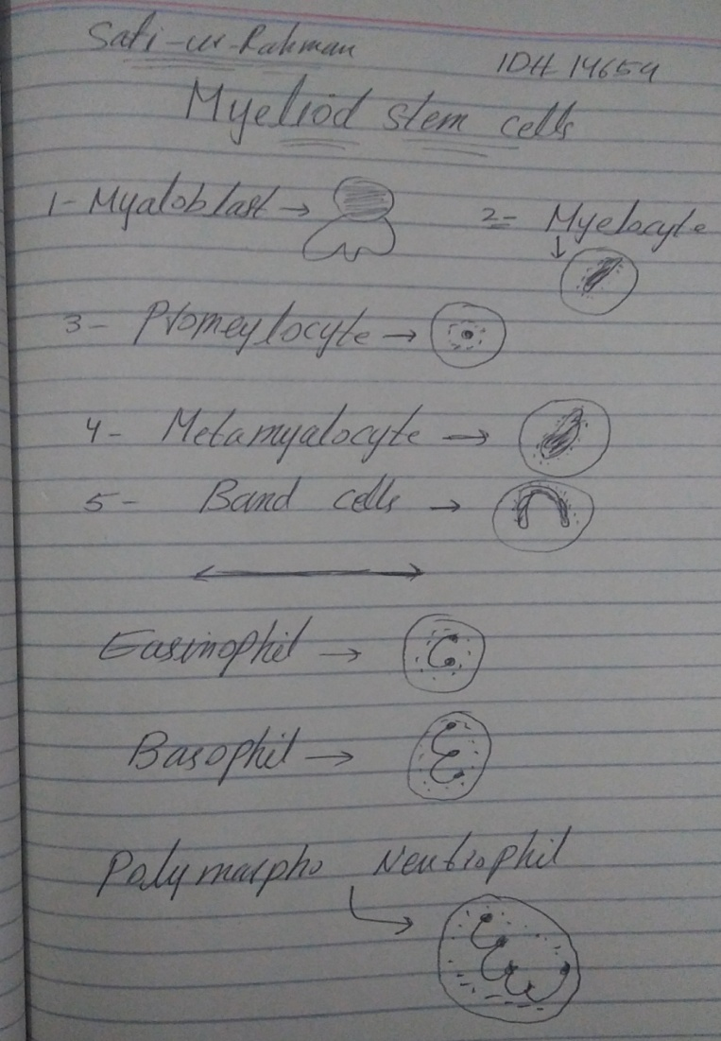
Q2. ANSWER
Phases of CML
There are three phases of chronic myeloid leukema,which are Accelerated pashe,chronic phase,and bast crisis.
The chronic phase is a normal as compare to accelerated and balst crisis ,but if in the first phase the patient not treat may be converts to blist crisis and or accelerated phase.
1. Chronic Phase,
In this phase ,about 85% of patients are affected.
Patients may be asymptomatic or mild symtoms are shows.
About 10% of blast cell .and no speenomegly and no anemia occurred in this phase.
This phase is not dangerous as compare to other phase,but if the patient not uses medicines ,it may possible to convert to accelerated phase.
2. Accelerated Phase,
In this ,the bast cells are about 10-19% in the bone marrow.
The platelets will show left shift ,means platelets increased.
And spleenomegly occurred.(large amount of spleens)

3. Blast Crisis,
This is the last and final phase,which looks like acute leukemia.
About 20% of blast cell are presented here.
Spleenomegly occurred.
And lose of blood (anemia)
This phase will increasing suddenly
The chloroma can be caused in this phase as well (chloroma means,to making small peices of mass)
Blast crisis is the dangerous phase in which the patient may be died and also possible to recover.
- Definition
Chronic myeloid leukemia is a meyaloproleferative disorder of occurred in specific genes like ,ABL gene and BCR .
There are tow chromosomes are presents ,chromosome 9,and chromosome 22.
In the chromosome 9 above present SBL gene ,while in chromosome 22,above presents BCR gene.
Whene any abnormilities occurred in those genes ,may be provides an abnormal gene,that is philidephia chromosome .

Q3. ANSWER

Leukemia,
- This is a the type of blood and bone marrow cancer occurred by the elevated of abnormal production of white blood cells.
- Leukemia are neuplastic.
- Leukemia also mean that, to produce increase amount of immature /abnormal leukocytes in the bone marrow or blood forming.
- It is also called as proliferation of the hematopoietic cells.
Or,
- Leukemia is the cancer of blood and bone marrow, while it is increasing due to any problem of production of blood cells. It is mostly infects the leukocytes or WBC.(white blood cells).

>which symptoms may include,
Bone and joint pains, bleeding easily, bruising, weakness and poor appetite.

*Etiology/Causes of leukemia
Leukemia can be spread quickly into the blood and affects different parts of the body, such as spleen .liver. Central nervous system, lymph nodes or other organs.
1.Heriditary (down syndrome) it is a genetic dissorder

2.Infection (Human T-cell leukemia)

3.Environmental factors
> Ionization radiations
And> chemical carcinogen
OTHER CAUSES
Smooking and having the family history leukemia.

Q6. ANSWER
Chronic myeloid leukemia causes
> Chronic myeloid leukemia also known as granulocytic or meyalocytic leukemia,This condition occurs due to genetic abnormalities.
Like,there is tow chromosomes involved ,chromosome 9 and ch.22,
In the upper side there presents ABL gene in the chromosome 9,and in chromosome 22,is above BCR gene.
When changes occurred in those genes ,as we call as chronic myeloid leukemia.

Epidemiology
Epidemiology mean that from which things chronic meyaloid leukemia occurred or may be occurred,
The first reason is that is chronic myealoid leukemia caused by WOELD WAR 2 was done,and
The second reason is that the people whose works at the industries ,due to which they used benzene chemicals ,also occurred from these chemicals.
Chronic meyaloid leukemia occurs when something goes wrong in the bone marrow.

Sign/Symptoms of CML
Clinical Features
- Spleenomegly (large amount of spleens)
- Hyperurecemia (increases of the uric acid)
- Bruiding (skine become blhish)
- Epistoxis (nose bleeding)
- Menorrhagia (heveay bleeding)>it is infections which is common in women,manorrhaigia is serious condition ,but not as dangerous to kill peoples)
- Goute like symptoms (it is common ,and infect anyone,like swelling,pain attacke, or joint pain)

Other symptoms are,
*Fever
*Lost of weight
*Poor apetite
*Night sweets etc.

Q5. ANSWER

Rai Classification Of Chronic Lymphocyic leukemia,
The staging system of lymphocytic leukemia is divided into tow systems,’which are 1.Rai stage >which is commonly uses in the united state and 2nd is Banet system ,that is mostley in the eurape.

Rai Staging System,
It is bases on the lymphocytosis,the patient would increased the number of lymphocytes in the bone marrow and blood.
But isn’t linked to any like infections.
Chronic lymphocytic leukemia is classified into 5 stages,

Rai Stage 0,

>Include lymphocytosis
>Liver,RBCs and platelets are normal in this stage.
>And there is no enlargement of lymph nodes.

Rai Stage i,
>lymphocytosis
>no enlargement of lymph nodes
>platelete counts and red blood cells are near normall
This stage is same as (0)

Rai Stage ii,
>spleens are enlarged
>also may enlarge liver,but lymph nodes may or may not enlarged.

Rai Stage iii,
Same to stage i and 0,but liver,spleens or lymph nodes may be enlarged or may be not enlarged.
>Red blood cells and platelet counts are normal.

Rai Stage iv,
Different from other stages,0,i,ii and ii.,because there is enlarged of lymp node and spleenomegly.
>lymphocytosis
>platelet are dicreases
>but red blood cells may decreased or near normal.
SO,
* Stage (0) is a low risk. stage (iv) and( iii) are high, while(ii) and( i) are intermediate.

Q4. ANSWER
Difference b/w Acute and Chronic leukemia

Acute Leuckemia

This is a type of leukemia in which white blood cells can be infected and caused the disease as fast/quickly.
* The meyloid and lymphocyte cells are affected by acute leukemia.
* In this the early and young cells are present called <blast>cells>,
* Blast crisis is a phase here which changes acute leukemia to chronic leukemia,while the production of WBC are impossible.
* About 20 percent or more than 20% blast cells are present here.
*It is sudden onset and symptoms appears are faster.

Chronic Leukemia
This is another type of leukemia in which white blood cells are infected and cause disease as slowly not quickly.
*Here also the meyaloid and lymphoblastic cells can be infected.
*The cells abnormal ,the grouth cells are slow from normal,
*There is occured less blast cells than 20%,
*slow onset.
*The symptoms here take more time to recover.
*********************************************************************
(()) (()) The End (()) () (()) No copied or paste

