NAME: Muhammad Azam Khan
Subject: Logic & Critical Thinking
Submitted to: Sir Mehboob Alam
ID: 13130

Q1# what is Aristotelian logic? Discuss the four kinds of categorical propositions with at least five examples of each.

Aristotelian logic:
It is the logic of classes or categories hence it is often called “categorical logic”. Or rather, it’s the logic of statements that can be characterized in terms of classes of things, and relationships between those classes.
For example the natural language statement “All cows are mammals” would be characterized as a relation between the class of cows and the class of mammals (that the class of cows is a subsection of the class of mammals, or equally, that all members of the class of cows are also members of the class of mammals).
The logic gives us tools for representing statements of the following form, which are called “categorical statements”:
- All S are P
- Some S are P
- No S are P
- Some S are not -P
This reflects the subject-predicate structure of a wide class of prepositions, but certainly not all statements. A categorical syllogism is an argument includes of exactly three categorical statements (2 premises & a conclusion) where there appear a total of exactly three categorical terms, where each of the statements are used exactly twice.

Examples:
- All humans are mammals.
- Some vendors are human.
Therefore, some mammals are vendors.

- No geese are Lynxes.
- Some birds are geese.
Therefore, some birds are not Lynxes.

Aristotle examined all the logically different types of syllogisms that could be shaped using the basic categorical statements, and recognized which are deductively valid and which are invalid. So, what is the fragment of natural language whose logical structure Aristotelian logic is able to model or replicate?
It’s the fragment of natural language that includes statements with a two-place subject-predicate structure, where the subject and the predicate terms can be characterized as classes of objects, and where the logical relations amongst statements are determined by relations of inclusion, exclusion, and overlap among the classes.
Categorical proposition:
A truth claim that affirms or denies as a whole or in parts, that members of the one class or category are included or excluded in another class or category. Since categorical propositions deal with two states affirmative and negative of two classes universal and particular there are then just four possible categorical propositions.
These 4 categorical propositions are known by its 'Types', A, E, I and O and that have nothing to do with vowel and having different meanings.

The universal affirmative:
Type “A” proposition is of the view that every member of one class is also a member of the second class.

Examples:
- All S are P
- All cats are animals.
- All planets are flat.
- God is one.
- Rain comes from the clouds.

The universal negative:
Type “E” proposition says that no member of one class is a member of the second.

Examples:
- No S are P
- No fish are birds
- Not every beverage that contains alcohol
- No lions are fishes.

In a particular affirmative:
Type “I” propositions, states that some members at least one of one class are members of the second.
Examples:
- Some fish are animals which swim
- Some years are leap years.
- Some S are P

In the particular negative:
Type “O” propositions states, that some members of one class are not members of the second class.
Examples:
- Some birds are not flying birds
- Some jugglers are not joggers
- Footballs are not balls
- Some carnivores do not eat meat
- Some planes are not flying planes

Q2# Discuss the Venn diagram technique for testing syllogism with the help of examples.

Syllogism:
In logic, a syllogism is a form of deductive reasoning consisting of a major premise, a minor premise, and a conclusion. The term syllogism is from the Greek, "to infer, count, reckon". Syllogism is a form of reasoning in which a conclusion is drawn from two or three set of propositions or statements. Syllogism uses deductive reasoning rather than inductive reasoning. One has to take the given statements to be true, even if they are at a variance from established sets of facts.
Example:
Statements:
- All cats are dogs.
- All dogs are rats.

Conclusion:
- All cats are rats.

This conclusion is quite visible is the above example but to solve difficult problems we have some standard methods.

Testing Syllogisms Using the Venn Diagramming Method:

One of the methods used for solving such type of questions is by drawing Venn diagram representing the statements. Though, it is important that all possible Venn diagrams be drawn. The technique of Venn diagrams for categorical syllogisms is centered on the fact that in a valid syllogism, the conclusion states no more than what is already contained, implicitly, in the premises. If the conclusion states more than that, it does not follow from the premises, and the syllogism is invalid. The technique is to diagram the premises, and then see whether anything would have to be added in order to diagram what the conclusion asserts. If so, the syllogism is invalid; if not, it is valid.
Since we have three classes, we expect to have three overlapping circles.
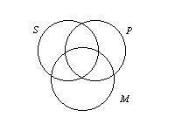
1. The area in the denoted circle represents where members of the class would be, and the area outside the circle represents all other individuals. The various area of the diagram is noted above.
2. Shading represents the knowledge that no individual exists in that area. Empty space represents the fact that no information is known about that area.
3. An "X" represents "at least one (individual)" and so corresponds with the word "some."

Example1: Which of the two conclusions can be concluded on the basis of given statements?

Statements:
Some parrots are scissors.
Some scissors are not combs.
Conclusions:
Some scissors are parrots.
Some combs are parrots.
Solution: Now, in this case, the possible conclusion is: Some scissors are parrots (I to I), as the universal principal no. 4 says, that with two particular statements only I to I is possible. Therefore, only 1 conclusion is possible. Nothing else is possible.
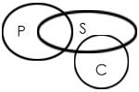

Example 2: Which of the two conclusions can be concluded on the basis of given statements?
Statements:
All flowers are candles.
All lanterns are candles.
Conclusions:
Some flowers are lanterns.
Some candles are lanterns.
Solution:
Three possible diagrams are shown above for the given statements.
Conclusion I follow from last two possible solutions, but do not follow from the first possible solution. Therefore, this conclusion is false.
Conclusion II follows from all the three possible solutions.
Therefore, conclusion II is true.

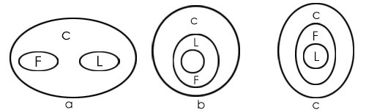

Q3# Discuss symbolic logic in terms of negation, conjunction and disjunction supplemented by examples. Also state the different symbols used in symbolic logic.

SYMBOLIC LOGIC:
Symbolic logic is a method which is used for representing logical expressions through the use of symbols and variables, rather than in ordinary language. This has the benefit of removing the ambiguity that normally accompanies ordinary languages, such as English, and allows easier operation. Basically it is an effort to use a series of symbols and letters to take out some of the confusion (which is brought up by vague language or emotion) out of deduction. It's an attempt to fetch simplicity in logic. It can also be termed as Mathematical logic.

OR

Symbolic logic is a system for representing logical relationships between propositions. It provides a precise definition for the words and phrases of logic, eliminating the ambiguity that often comes with natural language. By representing an argument in symbolic form abstracted from the underlying subject of inquiry, one can then focus solely on the logical structure of the argument. This facilitates the application of mechanical methods for the evaluation and deduction of truth. Symbolic logic is by far the simplest kind of logic—it is a great time-saver in argumentation. Additionally, it helps prevent logical confusion.

Negation – “not p”:

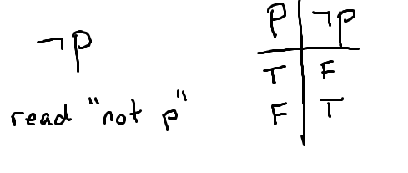
Negation is the statement “not p”, denoted ¬p, and so it would have the opposite truth value of p. If p is true, then ¬p is false. If p is false, then ¬p is true. Notice that the truth table shows all of these possibilities.

Conjunction – “and”:
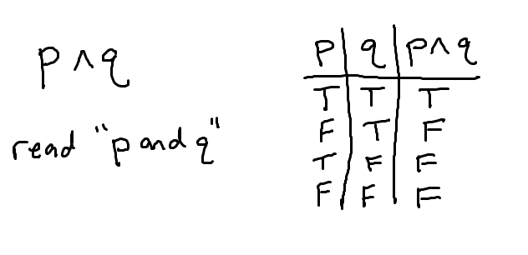
Consider the statement “p and q”, denoted p∧ q. To analyze this, we first have to think of all the combinations of truth values for both statements and then decide how those combinations influence the “and” statement. In words:

- Row 1: the two statements could both be true.
In this case, it would make sense that “p and q” is also a true statement.

- Row 2: p could be false while q is true.
For “p and q” to be true, we would need BOTH statements to be true. Since one is false, “p and q” is false.

- Row 3: p could be true while q is false.
If this is the case, then by the same argument in row 2, “p and q” is false.

- Row 4: the two statements could both be false.
If both statements are false, then “p and q” is false.
The order of the rows doesn’t matter – as long as we are systematic in a way so that we do not miss any possible combinations of truth values for the two original statements p, q.

Disjunction – “or”:
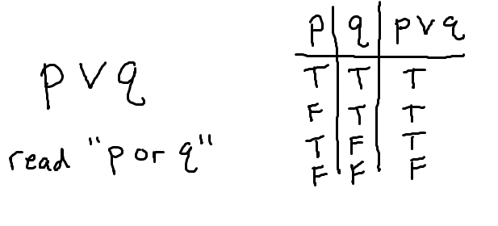
You may not realize it, but there are two types of “or” s. There is the inclusive or where we allow for the fact that both statements might be true, and there is the exclusive or, where we are strict that only one statement or the other is true. In math, the “or” that we work with is the inclusive or, denoted p∨ q. When we want to work with the exclusive or, we are specific and use different notation. This shows in the first row of the truth table, which we will now analyze:

- Row 1: the two statements could both be true.
Since we are working with the inclusive or, the statement “p or q” will be true in this case.
- Row 2: p could be false while q is true.
This is the essence of or. We are saying “one or both of the statements is true”. Therefore, “p or q” is true in this case.

- Row 3: p could be true while q is false.
Same idea as the second row.

- Row 4: the two statements could both be false.
Considering the meaning of or, if both statements are false, then it is not true that “p or q”, thus we list false for this statement.

Some of the basic symbols used in the Symbolic Logic:
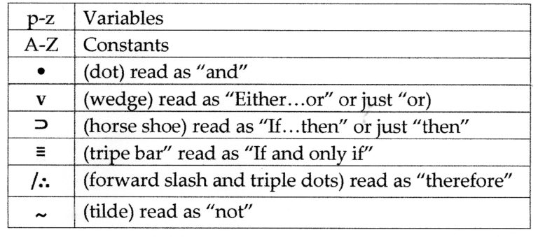

Q4# what are truth value, truth table and validity? Discuss and draw truth tables for negation, conjunction and disjunction.

Truth-value:
A truth-value is a label that is given to a statement (a proposition) that denotes the relation of the statement to truth. In general, all statements, when worded properly, are either true or false (even if we don’t know with certainty their truth-value, they are ultimately true or false despite our ability to know for sure. With that said, and as noted, humans can’t know every truth for certain, and thus there are some “unknowns.” Thus, all truth-values can be transposed to a three-value form: True, False, and Unknown (where unknown denotes our lack of knowledge, not a lack of truth). Further, because there are things humans can’t know for sure, we have to express the likelihood of some truths using multiple-value truth-values. For example: very likely false, likely false, likely true, very likely false. Or, such is the case where the quality of a complex statement or argument is being considered, False, Mostly False, Half True, Mostly True, and True.

Validity: A property of arguments, i.e., that they have a good structure.
For example, consider the structure of this argument.
All B-s are Cs.
All As are Bs.
Therefore, All As are Cs.
The premises and conclusion are so related that it is absolutely impossible for the premises to be true unless the conclusion is true also. Note that an argument can be valid even though its premises are false. Also note that an argument is not mistaken just on account of its conclusion being false or ridiculous.

TRUTH TABLE:
Truth tables are a way of analyzing how the validity of statements (called propositions) behave when you use a logical “or”, or a logical “and” to combine them. Propositions are either completely true or completely false, so any truth table will want to show both of these possibilities for all the statements made or simply it can be said that truth table is used to determine when a compound statement is true or false.
In math logic, a truth table is a chart of rows and columns showing the truth value (either “T” for True or “F” for False) of every possible combination of the given statements (usually represented by uppercase letters P, Q, and R) as operated by logical connectives.

TRUTH TABLE FOR NEGATION, CONJUNCTION AND DISFUNCTION:

Truth Table of Logical Negation:
The negation of a statement is also a statement with a truth value that is exactly opposite that of the original statement. For instance, the negation of the statement is written symbolically as ~ or ¬ is read as NOT.

The negation operator denoted by the symbol ~ or ¬ takes the truth value of the original statement then output the exact opposite of its truth value. In other words, negation simply reverses the truth value of a given statement. Thus, if statement PP is true then the truth value of its negation is false. In the same manner if PP is false the truth value of its negation is true.
Example: ~P or ¬P is translated as “not P” or “it is not true that P”

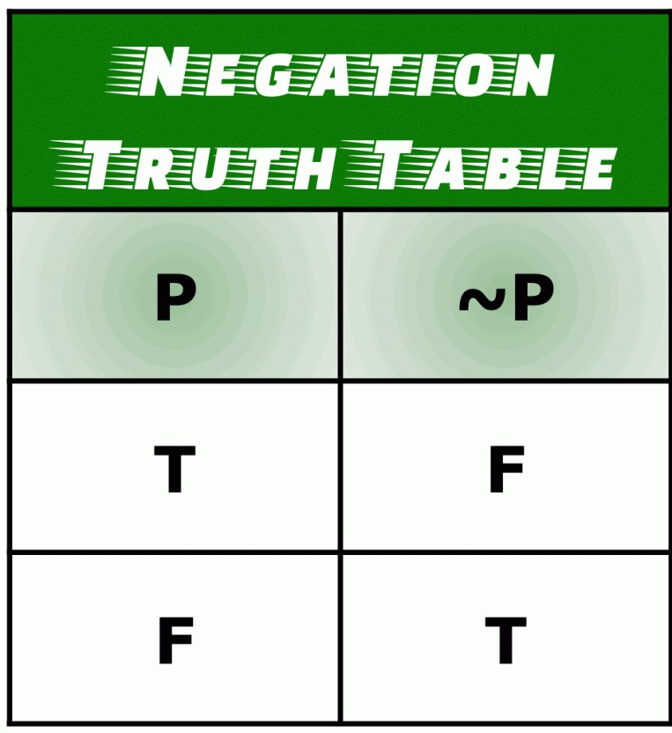

Truth Table of Logical Conjunction:
A conjunction is a type of compound statement that is comprised of two propositions (also known as simple statements) joined by the AND operator.

The symbol that is used to represent the AND or logical conjunction operator is ∧. It looks like an inverted letter V.

If we have two simple statements P and Q, and we want to form a compound statement joined by the AND operator, we can write it as P∧Q and P∧Q is read as “P and Q.”

The truth value of the compound statement P∧Q is only true if the truth values P and Q are both true. Otherwise, P∧Q is false.

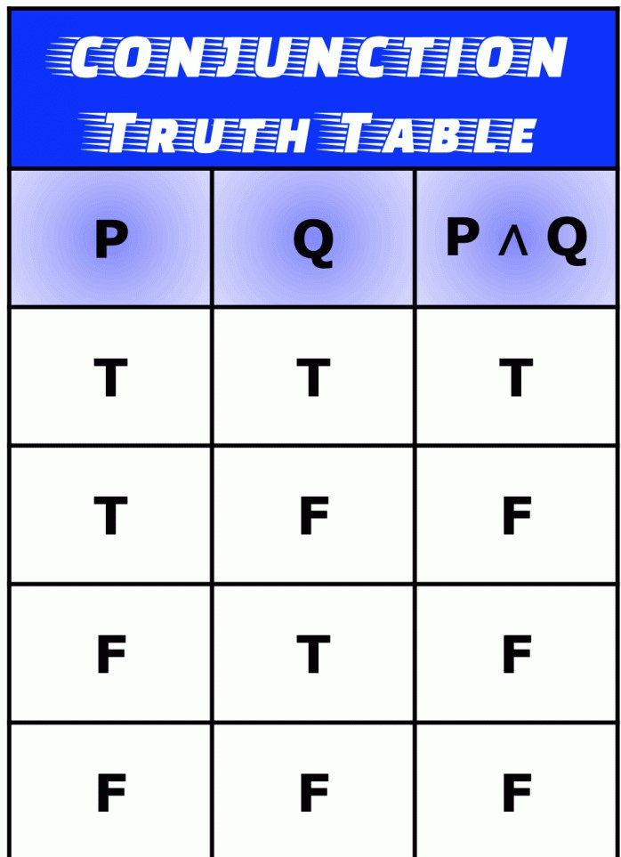

The conjunction is true only when both p and q are true.

Truth Table of Logical Disjunction:
A disjunction is a kind of compound statement that is composed of two simple statements formed by joining the statements with the OR operator.
In a disjunction statement, the use of OR is inclusive. That means “one or the other” or both.
The symbol that is used to represent the logical disjunction operator is ∨. It resembles the letter V of the alphabet.
Two propositions P and Q joined by OR operator to form a compound statement is written as P∨Q and P∨Q is read as “P or Q.”

The truth value of the compound statement P∨Q is true if the truth value of either the two simple statements PP and QQ is true. More so, P∨Q is also true when the truth values of both statements PP and QQ are true. However, the only time the disjunction statement P∨Q is false, happens when the truth values of both P and Q are false.

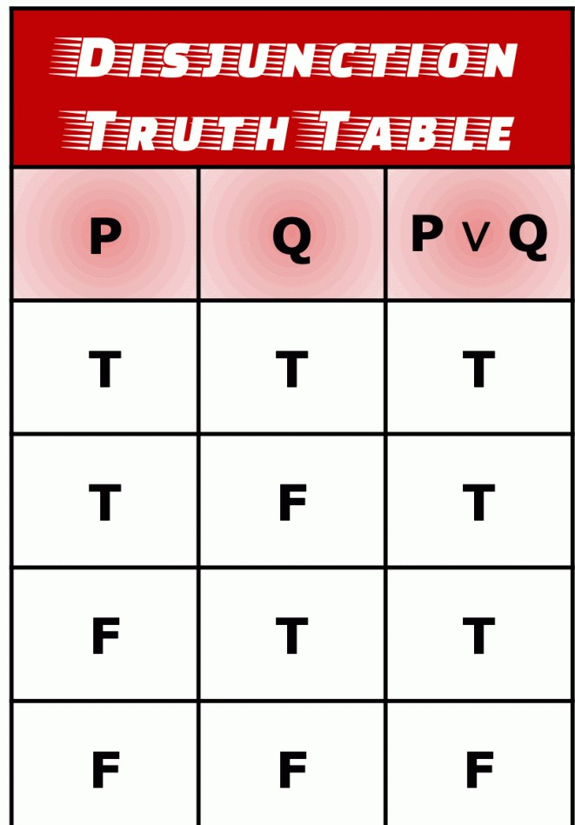

The disjunction is true when either p is true, or q is true, or both p and q are true.

Q5# Discussion of argument by analogy, casual connection and cause and effect with the help of examples.

ANALOGICAL REASONING:
It is a method of processing information that compares the similarities among new and understood concepts, and then uses those similarities to gain or enhance the understanding of the new concept. Analogical reasoning is a form of inductive reasoning because it strives to provide understanding of what is probable to be true rather than deductively proving something as a fact. This method can be utilized by both children and adults as a way to learn new information or as part of a convincing argument.

The reasoning process starts by a person determining the target sphere, or a new idea to be learned or explained. Then it is compared to a general matching area, or an idea that is already well-understood. The two domains must be similar enough to make a valid, substantial comparison. Specific qualities are chosen that belong to the matching domain, then related items are searched for in the target domain to tie the two domains together. For example, food’s effect on the human body can be an analogy to gasoline’s effect on a car because they are both responsible for making entities function correctly.
Analogical reasoning is based on the brain’s ability to form patterns by association. The brain may be able to understand new concepts more easily if they are perceived as being part of a pattern. If a new concept is compared to something the brain already knows, it may be more likely that the brain will store the new information more readily.

The study of the process and effectiveness of analogical reasoning is applied to many fields. Since analogies demonstrate the likelihood of similarities rather than factually proving them, lawyers may use analogical arguments during cases that don’t have a lot of evidence. Such an argument points out a similarity shared by two ideas or objects, then uses that shared similarity to argue that the ideas are likely to have other things in common as well. For example, a lawyer may form an analogy between his or her client and a past court trial for the same offense where the person was found not guilty. Since the circumstances of the charges are similar, a lawyer will argue the outcomes should be similar as well.

The field of science also uses this type of reasoning, but it is used for coming up with new concepts rather than for persuasion. Scientists will often compare a proven scientific process with an unproven one to form hypotheses to base new research on. They may reason that because two processes are similar in one way, they may be more likely to have more things in common.
Psychologists often focus on the cognitive aspects of reasoning. They may perform research to determine how and why the brain retains information through analogies. Psychologists may also study the differences between how children and adults use them.

To use an analogy:

- Start with a target domain where you want to create new understanding.
- Find a general matching domain where some things are similar to the target domain.
- Find specific items from the matching domain.
- Find related items in the target domain.
- Transfer attributes from the matching domain to the target domain.

Examples:
- This company is like a racehorse. It's run fast and won the race, and now it needs feed and rest for a while.
- Today is like a day in paradise. We don't need an umbrella.
- Dating is like flying. At some point, your feet are going to leave the ground.
- Capitalists are mostly like vampires.
- Like the Earth, Africa has an atmosphere containing oxygen.

CUASES AND EFFECTS (CASUAL REASONING):
Causal reasoning is the process of identifying causality: the relationship between a cause and its effect. The study of causality extends from ancient philosophy to contemporary neuropsychology; assumptions about the nature of causality may be shown to be functions of a previous event preceding a later one. The first known proto scientific study of cause and effect occurred in Aristotle's Physics. Causal inference is an example of causal reasoning.

OR

It is based on the idea that for every action there is a reaction. The goal is to figure out how or why something happened. The cause must be capable of producing the effects described, and vice versa. Cumulative causal reasoning increases the soundness of the conclusion. Counter causal factors must be accounted for. There are two forms of causal reasoning:

- Cause to effect
- Effects to cause

Cause to effect: A known cause or causes is capable of producing some unknown effect or effects.

Effect to cause: Some known effect(s) has/have been produced by some unknown cause, or causes.

Example:
- The professors at this college are good because they all have at least a Master’s Degree in their teaching field.
- A chef at a restaurant is good because they have a Master’s Degree in the culinary field.

Cause and Effect:
Causal relationships may be understood as a transfer of force. If A causes B, then A must transmit a force (or causal power) to B which results in the effect. Causal relationships suggest change over time; cause and effect are temporally related, and the cause precedes the outcome.
Causality may also be inferred in the absence of a force, a less-typical definition. A cause can be removal (or stopping), like removing a support from a structure and causing a collapse or a lack of precipitation causing wilted plants.
Humans can reason about many topics (for example, in social and counterfactual situations and mathematics) with the aid of causal understanding. Understanding depends on the ability to comprehend cause and effect. People must be able to reason about the causes of others’ behavior (to understand their intentions and act appropriately) and understand the likely effects of their own actions. Counterfactual arguments are presented in many situations; humans are predisposed to think about “what might have been”, even when that argument has no bearing on the current situation. Although causality is related to mechanism, an understanding of causality does not necessarily imply an understanding of mechanism.
Cause-and-effect relationships define categories of objects. Wings are a feature of the category "birds"; this feature is causally interconnected with another feature of the category, the ability to fly.

