Name:. Ihtesham Khan

ID : 16005

DEGREE :. BBA

Submit to : Ms Beenish Shuja

Q 1= What is Ideology and what were the Aims And objective of the creation of Pakistan?

Ans=

Ideology:

The social or political Programe of any movement that becomes a collective objective of any nation is called Ideology. OR

Ideology means such an aim according to which human beings planned about their future
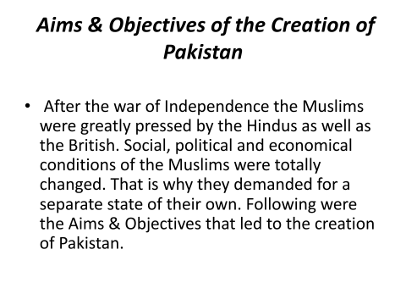

Q2. = What were the efforts of Sir Syed Ahmad Khan for Education?

Ans = Sir Syed played a vital role in the educational up lift of the Muslims in India. He did the following things to improve the educational standards: set up a journal, Tahzib-ul-, which contained articles of influential Muslims who agreed with Sir Syed's approach towards education.

Q3. Write down any form of government and also describe what are the advantages and disadvantages of that form of government for Pakistan which you have written?

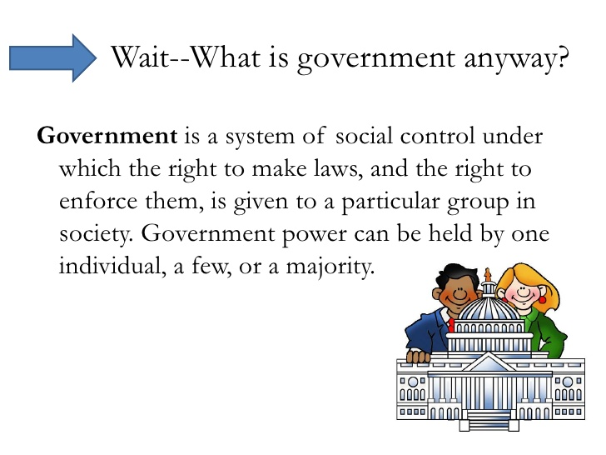
Ans =

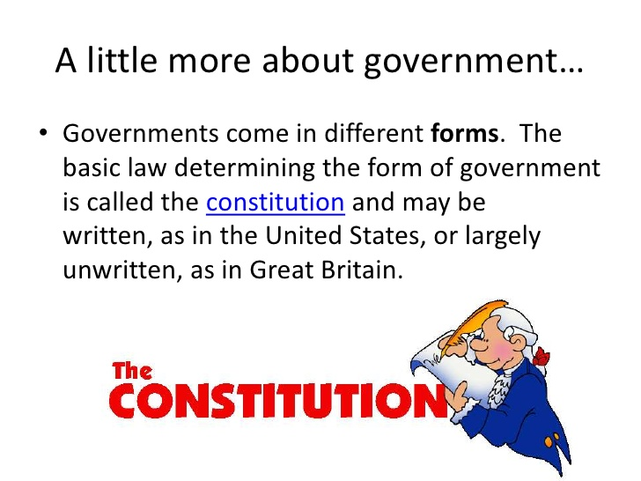

Advantages and disadvantages of Presidential and Parliamentary systems of Government. cont on Presidential system Disadvantages: Separation of Powers indicates limited level of accountability. Could end up making both Executive and Legislature branch blame each other.

