Name = Shahab Shah
ID = 15848
Degree. = BS(Rad)
Section = B
Subject = Physiology
Madam = Mam Kousar Shah Jehan
Attempt all questions. Every question carry 10 marks.
Q1. Write the functions and composition of blood?
Functions of blood
Blood has three main functions: transport, protection and regulation.
Transport
Blood transports the following substances:
Gases, namely oxygen (O2) and carbon dioxide (CO2), between the lungs and rest of the body
Nutrients from the digestive tract and storage sites to the rest of the body
Waste products to be detoxified or removed by the liver and kidneys
Hormones from the glands in which they are produced to their target cells
Heat to the skin so as to help regulate body temperature
Protection
Blood has several roles in inflammation:
Leukocytes, or white blood cells, destroy invading microorganisms and cancer cells
Antibodies and other proteins destroy pathogenic substances
Platelet factors initiate blood clotting and help minimise blood loss
Regulation
Blood helps regulate:
pH by interacting with acids and bases
Water balance by transferring water to and from tissues
Composition of blood
Blood is classified as a connective tissue and consists of two main components:
Plasma, which is a clear extracellular fluid
Formed elements, which are made up of the blood cells and platelets
The formed elements are so named because they are enclosed in a plasma membrane and have a definite structure and shape. All formed elements are cells except for the platelets, which are tiny fragments of bone marrow cells.
Formed elements are:
Erythrocytes, also known as red blood cells (RBCs)
Leukocytes, also known as white blood cells (WBCs)
Platelets
Leukocytes are further classified into two subcategories called granulocytes which consist of neutrophils, eosinophils and basophils; and agranulocytes which consist of lymphocytes and monocytes.
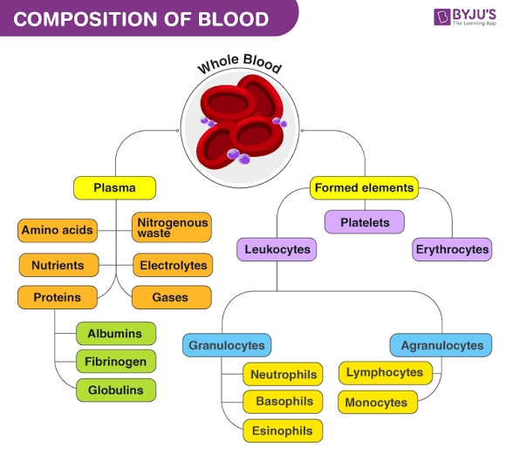
TheThe formed elements can be separated from plasma by centrifuge, where a blood sample is spun for a few minutes in a tube to separate its components according to their densities. RBCs are denser than plasma, and so become packed into the bottom of the tube to make up 45% of total volume. This volume is known as the haematocrit. WBCs and platelets form a narrow cream-coloured coat known as the buffy coat immediately above the RBCs. Finally, the plasma makes up the top of the tube, which is a pale yellow colour and contains just under 55% of the total volume.

Q2. What is erythrocyte, erythropoiesis, erythrocytosis and erythropenia?
Erythrocyte
A type of blood cell that is made in the bone marrow and found in the blood. Erythrocytes contain a protein called hemoglobin, which carries oxygen from the lungs to all parts of the body. Checking the number of erythrocytes in the blood is usually part of a complete blood cell (CBC) test. It may be used to look for conditions such as anemia, dehydration, malnutrition, and leukemia. Also called RBC and red blood cell.
Blood cells. Blood contains many types of cells: white blood cells (monocytes, lymphocytes, neutrophils, eosinophils, basophils, and macrophages), red blood cells (erythrocytes), and platelets. Blood circulates through the body in the arteries and veins.
Erthropoiesis
ormal erythropoiesis results in the generation of sufficient numbers of fully functional mature red blood cells to replace senescent ones. To achieve this goal, a host of growth factors and the element iron are necessary ingredients that are used by erythroid precursor cellsfor effective erythropoiesis. Erythropoietin (EPO) is the key hormone responsible for effective erythropoiesis, and iron is the essential mineral required for hemoglobin production. EPO allows survival and proliferation of erythroid precursor cells by generating intracellular signals resulting in the prevention of apoptosis. Iron availability is highly regulated to ensure an adequate supply for the production of hemoglobin required during erythropoiesis. Iron itself regulates globin synthesis at both the transcriptional and translational levels. New insights about the interplay between hepcidin, iron availability, and erythropoiesis have modified our understanding of hemoglobin synthesis. Newly discovered erythroid hormone erythroferrone, iron regulatory protein 1(IRP1) and HIF2α in the IRP1–HIF2α axis, and aconitase appear to play important roles in regulating erythropoiesis. Novel therapeutic agents that influence iron and erythropoietic regulation are now under development.
Erythrocytosis
Erythrocytosis is a condition in which your body makes too many red blood cells (RBCs), or erythrocytes. RBCs carry oxygen to your organs and tissues. Having too many of these cells can make your blood thicker than normal and lead to blood clots and other complications.
There are two types of erythrocytosis:
Primary erythrocytosis. This type is caused by a problem with cells in the bone marrow, where RBCs are produced. Primary erythrocytosis is sometimes inherited.
Secondary erythrocytosis. A disease or the use of certain drugs can cause this type,
Between 44 and 57 out of every 100,000 people have primary erythrocytosis, according to a 2013 reviewTrusted Source of the condition. The number of people with secondary erythrocytosis may be higher, but it’s hard to get an exact number because there are so many possible causes.
Erythropenia
AnimiaThe presence of decreased number of Erythrocytes in the blood, is occurs in some forms called Erythrocytopenia
Q3. What is platelets and write about clotting mechanism and its all steps?
Ans:- Platelets
Platelets are tiny blood cells that help your body form clots to stop bleeding. If one of your blood vessels gets damaged, it sends out signals to the platelets. The platelets then rush to the site of damage. they form a plug (clot) to fix the damage.
Mechanism
The process of spreading across the surface of a damaged blood vessel to stop bleeding is called adhesion. This is because when platelets get to the site of the injury, they grow sticky tentacles that help them stick (adhere) to one another. They also send out chemical signals to attract more platelets. The additional platelets pile onto the clot in a process called aggregation.

Q4. Write a detail note on ABO system?
Ans:- ABO System
ABO blood group system, the classification of human blood based on the inherited properties of red blood cells (erythrocytes) as determined by the presence or absence of the antigens A and B, which are carried on the surface of the red cells. Persons may thus have type A, type B, type O, or type ABblood. The A, B, and O blood groups were first identified by Austrian immunologist Karl Landsteiner in 1901.

ABO blood group system
the classification of human blood based on the inherited properties of red blood cells (erythrocytes) as determined by the presence or absence of the antigens A and B, which are carried on the surface of the red cells. Persons may thus have type A, type B, type O, or type ABblood. The A, B, and O blood groups were first identified by Austrian immunologist Karl Landsteiner in 1901
Blood containing red cells with type A antigen on their surface has in its serum (fluid) antibodies against type B red cells. If, in transfusion, type B blood is injected into persons with type A blood, the red cells in the injected blood will be destroyed by the antibodies in the recipient’s blood. In the same way, type A red cells will be destroyed by anti-A antibodies in type B blood. Type O blood can be injected into persons with type A, B, or O blood unless there is incompatibility with respect to some other blood group system also present. Persons with type AB blood can receive type A, B, or O blood.

Blood group O is the most common blood type throughout the world, particularly among peoples of South and Central America. Type B is prevalent in Asia, especially in northern India. Type A also is common all over the world; the highest frequency is among Australian Aboriginal peoples, the Blackfoot Indians of Montana, and the Sami people of northern Scandinavia.
The ABO antigens are developed well before birth and remain throughout life. Children acquire ABO antibodies passively from their mother before birth, but by three months of age infants are making their own; it is believed that the stimulus for such antibody formation is from contact with ABO-like antigenic substances in nature. ABO incompatibility, in which the antigens of a mother and her fetus are different enough to cause an immune reaction, occurs in a small number of pregnancies. Rarely, ABO incompatibility may give rise to erythroblastosis fetalis(hemolytic disease of the newborn), a type of anemia in which the red blood cells of the fetus are destroyed by the maternal immune system. This situation occurs most often when a mother is type O and her fetus is either type A or type B.

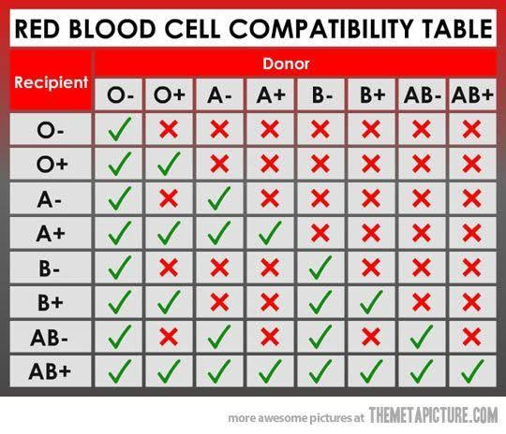
Q5.(i) A person fell down from a tree and become unconscious, with bleeding from head, what will you do as a first aid?
Ans:- First aid when the injured person is unconscious
The person should not be moved unless they are in immediate danger. Any unnecessary movement may cause greater complications to the head injury itself, the spine or other associated injuries. A good rule is that if the head is injured, the neck may be injured too.

Your role is to protect the injured person from any potential dangers at the scene. You should also monitor their airway and breathing until the arrival of an ambulance. If the person’s breathing becomes impaired due to a problem with their airway, you may need to very carefully tilt their head back (and support it) until normal breathing returns. If the person stops breathing or has no pulse, cardiopulmonary resuscitation (CPR) may be required.
Bleeding from head
Mild enjury :
Wash hand in tri to clean the wound are with gauze are clean clothe
Seveyer enjury
1, call the ambulance immediately .
2,Tri to stop the bleeding
3, Don’t move the head.
4, Keeping there neck and head in line with there spine
(ii) you have to meet with your friend and you came to know he is covid positive, what precautionary measures will you take?
Ans:-.1: I will first Isolate my self
2: Then I will send my sampling for covid 19 I wait for result if positive I will be Isolate for 14 days. If negative no need for isolation.

