Mid-Term Assignment
Course Title: Human Physiology Instructor: Dr Sara Naeem
Total Marks: 30
Name: Syed Muhammad Raahim
Roll no: 14838
Questions / Answers
Q1. Explain homeostatic mechanism regarding the control of calcium in the body with reference to parathyroid hormone and calcitonin.
Ans. Homeostatic Mechanism:
Homeostatic mechanism is a process in which the human body regulates its function to be normal. Body adjusts temperature, fluid composition, and blood sugar e t c. to constantly be in steady state.
Control of calcium:
When increase in plasma calcium occurs it stimulates calcitonin secretion. Iff 10 % increase in plasma calcium concentration an increase of calcitonin by 2 fold occurs. And there is weak calcium control. Calcitonin decreases plasma calcium concentration and 2 effects immediately occurs after the administration of calcitonin.
- Decreased absorptive capacity of osteoclasts.
- Decreased formation of new osteoclasts
In adults there is weak effect of calcitonin on calcium concentration and this causes.
- 1. Decrease in calcium concentration causes powerful stimulation of PTH which over rides calcitonin effect.
- 2. In adults, daily rates of absorption and deposition of calcium are small. Calcitonin has small effect on plasma calcium ion concentration.
Decrease in plasma calcium stimulates parathyroid hormone secretion
Defense mechanism:
1st line of defense buffering action of exchangeable calcium in bones. In 2nd line of defense hormonal control of calcium occurs.
1st line of defense:
Loosely bound CaHPO4 salts in bone are in reversible equilibrium with ECF. This is 0.5-1% of total calcium salts of bone (5-10 grams)
Easy deposition & resolubility
- Increased ECF calcium increased deposition
- Decreased ECF calcium increased resolubility
Bones receive 5% of blood flow per minute excess calcium is removed. Mitochondria of many tissues including liver and intestines contain exchangeable calcium.
2nd line of defense:
Hormonal control of calcium PTH & Calcitonin begin to act 3-5 minutes after calcium increase, PTH secretion decrease decreases calcium concentration Calcitonin deposits calcium in bones concentration returns to normal Bones supply Ca+ for a year in case of diet deficient of Ca+.
Q2. What is the role of anterior pituitary hormones in your body?
Ans. Pituitary gland:
It is 1 cm in diameter and 0.5 to 1 gm in weight lies in sella turcica (bony cavity at the base of brain) connected to hypothalamus by pituitary stalk
Anterior pituitary gland:
The anterior pituitary gland produces the following hormones and releases them into the bloodstream. Adrenocorticotropic hormone, which stimulates the adrenal glands to secrete steroid hormones, principally cortisol. Growth hormone, which regulates growth, metabolism and body composition. Luteinising hormone and follicle stimulating hormone, also known as gonadotrophins. They act on the ovaries or testes to stimulate sex hormone production, and egg and sperm maturity. Prolactin, which stimulates milk production. Thyroid stimulating hormone, which stimulates the thyroid gland to secrete thyroid hormones. Each of these hormones is made by a separate type of cell within the pituitary gland, except for follicle stimulating hormone and luteinising hormone, which are made together by the same cell. Two hormones are produced by the hypothalamus and then stored in the posterior pituitary gland before being secreted into the bloodstream.

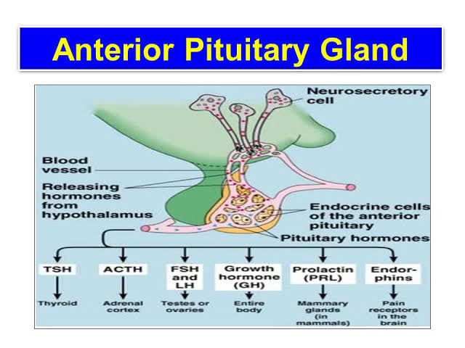

Q3. Explain the formation of T3 and T4 of thyroid gland.
Ans. Thyroxine (T4) and triiodothyronine (T3) are produced from thyroid follicular cells within the thyroid gland, a process regulated by the thyroid-stimulating hormone secreted by the anterior pituitary gland.
Thyroglobulin, the pre-cursor of T4 and T3, is produced by the thyroid follicular cells before being secreted and stored in the follicular lumen. Iodide is actively absorbed from the bloodstream by a process called iodide trapping. In this process, sodium is co-transported with iodide from the basolateral side of the membrane into the cell, and then concentrated in the thyroid follicles to about thirty times its concentration in the blood. Through a reaction with the enzyme thyroperoxidase, iodine is bound to tyrosine residues in the thyroglobulin molecules to form monoiodotyrosine (MIT) and diiodotyrosine (DIT). Linking two moieties of DIT produces T4. Combining one particle of MIT and one particle of DIT produces T3. Proteases digest iodinated thyroglobulin, releasing the hormones T4 and T3, the biologically active agents central to metabolic regulation. T3 is identical to T4, but it has one less iodine atom per molecule. T4 is believed to be a pro-hormone and a reservoir for the more active and main thyroid hormone T3. T4 is converted as required in the tissues by iodothyronine deiodinase.
