Name:. Ihtesham Khan

ID:. 16005

DEGREE:. BBA

Subject. Microeconomics

Submit to:. Sir Zohiab Ali

Q1: Explain the following concepts.

The benefit principle

Lump- sum Taxes

Marginal tax rate versus average tax rates

Proportional tax

Regressive tax

Progressive tax

Ans.

The benefit principle

The benefit principle is the idea that government spending should be met by the people who receive them. In other words, everyone who receives government spending, should contribute towards it.

This benefit principle was the justification for Margaret Thatcher’s poll tex. Everyone was charged the same poll tax rate because the argument was that everyone benefited from the same public services.

In practice the benefit principle is hard to apply because many of those in need of government benefits – the old, sick and unemployed are the least likely to be able to pay. A general principle more commonly used is the ability to pay.

Lump- sum Taxes

A tax in which the taxpayer is assessed the same amount regardless of circumstance. An example of a lump-sum tax is a $55 fee on employees work in a township. Another example is tag fees on vehicles, which are the same regardless of income vehicle owners. Lump-sum taxes are regressive, meaning persons with lower income pay more as a percentage of their income.

Marginal tax rate versus average tax rates

The average tax rate is the total amount of tax divided by total income. For example, if a household has a total income of $100,000 and pays taxes of $15,000, the household’s average tax rate is 15 percent. The marginal tax rate is the incremental tax paid on incremental income. If a household were to earn an additional $10,000 in wages on which they paid $1,530 of payroll tax and $1,500 of income tax, the household’s marginal tax rate would be 30.3 percent.

Average tax rates are a measure of a household’s tax burden; that is, how taxes affect the household’s ability to consume today or (through saving) in the future. Marginal rates measure the degree to which taxes affect household (or business) economic incentives such as whether to work more, save more, accept more risk in investment portfolios, or change what they buy. Higher marginal rates reduce incentives to engage in a particular activity (such as work) or (in the case of sales taxes) consume a particular item.

Proportional tax

A proportional tax is a tax imposed so that the

tax rate is fixed, with no change as the taxable base amount increases or decreases. The amount of the tax is in proportion to the amount subject to taxation. "Proportional" describes a distribution effect on income or expenditure, referring to the way the rate remains consistent (does not progress from "low to high" or "high to low" as income or consumption changes), where the marginal tax rate is equal to the average tax rincreas

It can be applied to individual taxes or to a tax system as a whole; a year, multi-year, or lifetime. Proportional taxes maintain equal tax incidence regardless of the ability-to-pay and do not shift the incidence disproportionately to those with a higher or lower economic well-being.

Flat taxes are defined as levying a fixed (“flat”) fraction of taxable income. They usually exempt from taxation household income below a statutorily determined level that is a function of the type and size of the household. As a result, such a flat marginal rate is consistent with a progressive average tax rate . A progressive tax is a tax imposed so that the tax rate increases as the amount subject to taxation increases.

The opposite of a progressive tax is a

regressive tax , where the tax rate decreases as the amount subject to taxation increases.

Regressive tax

A regressive tax is a tax imposed in such a manner that the tax rate decreases as the amount subject to taxation increases.

"Regressive" describes a distribution effect on income or expenditure, referring to the way the rate progresses from high to low, so that the

average tax rate exceeds the marginal tax rate . In terms of individual income and wealth, a regressive tax imposes a greater burden (relative to resources) on the poor than on the rich: there is an inverse relationship between the tax rate and the taxpayer's ability to pay, as measured by assets, consumption, or income. These taxes tend to reduce the tax burden of the people with a higher ability to pay, as they shift the relative burden increasingly to those with a lower ability to pay.

The regressivity of a particular tax can also factor the propensity of the taxpayers to engage in the taxed activity relative to their resources (the demographics of the tax base). In other words, if the activity being taxed is more likely to be carried out by the poor and less likely to be carried out by the rich, the tax may be considered regressive. [8] To measure the effect, the income elasticity of the good being taxed as well as the income effect on consumption must be considered. The measure can be applied to individual taxes or to a tax system as a whole; a year, multi-year, or lifetime.

The opposite of a regressive tax is a progressive tax , in which the average tax rate increases as the amount subject to taxation rises

In between is a flat or proportional tax , where the tax rate is fixed as the amount subject to taxation increases.

Progressive tax

A progressive tax is a tax rate that increases as the taxable value goes up. It is usually segmented into tax brackets that progress to successively higher rates. For example, a progressive tax rate may move from 0% to 45%, from the lowest and highest brackets, as the taxable amount increases. In a progressive tax system, a taxpayer’s marginal tax rate is higher than their average tax rate.

their average tax rate.

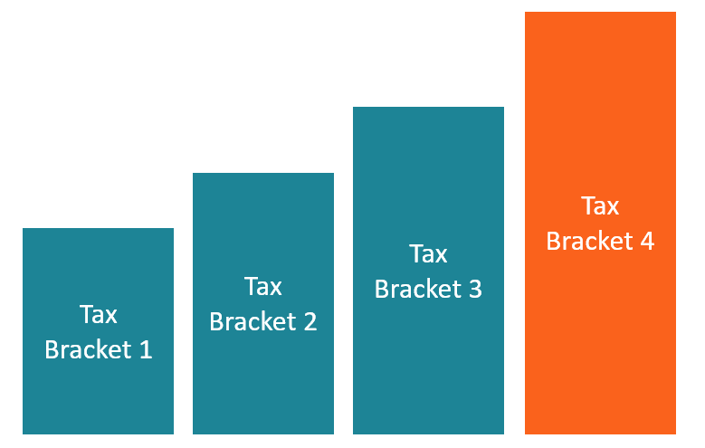

Various tax methods that governments may use include progressive, regressive, digressive, or proportional. The Progressive Tax System is one where the tax burden increases as taxable income increases. In some instances, there is a minimum tax-free amount where individuals earning less than the stated minimum taxable amount are not liable to submit any returns to tax authorities.

Examples of Progressive Tax

Investment income taxes: These are taxes on most of the income-generating activities. They mostly fall on those with excess money to save and engage in investment.

Tax on interest earned: Interest is only earned from savings or investments. Those who can manage to do these things are taxed.

Rental earnings: Although there is a chance to deduct all the costs associated with building operations, once they are done, this is a very progressive kind of tax since it targets those who invest in rental property.

Estate tax: This is a form of tax levied against those who succeed a deceased. It applies only if the value of the estate of the deceased is above a certain amount as set by the government.

Tax credits: These are benefits and perks awarded to less fortunate citizens by the government to save them some cash. They are many and might include earned income tax credit, elderly and disabled tax credit, child tax credit, or retirement savings contribution credit.

Q2: Define elasticity and explain the following elasticity concepts.

Income elasticity

Price elasticity

Cross price elasticity of demand

Ans. Elasticity.

Elasticity is a measure of a variable's sensitivity to a change in another variable, most commonly this sensitivity is the change in price relative to changes in other factors. In business and economics, elasticity refers to the degree to which individuals, consumers or producers change their demand or the amount supplied in response to price or income changes. It is predominantly used to assess the change in consumer demand as a result of a change in a good or service's price.

Income elasticity

Income elasticity is an economic term that explains the connection between the demand of a product and the income of the consumer. In other words, if a person's income goes up or down, his income elasticity impacts if he will purchase a product or not. As a result, companies must be aware of how their customers will react if their customers income changes.

Income elasticity has more of an impact on larger purchases or non-essential items. A consumer will likely still buy bread or eggs if her income changes. However, if her income goes down, she may not buy a new TV. Likewise, if she gets a raise, she may splurge for that larger TV that she's been wanting. Income elasticity of a TV purchase is high while the income elasticity of bread is very low.

How Is Income Elasticity Calculated?

The formula for calculating income elasticity is:

Income Elasticity of Demand = Percent Change in Quantity Demanded / Percent Change in Income

If your income goes up 10% and that changes your demand for a product by 15%, the calculation is:

Income Elasticity of Demand = 15% / 10%

Income Elasticity of Demand = 1.5

Example of Income Elasticity

A local furniture store offers patio furniture in summer. Because they have offered the furniture for the last 5 years and the sales have been consistent, the store expects they will sell the same amount of furniture this year as they did last year. However, at the end of the summer, they realize the sales were up 10% from last year.

As they analyzed the situation, they realized the most notable change was an overall pay increase at the local plant that hires a large percentage of their customers. In fact, pay amounts had increased an average of 5% from last year.

Price elasticity

Price Elasticity is a measure of the relationship between a change in the quantity demanded of a particular good and a change in its price. Price Elasticity of Demand (PED) is a term used in economics when discussing price sensitivity. The formula for calculating price elasticity of demand is:

Price Elasticity of Demand = % change in Quantity Demanded / % Change in Price

If a small change in price is accompanied by a large change in quantity demanded, the product is said to be elastic (or responsive to price changes). On the other hand, a product is deemed inelastic if a large change in price is accompanied by a small amount of change in quantity demanded.

So, Why Is Price Elasticity Of Demand (PED) So Important For Your Firm?

Gathering data on how consumers respond to changes in price can help reduce your risk and that nagging feeling of uncertainty. It will help with forecasting your sales and setting prices. For instance, you can forecast the impact of a change in price on sales volume and sales revenue.

For example, if PED for a product is (-) 2, a 10% reduction in price (say, from £10 to £9) will lead to a 20% increase in sales (say from 1000 to 1200). In this case, your revenue would increase from £10,000 to £10,800.

Having a knowledge of PED helps you decide whether to raise or lower prices, or whether to price discriminate. Price discrimination is a policy of charging consumers different prices for the same product. If demand is elastic, revenue is gained by reducing the price, but if demand is inelastic, revenue is gained by raising the price. When PED is highly elastic, you can use advertising and other promotional techniques to reduce elasticity.

Cross price elasticity of demand

The cross elasticity of demand is an economic concept that measures the responsiveness in the quantity demanded of one good when the price for another good changes. Also called cross-price elasticity of demand, this measurement is calculated by taking the percentage change in the quantity demanded of one good and dividing it by the percentage change in the price of the other good.

In economics, the elasticity of demand refers to how sensitive the demand for a product is to changes in price of another product.

Cross Elasticity Demand Formula

<br><br><br><br><br><br><br><br><br>​Exy​=Percentage Change in Price of YPercentage Change in Quantity of X​Exy​=Py​ΔPy​​Qx​ΔQx​​​Exy​=Qx​ΔQx​​×ΔPy​Py​​Exy​=ΔPy​ΔQx​​×Qx​Py​​where:Qx​=Quantity of good XPy​=Price of good YΔ=Change​

Explaining Cross Elasticity of Demand

Substitute Goods

The cross elasticity of demand substitute good always positive because the demand for one good increases when the price for the substitute good increases. For example, if the price of coffee increases, the quantity demanded for tea (a substitute beverage) increases as consumers switch to a less expensive yet substitutable alternative. This is reflected in the cross elasticity of demand formula, as both the numerator (percentage change in the demand of tea) and denominator (the price of coffee) show positive increases.

Q3: (a) Define Monopoly and explain characteristics of Monopoly?

Discuss price determination under monopoly?

(a) Define Monopoly and explain characteristics of Monopoly?

Ans.

A monopoly is a specific type of economic market structure. A monopoly exists when a specific person or enterprise is the only supplier of a particular good. As a result, monopolies are characterized by a lack of competition within the market producing a good or service.
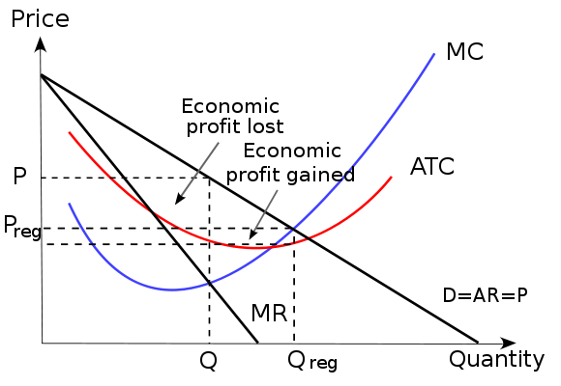
Monopoly: The graph shows a monopoly and the price (P) and change in price (P reg) as well as the output (Q) and output change (Q reg).

Characteristics of a Monopoly

A monopoly can be recognized by certain characteristics that set it aside from the other market structures:

Profit maximizer: a monopoly maximizes profits. Due to the lack of competition a firm can charge a set price above what would be charged in a competitive market, thereby maximizing its revenue.

Price maker: the monopoly decides the price of the good or product being sold. The price is set by determining the quantity in order to demand the price desired by the firm (maximizes revenue).

High barriers to entry: other sellers are unable to enter the market of the monopoly.

Single seller: in a monopoly one seller produces all of the output for a good or service. The entire market is served by a single firm. For practical purposes the firm is the same as the industry.

Price discrimination: in a monopoly the firm can change the price and quantity of the good or service. In an elastic market the firm will sell a high quantity of the good if the price is less. If the price is high, the firm will sell a reduced quantity in an elastic market.

B. Discuss price determination under monopoly?

Ans.

Price Determination under Monopoly

Monopoly is that market form in which a single producer controls the whole supply of a single commodity which has no close substitute.

From this definition there are two points that must be noted:

(i) Single Producer: There must be only one producer who may be an individual, a partnership firm or a joint stock company. Thus single firm constitutes the industry. The distinction between firm and industry disappears under conditions of monopoly.

(ii) No Close Substitute: The commodity produced by the producer must have no closely competing substitutes, if he is to be called a monopolist. This ensures that there is no rival of the monopolist. Therefore, the cross elasticity of demand between the product of the monopolist and the product of any other producer must be very low.

PRICE-OUTPUT DETERMINATION UNDER MONOPOLY:

A firm under monopoly faces a downward sloping demand curve or average revenue curve. Further, in monopoly, since average revenue falls as more units of output are sold, the marginal revenue is less than the average revenue. In other words, under monopoly the MR curve lies below the AR curve.

The Equilibrium level in monopoly is that level of output in which marginal revenue equals marginal cost. The producer will continue producer as long as marginal revenue exceeds the marginal cost. At the point where MR is equal to MC the profit will be maximum and beyond this point the producer will stop producing.

Q4: Discuss the following models.

1. The Cournot Model:

2. The Stackelberg Model:

Ans.

The Cournot Model:

Definition:
The Cournot model of oligopoly assumes that rival firms produce a homogenous product, and each attempts to maximize profits by choosing how much to produce. All firms choose output (quantity) simultaneously. The basic Cournot assumption is that each firm chooses its quantity, taking as given the quantity of its rivals. The resulting equilibrium is a Nash equilibrium in quantities, called a Cournot (Nash) equilibrium.

Context:
The Cournot model provides results which are of some importance to industrial economics. First of all, it can be shown that price will not in most cases equal marginal costs (see costs) and Pareto efficiency is not achieved. Moreover, the degree to which each firm’s price exceeds marginal cost is directly proportional to the firm’s market share and inversely proportional to the market elasticity of demand.
If the oligopoly is symmetric, that is, all firms have identical products and cost conditions, then the degree to which price exceeds marginal cost is inversely related to the number of firms.
Thus, as the number of firms increases, the equilibrium approaches what it would be under perfect competition. More generally, it can be shown that for the industry the degree to which price exceeds marginal cost is directly proportional to the Herfindahl-Hirschman Index of concentration. As concentration rises, industry performance deviates more from the norm of perfect competition.

Source Publication:
Glossary of Industrial Organisation Economics and Competition Law, compiled by R. S. Khemani and D. M. Shapiro, commissioned by the Directorate for Financial, Fiscal and Enterprise Affairs, OECD, 1993

The Stackelberg Model:

The Stackelberg leadership model is a strategic game in economics in which the leader firm moves first and then the follower firms move sequentially. It is named after the German economist Heinrich Freiherr von Stackelberg who published Market Structure and Equilibrium (Marktform und Gleichgewicht) in 1934 which described the model.

In game theory terms, the players of this game are a leader and a follower and they compete on quantity. The Stackelberg leader is sometimes referred to as the Market Leader.

There are some further constraints upon the sustaining of a Stackelberg equilibrium. The leader must know ex ante that the follower observes its action. The follower must have no means of committing to a future non-Stackelberg leader's action and the leader must know this. Indeed, if the 'follower' could commit to a Stackelberg leader action and the 'leader' knew this, the leader's best response would be to play a Stackelberg follower action.

Firms may engage in Stackelberg competition if one has some sort of advantage enabling it to move first. More generally, the leader must have

commitment power. Moving observably first is the most obvious means of commitment: once the leader has made its move, it cannot undo it - it is committed to that action. Moving first may be possible if the leader was the incumbent monopoly of the industry and the follower is a new entrant. Holding excess capacity is another means of commitment

