Qno1:- TRRS stands for? When, where and why we use TRRS jack?
TRRS stands for:-
"Tip, Ring, Ring, Sleeve,"
When and why we use TRRS jack:-
- Line in (stereo)
- Line out (stereo)
- Headphones/loudspeaker out (stereo)
- Microphone input (mono, usually with 5 V power available on the ring. ...
- Older laptop computers generally have one jack for headphones and one mono jack for a microphone at microphone level.
Where we use jack:-
TRRS with conflicting wiring standards
The TRRS connector is extremely popular with smartphones and tablets, and to some degree with computers, including Chromebooks and Macs. Unfortunately, there are two conflicting standards associated with its use with stereo unbalanced audio plus a mono microphone conductor.
Picture of TRRS jack:-
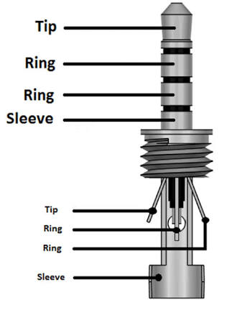
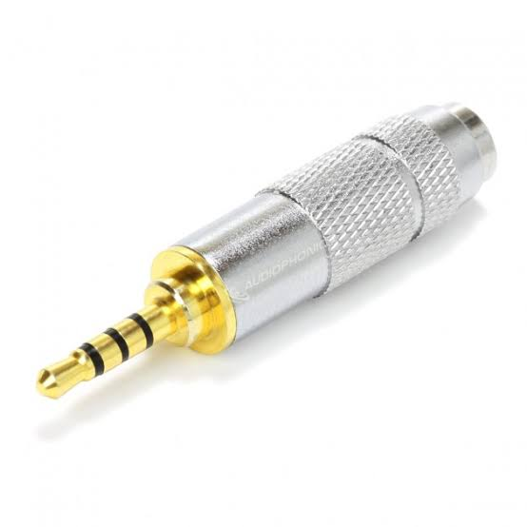
Qno2:- When and why we increase IRIS?
The iris is an adjustable opening aperture, which controls the amount of light coming through the lens (i.e. the "exposure"). The video camera iris works in basically the same way as a still camera iris, as you open the iris, more light comes in and the picture appears brighter.

Qno3:- Let suppose if you have to record a speech of Prime Minister and you have Panasonic PV100
what other equipment you will need? Mention all necessary steps to be followed by you.
- Bags.
- Battery.
- Battery Grip.
- Tripods.
- Lens Hood.
- Chargers.
- Memory Modules.
- Soft box & Umbrella.
- Gimbals. Others.
- Lighting Equipment.

Qno4:- What is the best way to capture dark environment "Manually" through Professional video recorder if you have not equipped with baby light/portable lights?
If you are looking to improve your night-time photographs, consider these basic photography tips on using the International Organization for Standardization (ISO) setting, slowing the shutter speed or using a night-scene mode on your camera. Most night photography is done using the flash, but this can actually hinder you from getting the best photograph possible. Instead, features of your camera other than the flash can help you take better pictures at night or in dark or dim light.

Step 1 - Understand the ISO Ratings
An vital component of using the ISO is understanding the purpose of the ISO. This little device in a digital camera measures the light sensitivity, and improves or reduces the light sensitivity. This allows it to act as though it were a fast film (1000 ISO or more) and take better images in the dark.

Step 2 - Avoid the Noise
When you use a higher ISO rating on your camera, you will probably be aware that you get a larger ratio of noise to good picture quality in your photographs. Remember that with a digital camera, the machine automatically slows down the shutter speed (to allow more light to hit the lens), and so any movement will be caught as a blur. You can try and avoid this by firstly, increasing the aperture that allows light to hit the lens, which should improve shutter times, and you can also try a small flash before the photograph (although this can also cause faces to appear pale).

Step 3 - Avoid Using High ISO
Although ISO is a great way to take photographs at night, using a high ISO can have drawbacks, such as the noise described above. One way of avoiding this noise is to use a tripod and a low ISO. Using low ISO gives you better quality, but you will need to have the shutter open for longer: this is where the tripod comes in. A tripod means that you won't suffer the blurring and fuzziness associated with slow shutter speeds. It is a good way of photographing night scenes, although you may have to use a different method if you intend to photograph people at night. In most situations, however, the tripod and slow shutter speed compensates for the use of low ISO.

Shutter Speed in dark environment:-
The first thing you will need to try to do is set your lens aperture to the lowest f-number on the camera, which is called the “maximum aperture”. Opening up your lens aperture will allow more light to pass through the lens into the camera body, which will result in faster shutter speeds.

Qno5:- How can you get "Stereo Audio" from "Mono audio clip"?
Locate the audio file that you want to convert to stereo, highlight it and click the "Open" button to open the file in the program. Click the "Effects" tab and select the "Mono to Stereo" option from the Effects menu. Follow the onscreen instructions to convert the mono track into a stereo track.

Qno6:- What is the function of "ZEBRA"?
Not all cameras have the Zebra Pattern function. Also, the setting or the operating procedure for the Zebra function differs depending on the model.
Zebra Pattern is a camera feature that overlays some stripes onto the image that indicate exposure levels. It is a function that aids exposure by showing a striped pattern over the areas that are close to overexposure. If the maximum brightness that can be expressed in shooting is defined as 100, use the Zebra function to check the amount of brightness to which the subject has been exposed.
The Zebra Pattern is a highlight warning indicator that is common in video cameras, it does not control exposure it just warns you that highlights are blown out. It is not recorded onto the resulting image.

Qno7:- "Input 1" and "Input 2" refers to?
Input 1 will be used for the channel you are watching, and input 2 for recording another channel.
Input 2 will be used for the channel you are watching if input 1 is being used for recording.
If using one cable feed, you need to put the box into "single feed mode" to tell it to use input 1 and only input 1. It will record, but clashes may occur if trying to do two things at once.

Selecting the audio input for recording audio to the channels on the camera

With the INPUT SELECT switch, select the audio input jack on the unit (INPUT1 or INPUT2) through which audio is recorded to the channels on the attached camera. When only the INPUT1 jack has an external device connected:

Set the switch to “IN1.” The input audio from the INPUT1 jack is recorded to both the CH1 and CH2 channels on the attached camera. When both the INPUT1 and INPUT2 jacks have an external device connected:
Set the switch to “IN1·IN2.” The input audio from the INPUT1 jack is recorded to the CH1 channel on the attached camera while the input audio from the INPUT2 jack is recorded to the CH2 channel.

Qno8:- In Panasonic PV100 "Channel I and Channel 2" refers to?
In Panasonic PV-100 channel 1 and channel 2 refers to audio level switches and audio level dials for CH1 and CH2 which connect to mic through XLR.
when using the INPUT terminals, each audio input is recorded to a separate audio channel (INPUT 1 to CH1 and INPUT 2 to CH2). If necessary (for example, as an audio backup recording), you can record the audio input into the INPUT 1 terminal to both audio channels, CH1 and CH2. In that case, you can adjust the audio recording levels of each channel independently of each other.

Qno11:- Explain hard and soft light?
Hard Light:-
Hard light is a focused, often bright light that casts harsh shadows and draws attention to a specific part of a photo.
In hard lighting, the transition between the light and the shadows is very harsh and defined. When your subject is bathed in hard light, their silhouette will cast a distinct, hard shadow. Think of hard light as how things look on a sunny day, with the sun shining directly onto an object.
Soft Light:-
Soft lighting is a type of light with few hard shadows that’s bright yet balanced. In soft lighting, the transition between the light and the shadows is more of a gradient and much smoother. When your subject is bathed in soft light, there will be little to no shadows on their face. And if there is a shadow, it is not as dark as they are in shadows cast in hard light.
Think of soft light as how things look on a cloudy day or an overcast day, with clouds creating a diffusion between the sun and an object. The cloud diffuses the light from the sun, which lights the object from every direction, creating a soft light.

Qno10:- What are the best possible way to check and monitor audio while recording through professional video camera?
Just because your camera doesn't have a headphone jack doesn't mean you can't still monitor your audio.
There's no such thing as a perfect camera, which is something you might know all too well if yours doesn't have a headphone jack. For indie/no-budget filmmakers who frequently one-man-band it, monitoring audio on your camera is often the most sensible option, but there are quite a few cameras out there that don't have an input for headphones. When it comes to monitoring audio for a feature or short, the best solution in most cases is to have a boom operator/sound recordist, but let's get real—some of us barely have money to buy ramen let alone hire a crew. Perhaps even more tragically, some of us don't know anyone who could do the job.
So if you're the sole filmmaker on your set, are recording sound on a smaller project, or damn, just want to monitor your own audio as you shoot because you just do, then Pike's hacks are definitely worth taking a look at. Each one of these tools will not only provide you with that all-important headphone jack, but some will also allow you to adjust your levels.

Use a monitor
Use HDMI dongles
Use a preamp
Use a handheld audio recorder
Use an audio recorder/external mic combo
Qno9:- Let suppose you have to record a clean audio of someone's speech not "General Audio". Your camera has 3.5mm Jack female for microphone connection and you have "XLR" microphone. How can you get clean audio by different methods?
if the device you connecting the cable to uses a balanced female 3.5mm input then there wouldn’t be any quality loss
Ideal solution for connecting a microphone to the 3.5mm mini input of a digital camcorder, DSLR camera, or computer sound card

Designed to connect a microphone with XLR
Carries balanced signal to a 3.5mm mini-jack port
XLR to 3.5mm converter solution

