INU Peshawar Date 23 June 2020
Department | (AHS) MIC, DT,RAD & DPT
Subject | English-II
Marks | 30
Semester | -II
Final Term Assignment | Spring 2020
Instructor | Hajra Iqbal
Fill below blocks.
Student Full Name | Ishfaq Ahmad Afridi
Student Father Name | Abdul Rafiq
University ID Card Number | 16723
Department | D.T
Instructions: Your time starts once you log in. You have only 6 hours to complete and submit your paper on the portal. After 6 hours your time would be automatically expired. Download this paper and save it with your full name and subject. Attempt all the answers on the same page and keep in your mind to click the SAVE after every 10 minutes. When you are done with paper, go through it and submit your final copy with your name and id on SIC portal.
Note: i. Attempt all four questions.
- Write Short Notes . / 20 Marks
a.Three Steps of Essay
b. Five Uses of Comma and Full Stop.
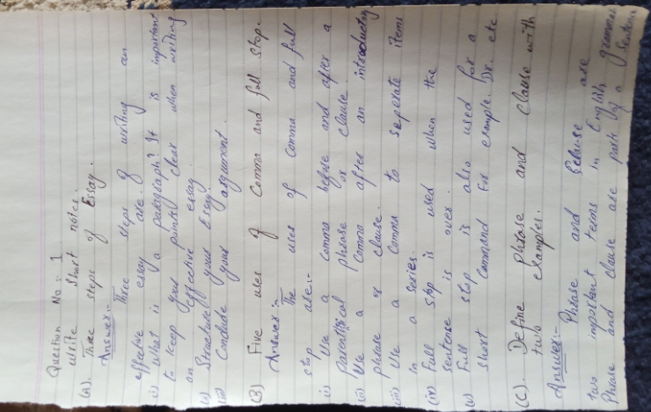
c.Define Phrase and Clause with two examples.
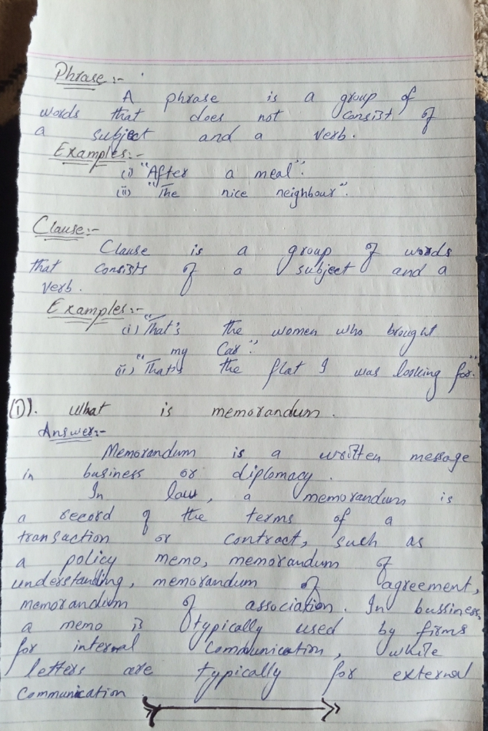
d.What is Memorandum
2.Write an essay on any one Topic. (340-350) Word Count /20 Marks
a. Smoking in public places has to be banned.
b. Parents are our first and most important teachers. Describe a specific valuable lesson from one of your parents
c. The way I spend my lockdown during Covid-19..

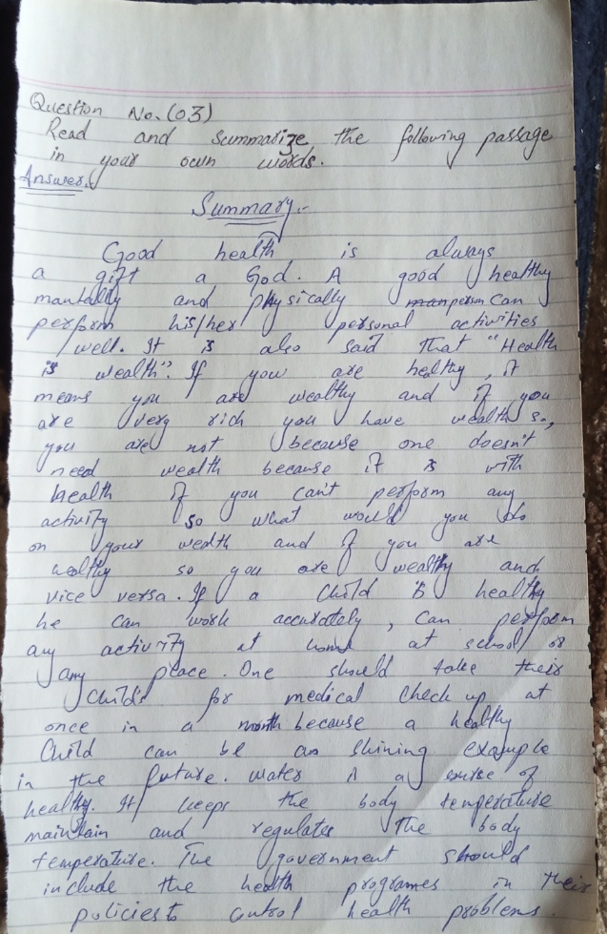
3.Read and Summarize the following Passage in your own words . /10 Marks

Health' is a state of complete physical, social and mental well being and not merely the absence of disease or infirmity. Health is thus a level of functional efficiency of living beings and a general condition of a persons mind, body and spirit, meaning it is free from illness, injury and pain. It is a resource of everyday life and a positive concept emphasizing physical capabilities.
Good health is a secret of every happy man. There is an old saying, 'Health is Wealth'. Staying healthy for children is vital for proper growth and development of mind and body as they need to focus in the class and fully participate in the activities on the field. Parents must take their children for medical check-up and learn from experts about their development in terms of height and weight, as it has a huge impact on their overall performance and efficiency. If you are strong and healthy, you can be a shining example to others and teach them how to achieve vibrant health.
Good health is a matter of great concern, to maintain it, healthy living and a disciplined life is a must. One of the best ways is to drink plenty of water as it reduces the risk of infection, keeps your skin healthy, reduces the risk of heart attack, burns body fat and regulates our body temperature. We should sleep well as it relaxes our body and reduces stress. We need to have a balanced diet and go for long, brisk walks. Our motto should be to keep our body clean in order to remain healthy. We must laugh more as laughing is a therapy and a secret of good health. The government should include integrated health programs into their public policies and control specific health problems.

