Name: Abdul wahab
Class ID: 13805
Assigment: Radiological and cross sectional anatomy
Submitted to: Sir waqas ihsan
Department: Radiology

Spinal cord;
Spinal cord are the long supporting structure of the body , it is divide into cervical ,thorasic and lumbar spine.
Cervical spine;
The neck are also called cervical spine ,it is a well enginered structure of bone ,nerve,muscle ,ligament and tendon

The cervical spine send message from the brain to controll all aspect of the bogy while also remarkbly strong flexion and allow the nect to move in all the direction
The cervical spine are 7 stacked bone called vertebre fromj C1 to C7.
The topo of the cervical spine connect the skull and the bottom connect to the upper back at about shoulder level
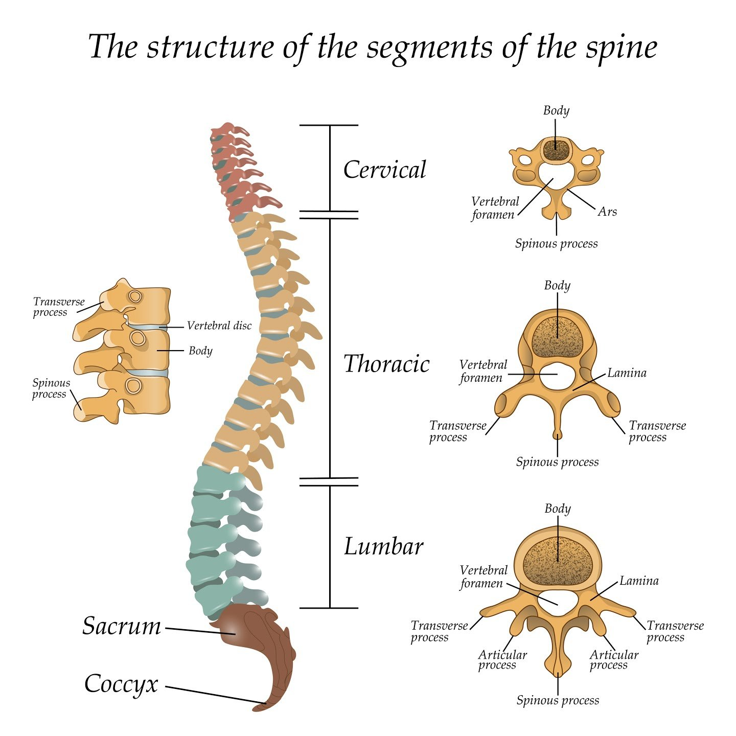
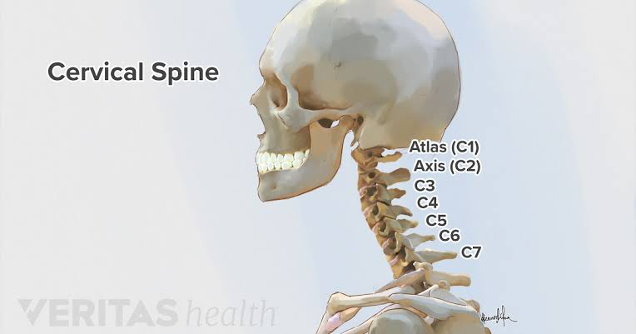
Role of cervical spine;
- Protecting the spinal cord;
The spinal cord is a bundle of nerve that extend from the brain and runs to the cervical spine .
- Supporting the head and its movement;
The cervical spine can handle a heave load , as the head weight on average between 10 to 13 pounds
- Facilitating flow of blood to the brain;
Small hole in a transverse in the cervical spine provide a passage way for the vertebral arteries to carry blood to the brain

Movement of the cervical spine;
The cervical spine is the most mobile region of the spine,heat and neck movement tytpically involve the following movement
- Flexion;
the cervical spine bend directly forward with the chin tilting down

- Extention; The cervical spine can move directly backward with thw chin tilting up,neck extention is common when performing over head work
- Rotation;
The cervical spine and head turn to one side.neck rotayion is particularly usefull when trying to look to the sides and over the shoulder
- Lateral flexion;
The cervical spine bend to the one side with the ear moning toward the shoulder

Atlas and Axis;
- Atlas;
The atlas is a first cervical vertebra and articulation with the acciput of the head and axis It is differ from the other cervical vertebrae in that has no vertebral body and no spinous proces instead ,the atlas has lateral masses which are cinnected by an anterior and posterior arch
- Axis;
The axis C2 is easily identifiable due to its dens which extend suoeriorly from the anterior portion of the vertebrea
The axis also cantain superior articular facets ,which articulate with the inferior areticular facets of the atlas to form thre two lateral altano axial joints
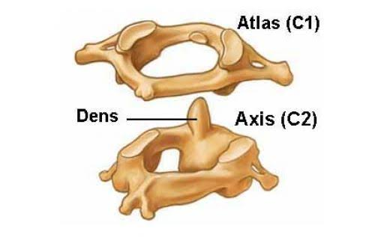

Basic function of the cervical vertebrea;
- C1,C2,and C3 provide motor function to the head and neck as well as sensation from the top of our scalp to the sides of ypu faces
- C4 enable you to shrug your shoulders automitically causes the diphragm to contract with the breating
- C5 enable various upper body movemevt like lifting your shoulder and flexing your biceps
- C6 allow you to move your wrists and flex ypur biceps and also provide sensation of the inner side of your forearms and hands
- C7 power the triceps muscle on the back of ypur upper arms and transmit sensation along the back of the arms and down to the middle finger

Cervical spine images in MRI;

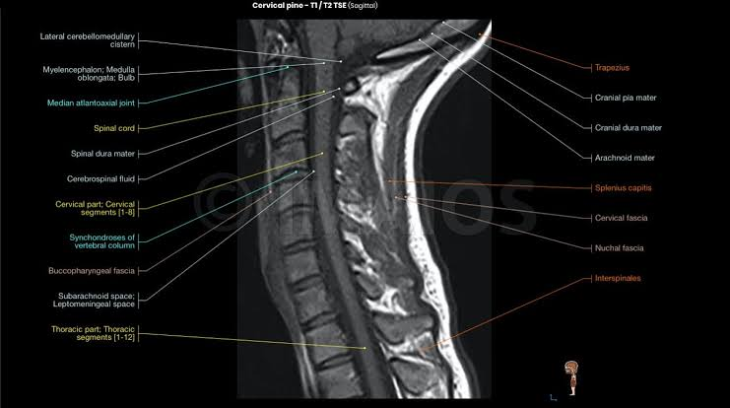
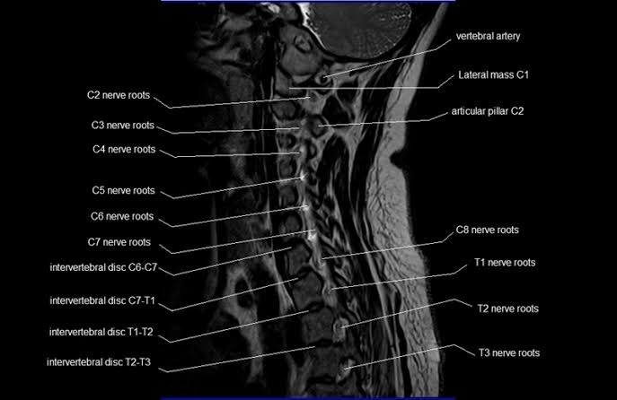

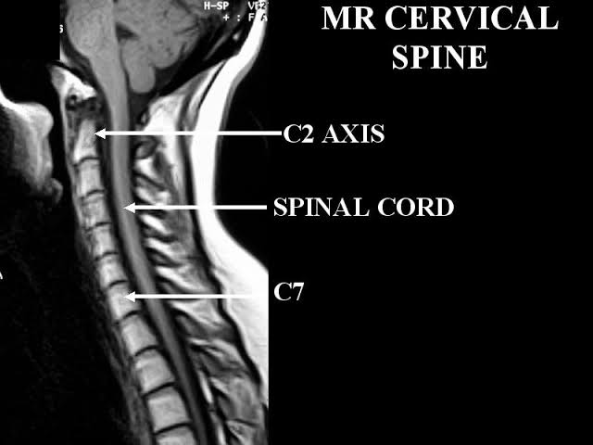

Cervical spine images on CT Scan;

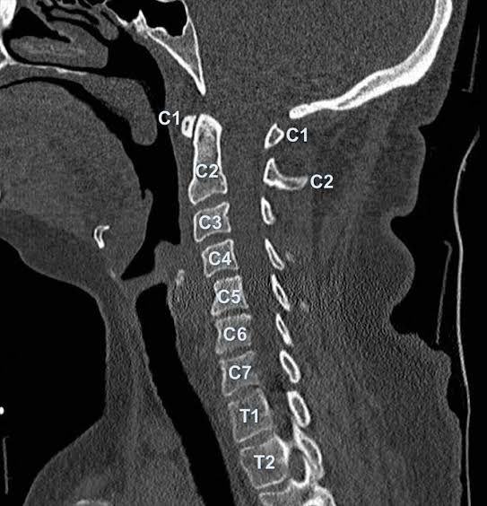
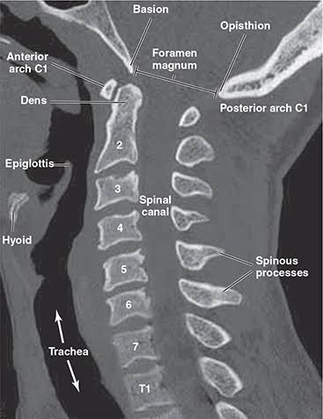
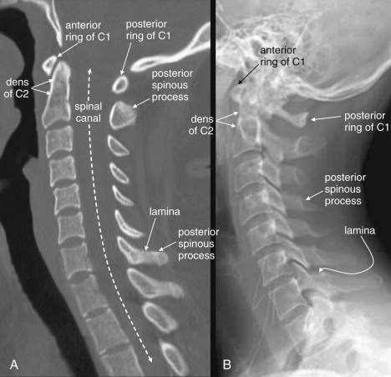
Cervical spine images on 3D Scan;

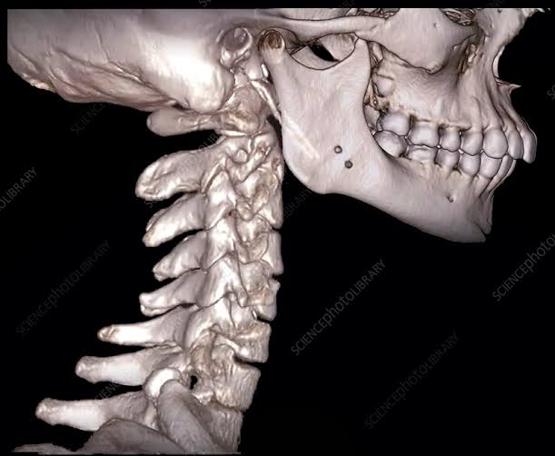
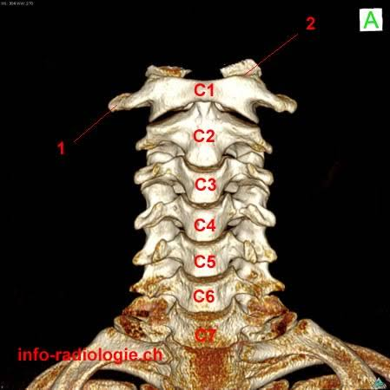

Thorasic spine;
The thorasic spine is the longest complex region of the spine ,it connect the cervical spine above and lumber spine below
It is the only region of the spina cord which attached to the rib cage
The thorasic spine are 12 in number and start fron T1 below the C7 and uoto T12 above the L1 and each is seperated ofinter vertebral disc.
Whev viewed from the side a normal forward curvature called kypotic curve is seen besause the ribs are attach to the thorasic spines .
This section of the spine is strong and stabalizing with less range of motion than cervical spine and also tje thorsic spine are less pron to injury than any other section of the spine.
Along with the sternem and ribs , the thorasic spines form par od the thorasic cade ,this bonny structure help to protect the internal viscreas such as a heart,lungs and esopagus

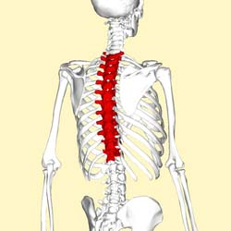
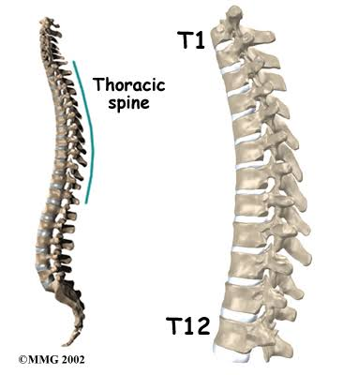
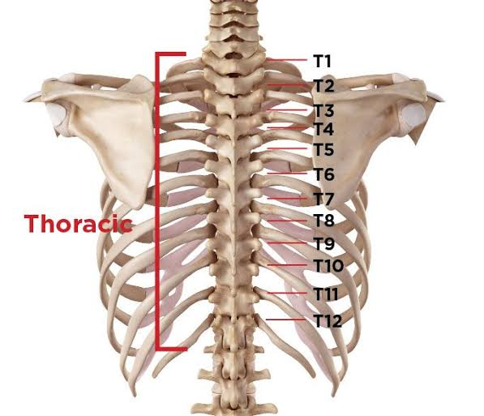

Types of thorasic spinal dissorder;
- Vertebral comprassion fracture VCF;
It can causes one or more bony bodies to flatten or become wedge shaped resulting in spinal cord and nerve compression .sudden and acute back poin in associated with a VCF
- Different type os scoliosis;
It is an abnormaL side to side carvature of the spine
3. Abnormal kyposis;
It is an exaggerated amount of forward thorasic spinal carvature of the spine

Thorasic spine images on MRI;

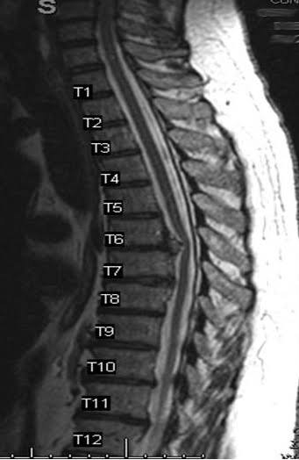
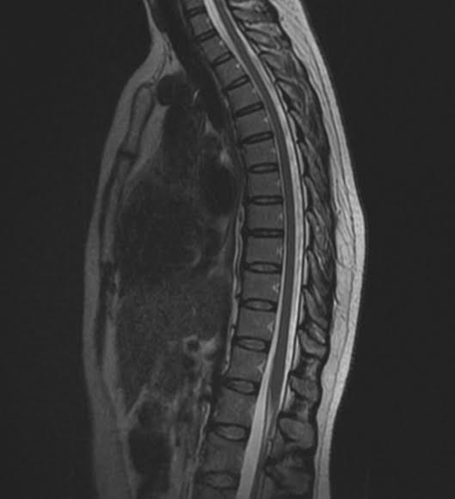

Thorasic spine images on CT scan;

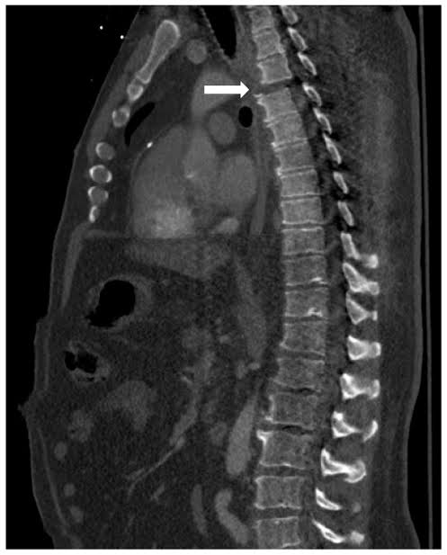
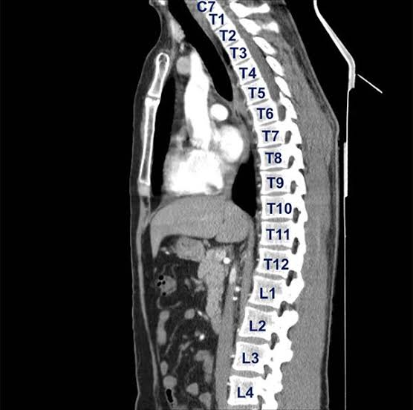

Thorasic spine images on 3D scan;
