NAME : JUNAID MASOOD
ID : 16718
DEGREE : B TECH CIVIL
SUBJECT : APPLIED MECHANICS
SUMITTED TO : Engr Khurshid Alam
FINAL EXAMINATION SUMMER 2020
Q1(A)
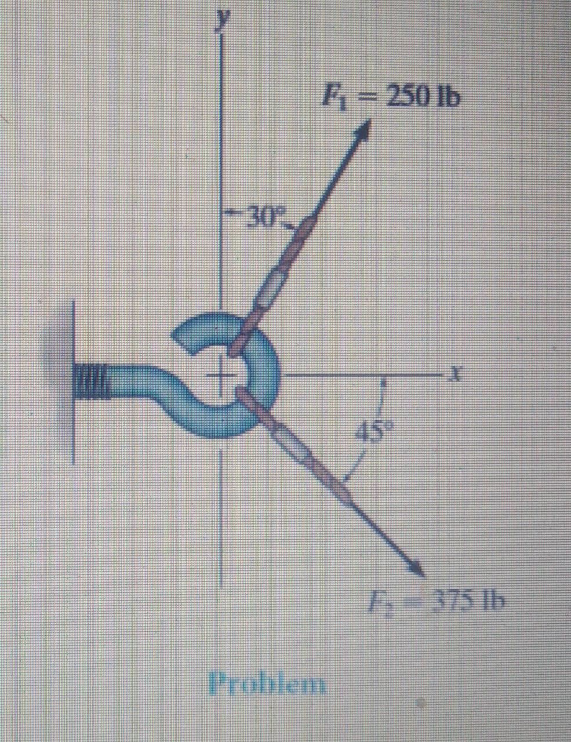

SOLUTION

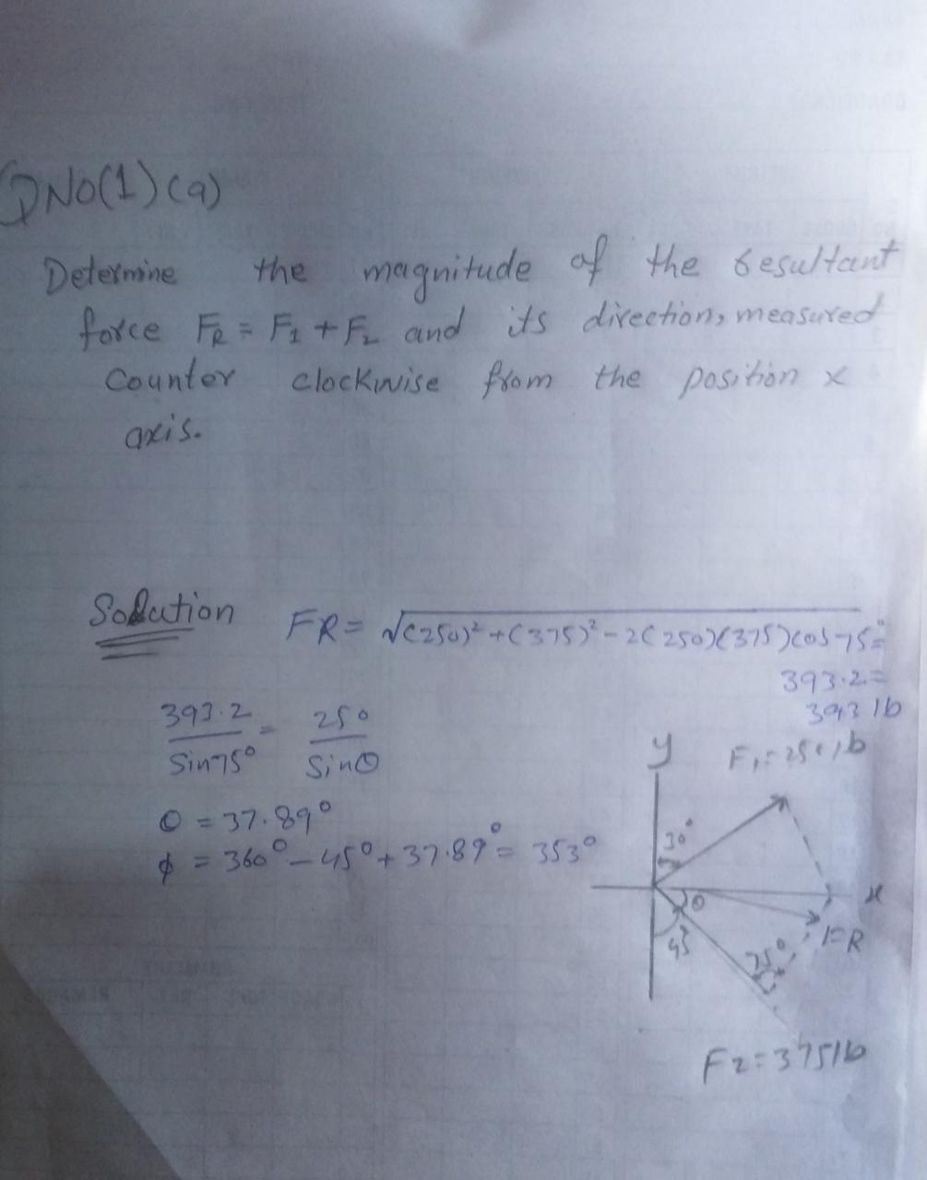

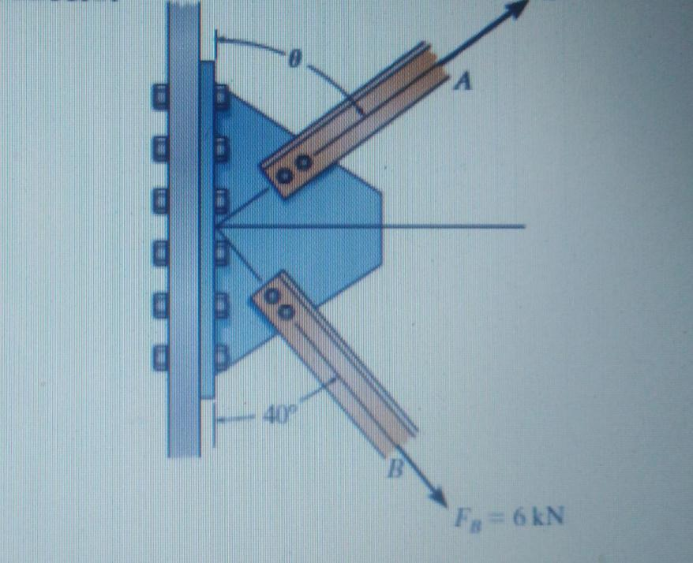

ANSWER
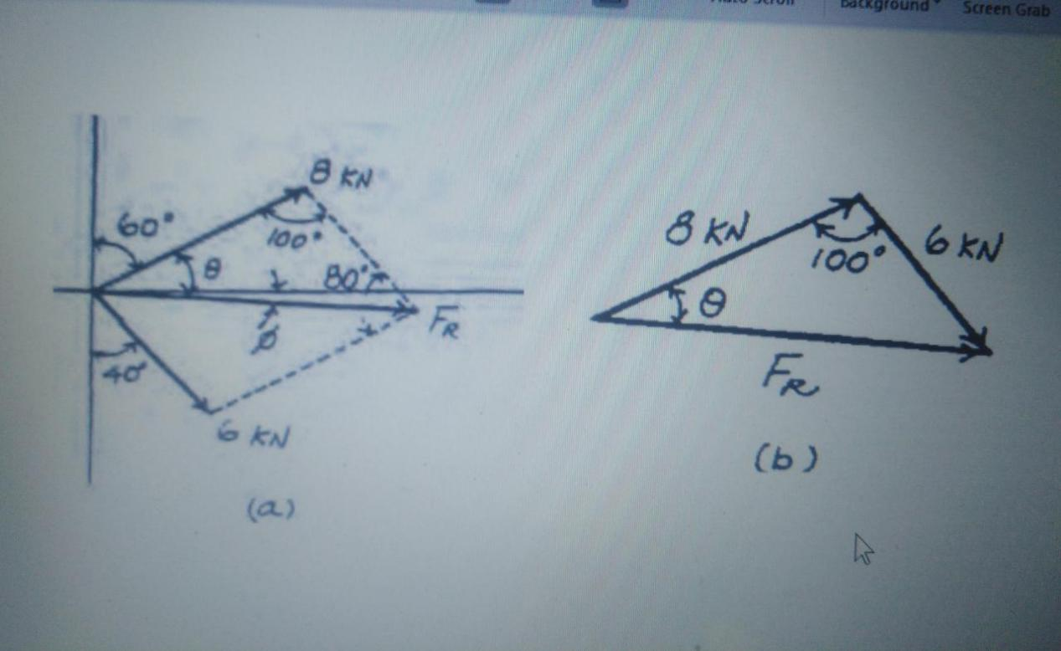

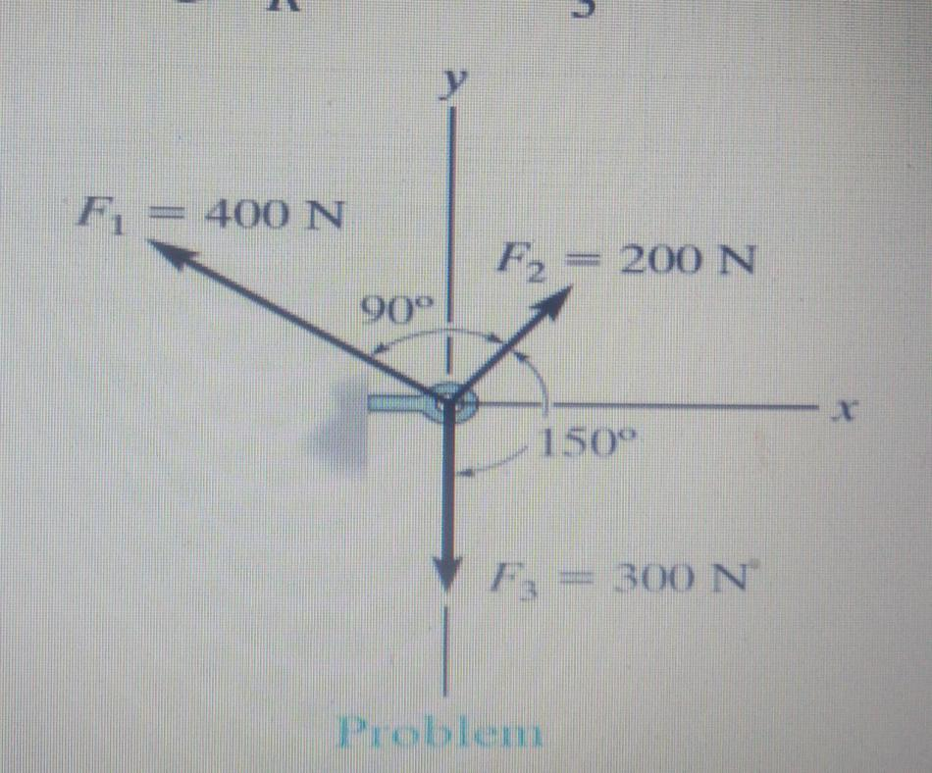

SALUTION
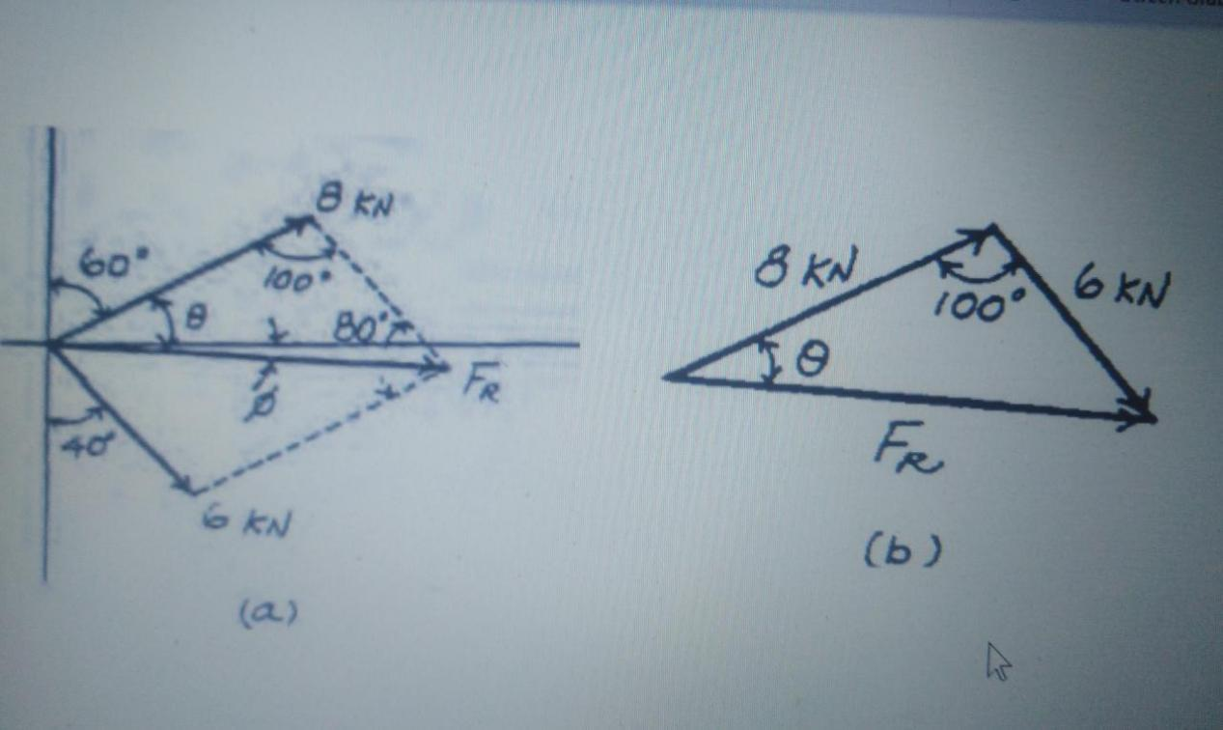

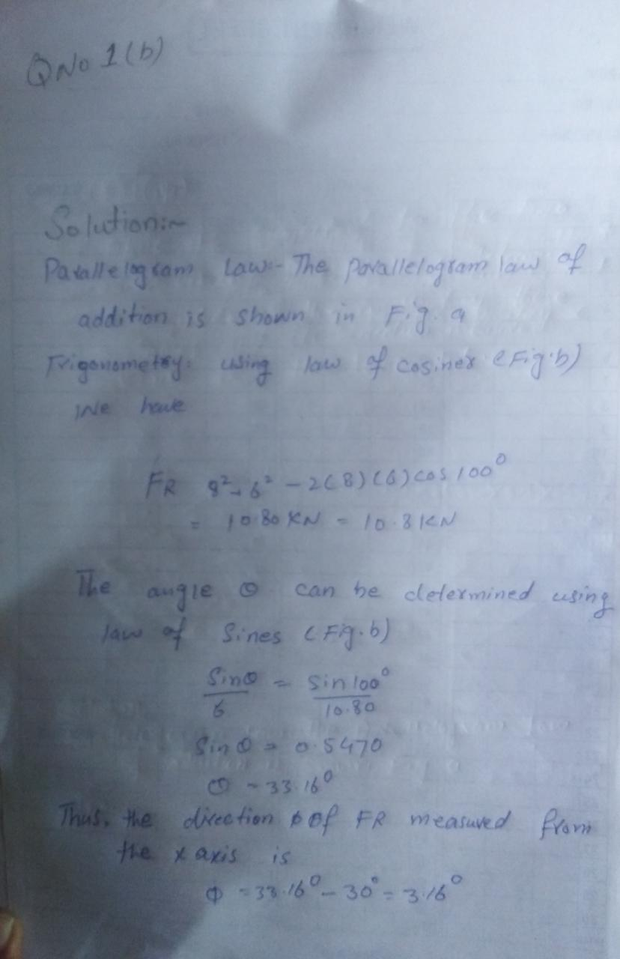

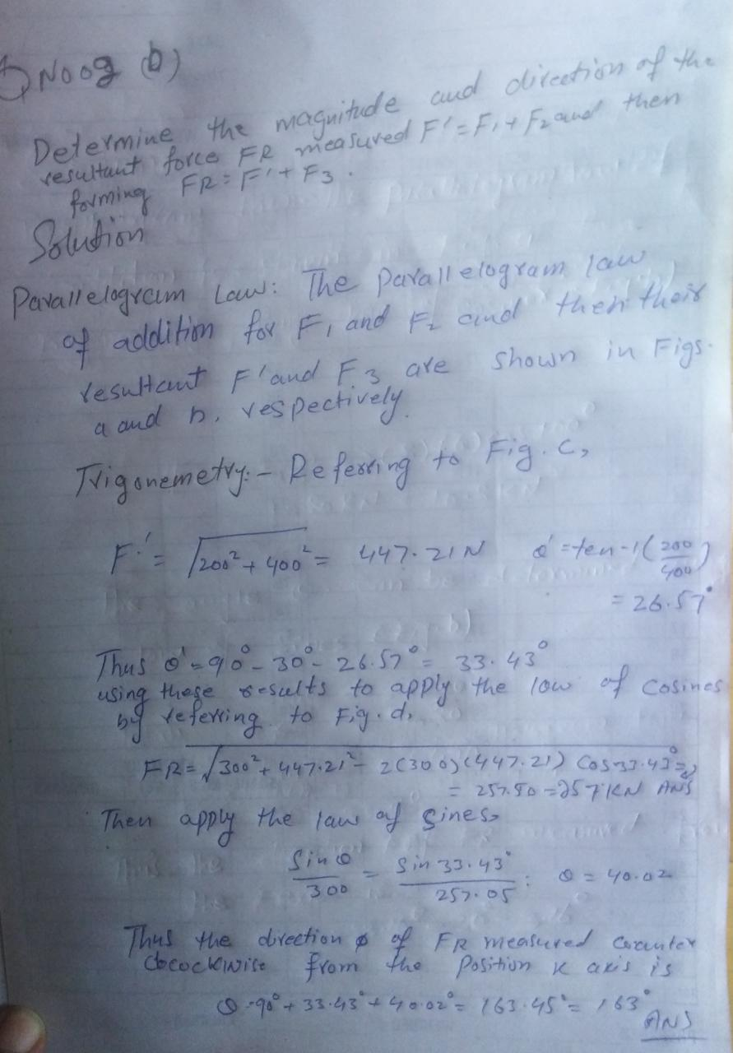

Q2b)

ANSWER

Equilibrium,When a rigid body is in equilibrium, both the resultant force and the
resultant couple must be zero.
EQUILIBRIUM OF RIGID BODIES
• Forces and moments acting on a rigid body could be external
forces/moments or internal forces/moments.
• Forces acting from one body to another by direct physical contact or
from the Earth are examples of external forces.
• Fluid pressure acting to the wall of a water tank or a force exerted by
the tire of a truck to the road is all external forces.
EQUILIBRIUM OF RIGID BODIES
In rigid bodies subjected to two dimensional force systems, the forces
exerted from supports and connection elements are shown in the free
body diagram as follows:
It should be kept in mind that reaction will occur along the direction in
which the motion of the body is restricted.

in phsics, the condition of a system when neither its state of motion nor its internal energy state tends to change with time. A simple mechanical body is dody is said to be in equilibrium if it experiences neither linear acceleration nor angulan acceleration; unless it is disturbed by an outside force, it will continue in that condition indefinitely, For a single particle, equilibrium arises if the vector sum of all forces acting upon the particle is zero. A rigid body (by definition distinguished from a particle in having the property of extension) is considered to be in quilibrium if, in addition to the states listed for the particle above, the vector sum of all torques acting on the body equals zero so that its state of rotational motion remains constant. An equlibrium is said to be stable if small. Externally indueed displacements from that state produce forces that tend to oppose the displacement and return the body or particle to the equilibrium state. Examples include a weight suspended by a spring or a brick lying on a level surfase. An equilibrium is unstable if the least
departure produces forces that tend to inerease the displacement. An example is a ball bearing balanced on the edge of a rezor blade.

Q3(a)
ANSWER

Q3(b)
TWO-FORCE MEMBER
Members which are subjected to only two forces are named as “two
force members”. Forces acting on these members are equal in
magnitude, opposite in direction and are directed along the line joining
the two points where the forces are applied
Weight is neglected. If
weight is considered, the
member will not be a
two force member!
P
By
Bx
Ax
Ay
FB
FA=FB
FA
B
A
Examples of Two Force Member
THREE-FORCE MEMBER
In rigid bodies acted on by only three forces, the lines of action of the
forces must be concurrent; otherwise the body will rotate about the
intersection point of the two forces due to the third force which is not
concurrent. If the forces acting on the body are parallel, then the point of
concurrency is assumed to be in infinity.
THREE-FORCE MEMBER
A
P
B
FA
FB
P
FREE BODY DIAGRAM
The procedure for drawing a free body diagram which isolates a body or
system consists of the following steps:
▪ If there exists, identify the two force members in the problem.
▪ Decide which system to isolate.
▪ Isolate the chosen system by drawing a diagram which represents its
complete external boundary.
FREE BODY DIAGRAM
▪ If not given with the problem, select a coordinate system which
appropriately suits with the given forces and/or dimensions.
▪ Identify all forces which act on the isolated system applied by
removing the contacting or attracting bodies, and represent them in
their proper positions on the diagram.
▪ Write the equations of equilibrium and solve for the unknowns.

Q3(B)
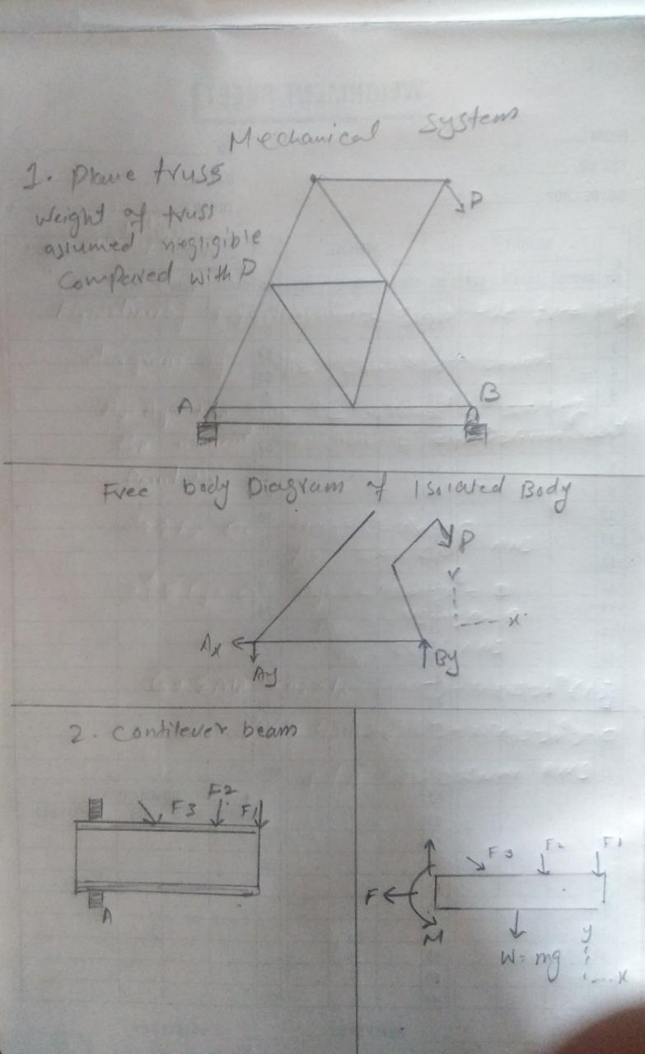

Q4(A)
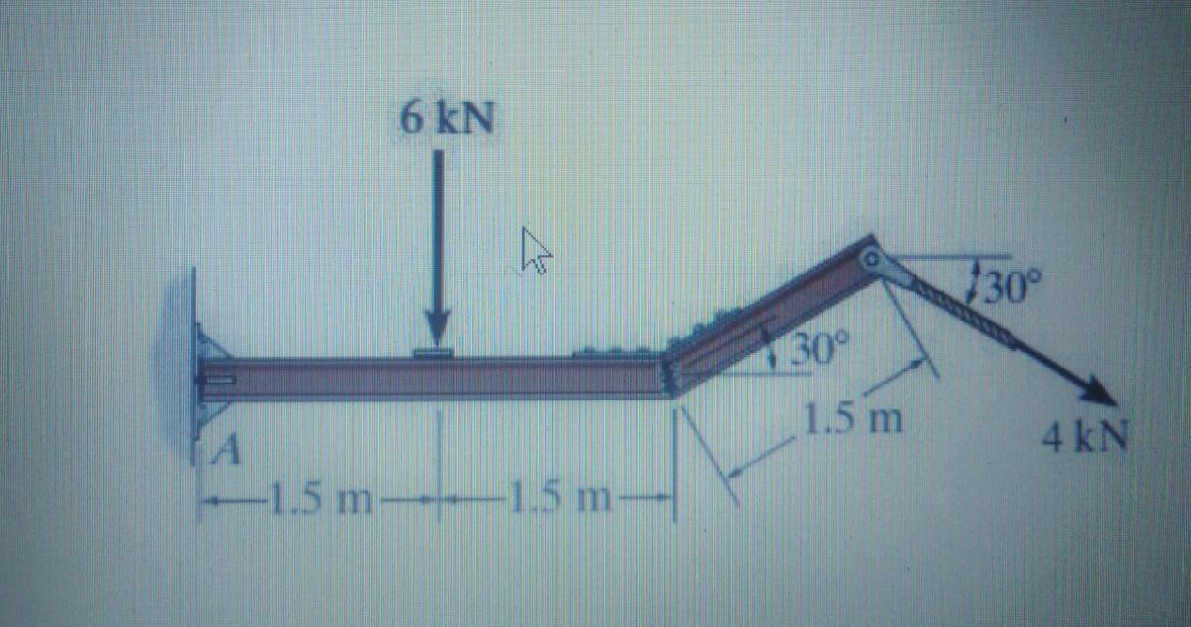

Solution
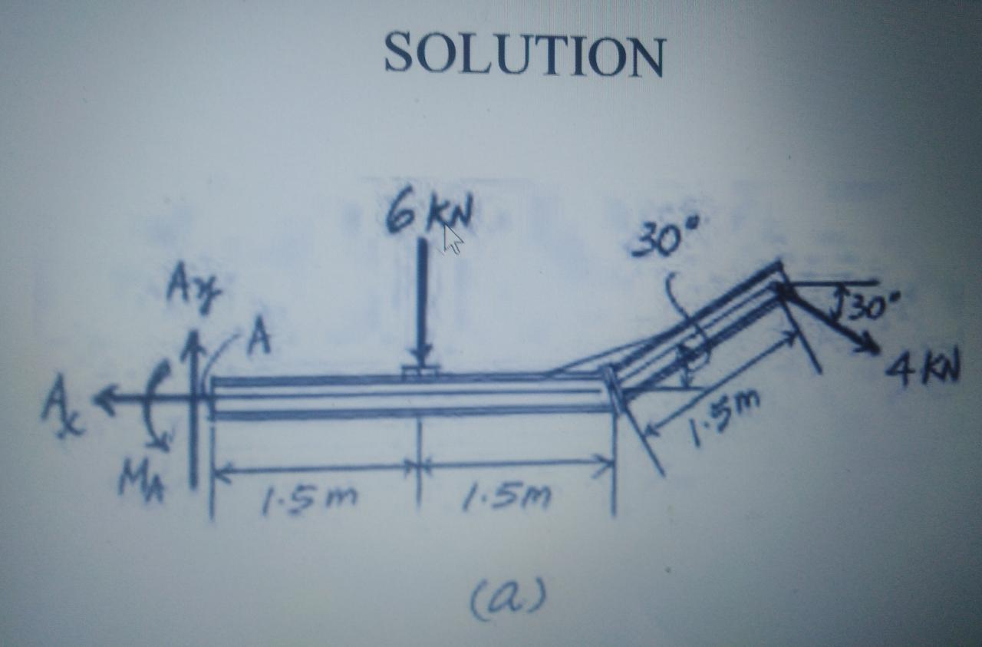

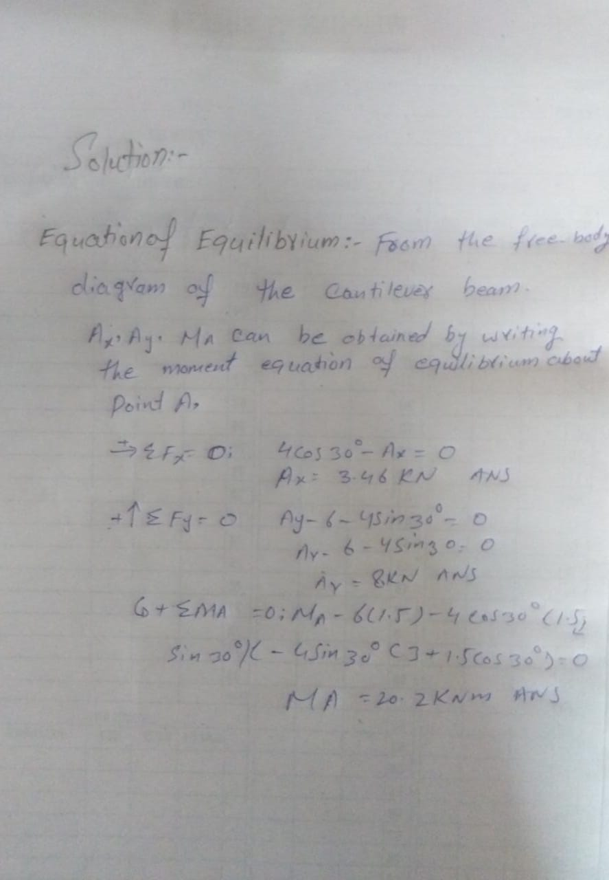

Q4(b)
