Subject: Human Anatomy II
Class: Radiology, 2nd semester
Section: B
Instructor: Dr. Arooba.
MidTerm Assignment, spring 2020. Marks 30.
Name sayed Tahirullah
ID 16331
Select the best option.

1. A metatarsal bone has the following basic parts:
A. Head, shaft, and tail
B. Head, shaft, and base
C. Head, neck, tubercle, and base
D. Head, neck, tubercle, and tail
2. Sustentaculum tali is located on______ of calcaneum.
A. Medial surface
B. Lateral surface
C. Anterior surface
D. Superior surface
3. Circumduction is the combination of?
A. Flexion, extension, medial rotation, and lateral rotation
B. Flexion, extension, abduction, and adduction
C. Abduction, adduction, medial rotation, and lateral rotation
D. Extension, adduction, medial rotation, and lateral rotation

4. It looks like inverted Y shaped:
A. Iliofemoral ligament
B. Pubofemoral ligament
C. Ischiofemoral ligament
D. Plantar aponeurosis
5. The increase in neck angle with the shaft of the femur is called:
A. Coxa valga
B. Coxa vara
C. Coxa benda
D. Coxa increase
6. The floor of the acetabulum is non-articular called:
A. Acetabular fossa
B. Acetabular margin
C. Acetabular notch
D. Capsule
7. The tubercle separating the tendons of peroneus longus and peroneus brevis is:
A. Anterior tubercle
B. Posterior tubercle
C. Medial tubercle
D. Peroneal tubercle
8. The symphysis pubis is:
A. Primary cartilaginous joint
B. Secondary cartilaginous joint
C. Synovial joint
D. Fibrous joint
9. Which bone does not part in the formation of the knee joint?
A. Femur
B. Tibia
C. Fibula
D. Patella
10. Regarding tibia:
A. Anterior border is subcutaneous
B. Lateral border is subcutaneous
C. Medial border is subcutaneous
D. Medial surface is subcutaneous

Give brief answers to the following questions. Add diagrams/ pictures where needed.
Each question carries 5 marks.

1. Describe the arches of foot. Name the factors responsible for the maintenance of these arches.

2. Mention the attachments, nerve supply and actions of the muscle largely responsible for the prominence of buttocks. Which site is safe for the intramuscular injection in this region?

3. How greater and lesser sciatic foramina formed and enlist the structures passing through them

4. What are hamstring muscles? Give their origin, insertion, nerve supply and action
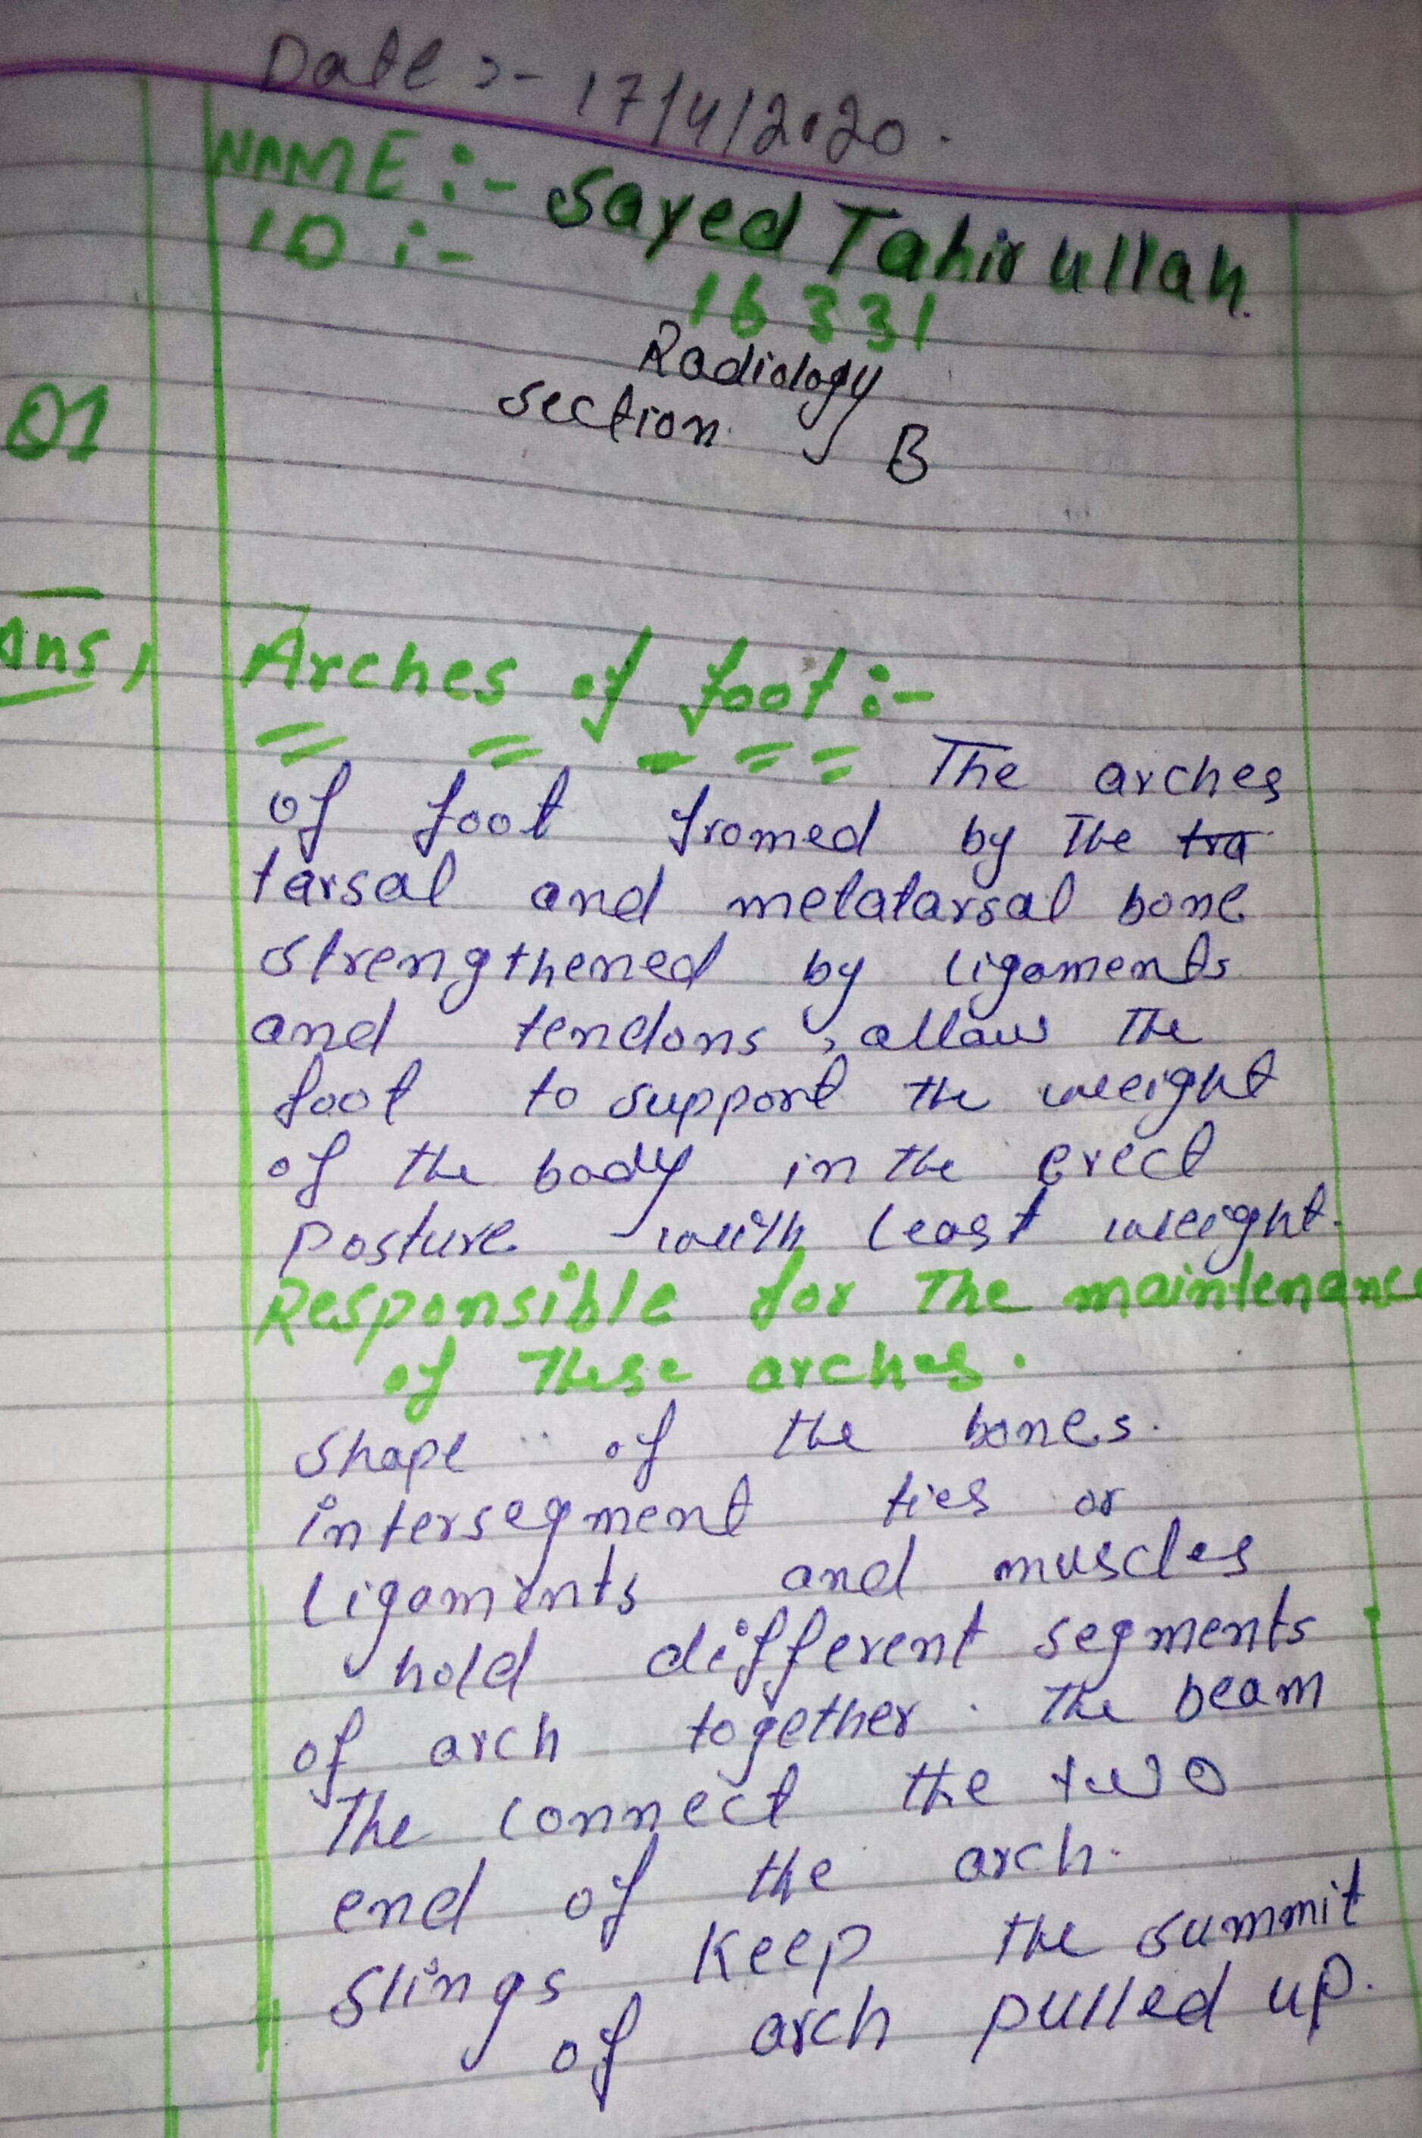
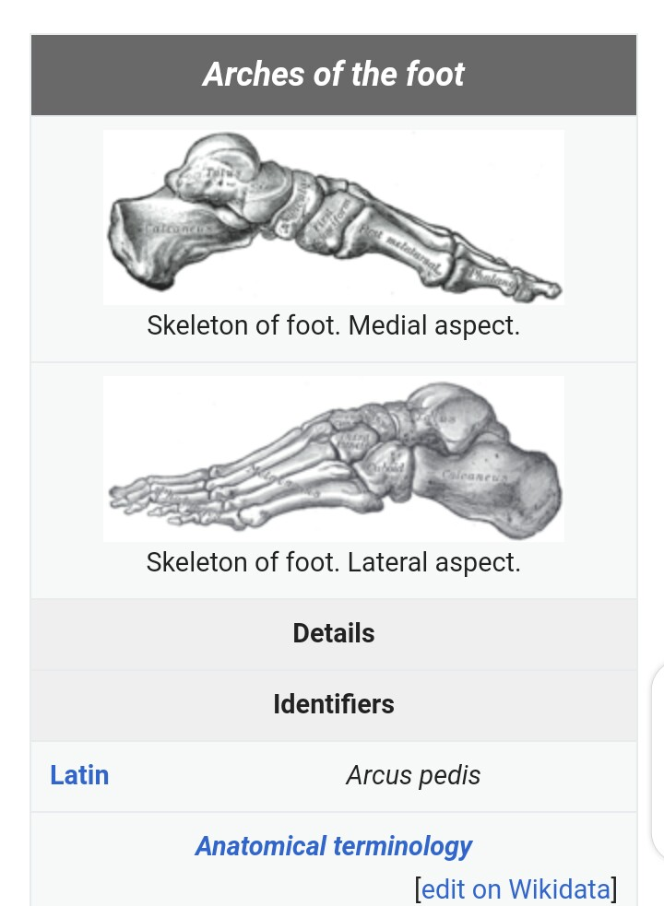
BH