PROJECT LIFE CYCLE

The 4 Phases of the Project Management Life Cycle
- Initiation
- Planning
- Execution
- Closure

Initiation
First, you need to identify a business need, problem, or opportunity and brainstorm ways that your team can meet this need, solve this problem, or seize this opportunity. During this step, you figure out an objective for your project, determine whether the project is feasible, and identify the major deliverables for the project.
Instead of waiting to have the project strategy decided for you, Moira Alexander advocates for a mental switch from being a project "manager" to becoming a project "leader":
"Project managers must be able to sell business leaders on the intrinsic value they offer to the business at a strategic level when they are at the table from the start of strategic planning instead of after the fact decision-making. Project managers effectiveness is drastically muted when offering a "fix-it" or "workaround" once high-level directional business decisions are made without their expertise."
Clearly, it's worth it to do what it takes to make your voice heard early—before the strategy is set in stone.

Project management steps for the initiation phase
Steps for the project initiation phase may include the following:
- Undertaking a feasibility study: Identify the primary problem your project will solve and whether your project will deliver a solution to that problem
- Identifying scope: Define the depth and breadth of the project
- Identifying deliverables: Define the product or service to provide
- Identifying project stakeholders: Figure out whom the project affects and what their needs may be
- Developing a business case: Use the above criteria to compare the potential costs and benefits for the project to determine if it moves forward
- Developing a statement of work: Document the project’s objectives, scope, and deliverables that you have identified previously as a working agreement between the project owner and those working on the project

2. Planning
Once the project is approved to move forward based on your business case, statement of work, or project initiation document, you move into the planning phase.
During this phase of the project management life cycle, you break down the larger project into smaller tasks, build your team, and prepare a schedule for the completion of assignments. Create smaller goals within the larger project, making sure each is achievable within the time frame. Smaller goals should have a high potential for success.

Project management steps for the planning phase
Steps for the project planning phase may include the following:
- Creating a project plan: Identify the project timeline, including the phases of the project, the tasks to be performed, and possible constraints
- Creating workflow diagrams: Visualize your processes using swimlanes to make sure team members clearly understand their role in a project
- Estimating budget and creating a financial plan: Use cost estimates to determine how much to spend on the project to get the maximum return on investment
- Gathering resources: Build your functional team from internal and external talent pools while making sure everyone has the necessary tools (software, hardware, etc.) to complete their tasks
- Anticipating risks and potential quality roadblocks: Identify issues that may cause your project to stall while planning to mitigate those risks and maintain the project’s quality and timeline
- Holding a project kickoff meeting: Bring your team on board and outline the project so they can quickly get to work

3. Execution
You’ve received business approval, developed a plan, and built your team. Now it’s time to get to work. The execution phase turns your plan into action. The project manager’s job in this phase of the project management life cycle is to keep work on track, organize team members, manage timelines, and make sure the work is done according to the original plan.

Project management steps for the execution phase
Steps for the project execution phase may include the following:
- Creating tasks and organizing workflows: Assign granular aspects of the projects to the appropriate team members, making sure team members are not overworked
- Briefing team members on tasks: Explain tasks to team members, providing necessary guidance on how they should be completed, and organizing process-related training if necessary
- Communicating with team members, clients, and upper management: Provide updates to project stakeholders at all levels
- Monitoring quality of work: Ensure that team members are meeting their time and quality goals for tasks
- Managing budget: Monitor spending and keeping the project on track in terms of assets and resources
If you have a properly documented process already in place, executing the project will be much easier.

4. Closure
Once your team has completed work on a project, you enter the closure phase. In the closure phase, you provide final deliverables, release project resources, and determine the success of the project. Just because the major project work is over, that doesn’t mean the project manager’s job is done—there are still important things to do, including evaluating what did and did not work with the project.

Project management steps for the closure phase
Steps for the project closure phase may include the following:
- Analyzing project performance: Determine whether the project's goals were met (tasks completed, on time and on budget) and the initial problem solved using a prepared checklist.
- Analyzing team performance: Evaluate how team members performed, including whether they met their goals along with timeliness and quality of work
- Documenting project closure: Make sure that all aspects of the project are completed with no loose ends remaining and providing reports to key stakeholders
- Conducting post-implementation reviews: Conduct a final analysis of the project, taking into account lessons learned for similar projects in the future
- Accounting for used and unused budget: Allocate remaining resources for future projects.

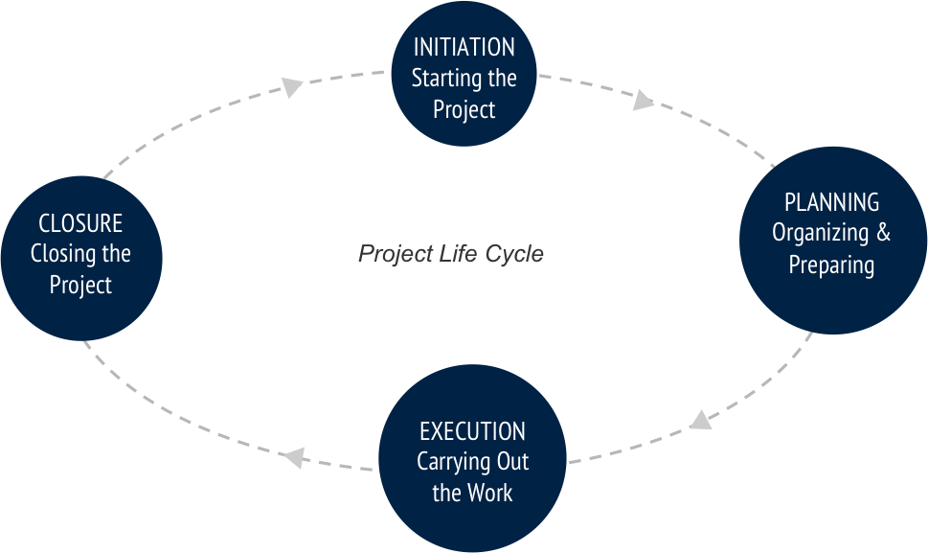

MAJOR TYPES OF CONSTRUCTION
In planning for various types of construction, the methods of procuring professional services, awarding construction contracts, and financing the constructed facility can be quite different. For the purpose of discussion, the broad spectrum of constructed facilities may be classified into four major categories, each with its own characteristics.

RESIDENTIAL HOUSING CONSTRUCTION
Residential housing construction includes single-family houses, multi-family dwellings, and high-rise apartments. During the development and construction of such projects, the developers or sponsors who are familiar with the construction industry usually serve as surrogate owners and take charge, making necessary contractual agreements for design and construction, and arranging the financing and sale of the completed structures. Residential housing designs are usually performed by architects and engineers, and the construction executed by builders who hire subcontractors for the structural, mechanical, electrical and other specialty work. An exception to this pattern is for single-family houses which may be designed by the builders as well.
The residential housing market is heavily affected by general economic conditions, tax laws, and the monetary and fiscal policies of the government. Often, a slight increase in total demand will cause a substantial investment in construction, since many housing projects can be started at different locations by different individuals and developers at the same time. Because of the relative ease of entry, at least at the lower end of the market, many new builders are attracted to the residential housing construction. Hence, this market is highly competitive, with potentially high risks as well as high rewards.

INSTITUTIONAL & COMMERCIAL BUILDING
Institutional and commercial building construction encompasses a great variety of project types and sizes, such as schools and universities, medical clinics and hospitals, recreational facilities and sports stadiums, retail chain stores and large shopping centers, warehouses and light manufacturing plants, and skyscrapers for offices and hotels. The owners of such buildings may or may not be familiar with construction industry practices, but they usually are able to select competent professional consultants and arrange the financing of the constructed facilities themselves. Specialty architects and engineers are often engaged for designing a specific type of building, while the builders or general contractors undertaking such projects may also be specialized in only that type of building.
Because of the higher costs and greater sophistication of institutional and commercial buildings in comparison with residential housing, this market segment is shared by fewer competitors. Since the construction of some of these buildings is a long process which once started will take some time to proceed until completion, the demand is less sensitive to general economic conditions than that for speculative housing. Consequently, the owners may confront an oligopoly of general contractors who compete in the same market. In an oligopoly situation, only a limited number of competitors exist, and a firm’s price for services may be based in part on its competitive strategies in the local market.

SPECIALIZED INDUSTRIAL CONSTRUCTION
Specialized industrial construction usually involves very large scale projects with a high degree of technological complexity, such as oil refineries, steel mills, chemical processing plants and coal-fired or nuclear power plants. The owners usually are deeply involved in the development of a project, and prefer to work with designers-builders such that the total time for the completion of the project can be shortened. They also want to pick a team of designers and builders with whom the owner has developed good working relations over the years.
Although the initiation of such projects is also affected by the state of the economy, long range demand forecasting is the most important factor since such projects are capital intensive and require considerable amount of planning and construction time. Governmental regulation such as the rulings of the Environmental Protection Agency and the Nuclear Regulatory Commission in the United States can also profoundly influence decisions on these projects.

INFRASTRUCTURE & HEAVY CONSTRUCTION
Infrastructure and heavy construction includes projects such as highways, mass transit systems, tunnels, bridges, pipelines, drainage systems and sewage treatment plants. Most of these projects are publicly owned and therefore financed either through bonds or taxes. This category of construction is characterized by a high degree of mechanization, which has gradually replaced some labor intensive operations.
The engineers and builders engaged in infrastructure construction are usually highly specialized since each segment of the market requires different types of skills. However, demands for different segments of infrastructure and heavy construction may shift with saturation in some segments. For example, as the available highway construction projects are declining, some heavy construction contractors quickly move their work force and equipment into the field of mining where jobs are available.

