Subject: Anatomy-II Lab
Semester: DPT 2nd
NAME: hammad ullah khan
CLASS: DPT 2ND section A
ROLL: 16878

Write down a comprehensive note on blood supply and venous return of lower limb.

Describe anatomical course of femoral and sciatic never with the help of diagrams

ANSWER 1)
BLOOD SUPPLY OF LOWER LIMB:
Femoral corridor is the essential supply route of the lower appendage. It is the expansion of the outside liac corridor. Outside iliac changes into femoral supply route in the wake of traverse the inguinal tendon. At that point it enters the femoral triangle.
The profounds femoris corridor in the femoral triangle voyages distally and posteriorly and offers ascend to three additional branches:
• Perforating Branches: It assists with providing the muscles which are available in the average and back thigh and it enters the adductor magnus.
• Medial Femoral Circumflex Artery: It outfits the neck and head of Femur. It is available around the horizontal side of the Femur. In the event that a crack of the neck happens this supply route can be harmed without any problem.
• lateral Femoral Circumflex: As the name shows it is available on the sidelong side of the
Femur and outfits some of muscles which are available on the sidelong side of the thigh.
The Femoral course leaves the femoral triangle and goes down to and ventures out down to the tight
through the adductor waterway (a passage), it supplies the front thigh muscles. The Femoral supply route enters
the back piece of the thigh by going through the adductor magnus. After which it is called Popliteal artery.
OTHER ARTERIES IN THIGH:
Some different vessels additionally gracefully the lower appendage. The Obturator Artery isolates into two branches:
ANTERIOR BRANCH:
Pectineus, Adductor muscles, Gracilis and Obturator externus are provided by this branch.
POSTERIOR BRANCH:
Profound Gluteal muscles are provided by this branch.
Prevalent and second rate Gluteal conduits gracefully the Gluteal. Likewise, the second rate Gluteal supply route contributes towards vasculature of the back side of the thigh.

ARTERIES IN THE LEG:
The Popliteal Artery goes to the Posterior thigh and offer ascent to the branches which outfit the knee joint. Subsequent to experiencing the Popliteal fossa, it exits in the middle of Popliteal muscles and Gastrocnemius.
The Popliteal supply route closes by parting in Tibioperoneal trunk and front tibial conduit. After that the Tibioperoneal trunk branches into fibular conduits and back Tibial supply routes:
1)fibular Arteries: Another name for this supply route is Peroneal Artery. It outfits the horizontal some portion of the leg through its puncturing branches which overwhelm the intermuscular septum.

2)Posterior Tibial Artery: It supplies the back piece of the leg and furthermore the grower surface of the foot by entering the underside of the foot through the Tarsal passage. It is joined by the tibial Nerve.
The foremost tibial supply route which is another part of the popliteal conduit goes totally among fibula and tibia, by means of the interosseous layer's hole. It at that point covers and voyages through the whole leg, into the foot where it is then called Dorasalis Pedis Artery.

VENOUS RETURN OF THE LOWER LIMB:
The veins of the lower appendage are isolated into two classes, profound and shallow. These veins get out the deoxygenated blood and takes it back to the heart.
1) Deep veins: They are available under the sash of the lower appendage.
2) Superficial: These veins are available in the subcutaneous tissues.

VENOUS DRAINAGE OF THE FOOT AND LEG:
The essential venous seepage structure is the dorsal venous curve. It channels in the shallow veins. A few veins from the curve puncture profound into the leg which frames the front tibial vein.
On the grower side of foot, the average and parallel grower veins emerge. At the point when these veins consolidate and structure the back tibial and fibular veins.
In the knee on the back side front tibial, fibular and back tibial veins consolidate also, make the popliteal vein. This vein at that point experiences the adductor trench to the thigh.
VENOUS DRAINAGE OF THE THIGH:
At the point when the popliteal vein enters the thigh is then called femoral vein. Profounds Femoris vein is the essential structure in the thigh, the blood from the thigh muscles is depleted through this vein into the distal segment of the femoral vein, femoral vein leaves the thigh by running under the inguinal tendon, where it is known as the outer iliac vein.

ANSWER 2)
ANATOMICAL COURSE OF SCIATIC NERVE:
Sciatic is the biggest nerve in the body and it broadened or got from the lumbosacral plexus. At the point when it is framed it leaves the pelvis and moves to the gluteal area through the sciatic foramen. It seems sub-par compared to the piriformis muscle and goes down in an inferolateral course.
In the wake of traveling through the gluteal territory, it passer through the back side of obturator internus, prevalent gemellus, mediocre gemellus and quadratus femoris muscle. After with it sets its foot the back thigh.
The nerve at that point offers ascend to branches to the adductor magnus and hamstring muscle inside the thigh. The sciatic nerve closes when it arrives at the peak of popliteal fossa and bilocates in tibial fibular nerve.
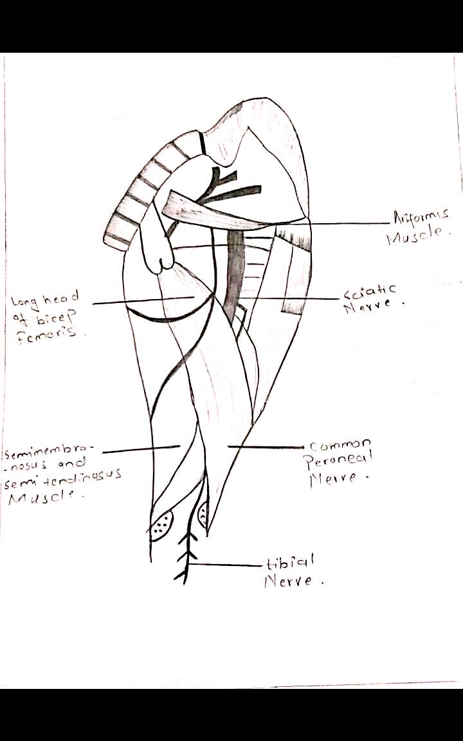

ANATOMICAL COURSE OF FEMORAL NERVE:
It is the biggest part of the lumbar plexus. It is the augmentation of foremost rani of nerve roots L2, L3 and L4.
It emerges from the plexus and afterward travels through the psoas significant muscle of the stomach divider (Posterior), The femoral nerve before entering the thigh supplies branches to the pectineus and illaous muscle.
The femoral nerve enters the femoral triangle by going under the inguinal tendon. In this triangle the nerve is available sidelong to the femoral vessels. The femoral nerve isolates into foremost and back nerve 4cm underneath the inguinal tendon.
