IQRA NATIONAL UNIERSITY
Name : Hafiz jamal uddin
ID : 16094
Paper: Introduction to Architecture and Town planning
Department : Civil engineering

Q:1
Ans: Following are the main slums of Peshawar :
1.Shaheedabad/Subhanabad
2. Tajabad
3. Gujjar Camp
4. Changarabad

Changarabad:
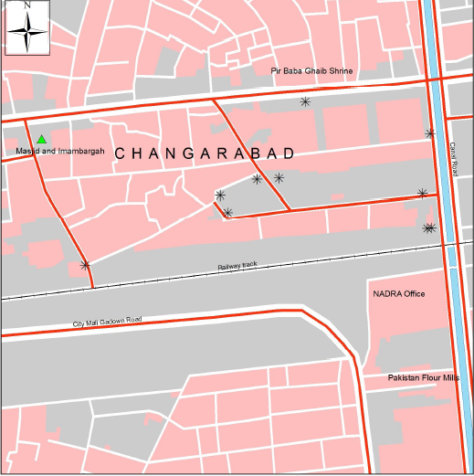
Changarabad is located in the middle of the Peshawar city. This area is restricted by the railway line in the South and an irrigation canal in the East. The Pakistan Railway’s residential colony is located in the West.
Currently there are an estimated 1,200 households established in the slum, with an average
household size of 8.25 members. Almost 75% of the citizens are home owners and the
remaining are paying an average monthly rent of Rs. 2,360. However, based on the
information gathered during FGDs and HHIs, the inhabitants of the settlements on the railway
owned land are illegal squatters who enjoy patronage of major political parties owning to their
vote bank. Average plot size of 72% houses is 3 marlas or less.
The size of 3 marls are 72 %, 21% 3to 5 marlas and 7% are 8 marlas .

Recommended steps to improve livehood of these people:
Provision of Water, Sanitation, and Education are the highlighted issues of the slum. Moreover,
the slum experiences high crime rate related to petty theft.

The government should provide clean water to these people because most disease are due to water by providing clean water to them they will be healthy .

The sanitation system of gareeb abad is very poor to improve sanitation they should provide toilets and latrines that flush into a sewer or safe place .

in changarabad there is no much school where the children go and take some quality education they should provide schools and colleges .
There is no public or private healt facility avalibale here . The current government should provide health facilities to them to improve there living hood.

Q:2
Ans :master plane of Islamabad: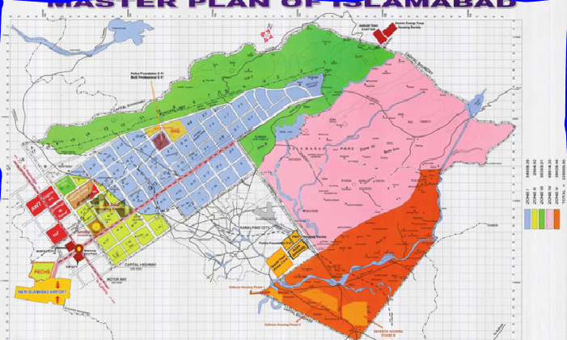

Islambad is the capital city of Pakistan , islambad is the 9th largest city in Pakistan with the population of 7.4 million.it was build as a planned city in 1960 to replace Karachi as Pakistan capital.islambad is khown for its high standards of living,safety and its greenery islambad is the political seat of Pakistan and run by the islambad metropolitan corporation and it is supported by capital development authority. (CDA).it is located between rawalpandi district and margalla hills national park .the region is historically been a part of cross roads of Punjab and KPK with the margalla pass .Ict is the civil and main law and order agency of the city.
Master plane :
The master plane was design by greek arcchitact Constantinos aposstolou Doxiadis . he divided the city into eight (8) zones ,including residential areas,industrial zones, educational sectors ,commercial areas ,rular and green areas,administrative and diplomatic enclave . this city is famous for parks and forests i.e margalla hills ,national parks sshakarparian park.this city has also the largest mosque in south asia namely Faisal mosque .
The series A,b,c are still underdeveloped, the d series have seven sectors ( d-11 to d-17 )in which D-12 is completely developed ,it is located under margalla hills .
The E sector are from (E-7 to E-17) many foriners and other diplomatic are housed in these sectors . in the revice dmaster plane the CDA has desided to build a park Fatima janahh park in secter E-14 .
The g sector have the most developed sectors.
F sector contain F-5 ti F-17.
The H sectors are numbered with H-8 to H17 . this sector have mostly dedicated to educational and health institutions .
The I sector are numbred with ( i-8 to i-18 ) i-8 is the is the most developed residential area these sectors are primarily part of industrail zone .Zone IV and V consist of islambad park ,and rular area of the city .the soan river flow into city through zone V.

If the metropolitan area was not divided into three major parts i.e islambad ,Rawalpindi and cantonment it will be much better for it for being a capital city.
Islambad high court and judgment dated 09-07-2018 nwp NO. 676/2017 , highlited the necessity of review of master plane directed the fedral govermnet forth with takes steps of constouting a commission, inter alia,a professional experts ,preferably of international repute ,in the field of town planning ,envirmental management in finance . the comession shall make recommendations to the federal government.the terms of refrence shall also be formulated by experts.

Q:3
Ans: The best land model represent peshwar is sector model.
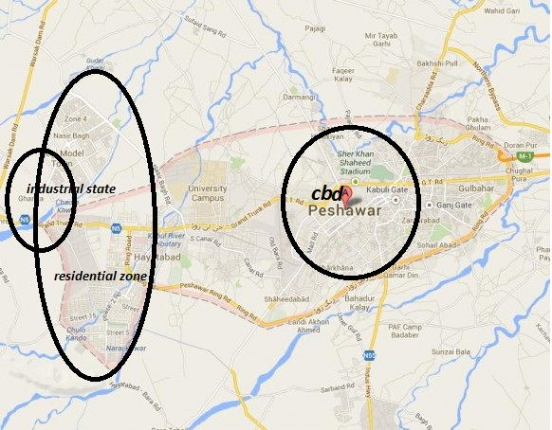

Forms of peshwar city:
Peshawar is the city of KPK and its largest city. And it’s the 6th largest city in Pakistan.
Peshawar is the largest pookton majority city in Pakistan Situated in the broad valley of Peshawar near the eastern end of the historic Khyber pass, close to the border of afganistan. Peshwar is one of the oldest city of Pakistan and south asia. Historically, the old city of Peshawar was a heavily guarded citadel that consisted of high walls. In the 21st century, only remnants of the walls remain, but the houses and havelis continue to be structures of significance. Most of the houses are constructed of unbaked bricks, with the incorporation of wooden structures for protection against earthquakes, with many composed of wooden doors and latticed wooden balconies. Numerous examples of the city's old architecture can still be seen in areas such as Sethi Mohallah. In the old city, located in inner-Peshawar, many historic monuments and bazaars exist in the 21st century, including the Mohabbat Khan Mosque, Kotla Mohsin Khan, Chowk Yadgar and the Qissa Khawani Bazaar. Due to the damage caused by rapid growth and development, the old walled city has been identified as an area that urgently requires restoration and protection.
The walled city was surrounded by several main gates that served as the main entry points into the city — in January 2012, an announcement was made that the government plans to address the damage that has left the gates largely non-existent over time, with all of the gates targeted for restoration.
The population of Peshawar district in 1998 was 2,026,851, the 2016 population of Peshawar district is estimated to be 3,405,414. With a population of 1,970,042 according to the 2017 census, Peshawar is the sixth-largest city of Pakistan. Peshawar's Industrial Estate on Jamrud Road is an industrial zone established in the 1960s on 868 acres. The industrial estate hosts furniture, marble industries, and food processing industries, though many of its plots remain underutilized. The Hayatabad Industrial Estate hosts 646 industrial units in Peshawar's western suburbs, though several of the units are no longer in use.

