NAME hira sabit ullah
ID 16525

Final-Term Assignment

Course Title: Human Physiology II
Rad 2nd semester section A
Instructor: Dr.M.Shahzeb khan (PT)
Marks: 50

Note:
- Attempt all questions, all questions carry equal marks.
- Answer Briefly and to the point, avoid un-necessary details

Q1: (A) How stimulus of smell moves from nostril to brain? Make a Diagram as well

ANSWER:
- As we know that the nose is an organ which is responsible for sense of smell and the sense of smell called olfaction.
- the sense of smell is called chemical senses because it detect chemicals from the environment and then transmit the sensation to brain
- olfactory nerve is associated with the sense of smell and starts from the nose and ends on primary and secondary cortex
- In the cavity of nose mucous membrane is present which have smell receptor connected to the olfactory nerve
- olfactory cell has a thick dendrite with an expanded end called olfactory rod.
- From rods cilia project to the mucous surface.cilia react to odors in the air and stimulate the olfactory cells.
- Olfactory bulb’s receives the information from axons of olfactory receptors neurons and transfer it to brain ( temporal lobe of cerebral cortex) . the brain centers perceive odors and acces memoris to remind.
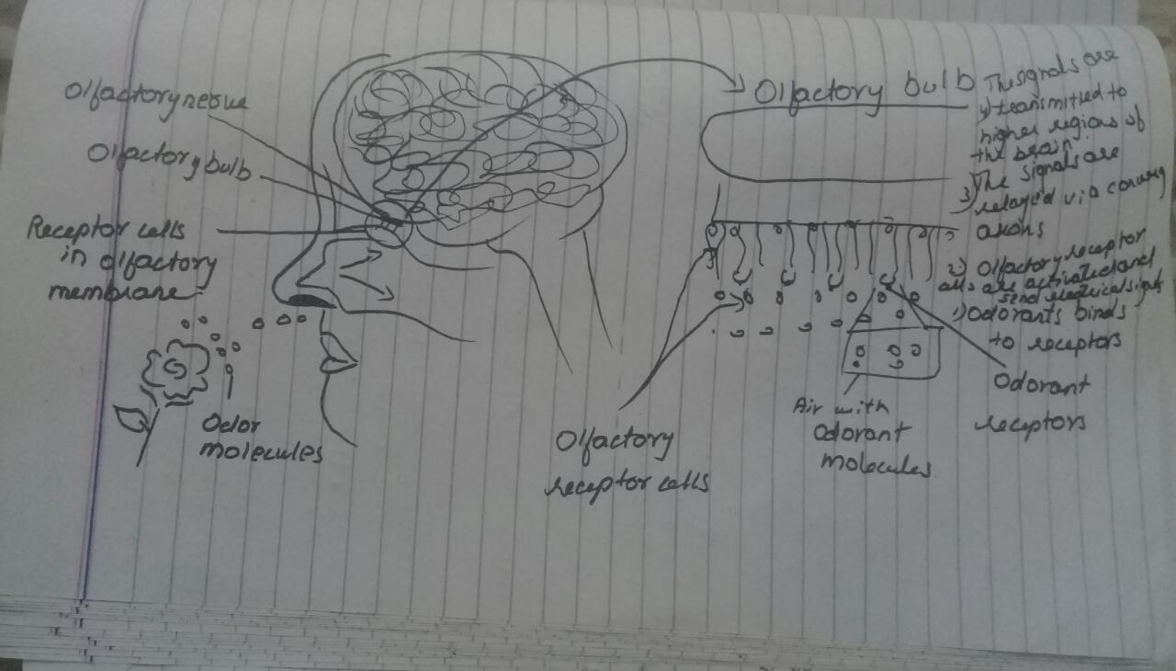

Q 2:(A) What is difference between Haemostasis, Haematopoiesis and Homeostasis?

ANSWER:

HAEMOSTASIS:
- Haemostasis is also called hemostasis .
- Haemostasis is the process to prevent and stop bleeding
- It keeps the blood within a damaged blood vessel.
- It is the first stage of wound healing.
- This involves coagulation, blood changing from a liquid to a gel
- Intact blood vessels are central to moderating blood’s tendency to form clots.

HEMATOPOIESIS:
- Hematopoiesis is the process where the formation of blood cells occur i-e , RBC’S , WBC’S and platelets.
Or
Haematopoiesis is the formation of blood cellular components.
- The sites where this process occurs are known as hemopoietic tissues or organs ( bone marrow, liver , spleen).
- All cellular blood components are derived from haematopoietic stem cells.

HOMEOSTASIS:
- Homeostasis literally means “ same state” .
- The process of keeping the internal body environment in a steady state. When the external environment is changed.
- Much of the hormone system and autonomic nervous system is dedicated to homeostasis , and their action is coordinated by the hypothalamus.

(B) What is Erythroblastosis fetalis?

ANSWER:

ERYTHROBLASTOSIS FETALIS:
Erythroblastosis fetalis is haemolytic disease of the newborn. Haemolytic is term which means ‘’ relating to or involving the rupture or destruction of red blood cells’’.
- It is a disease of the fetus and newborn child characterized by agglutination and phagocytosis of fetus’s red blood cells.
- Agglutination clumping of particles.
- Phagocytosis process where in a cell binds to the item it wants to engulf on the cell surface and draws the item inward while engulfing around it.
- In most cases of erythroblastosis fetalis, the mother is Rh negative while the father is Rh positive. The baby inherited Rh positive antigen from father, and the mother developd anti – Rh agglutinins from exposure to the fetus’s Rh antigen.
- In turns , the mother’s agglutinins diffuse through the placenta into the fetus and cause red blood cell agglutination.

SYMPTOMS AND SIGNS IN THE FETUS :
Enlarged liver , spleen , or heart.
Fluid bulidup in the fetus ‘ abdomen seen via ultrasound .

SYMPTOMS AND SIGNS IN THE NEWBORN:
Anemia that creates the newborn’s pallor ( pale appearance).
Jaundice or yellow discoloration of the newborn’s skin.
Enlargement of the newborns liver and spleen .
Severe edeme of the entire body.
Dyspnea or difficulty breathing.

Q3: (A) What is Immunity? Explain different types of immunity

Answer:

IMMUNITY:
Immuis resistance
Ity condition / occurance
IMMUNOLOGY the study of the structure and function of the immune system.

DEFINITION:
The ability of an organism to resist against harmful substance and protect itself from foreign toxin by the action of specific antibodies or sensitized white blood cells.
- In addition , we develop immune responses against our own proteins in autoimmunity and against our own aberrant cells in tumor immunity.
- Lack of immunity is known as susceptibility.
- Immunity is done by immune system which is the complex network of lymphoid organ such as bone marrow, thymus, and spleen etc.

TYPES OF HUMAN IMMUNITY:
- Human immunity is divided into two types.
- Innate immunity
- Acquired immunity

Innate immunity:
It is also called natural or native immunity.
It is natural resistance with which person is born. It is comes because of genetic and constitutional make up.
The innate immune system is the first part of the body to detect invaders such as viruses, bacteria , parasites and toxins.

TYPES OF INNATE IMMUNITY:
There are three types of innate immunity.
- Species immunity
- Racial immunity
- Individual immunity

SPEC IES IMMUNITY:
Species immunity is the total immunity shown by all members of a species against pathogens
Or
If one species is resistant to certain infection and other species is susceptible to the same infection then it is called as species immunity.
e.g birds immune to tetanus.

RACIAL IMMUNITY:
Natural immunity shared by all members of a particular race.
Racial immunity is that in which various races show marked difference in their resistance to certain infectious disease .
Or
In which a species different races show differences in susceptibility to infection.
Plasmodium falciparum malaria is resistance in Africa.

INDIVIDUAL IMMUNITY:
Where members of a certain group have a more developed immunity to specific diseases.
Some people are prone to cold sores caused by herpes virus , whereas other ( possibly in the same family ) have never experienced this type of infection.

ACQUIRED IMMUNITY:
Acquired ( adaptive or specific ) immunity is not present at birth. It is learned . the learning process starts when a person’s immune system encounters foreign invaders and recognizes nonself substance ( antigens).
- Types of acquired immunity
- Acquired immunity is of two types
- Active
- Passive

Active immunity:
The immunity which results from the production of antibodies by the immune system in response to the presence of an antigen.
- Natural active immunity:
Natural active immunity occurs when the person is exposed to a live pathogen , develops the disease , and become immune as a result of the primary immune response.
Example like small pox are cured by the active function of the immune system.
- Artificial active immunity:
Artificial active immunity refers to any immunization with an antigen. By giving a safe form of the antigen artificially , the body will produce its own antibodies and more importantly , develop circulating , long lived b memory cells with high affinity B cell receptos on their surface.

2 PASSIVE IMMUNITY :

Acquiring of the antibodies from an immunized donor to a non immunized recipient in known as passive immunity.
- Natural passive immunity:
It occurs when antibodies are transfer from donar to the recipient in a natural manner.
- Artificial passive immunity:
The transfer anti bodies and sensitized lymphocytes from immunized donar to the nonimmunized recipient artificially.

(B) What is difference between Antigen and Antibody?

Answer:

Antigen:
Antigens are molecules capable of stimulating an immune response . each antigen has distinct surface features, or epitops, resulting in specific responses,.
An antigen is a substance which when introduced into a body evokes an immune response to produce a specific antibody with which it reacts specifically.
Antigens are classified in order of their origins.
Exogenous antigens : are antigens that have entered the body from the outside.
Endogenous antigens : are antigens that have been generated within the cell as a result of normal cell metabolism.
An autoantigen is usually a normal protein or complex of proteins that is recognized by the immune system of patients who suffering from a specific autoimmune disease.
Immunogenicity:
Is the ability to induce a humoral and / or cell mediated immune responses.
Antigenicity:
The ability to bind with antibody.
Complete antigen
Incomplete antigen also known as hapten
- A complete antigen is one that is sufficient to unduce a full immune response.
- Incomplete antigens have antigenic determinants but cannot induce immune responses because they lack one or more of the important attributes needed for this function.
- Epitope , or antigenic determinents are the portions of antigen molecules that physically interact with paratopes of immune response molecules.

ANTIBODY:
Antibodies are Y shaped proteins produced by B cells of the immune system in response to exposure to antigens.
Each antibody contains a paratope which recognizes a specific epitope on an antigen acting like a lock and key binding mechanism. This binding helps to eliminate antigens from the body , either by direct neutralization or by tagging for other arms of the immune systems .

Neutralization of infectivity,
Phagocytosis,
Antibody dependent cellular cytotoxicity ( ADCC) where by an effector cell of the immune system actively lyses a target cell, whose membrane – surface antigens have been bound by specific antibodies).
Complement mediated lysis of pathogens or of infected cells antibodies activate the complement system to destroy bacterial cells by lysis.
ADCC is independent of the immune complement system that also lysis targets but does not require any other cell ADCC requires an effector cell which classically is known to be natural killer NK cells.

Q4: (A) Write down different functions of Antibody

Answer:
Antibodies are secreted into the blood and mucosa , where they bind to and inactivate foreign substances such as pathogens and toxins.

Function of antibody:
Neutralization of infectivity,
Phagocytosis,
Antibody dependent cellular cytotoxicity ( ADCC) where by an effector cell of the immune system actively lyses a target cell, whose membrane – surface antigens have been bound by specific antibodies).
Complement mediated lysis of pathogens or of infected cells antibodies activate the complement system to destroy bacterial cells by lysis.
ADCC is independent of the immune complement system that also lysis targets but does not require any other cell ADCC requires an effector cell which classically is known to be natural killer NK cells.
- Concentration of secreted antibodies is different at different stages of latent period.
- In the initial stage antibodies against the new antigens are almost absent and this period is known as lag phase.
- Antibodies gradually rise from zero stage to a maximum and this raising period is reffered as log phase
- After attaining maximum antibody levels remain constant for some time and the period with constant antibody levels is reffered as plateau phase.
- Presence of antigen is necessary for the production of plasma cells
- The antigen are removed by the action of antibody, B cells fail to get stimulation from antigens and stop producing plasma cells.
- The number of plasma cells producing Abs gradually decreases due to their short life.’
- Death plasma cells producing antibodies and drop in the formation of plasma cells leads to a reduced Abs level in the decline phase.

(B) Write difference between Primary and secondary response to an antigen

Primary response of an antigen:
The primary response occurs when an antigens comes in contact to the immune system for the first time. During this time the immune system has to learn to recognize antigen and how to make antibody against it eventually produce memory lymphocytes the person is exposed to the same antigen.

Secondary immune response:
Secondary immune response is the reaction of the immune system when it contacts an antigen for the second and subsequent time. Appears meainly in the lymp nodes and spleen. Appears mainly in the bone marrow and then in the spleen the lumph nodes. This occurs in response to the primary contact of the antigen.

Difference;

Primary immune response of antigen:
- Primary immune response occurs as a result of primary contact with an antigen
- Responding cell is naïve B cell and T cell .
- Lag phase is often longer ( 4 – 7 days) , sometime as long as weeks or months
- Levels of antibody reaches peak in 7 to 10 days.
- It takes longer time to establish immunity.
- First antibody produced is mainly IgM. Although small amount of IgG also produced .
- Amount of antibody produced depends on the nature of antigens. Usually produced in low produced amount.
- Antibody level declines rapidly .
- Primary response appears mainly in the lymph nodes spleen.
- Affinity of antibody of lower for its antigen.

Secondary immune response of antigen:
- This occurs as a result of second and subsequent exposure of the same antigen.
- Responding cell is memory cell.
- Lag phase is shorter ( 1 – 4 days ) due to the presence of memory cell.
- Level of antibody reaches peak in 3 to 5 days.
- Mainly IgG antibody is produced. Although sometimes small amount of IgM are produced.
- Usually 100 – 100 times more antibodies are produced .
- Antibodies level remain high for longer period.
- Secondary response appears mainly in the bone marrow , followed by the spleen and lymph nodes.
- Antibodies have greater affinity for antigen.

Q5: Write difference between cell mediated and Antibody Mediated Immunity

Answer:

Cell mediated immunity:
Cell mediated immunity is an immune response that does not involve antibodies. Rather, cell mediated immunity is the activation of phagocytes, antigen specific cytotoxic T lymphocytes and the release of various cytokines in response to antigen.
Cell mediated immunity is an immune response that does not involve antibodies but rather involves the avtivationof macrophages and NK cells , the production of antigen specific cytotoxic T lymphocytes, and the release of various cytokines in response to an antigen.
Cell mediated immunity can be acquired through T cells from someonr who is immune to the target disease or infection.
Cell mediated refers to the fact that the response is carried out by cytotoxic cell.
Example of cell mediated immunity is the delayed hypersensitivity response to the tuberculin skin test in people who have been infected with mycobacterium tuberculosis.
B cell proliferate and produce plasma cells. The plasma cells bear antibodies with the identical antigen specificity as the antigen receptors of the activated B cells.
The antibodies are released and circulate through the body binding to antigens .
B cells produce memory cells.
Cell mediated immunity is that arm of the immune response that does not involve antibodies but rather incorporates the activation of the macrophages and NK cells enabling them to destroy intracellular pathogens
The production of antigen specific CD8 cytotoxic T lymphocytes CTLs .

Antibody mediated immunity:
Main defence against extracellular encapsulated pyogenic bacteria like staphylococci and streptococci.
Humoral immunity also called antibody mediated immunity with assistace from helper T cells, B cells will differentiate into plasma B cells that can produce antibodies against a specific antigen.
The humoral immune system deals with antigens from pathogens that are freely circulating, or outside the infected cells.
Humoral immunity secretes antibodies to fight against , wheras cell mediated immunity secretes cytokines and no antibodies to attack the pathogens.
The humoral immunity is rapid or quick in their action against antigens, while the cell mediated immunity show delay though permanent action against any pathogens.
It mainly defends against fungi and protozoa it protects the body againt cancerous cells. It produces antibodies that circulate in the body it mainly defends against bacteria and virus that have already infected cells.
When a naive B cell interacts with an antigen specific for its surface antibody, it grts activated and starts dividing rapidly . the process is called clonal selection.
The phrnomenon of selective proliferation of B cells in response to their interaction with the antigen is called clonal selection.
Antibodies are the agents of humoral immunity .
Antibodies occur in the blood, in gastric and mucus secretions , and in breast milk.

