Name. Said Shahbaz

ID. 16565

Course. Microeconomics

Mid Term Paper (Summers)

**Answer # 3**

**Part A**

**Cardinal Utility**

Cardinal Utility is the idea that economic welfare can be directly observable and be given a value.

For example, people may be able to express the utility that consumption gives for certain goods. For example, if a Nissan car gives 5,000 units of utility, a BMW car would give 8,000 units. This is important for welfare economics which tries to put values on consumption. For example, allocative efficiency is said to occur when Marginal cost = Marginal Utility.

One way to try and put values on goods utility is to see what price they are willing to pay for a good.

If we are willing to pay £5,000 for a second-hand Nissan Car, we can infer we must get 5,000 utils. In other words, the value of cardinal utility is related to the price we are willing to pay.

The idea of cardinal utility is important to rational choice theory. The idea consumers make optimal choices to maximise their utility.

**Ordinal Utility**

In ordinal utility, the consumer only ranks choices in terms of preference but we do not give exact numerical figures for utility.

For example, we prefer a BMW car to a Nissan car, but we don’t say by how much.

It is argued this is more relevant in the real world. When deciding where to go for lunch, we may just decide I prefer an Italian restaurant to Chinese. We don’t calculate the exact levels of utility.

Carl Menger, an Austrian economist, developed concepts of utility which rested on ranked preferences.

**Total utility and Marginal utility**

In economics, utility refers to the amount of satisfaction that a consumer gains from a particular good or service.

**Total utility**

Refers to the complete amount of satisfaction gained by consuming a product for example drinking many glasses of cold water in hot summer until your thirst is satisfied.

**Marginal utility**

Refers to the satisfaction gained from an extra unit consumed for example taking sips of cold drinks or juice with each sips your get extra satisfaction.

If the marginal utility of the last item is positive then total utility will be increasing.

If the marginal utility of the last consumption is negative total utility will be falling.

Example of Marginal and Total Utility for Ice cream consumption.

[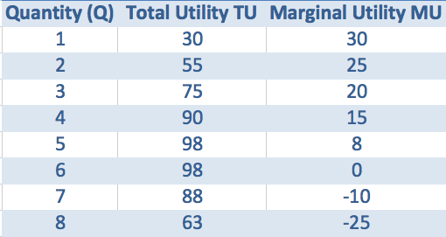](https://www.economicshelp.org/wp-content/uploads/2013/09/total-utility-graph.png)

Total utility is maximized at the point where Marginal utility is zero. (Quantity 5 or 6)

Total utility starts to fall when marginal utility is negative.

**Cost**

In [production](https://en.wikipedia.org/wiki/Production_(economics)), [research](https://en.wikipedia.org/wiki/Research), [retail](https://en.wikipedia.org/wiki/Retail), and [accounting](https://en.wikipedia.org/wiki/Accounting), a cost is the value of money that has been used up to produce something or deliver a service, and hence is not available for use anymore. In [business](https://en.wikipedia.org/wiki/Business), the cost may be one of acquisition, in which case the amount of money expended to acquire it is counted as cost.

**Benefit**

Benefit is something that will provide an advantage for others in terms of money, something you may receive as compensation from an insurance company or an event to raise money for a worthwhile cause or selling product or services.

**Part B**

A budget line represents various combinations of two goods, which can be purchased with a given amount of money at the given price of each unit.

Change in Consumer’s Income

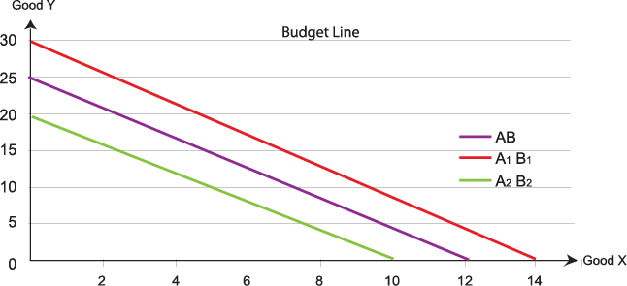

When there is an increase in income, a consumer can buy more of both goods and this shows an outward i.e. rightward shift in the budget line. On the other hand, when there is a decrease in income, the consumer's consumption possibility decreases, and the budget line shifts inwards.

With a specific income a consumer could buy 12 unit of Good X and 25 units of Good Y, it’s budget line can be seen in the graph in purple color, when the income of the consumer increases he can buy 14 units of Good X and 30 unit of Good Y which results to shift the budget line to the right side as it can be seen in the graph in red line, but when the income of the consumer decreases he can buy 10 unit of Good X and 20 units of Good Y which shifts the budget line to left side it can be seen in green color.

**Answer # 1**

**Part A**

**Opportunity cost**

When economists refer to the “opportunity cost” of a resource, they mean the value of the next-highest-valued alternative use of that resource. If, for example, you spend time and money going to a movie, you cannot spend that time at home reading a book, and you can’t spend the money on something else. If your next-best alternative to seeing the movie is reading the book, then the opportunity cost of seeing the movie is the money spent plus the pleasure you forgo by not reading the book.

The idea of an opportunity cost was first begun by John Stuart Mill.

1. Opportunity cost of studying for exam could be working online as a freelancer and earning money in this Pandemic where it is difficult to go out for work.
2. Opportunity cost of spending 2 hours playing computer games instead of doing exercise would be doing something productive like reading books or searching in internet to increase in our general knowledge.
3. Opportunity cost of going to a university instead of staying at home would be going to the fitness club or Gym for exercise because mental and physical fitness both are crucial.
4. Opportunity cost of spend $80 on some great shoes and not paying for electric bill would be saving the money for future outcomes or for university fee payment.

**Part B**

**Positive Economics**

Is the branch of [economics](https://en.wikipedia.org/wiki/Economics) that concerns the description and explanation of economic phenomena. It focuses on facts and cause-and-effect behavioral relationships and includes the development and testing of [economic theories](https://en.wikipedia.org/wiki/Economic_theory).

**Normative Economics**

Normative economics is a school of thought which believes that economics as a subject should pass value statements, judgments, and opinions on economic policies, statements, and projects. It evaluates situations and outcomes of economic behavior as morally good or bad.

An example of normative economics would be, "We should cut taxes in half to increase disposable income levels." By contrast, a positive or objective economic observation would be, "Based on past data, big tax cuts would help many people, but government budget constraints make that option unfeasible."

* There is an inverse relationship between wealth and demand for inferior goods. (Positive Economics)
* Wealth tax should be implemented to reduce the disproportionate distribution of wealth. (Normative Economics)
* Adopting protectionist policies results in shrinkage of the total global gross domestic product. (Positive Economics)
* An increase in tax rate ultimately decreases total tax revenue. (Positive Economics)
* Tariffs should be increased on imports from countries with poor human rights record. (Normative Economics)
* Developing countries should adopt democracy as a system only when they population is educated and emancipated. (Normative Economics)

**Answer # 2**

**Part A**

**Law of Diminishing Marginal Utility**

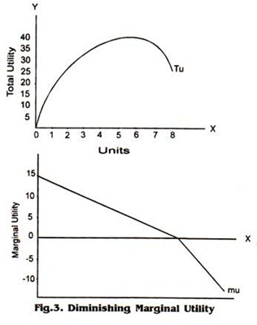

The first graph shows the total utility that a consumer gets from consuming a product, in the graph it can be seen that with each additional unit consumed the total utility keeps increasing until the consumer gets the highest total utility or satisfaction by consuming the product then it will decline because consumer don’t fell or have need for the commodity.

|  |  |  |
| --- | --- | --- |
| **Units of Commodity** | **Total Utility** | **Marginal Utility** |
| 1 | 15 | 15 |
| 2 | 25 | 10 |
| 3 | 30 | 5 |
| 4 | 35 | 5 |
| 5 | 40 | 5 |
| 6 | 40 | 0 |
| 7 | 35 | -5 |
| 8 | 25 | -10 |

The second graph shows the Marginal utility or additional utility that the consumer gets by consuming the product or commodity, the graphs starts from point 15 and declined to 0, at point zero it means that the consumer can’t get extra satisfaction by consuming the product and if keeps on consuming the product the marginal utility will be in negative which will be a burden for consumer to consume more of the commodity.

This law is called Law of Diminishing Marginal Utility which states that as consumption increases more and more, marginal utility will be less and less.

**Part B**

**Marginal Rate of Substitution**

Often times referred to as MRS, The marginal rate of substitution quantifies the amount of one good a consumer will give up to obtain more of another good; the slope of the indifference curve measures it. The principle of diminishing marginal utility states that as more and more of a good is consumed, consuming additional amounts will yield smaller and smaller additions to utility. MRS enables businesses to analyze how a rational user/consumer/organization chooses between two goods.

For example, I am in the process of choosing between burger or pizza for a little get together. In order to determine the marginal rate of substitution, I (consumer) is asked what combinations of burger and pizza provide the same level of satisfaction. When these combinations are graphed, the slope of the resulting line is negative. This means that I (consumer) faces a diminishing marginal rate of substitution: the more burger I have relative to pizza, the fewer pizza the consumer is willing to give up for more burger. If the marginal rate of substitution of burger for pizza were 2, then the individual would be willing to give up 2 pizzas in order to obtain 1 extra order of burger. Marginal product eventually diminishes because the cost of doing business increases with production. The company would need to make a change in the organization so that they can shift their production possibilities. Marginal rate of substitution diminishes over time because there is a principle of diminishing marginal utility; in other words, the more we consume something, the more willing we are to substitute it away.

**Part C**

**Characteristics of Indifference Curve**

1. Indifference curve slops to downward from left to right

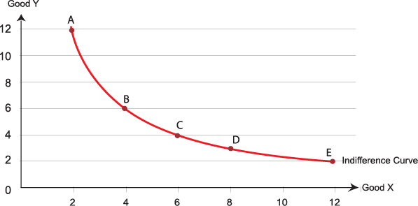

As it can be seem in the graph the indifference curve is in red color and sloped to down side and it is started from left side point A and moves to right side and ended at point E.

2. Indifference curve are convex to the origin.



As it can be seen in the graph that the red color indifference curve is convex to origin, it means that the bell shape point tends to be towards origin point (Origin is the point where the X axis and Y axis value is zero).