DPT IV
NAME: FAIQA HASSAN ID: 15137
Biochemistry
Final term
Marks 50
Attempt the following questions each carries equal marks
- Write brief note on steroid hormone?
ANSWER:
- Steroid hormone, Definition: any of a group of hormones that belong to the class of chemical compounds known as steroids.
- Glands secreting steroid hormones:
The adrenal cortex, testes, and ovaries and during pregnancy by the placenta.
- Derivation:
All steroid hormones are derived from cholesterol and differ only from each other on the basis of its ring structure and side chains attached to it.
- Permeability:
Steroid hormones are a major class of hormones characterized as being fat-soluble organic compounds that can easily pass through cell membranes.
On the basis of their receptors, steroid hormones have been classified into five groups: glucocorticoids, mineralocorticoids, androgens, estrogens and progesterone.

- Structure:
The steroid core structure is typically composed of seventeen carbon atoms bonded in four rings: three six-member cyclohexane rings and one five-member cyclopentane ring. Steroids vary by the functional groups attached to this four-ring core and by the oxidation state of the rings. Sterols are forms of steroids with a hydroxy group at position three and a skeleton derived from cholestane. Steroids can also be more radically modified, such as by changes to the ring structure, for example, cutting one of the rings. Cutting Ring B produces secosteroids one of which is vitamin D3.

- Solubility: All steroids are lipid soluble.
- Function:
Signaling molecules
Carbohydrate function (glucocorticoids)
Mineral balance (mineralocorticoids)
Reproductive balance (gonadal steroids)
Inflammatory responses (drug dexamethasone)
Stress responses
Bone metabolism
Cardiovascular fitness
Behavior
Cognition and mood.
- What is deamination and transanimation?
ANSWER: Transamination:
- Definition: Transamination is a type of biochemical reaction in which an amine group (-NH2) of amino acids transfers into other molecules with a keto (C=O) group.
- Explanation:
Here, the molecules with the keto group are known as keto acids. With the exchange of the amine group and the keto group, the amino acid becomes a keto acid and the keto acid becomes a new amino acid. Therefore, transamination is a major form of biochemical reaction responsible for the synthesis of nonessential amino acids from the body.
Transamination reactions occur in all cells in the body. Also, the enzymes responsible for these reactions are transaminases or aminotransferases. The general scheme of transamination reactions, 2-oxoglutarate (α-ketoglutarate), serves as the keto acid. In addition, pyridoxal phosphate serves as the cofactor. Most of the amino acids are involved in transamination reactions except lysine, threonine, proline, histidine, tryptophan, arginine, and methionine. Especially, glutamate is the main form of amino acid produced by most transamination reactions.

- Importance: transamination involves the synthesis of nonessential amino acids
- Occurrence: transamination occurs in all cell of the body
- Enzymes: transaminases or aminotransferases are the enzymes responsible for transamination
- Resulting in: transamination results in the exchange of an amine group with a keto group
- Glutamic acid: It is the main form of amino acid produced in transamination reactions
- Reversibility: transamination is a reversible reaction
- Conclusion: Transamination is a biochemical reaction undergone by amino acids. It is involved in the exchange of an amine group with a keto group. Transamination reactions are responsible for the synthesis of nonessential amino acids.
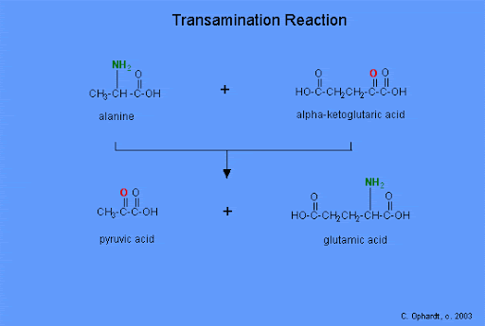

- Deamination
- Definition: A type of biochemical reaction responsible for the metabolism of amino acids.
- Explanation: It is responsible for the removal of an amine group from amino acids, releasing ammonia. Moreover, the liver uses deamination to breakdown excess protein in the diet. Also, the deamination reactions of glutamate occur in the kidney. It is because most transamination reactions produce glutamic acid; hence, it becomes the most frequent type of amino acid which undergoes deamination four types of deamination reactions can occur. They are oxidative, reduction, hydrolytic, and intramolecular deamination. Oxidative deamination is the most important form of deamination reaction in higher animals. It converts the amine group of the amino acids into the corresponding keto acid while releasing ammonia. In addition, in the reduction deamination, the amino acid becomes a fatty acid. On the other hand, in the hydrolytic deamination, the amino acid converts into a hydroxy acid. In intramolecular deamination, the amino acid converts into an unsaturated fatty acid. Deamination refers to the removal of an amino group from an amino acid or other compounds. Thus, this is the main difference between transamination and deamination.
- Importance: Deamination involves the breakdown of excess proteins.
- Occurrence: Deamination occurs in the liver
- Enzyme: Deaminases are the enzymes responsible for deamination.
- Resulting In: Deamination results in the elimination of ammonia.
- Glutamic Acid: The primary form of amino acid which undergoes deamination is glutamic acid.
- Reversibility: Deamination is an irreversible reaction
- Conclusion: Deamination is a biochemical reaction responsible for the breakdown of excess proteins in the liver. It involves the removal of the amine group from amino acids, releasing ammonia
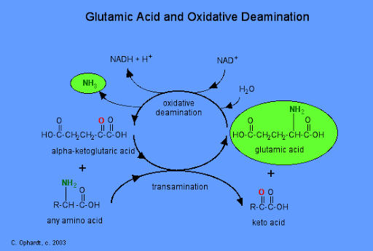

- Write down the metabolism of protein?
ANSWER: METABOLISM OF PROTEIN:
- Definition
- Protein metabolism is the chemical cycle of breaking down protein (catabolism) and using the components to synthesizing (anabolism) new molecules to be used in the body. The process is also known as proteometabolism.
- Protein anabolism is the process by which protein are formed from amino acids. It relies on five processes: amino acid synthesis, transcription, translation, post translational modifications, and protein folding. Proteins are made from amino acids. In humans, some amino acids can be synthesized using already existing intermediates. These amino acids are known as non-essential amino acids. Essential amino acids require intermediates not present in the human body. These intermediates must be ingested, mostly from eating other organisms.
- Protein catabolism is the breakdown of proteins into amino acids and simple derivative compounds, for transport into the cell through the plasma membrane and ultimately for the polymerization into new proteins via the use of ribonucleic acids (RNA) and ribosomes. Protein catabolism, which is the breakdown of macromolecules, is essentially a digestion process. Protein catabolism is most commonly carried out by non-specific endo- and exo-proteases. However, specific proteases are used for cleaving of proteins for regulatory and protein trafficking purposes. One example is the subclass of proteolytic enzymes called oligopeptidase.The amino acids produced by catabolism may be directly recycled to form new proteins, converted into different amino acids, or can undergo amino acid catabolism to be converted to other compounds via the Krebs cycle
- Function
Protein metabolism consists of a cycle of breaking down proteins, synthesizing new ones and removing nitrogenous waste products that result from these reactions. The amount of protein needed to balance this cycle changes throughout an individual' life. Growing children who are creating new muscle and bone, for example, have higher protein needs than adults.
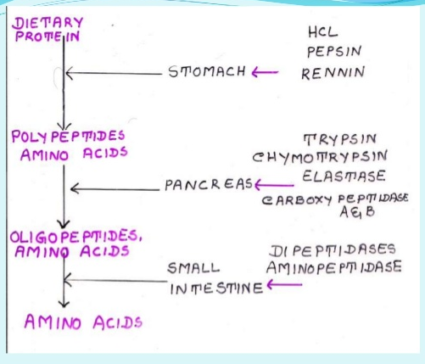

- Explain briefly translation of DNA in eukaryotes?
ANSWER:
- Translation (Protein Synthesis) in Eukaryotes
Translation involves translating the sequence of a messenger RNA (mRNA) molecule to a sequence of amino acids during protein synthesis.
It is the process in which ribosomes in the cytoplasm or ER synthesize proteins after the process of transcription of DNA to RNA.
Transcription and Translation of DNA in Eukaryotes
- General Description:
DNA contains genes .A gene is a continuous strand of nucleotide containing a region that originates RNA molecule.
This region begins with a promoter region and ends with a terminator .Gene also contain regular sequence that can be found near to promoter and a more distant location.
For some genes the encoded RNA is used to synthesize a protein in a process called Gene Expression. For these gene expression can be divided into two processes Transcription and Translation.
In eukaryotic cells transcription occurs in nucleus where DNA is used as Template to make messenger RNA. Whereas in Translation which occur in Cytoplasm of the cell the information contained in the messenger RNA is used to make a Polypeptide.
- Transcription:
During transcription the DNA and Template is used as a gene to make messenger RNA strand with the help of enzyme RNA polymerase. This process occur in three stages Initiation, Elongation and Termination.
- INIATIATION:
During initiation, the promoter region of the gene functions as a recognition site for RNA polymerase to bind this is where majority of gene expression is controlled by either permitting or blocking access to this site by RNA polymerase.
Binding causes the DNA double helix to unwind and open.
- ELONGATION :
Then during elongation the RNA polymerase slides along the template DNA strand. As a complementary base pair up the RNA polymerase links nucleotide to the 3` end of the growing RNA molecule. Once the RNA polymerase reaches the termination portion of the gene the messenger RNA Transcription is complete.
- TERMINATION :
Once it reach the termination site the RNA polymerase, the DNA strand and the
Messenger RNA transcript dissociate from each other.
The strands of messenger RNA that is made during transcription includes region called Exons that code for protein and a non-coding section called introns.
- Pre-translation modification :
In order of messenger to be used in translation, the non-coding introns need to be removed and modification such as 5` cap and a 3 ` poly A tail are added this process is called intron splicing is performed by complex made up of protein and RNA called a SPLICEOSOME . THIS complex removes the intron segments and join the adjacent exons to produce a mature messenger RNA strand that can leave the nucleus through a nuclear pore and enter cytoplasm to begin translation.
- TRANSLATION :
How is the information in a mature messenger RNA strand translated into a protein?
The nitrogenous bases are grouped into three letters codes called Codon. The genetic code includes 64 codons .Most codons codes for specific amino acids.
There are Four specific codons one that codes for START and the three that codes for stop.
i) INIATATION:
Translation begins with a messenger RNA strand binding to a small ribosomal subunit up stream to a start codon .Each amino acid is brought to a ribosome by a specific transfer RNA molecule.
The type of amino acid is determine by the anticodon sequence of transfer RNA .Complementary base pairing occurs between the codons of messenger RNA and the anti-codon of transfer RNA. After initiation transfer RNA molecule bind to a start codon, the larger ribosomal subunit binds to form the translation complex and initiation is complete.

ii) ELONGATION:
In larger ribosomal subunit there are three distinct regions called E,P and (A) sites .During elongation , individual amino acid are brought to mRNA strand by a Transfer RNA molecule through complementary base pairing of the codons and anticodons .Each anticodon of the transfer RNA corresponds to a particular amino acids .
(A) Charge Transfer RNA molecule bind to (A) site and a peptide bond forms between its amino acids and the one attached to a transfer RNA molecule at a P site. The complex slides down on E site to the right, where there a non-charged transfer RNA molecule exits from E site and (A) site is open to accept the next transfer RNA. Elongation will continue until a stop codon is reached.
iii) TERMINATION:
A release factor binds to (A) site at a stop codon and a polypeptide is released from transfer RNA reached.
A release factor bind to the A site at the stop codon and a polypeptide is released from a transfer RNA in a P site.
The entire complex dissociate and can resemble to begin the process again at initiation.
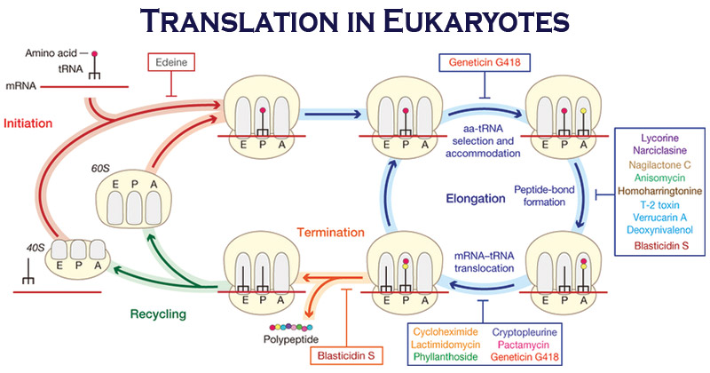

- Write down clinical significance of cholesterol?
ANSWER:
- CHOLESTEROL
It is required to build and maintain membranes.
It modulates membrane fluidity over the range of physiological temperatures.
It serves as a precursor for the biosynthesis of steroids hormones, bile acids, and vitamin D is the principal sterol synthesized by animals.
- CLINICAL SIGNIFICANCE:
- Atherosclerosis: Atherosclerosis refers to the buildup of fats, cholesterol and other substances in and on your artery walls which can restrict blood flow.
The plaque can burst, triggering a blood clot.
It can cause:
Coronary artery disease.
Carotid artery disease.
Peripheral arterial disease.
Diagnosis: A weak or absent pulse below the narrowed area of your artery
Decreased blood pressure in an affected limb
Whooshing sounds (bruits) over your arteries, heard using a stethoscope.
Diagnostic tests:
Blood tests
Doppler ultrasound test
Ankle-brachial index
Electrocardiogram (ECG)
Stress test
Cardiac catheterization and angiogram
(CT) scan
Magnetic resonance angiogram (MRA)
- Symptoms:
- Chest pain or angina.
- Pain in your leg, arm, and anywhere else that has a blocked artery.
- Shortness of breath.
- Fatigue.
- Confusion, which occurs if the blockage affects circulation to your brain.
- Muscle weakness in your legs from lack of circulation

- Treatment:
Cholesterol control:
Aggressively lowering your low-density lipoprotein (LDL) cholesterol, the bad cholesterol can slow, stop or even reverse the buildup of fatty deposits in your arteries. Boosting your high-density lipoprotein (HDL) cholesterol, the good cholesterol may also help.
- Other medications such as:
- Anti-platelet medications
- Beta blocker medications
- Angiotensin-converting enzyme (ACE) inhibitors
- Calcium channel blockers. Water pills (diuretics) can also be used.

- Hypercholesterolemia: Increased in plasma cholesterol Hypercholesterolemia is a condition which can be characterized by very high levels of cholesterol present in the blood. Individuals with hypercholesterolemia have a high risk of developing a form of heart disease called coronary artery disease.
- Hypocholesterolemia is the presence of abnormally low levels of cholesterol in the blood. It can also be due to malnutrition, decreased liver function, intestinal loss, hyperthyroidism, Addison’s-like disease.
- Xanthomas: If cholesterol accumulates in the tendons, it results in a characteristic growth called tendon Xanthomas.
- Xanthelasmata: Yellowish cholesterol that deposits under the skin of the eyelids are known as Xanthelasmata.

