Computer Applications (Major Assignment
Name "Zainab Ali
Id "16004"
Q. Different types of transmission media?
Your answer should include:
- Brief description of each media.
- Characteristics
- Benefits and limitations (if any)
Use appropriated diagram for each media type.
Ans:"Transmission"
Transmission media are necessary to form a computer network, as they are the physical paths between a transmitter and a receiver. In this lesson, let's learn the types of transmission media and the connectors.
Transmission Media & Types
In network communications, a transmission medium is a physical connection or an interface between the transmitter and the receiver. There are two major categories of transmission media, namely guided and wireless (or unguided).
There are two types of transmission
Guided Media
It is also referred to as Wired or Bounded transmission media. Signals being transmitted are directed and confined in a narrow pathway by using physical links.
Features:
- High Speed
- Secure
- Used for comparatively shorter distances
There are 3 major types of Guided Media:
(i) Twisted Pair Cable –
It consists of 2 separately insulated conductor wires wound about each other. Generally, several such pairs are bundled together in a protective sheath. They are the most widely used Transmission Media.
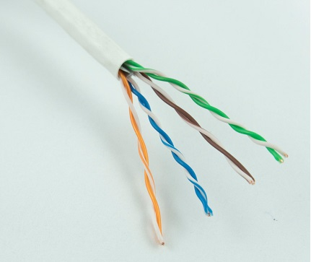
Twisted Pair is of two types:

1.Unshielded Twisted Pair (UTP):
This type of cable has the ability to block interference and does not depend on a physical shield for this purpose. It is used for telephonic applications.
Advantages:
- Least expensive
- Easy to install
- High speed capacity
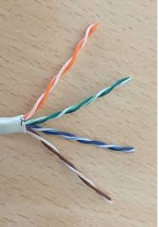
Unshielded Twisted Pair Cable
2. Shielded Twisted Pair (STP):
This type of cable consists of a special jacket to block external interference. It is used in fast-data-rate Ethernet and in voice and data channels of telephone lines.
Advantages
- Better performance at a higher data rate in comparison to UTP
- Eliminates crosstalk
- Comparitively faster
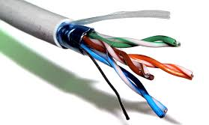
Shielded Twisted Pair cable

(ii) Coaxial Cable –
It has an outer plastic covering containing 2 parallel conductors each having a separate insulated protection cover. Coaxial cable transmits information in two modes: Baseband mode(dedicated cable bandwidth) and Broadband mode(cable bandwidth is split into separate ranges). Cable TVs and analog television networks widely use Coaxial cables.
Advantages
- High Bandwidth
- Better noise Immunity
- Easy to install and expand
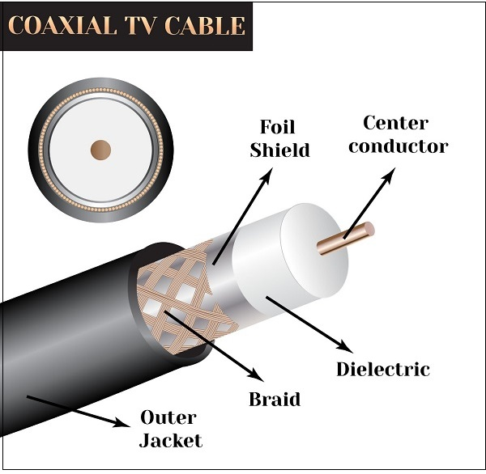
Coaxial cabla

(iii) Optical Fibre Cable –
It uses the concept of reflection of light through a core made up of glass or plastic. The core is surrounded by a less dense glass or plastic covering called the cladding. It is used for transmission of large volumes of data.
Advantages:
- Increased capacity and bandwidth
- Light weight
- Less signal attenuation
- Immunity to electromagnetic interference
- Resistance to corrosive materials e
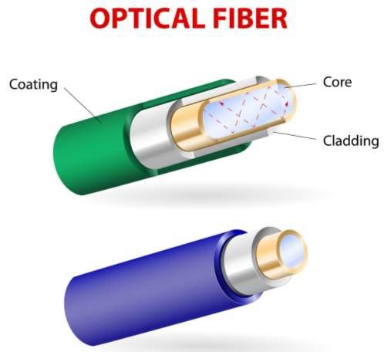
Optical fiber transmission

. Unguided Media:
It is also referred to as Wireless or Unbounded transmission media.No physical medium is required for the transmission of electromagnetic signals.
Features:
- Signal is broadcasted through air
- Less Secure
- Used for larger
Advantages of unguided media
- The signal is broadcasted through free space (air).
- Unguided signals can travel in several ways: sky propagation, ground propagation, and line-of-sight propagation.
- The electromagnetic spectrum, ranging from 3 kHz to 900 THz, used for wireless communication.

There are 3 major types of Unguided Media: :
(i) Radiowaves –
These are easy to generate and can penetrate through buildings. The sending and receiving antennas need not be aligned. Frequency Range:3KHz – 1GHz. AM and FM radios and cordless phones use Radiowaves for transmission.
Benefits
- One of the benefits is communication. Radio waves can help with communication by letting the astronauts out in space able to reach and talk to the people on earth.
- Another benefit is better navigation. Radio waves have enabled better navigaton on aircrafts and ships.
- The range in frequencies of radio waves is from 3Khz to 1 khz.
- In the case of radio waves, the sending and receiving antenna are not aligned, i.e., the wave sent by the sending antenna can be received by any receiving antenna.
- An example of the radio wave is FM radio.
(ii) Microwaves –
It is a line of sight transmission i.e. the sending and receiving antennas need to be properly aligned with each other. The distance covered by the signal is directly proportional to the height of the antenna. Frequency Range:1GHz – 300GHz. These are majorly used for mobile phone communication and television distribution.
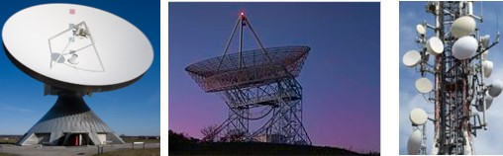
Types of Microwave Transmission
There are two types of microwave transmission.
- Terrestrial Microwave Transmission.
- Setallite Microwave Transmission.
Terrestrial Microwave Transmission
Terrestrial Microwave transmission is a technology that transmits the focused beam of a radio signal from one ground-based microwave transmission antenna to another.
Microwaves are the electromagnetic waves having the frequency in the range from 1GHz to 1000 GHz.
Microwaves are unidirectional as the sending and receiving antenna is to be aligned, i.e., the waves sent by the sending antenna are narrowly focussed.
Characteristics of Microwave:
Frequency range: The frequency range of terrestrial microwave is from 4-6 GHz to 21-23 GHz.
Bandwidth: It supports the bandwidth from 1 to 10 Mbps.
Short distance: It is inexpensive for short distance.
Long distance: It is expensive as it requires a higher tower for a longer distance.
Attenuation: Attenuation means loss of signal. It is affected by environmental conditions and antenna size.
Advantages of Microwave Transmission
- Used for long distance telephone communication
- Carries 1000's of voice channels at the same time
- Microwave transmission provides an easy communication in terrains as the installation of cable in terrain is quite a difficult task.
- Communication over oceans can be achieved by using microwave.
Satellite Microwave Communication
- A satellite is a physical object that revolves around the earth at a known height.
- Satellite communication is more reliable nowadays as it offers more flexibility than cable and fibre optic systems.
- We can communicate with any point on the globe by using satellite communication.
Advantages Of Satellite Microwave Communication:
- The coverage area of a satellite microwave is more than the terrestrial microwave.
- The transmission cost of the satellite is independent of the distance from the centre of the coverage area.
- Satellite communication is used in mobile and wireless communication applications.
- It is easy to install.

(iii) Infrared –
Characteristics Of Infrared:
It supports high bandwidth, and hence the data rate will be very high.
Infrared waves cannot penetrate the walls. Therefore, the infrared communication in one room cannot be interrupted by the nearby rooms.
An infrared communication provides better security with minimum interference.
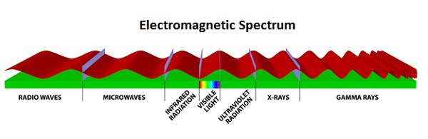
Advantage :-
- Asynchronous transmission is cheap and effective.
- It is used for low-speed transmission.

