PAPER

COURSE: WATER MICROBIOLOGY
EXAM: MID-TERM
INSTRUCTOR: SIR AMIR AFZAL
SUBMITTED BY: LATIF UR REHMAN
ID# 13808
SEMESTER: 6th
DATE: 18th APRIL 2020

IQRA NATIONAL UNIVERSITY
Q1: Explain briefly freshwater habitat with an ecological classification of freshwater animals?
Water microbiology
Water microbiology is the study of microbes such as bacteria, virus, fungi, protozoa and algae etc. that lives in the water.
Fresh water habitats
Fresh water is an essential component of life. Plants, animals, humans all need fresh water to survive. Fresh water is characterized by its low concentration of dissolved salts and some other dissolved solids. The fresh water habitats includes:
- Rivers
- Lakes
- Ponds
- Creeks
- Streams
- Bogs
- Glaciers
- Ice caps
- Ice bergs
- Ice sheets and
- Underground water etc.
Freshwater ecosystem
Freshwater ecosystems are a subset of earth’s ecosystems and is divided into two components i.e.
- Lentic ecosystem
- Lotic ecosystem

- Lentic ecosystem
Those water ecosystems which are not flowing are known as lentic ecosystems.
OR
The water which is standing are known as lentic water or lentic ecosystem.
- Lotic ecosystem
Those water ecosystems which are flowing are known as lotic ecosystems.
OR
The water which flows are known as lotic water or lotic ecosystem.
The abiotic factors such as light, alkalinity, temperature, PH, pressure etc. in both lentic and lotic ecosystems influence the life and growth of microorganisms.
Freshwater habitat with an ecological classification of freshwater animals
In all the fresh water habitats living activities takes place in different parts, i.e. at surface of the water, at middle of the water and at the bottom of water. The animals living in these fresh water ecosystems are:
- Plankton
- Nekton and
- Benthos

- Plankton
Those organisms which lives in water and are unable to swim against a current are known as planktons.
They are free floating animals/plants present on the surface of water. They includes both autotrophs (Phytoplanktons) and heterotrophs (Zooplanktons). They form the basis of food chains in water and are therefore important for the survival of water ecosystems.
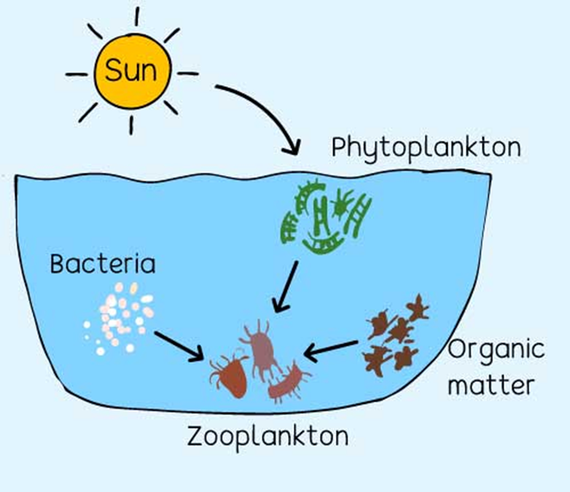
They maybe:
- Unicellular or
- Multicellular
Planktons are classified into two groups. i.e.
- Phytoplanktons
- Zooplanktons
- Phytoplanktons
They are autotrophic organisms, prepare their own food by using heat energy from the sun and are the basis of food chains in water ecosystems.
- Zooplanktons
They are heterotrophic organisms and are present at the surface of fresh water.

Planktons don’t dwell in any specific location as they constantly moves with the movement of water and are therefore known as “drifters” and “wanderers”.
Excessive bloom of planktons over a specific area can block the sunlight that enters into the water which is not good for other life forms in that ecosystem.
In basic food chain phytoplanktons prepare their food from sunlight and zooplanktons feeds on phytoplanktons, organic matter and other organisms for their survival and growth.

- Nekton
Nektons are heterotrophic organisms that are able to swim and move independently in water. It includes all swimming organisms present in water. They are heterotrophs, means that they don’t produce their own food, they depend on other organisms for their survival and growth and they can be both herbivores and as well as carnivores.
Nektons can be vertebrates such as fishes, seals, reptiles etc. and can also be invertebrates such as mollusks, arthropods etc. They have an important role in fresh water ecosystem as they provide food for other organisms and also helps in the organic makeup of the seabed. They can be affected by abiotic factors such as PH, temperature, pressure etc. but they are good swimmers, they move to favorable conditions as they detect any negative changes in their habitat.
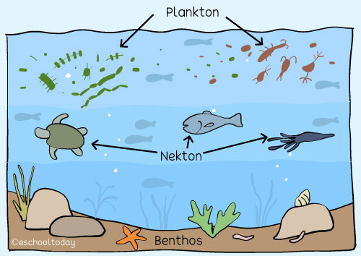
Smaller nektons depends on plankton for food while larger animals depends on nektons and as well as on other small animals for the food.
- Benthos
Benthos are organisms that lives in the benthic zone. Those organisms or communities that are living at or beneath the surface of the sea floor are known as benthos.
They include organisms such as sponges, sea stars, crabs, worms etc.
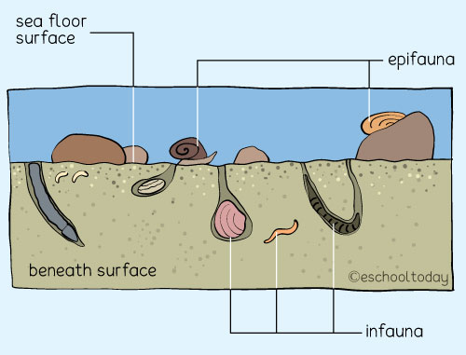

There are two groups of benthic organisms based on their habitat, i.e.
- Infauna
- Epifauna
- Infauna
Those organisms which lives in the sediment or layer of particles at sea floor are known as Infauna. Those sediments can be organic matter, rock debris, and fish droppings etc.
Infauna include organisms such as macoma, polydora, diatoms, worms, and flagellates etc.
- Epifauna
Those organisms which lives on the sediment or layer of particles at sea floor are known as Epifauna. They attach themselves to the rocks and debris, and many of them can also move. Epifauna includes organisms such as starfishes, crabs, snails and mussels etc.

Both infauna and epifauna enrich their environments with minerals and nutrients by breaking organic matters.

Q2: a) Why is water stratification important?
Importance of water stratification
Stratification of water is important as it creates barriers for nutrients mixing between the different layers, i.e. epilimnion, metalimnion and hypolimnion. Following are some of the importance of water stratification:
- Divergence and convergence of bacterial communities
The bacterial communities living in epilimnion, metalimnion and hypolimnion diverge during summer stratification and converged when lakes are mixed, while bacteria living in sediments remains stable over the year.
- Density differences
Due to stratification of water, the density differences in different layers facilitates evolution of chemical differences with many consequences for living organisms. Temperature and dissolve substances also contributes to density differences in water.
- Turn over
During thermal stratification the water of the epilimnion layer becomes cool due to conduction, evaporation and convection. The lakes attains uniform temperature from top to bottom as the water is now of uniform density and is well mixed by wind and wave action, called fall turnover which results in uniform distribution of nutrients, dissolved oxygen and planktons.
- Uniform temperature & circulation of oxygen
Due to winds in summer and fall seasons. There is a mixing between the top and bottom layers resulting in uniform temperature of water and also in circulation of oxygen throughout the lakes and ponds.
- Provide support and promotes productivity
The epilimnion layer is highly oxygenated and can tolerate high temperatures which promotes algal productivity and supports zooplanktons and fishes. When nutrients are in ample amount, algal growth is accelerated and blooms may occur.

- Sinking of organic matter to the hypolimnion
The hypolimnion is cold and dark where light can’t reach so the dead organisms in the epilimnion layer sinks down to the hypolimnion layer due to which it becomes nutrient rich and the organisms then feed on that organic matters. We can say that the epilimnetic material provides and energy source for the hypolimnion organisms.

b) Compare and contrast Epilimnion and Hypolimnion in terms of weather
Epilimnion
Epilimnion is the upper layer of water which usually have the highest dissolved oxygen concentration and have a temperature gradient of less than 1ºC per meter of depth. It contains fairy turbulent, circulating and uniformly warm water.
Hypolimnion
Hypolimnion is the lowest layer of water which is characterized by a temperature gradient of less than 1ºC per meter of depth. It contains relatively quiet, denser and cooler water.
Epilimnion and Hypolimnion in terms of weather
During spring and fall seasons
During stratification in spring the metalimnion was observed 2-10m, which then drops to 16-21m in summers and in fall it again appears between 24-26m depth.
During stratification in spring and fall seasons, the temperature and PH is significantly high in the epilimnion layer and drops in the hypolimnion layer.
During summer
During summer the hypolimnion becomes depleted of oxygen due to the biological oxygen demand by the decomposers.
During summer the lakes are very clear and permits photosynthesis, due to the oxygen demand by the bacterial decomposers. They reduced the photosynthetic activity and the minimal mixing with the upper layer of water resulting in density differences.
During autumn
During thermal stratification in autumns, the epilimnion layer gradually cools as a result of conduction, evaporation and convection.
During autumn the lakes attain uniform temperature from top to bottom and the water density also becomes uniform by well mixing with each other due to wave and wind action. As a result, the nutrients, dissolved oxygen and planktons are uniformly distributed between the layers.
During winter
During the winter, the lakes attain a uniform temperature of 4ºC which has the maximal density and the lakes become colder as the surface cools below and becomes lighter. Eventually the surface water may freezes to 0ºC.
During the winter season, the ice-covers which are formed on the surface of the epilimnion layer, there exist an inverse stratification of water temperature, means that the coldest water is at the surface and the warmest water is at the bottom of the lake.

Q3: a) What is the difference between the pour-plate method and the spread-plate method in the isolation of bacterial colonies?
Difference between the pour-plate method and the spread-plate method in the isolation of bacterial colonies
S.no. | Pour-plate method | Spread-plate method
1. | Definition  A microbial technique that is used to enumerate the number of viable cells in a sample. | Definition  A microbial technique that is used to enumerate bacterial colonies on the surface of media.
2. | Alternative definition  A plate prepared by mixing the inoculum with the cooled molten medium before pouring the latter into the petri dish. | Alternative definition  A technique use to isolate or count the bacterial colonies on a surface of agar.
3. | Sample adding  Molten agar is poured on inoculum in a petri dish and then gently swirled. | Sample adding  Inoculum is spread on the solidified agar on a plate by a spreader.
4. | Medium used  Liquid molten agar media necessarily performs pour plate method. | Medium used  Solidify agar media necessarily performs spread plate method.
5. | Growth of microbes  Aerobes, anaerobes and facultative anaerobes are enumerated by pour-plate method. It also allows the growth of micro aerophiles. | Growth of microbes  Only aerobes are enumerated by spread-plate method.
6. | Sample/Inoculum amount  Amount of inoculum is 1ml. | Sample/Inoculum amount  Amount of inoculum is 0.1ml.
7. | Colony Growth  Colony growth is in and on the medium. | Colony Growth  Colony growth is on the surface of the medium.
8. | Growth area  It is having more area for growth. | Growth area  It is having less area for growth.
9. | Purpose  It is used to count the number of colony forming bacteria in a sample. | Purpose  It is used to isolate specific clonal colonies.
10. | 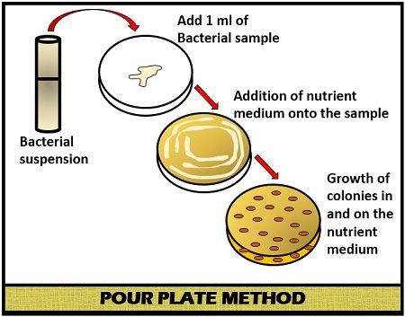

b) The advantage of pour-plate over spread-plate method
Advantages of pour-plate over spread-plate method
Pour plate method is a method for enumeration of bacteria in which a plate is prepared by mixing the inoculum with the cooled molten medium before pouring the latter into the petri dish. Following are some the advantages of pour-plate method over the spread-plate method:
- Grow variety of microbes
On pour plate method we can grow variety of microbes such as aerobic, anaerobic, facultative anaerobes and as well as aerophiles while on spread plate method we can only grow aerobic microorganisms.
- Large sample size
We can obtain large sample size on pour-plate method as microbes can grow in the media and as well as on the media while in spread-plate method microbes can only grow on the surface of the media.
- Doesn’t require previously prepared plates
Pour-plate method has the advantage of not requiring the previously prepared plates that is often used to assay bacterial contamination of foodstuffs.
- Determine microbes/ml in specimen
The pour-plate method has the advantage over the spread-plate method as they can be used to determine the number of microbes per milliliter in a specimen.
- No pre-drying
The pour-plate method doesn’t require any pre-drying of their agar surface as they are poured with the inoculum.
- More area for growth
The pour-plate method has more area for the growth of microbes because microbes can grow inside the medium and as well as on the outside of the medium while in spread-plates method microbes can grow only on the surface of media. Therefore it has low area for the growth of microbes.

