Name: FARISHTA SHAKEEL
ID: 15687
BS RADIOLOGY

1. A metatarsal bone has the following basic parts:
A. Head, shaft, and tail
B. Head, shaft, and base✅
C. Head, neck, tubercle, and bas
D. Head, neck, tubercle, and tail
2. Sustentaculum tali is located on______ of calcaneum.
A. Medial surface✅
B. Lateral surface
C. Anterior surface
D. Superior surface
3. Circumduction is the combination of?
A. Flexion, extension, medial rotation, and lateral rotation
B. Flexion, extension, abduction, and adduction ✅
C. Abduction, adduction, medial rotation, and lateral rotation
D. Extension, adduction, medial rotation, and lateral rotation
4. It looks like inverted Y shaped:
A. Iliofemoral ligament✅
B. Pubofemoral ligament
C. Ischiofemoral ligament£
D. Plantar aponeurosis

5. The increase in neck angle with the shaft of the femur is called:
A. Coxa valga✅
B. Coxa vara
C. Coxa Benda
D. Coxa increase
6. The floor of the acetabulum is non-articular called:
A. Acetabular margin✅
B. Acetabular margin
C. Acetabular notch
D. Capsule
7. The tubercle separating the tendons of peroneus longus and peroneus brevis is:
A. Anterior tubercle
B. Posterior tubercle
C. Medial tubercle
D. Peroneal tubercle✅
8. The symphysis pubis is:
A. Primary cartilaginous joint
B. Secondary cartilaginous joint✅
C. Synovial joint
D. Fibrous joint
9. Which bone does not part in the formation of the knee joint?
A. Femur
B. Tibia
C. Fibula✅
D. Patella
10. Regarding tibia:
A. Anterior border is subcutaneous✅
B. Lateral border is subcutaneous
C. Medial border is subcutaneous
D. Medial surface is subcutaneous
Q.1 Describe the arches of foot. Name the factors responsible for the maintenance of these arches.

Ans:
The arches of the foot, formed by the tarsals and metatarsals bones, strengthened by ligaments and tendons, allow the foot to support the weight of the body in the erect posture with least weight. They are categorized as longitudinal, transverse arches.
Factors responsible for maintenance of arches
- Shape of the bones
- Intersegment ties or ligaments and muscles hold different segments of arch together.
- The beams that connect the two ends of the arch… concavity of arches propro
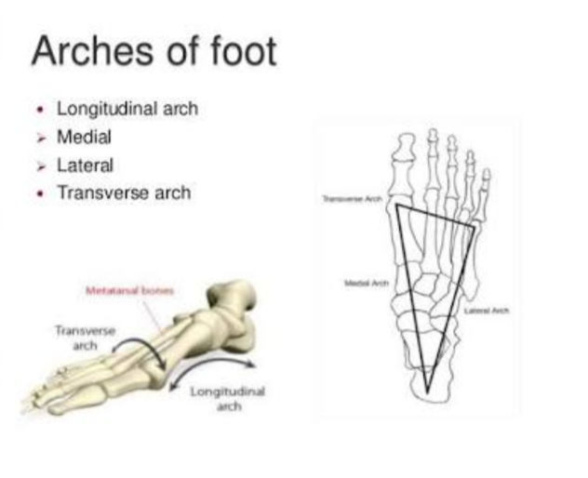
Medical longitudinal arch
Is formed of calcaneum, talus, navicular, 3 cuneiform bones and first medial 3 metatarsal bones.
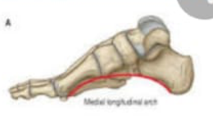

Lateral longitudinal arch
Is formed of calcaneum, cuboid and lateral 4th and 5th metatarsal bones

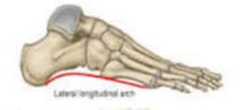

Transverse arch

Lies at the level of tarsometatarsal joints formed of bases of metatarsal bones cuboid and 3 cuneiform bones
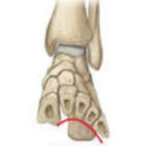

Q2.Mention the attachments, nerve supply and actions of the muscle largely responsible for the prominence of buttocks. Which site is safe for the intramuscular injection in this region?
Ans
Gluteus Maximus. Gluteus maximus is the largest muscle of the human body.
Location:
It lies superficial in the gluteal region and is largely responsible for the prominence of buttock.
Parts:
Gluteal muscles. The gluteal muscles are a group of three muscles which make up the buttock:
- The gluteus maximus
- Gluteus Medius
- Gluteus minimus
Structure: The Gluteus Medius muscles starts, originates on the outer surface of the ilium between the iliac crest and the posterior gluteal line above, and the anterior gluteal line below; the gluteal Medius also originates from the gluteal aponeurosis that cover its outer surface.
Nerve : superior and inferior gluteal nerves ( L4, L5, S1and S2 nerve roots)

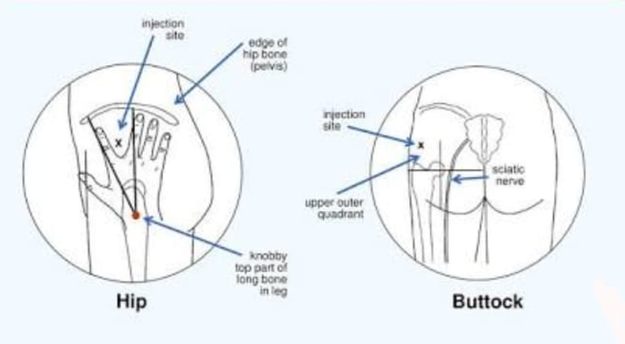

Q 3. How greater and lesser sciatic foramina formed and enlist the structures passing through them
Ans: Greater sciatic foramina:
The greater sciatic foramen is formed by the greater sciatic notch of the hip bone and the sacrotuberous and sacrospinous ligaments. It provides an exit from the pelvis an exit the from the pelvis into the gluteal region.
Structures:
- Piriformis
- Sciatic nerve
- Posterior cutaneous nerve of the thigh
- Superior and inferior gluteal nerves
- Pudendal nerve
- Internal pudendal artery and vein.

Lesser sciatic foramina: The lesser sciatic foramen is formed by the lesser sciatic notch of the hip bone and sacrotuberous and sacrospinous ligaments. It provides an entrance into the perineum from the gluteal region. It presence enables nerves and blood vessels that have left the pelvis through The greater sciatic foreman above the pelvic floor to enter the perineum below the pelvic floor,
Structures:
- tendons of obturator internus muscles
- Nerve to obturator internus
- Pudendal nerve
- Internal pudendal artery and vein.

Q4. What are hamstring muscles? Give their origin, insertion, nerve supply and action.

Ans:
In the human anatomy, a hamstring is any one of the three posterior thigh muscles in between the hip and the knee ( from medial to lateral). The hamstring are quite susceptible to injury.

Origin: Gluteal surface of ilium, lumbar fascia, sacrum, sacrotuberous ligament

Insertion : Gluteal tuberosity of the femur and iliotibial tract

Artery: Superior and inferior gluteal arteries

Nerve: Inferior gluteal nerve(L5, S1 and S2 nerve roots)

Action : External rotation and extension of the hip joint, supports the extended knee through the iliotibial tract, chief antigravity muscle in sitting and abduction of the hip

Nerve supply : the hamstring are innervated by the sciatic nerve, specifically by a main branch of it:

- The Gluteus nerve.
- The short head of the biceps femoris is innervated by the common fibula nerve.

