Topic
Ancient Etruscan and Roman Civilization

Etruscan is the name of Ancient Italy civilization . Central Itlay was its homeland . Just north of Rome , which is called Tuscany today .
A long tube ago there was a tradition that Etruscans had emigrated from Lydia . Which is present on the eastern side of Turkey . Modern historians discount the idea and believe that the Etruscans were an indigenous population . The sudden flowering of Etruscan civilization at date earlier than the indigenous people of central and north Itlay probably points to the blossoming of strong trading relations between the people of the area . Mining of metals like copper and iron especially led to the development of Etruscans , and to greater material culture .
This Etruscan culture begin in 8th century BCE . It was expanded over the whole wide area of Itlay in the 6th century and expanded its influence over over Itlay . The Ancient Rome was highly influence by the Etruscan civilization and culture .
It also maintain control over Corsica . The Etruscan power declined in between 6th and 4th centuries BEC . The Greek city states which were rising power had weekend the Etruscan political and military system , those cities which dominated or founded , like Rome throw out their overloads and became independent city states . Galllic tribes migrated to northern Itlay and destroyed Etruscan cities . But still in their homeland Etruscan cities were powerful and were the opponents and enemies of rising power of Rome . This was over long period , in the 4th and 3th centuries BEC ,they give out their independence to Romans .
They spoke a their own unique language , which was different from their nighbours . Greek trader affect their culture and Greek colonist of southern Itlay also affect their culture . Etruscan alphabets in its origin are greek . And in turn they passed on their alphabet to the Romans . The Etruscans considered the city states as their political units from Greeks before their neighbour in Central Itlay .
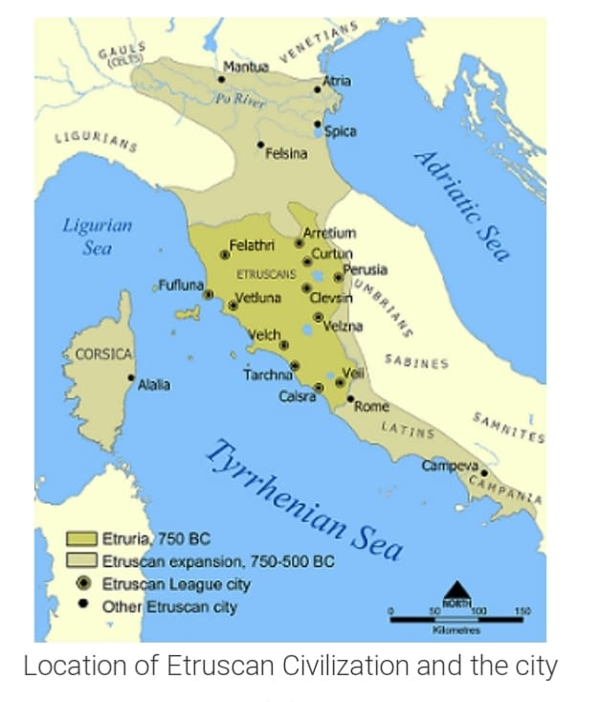

The Etruscans land was divided into twelve city – states , but new cities sprang up as the with the Etruscans extended their influence . Most Etruscan cities migrated from monarchy to oligarchy in 6th century BEC like Greeks . Some maintained back their monarchies .
Many different cities of Eutria were united through same religion and apparently too by Loose political confederacy . They didn’t stop their states from war with each other . The Etruscan maintained their religious system like Greeks and Roman they were believing in polytheism and believing in many gods and godesess ; later on Greek daties were put in to Etruscan system .
These daties were working for men and could be persuaded to influence human affairs . Its had that , to understand the will and wishes of the gods , and how to affect and interact them , It had been written down in series of mysterious sacred books these books were only near and known Priests Walfare was a great aspect of their political life like other old societies ; the Etruscans conducted tests and compaign during summer , raiding nibour areas , trying to gain territory and engaging in Pirag Men, s sacrifice was a great property and feature of their own religion and
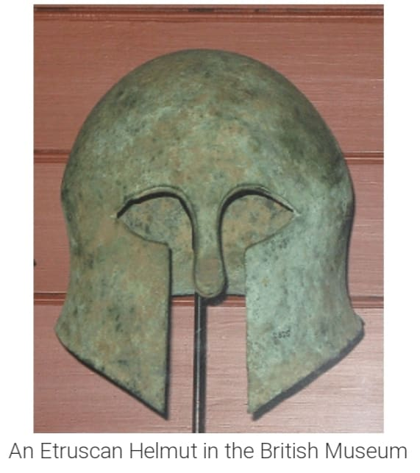

War Prisioners could end on the altars of their gods Prisioner were sometime put into fight each other as a part of sacrifice . Roman took out their exercise later .

It was developed into entertainment of Komans amphitheatres . The Art of survival come down to us is figurative sculpture in terracotta and cast bronze , wall painting and metalworking .
Their art was connected to their religion up to a great extent . This was the especiallity of of their art and also shows the importances of their art . They used to made many musical instruments . Especially the pipes in the musical instruments was their famous products e.g pan pipes and double pipes , precasion instrument .
The records which are written for the origin of Etruscan which remain are inscriptions , mainly funerary . The literature of Etruscan is the evidence in reference by later Roman authors .
The Archeitecture of Etruscans was mainly derived from Greeks and gone on to the influence of early Rome . Rome is located at the place which was a side the Etruscans Land . Many customs and institutions were shifted directly from Etruscans to Rome . In reality , the real name of Rome was from the origin of Etruscans .
re were strong elements of Latin Italin but later on the Romans celebrated and welcomed these many different origins .
Before the arrival of Etruscans Rome was contained of very small farming settlement . It elite provided it with a political system and arrangments and urban Infrastructure .
They were those people who developed Rome into a full blown aty state . Some words were entered into the latin language but those words were not tend to be done with the authority of this state .
The fasces symbolized magisterial power . The word populas is derived from Etruscans and it refer to the assembled people which go for fight andAs there are the names the name of their great and talented founders Romulus and Remus . At first the as an army .
Rome was greatly affected by its Etruscan rulers whose imprint was seen in writing , art and Architecture of Romans . And also can be seen in their religion and military matters and also many daily aspects of life .
So it helps a lot to make Roman civilization . The Etruscans on western culture later .
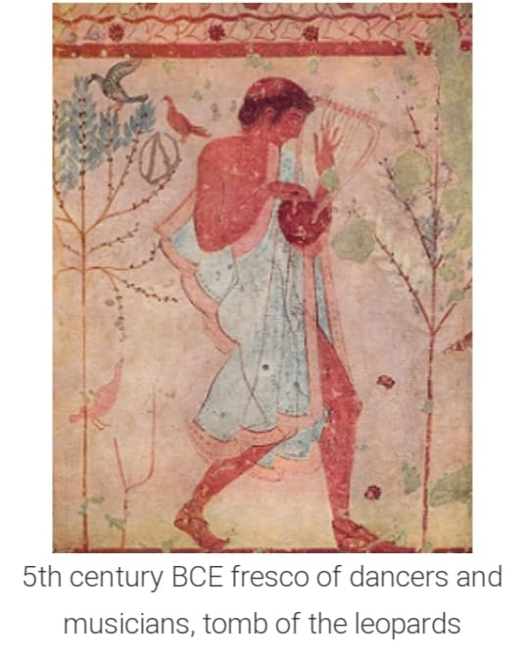
Circus Maximus
It was a chariot racetrack in Rome which was first constructed in 6th century BEC. It was also used for many public events like Roman Games and fight of gladiators and finally this was used for races .
This excavated partially in the 20th century CE . It was remolded back but it is one of the important place of modern city today . It also has the capacity to lost a huge numbers of crowds at rallies and musics concerts . It is situated in the valley in between Palatine and Aventine hills . It is the most longest and greatest public place in Rome .
Many great people say that it was originally laid out in 6th century BEC by the very first Roman king . In the beginning its shape was taken under Julius Cesar .
Its main function and property was chariot Race track and was the host of Games which were played by the Romans there were the most oldest games which were played every September for 14 or 15 days . Rome had many other games and 20 n games were of the type which were held and have one day at Circus Maximus .
Many other events were also hosted at this track which included the hunting of wild animals and public excavation and fights of gladiators . Among these fights , some were very great and greater level , such as pompay organized a contest between barbarian gladiators and 20 elephants .
During 1st century CE following its rebuilding after a five of 64 CE . This track had the capacity of 250,000 crowd which can set on the side of 30m wide and 28m high .
The seats were made of stone and concrete .

