Name : Irfanullah Affan
ID: 14862
Paper: pathology and microbiology
Submitt To: Dr. Imran khan
QNO1:What is cancer ?How cancer is diagnosed? What is the role of genetics in cencer ?Also explain TNM diagnostic test focancer ?
ANS: The word cancer is Greak word which mean ‘crab’ due to appendages it is a genetic pathology because itcan occure it any place in a body .It is nor specific orgen . A number of enviromental physical , radioactive substance can be the cause of cancer disease in all type of cancer .Some of the body cell begin to divide without stopping and spread into surrounding tissues cancer can start almost any where in the human body, which is made up of trillions of cells normally , human cell grow and divide to form new cells as the body needs them when cell grow old or become damage , they die , and new cells takes there place . When cancer develops this process break down as cell repidily increases abnormally old and damage cells survive how ever normly they meed to die and new cell should replace it ,these extra cell can divide without stopping and may form growths called tumor many cancer form solid tumor which are masses of tissue cancer of the blood such as leukeima do not form solid tumor cancerous are malignant which means they can spread near by tissue in addition as these tumor grows some cancer cells can break of and travel to distant placess through blood or lymph and form new tumor far from the orignal tumor on the other hand benign tumors duo do not spread to other organ they can sometime be very large in size once they are removed they do not grow back ,where as the malignant can grow back the cancer cells differ from normal cell in many ways . Cancer cell divide out of control and become in invasive and cancer cell are less specialized then normal cells ,normal cells mature into distinct cell types with specific function , and cancer cell do not and this is one reason cancer cells contineously under goes division nonstop . cancer cells ignore signals that tells to stop dividing or start a process known as programed cell death called apoptosis.
Role of genetic in cancer :
Cancer is a genetic disease ,it is caused by changes to genes especially to those genes that control growth and division of cells.Genetic changes that causes cancer can be inherited from parents to offsprings .However they can also arise in person life as a result of error that occur during cell division or damage to DNA due to environmental exposure.
Genetic changes that contribute to cancer trnd to effect three main types of genes .
PROTO- ONCOGENES :
Proto-oncogenes are involved in normal growth anddivision of cells .However when these genes are altered in certain ways or become active than normal they may become cancer causing gene (or oncogene).allowing cells to grow and survive when they should not .
TUMOR SUPPRESSOR GENE:
They are involved in controlling cell growth and division . cells with changes in these genes may divide in uncontrolled manner.
DNA REPAIR GENE :
They are involved in fixing damage to DNA . cells with mutation in these genes tend to developed mutation in other genes .
Togather these mutation may cause the cell to become cancerous .
GENE REGULATING APOPTOSIS :
Apoptosis is programed cell death ir altered normal cell death and a result growth of cell is formed in a region .
Diagnosis of cancer :
PLEOMORPHISM: (variation in size and shape )
Cancer cells are different in size and shape from parents cell .
ABNORMAL NUCLEUS :
- Nuclear content abnormal :
Chromosome may be increased or decreased than normal due to mutation .
- Nucleus to cytoplasm ratio :
In normal cell nucleus to cytoplasm ratio is 4:1 or 6:1 . where as in cancerous cell nucleus to cytoplasm ratio is 1:1 .
Atypical mitosis :
Normal mitotis is typical but in case of cancer mitosis become atypical because in cancer cell division become repid .
Loss of polarity :
Normal cells are bipolar but cancerous cells are multipolar they loss the polarity .
Anvasion :
Anvansion is the ability to abnormally grow And spread with in the same organ .
Metastasis :
It is spreading into other organs .
TNM Test for cancer diagnose ;
TNM stand for tumor node metastasis
T(tumor ) (1-4)
Mean tumor size
O=no tumor
1= small size
2= a little bit large
3= larger that the above
4= larger
N (where swollon nodes are present )
Basically there are three location where nodes are present
N(0-3)
O= no swollen nodes
1= one location point
2= at two points
3= at all three points
M (metastasis ) (0-1)
0= no metastasis
1= metastasis
QNO2:Explain structure of bacteral cell . How kill bacteria? What is the mood of action of antibiotic ?
ANS:

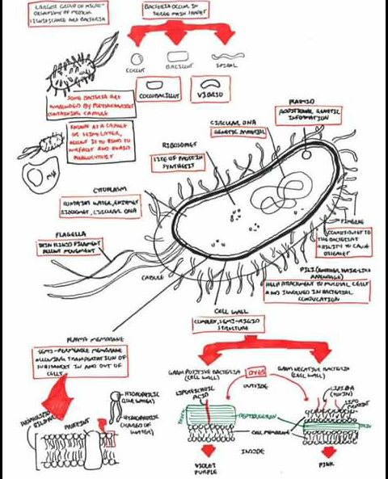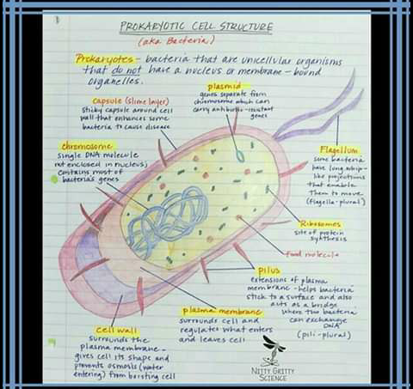

Bacteria are unicellular organism that do not have a nucleus or membrane bounded organelles
The following are the structure component of bacterial cell
1= cell wall: surrounds the cell membrane and give cell it shape and prevent osmosis from bursting cell
Plasma membrane : surrounds cell and regulate what enter in leave cell
Chromosome : single DNA molecule are not in closed in nucleus
Capsule: sticky capsule around cell wall that enhance some bacterial to cause disease .
Plasmid : Genes separated of chromosome also called extra DNA .
Flagellum : Some bacteria have living whip shape projection that enable them to move .
Ribosome : site of protein synthesis
Pilos : Extension of plasma membrane help bacteria stick to a surface and also act as a bridge for exchange of genetic material
(B): Antibiotic killing bacteria :
Antibiotic are anti microbial substances active against bacteria by fighting bacterial infection causing agents they may kill on the or inhibit growth of bacteria .They stopped the synthesis of nucleic acid and protein. so as the result the bacteria die .
©: Mode of action : Antibiotic work by inhibiting 5 main process in bacterial cell .Which are as followed
1: Inhibitors of cell wall synthesis:
As human and animal cell do not have cell wall .while the bacterial cell having it .so antibiotic that target cell wall can only kill or inhibit bacterial organism , For example (penicillin)
2: Inhibitor of cell membrane function :
Cell membrane is the structure that control exchange of material across cell as this membrane is present in both prokaryotes and eukaryotes , So drugs against cell membrane are of less important because they can also destroy the cell membrane of human cell and essential solutes can leak out so clinically there use is limited Example :Polymixim B
3: Inhibitor of protein synthesis :
Most of structure are made up of protein so for multiplication of cell protein synthesis is necessary several type of antibiotic target bacterial protein synthesis by binding to ribosome 30s or 50s sub units .This result distruption of normal cellular of metabolism of bacteria and lead to death of bacteria Example : Tetracycline .
4: Inhibitor of nucleic acid synthesis :
As DNA and RNA are necessary for replication of living forms including bacteria . These antibiotic work by binding to components that are involved in DNA and RNA synthesis . which stopped bacteria multiplication Example : Rifampin
5: Inhibitor of metabolic process :
Some antibiotic act only on selected that are essential for bacterial life For example sulfonamides and trimethoprim disturb folic acid path way .Which is important for bacteria to produce preacursors for DNA synthesis , Sulfonamide bind to dihydropteroate synthase and trimethophrim inhibit diehydrofolate reductase . These enzyme produce folic acid a vitimin synthesize by bacteria.
QNO3: Discuss any bacterial or viral disease ?
ANS: Pneumonia:
Pneumonia is the infection of lungs that can cause mild to severe illness in people in old age .often it is bacterial infection that can sweeps in after a cold of flu virus . vaccines can prevent sometime of pneumonia and it is the leading infection causing death in children below 5 year
Symptoms of pneumonia: viral pneumonia may start with flu like symptom like coughing , wheezing ,high fever may occur after 12 to 36 hours .bacterial pneumonia may cause fever as high as 105 F along with sweating bluish lips and nail .
- Who is at high risk :
Infants from birth to age 2 year are more at rest , and people who smoke or drink alcohol , people with weak immune system , chronic medical condition like Asthma , Heart failure ,Cystec fibrosis are at high risk .
- Is pneumonia contagious :
Most kind of pneumonia are contagious viral pneumonia are more then bacterial and fungal it spread from person to person. Some types like fungal like pneumonia are contagious in certain environment .
- Treatment:
Antibiotic, antiviral and antifungal drugs are used to treat pneumonia deponding on the cause of pneumonia . Mild pneumonia can be treated at home by taking antibiotics and plenty of fluids . While in severe cases you may consult doctor . In hospital fluid along with antibiotic in it are intervenously administered and sometime to help them in breathing .
- Prevention:
- Wash your hand .
- Don`t smoke .
- Disinfect the surfaces you touch .
Agents causing pneumonia:
Pneumonia does not refer to a singel bacterial or viral infection . It’s a condication that can be caused by a number of bacteria viruses and even fungi . The most common type of bacteria Is streptocces pneumonia
- HOW bacteria causes pneumonia :
A lot of bacterias and viruses are present around us it enters through mouth and nose and reach the lungs at 1st the body immune system response by attacking the macrophages on these foreign particle . But the macrophages wounds in it and causes inflamation in the lungs .And fluid accumulate in the alveoli .As these are the sacs where the gaseous exchange take place .So a person feels difficulty in breathing .

