Name Adnan Khan
Id # 14837
Dept Computer Science
Bscs 4
Subject Probability and Statistics

Q1

a)
As we know
Mean (np) = 4 … (i) Variance (npq) = 9 … (ii)
Dividing the LHS and RHS of equation (ii) by equation (i) we have
Npq/np = 9/4
=> q = 9/4
Therefore, we have p = 1 - q = 1 - 9/4 = -5/4
Putting the value of p = - 5/4 in equation (i),
We have n = - 16/5.

B)
A critical region, also known as the rejection region, is a set of values for the test statistic for which the null hypothesis is rejected. I.e. if the observed test statistic is in the critical region then we reject the null hypothesis and accept the alternative hypothesis.
C)

The t distribution has the following properties:
The mean of the distribution is equal to 0.
The variance is equal to v / (v - 2), where v is the degrees of freedom (see last section) and v > 2.
The variance is always greater than 1, although it is close to 1 when there are many degrees of freedom.

D)
Analysis of variance, or ANOVA, is a statistical method that separates observed variance data into different components to use for additional tests. A one-way ANOVA is used for three or more groups of data, to gain information about the relationship between the dependent and independent variables

E)
RBD: A diagram that gives the relationship between component states and the success or failure of a specified system function. The logical layout in an RBD can be as series system, parallel system, or a combination.
F)
Statistical quality control, the use of statistical methods in the monitoring and maintaining of the quality of products and services. One method, referred to as acceptance sampling, can be used when a decision must be made to accept or reject a group of parts or items based on the quality found in a sample
G)
Chance cause: a process that is operating with only chance causes of variation present is said to be in statistical control.
Assignable cause is a type of variation in which a specific activity or event can be linked to inconsistency in a system..
H)
traffic intensity: A measure of the average occupancy of a facility during a specified period of time, normally a busy hour, measured in traffic units (erlangs) and defined as the ratio of the time during which a facility is occupied (continuously or cumulatively) to the time this facility is available for occupancy

I)
A queuing system is specified completely by the following five basic characteristics: The Input Process. It expresses the mode of arrival of customers at the service facility governed by some probability law. The number of customers emanate from finite or infinite sources.

Q2
Part A)

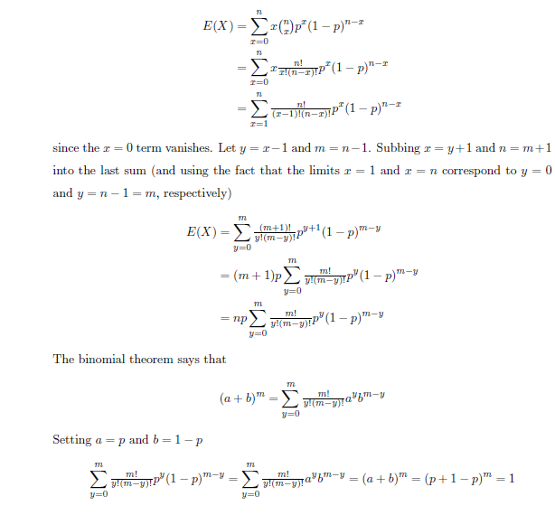
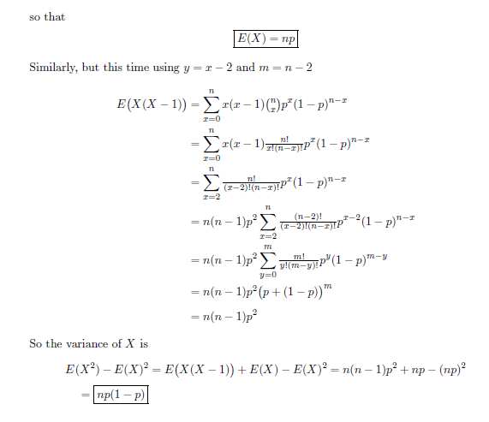

Part b)

Let X denote number of cars hired out per day
Poisson distribution mean = m = 1.5
P(X=x) = (((e^−m) (m^x))/(x!))= (((e^−1.5) (1.5^x))/(x!))
1) P (neither car is used):
P(X=0) = (e^−1.5) (1.5^0)/0.2231
2) P (Some demand is refused) = P (Demand is more than 2 cars per days)
P(x>2)
=1−P(x≤2)
=1−[P(x=0)+P(x=1)+P(x=2)]
=1−[((e^1.5)(1.5^0)/0!)+ ((e^1.5) (1.5^1)/1!)+ ((e^1.5) (1.5^2)/2!)]
=1−e^1.5[1+1.5+ (2.25/2)]=0.1912Proportion of days on which neither car is used = 0.2231 = 22.31 %
Proportion of days on which some demand is refused = 0.1912 = 19.12 %

Q3

