Subject: Anatomy II Total Marks 50
Final Term Assignment. Semester: DPT 2nd.
NAME: BAHAR ALI
ID: 16063
SUBJECT: ANATOMY
SECTION: A
DEPATRTMENT: DPT 2ND

Q:1 Enumerate muscles in the posterior compartment of the lower leg with clinical significances also write action and innervation of each posterior compartment muscle.
ANS: 1
MUSCLES IN THE POSTERIOR COMPARTMENT OF THE LOWER LEG:
The posterior compartment of the leg contains seven muscles, organized into two layers;
- Superficial layer
- Deep layer.
The above two layers are separated by a band of fascia. The posterior leg is the largest of the three compartment collectively the muscles in this area plantarflexion and invert the foot. They are inverted by the tibia nerve a terminal branch of sciatic nerve.
- SUPERFICIAL MUSCLES: the superficial muscles form the characteristic calf shape of the posterior leg. They all insert into the calcaneus of the foot via the calcaneal tendon. The calcaneal reflex tests spinal roots S1 S2. To minimize friction during movement there are two bursae associated with the calcaneal tendon.
- Subcutaneous calcaneal bursa 2) deep bursa of the calcaneal tendon.
GASTROCNEMIUS: the gastrocnemius is the most superficial of all the muscles in the posterior leg it has two heads medial and lateral which convergeto form a single muscle belly.
ACTION: it plantarflexion at the ankle joint and because it crosses the knee it is a flexor there.
INNERVATION: tibial neve
PLANTARIS: the plantaris is the small muscle with a long tendon which can be mistaken for a nerve as it descends down the leg. It is not present on about 10 percent people.
ACTIONS: IT plantarflexes at the ankle joint and because it crosses the knee it is a flexor there. It is not a vital muscle for these movement.
INNERVATION: Tibial nerve.
SOLEUS: the soleus is located deep to the gastrocnemius. It is large and flat named soleus due t its resemblance of a sole a flat fish.
ACTION: plantarflexes the foot at the ankle joint.
INNERVATION: tibial nerve
- DEEP MUSCLE: There are four muscles in the deep compartment of posterior leg. One muscle the popliteus, acts only on the knee joint. The remaining three muscles act on the ankle and foot.
- THE POPLITEUS: The poplitus is located superiorly in the leg. It lies behind the knee joint, formiting the base of the popopliteal fossa
ACTION: laterally rotates the femure on the tibia unlocking the knee joint so that the flexion can occur.
INNERVATION: tibial nerve
- Tibialis posterior
- Flexor halluces longus
- Flexor digitorum longus.
CLINICAL SIGNIFICANCE:
- DAMAGE TO THE HAMSTRINGS:
A hamstring strain refers to excessive stretch or tearing of the muscle fibers. They are often seen athletes involved in running or kicking sports. Damage to the muscle fibers is likely to rupture the surrounding blood vessels producing a hematoma is contained by the overlying fascia lata.

- AVULSION FRACTURE OF THE ISCHIAL TUBEROSITY:
An avulsion fracture occurs when a fragment of bone breaks away from the main body of bone. In an avulsion fracture of the ischial tuberosity the hamstring tendons tear off a piece of the ischial tuberosity. such an injury usually occurs in sports that require rapid contraction and relaxation of the muscles such as, sprinting, football and hurdling.

Q:2 Explain the following
- Foot drop
- Deep venous thrombosis
ANS: 2
- FOOT DROP:
Foot drop is a clinical sign indicating paralysis of the muscles in the anterior compartment of the leg it is most commonly seen when the common fibular nerve is damaged. In foot drop the muscles in the anterior compartment are paralyzed the unopposed full of the plantar flexor produce permanent plantarflexion. This can interfere with walking as the affected limb can drag along the ground.

- DEEP VENOUS THROMBOSIS:
Deep vein thrombosis is a serious condition that occur when a blood clot forms in a vein located deep inside body. A blood clot is a clump of blood that’s turned to a solid state. Deep vein blood clot typically form in thigh or lower leg but they can also develop in other areas of body. Its cause pain swelling and tenderness of the affected limb. The main complication of deep venous thrombosis is a pulmonary embolism. The patient that are considered high risk of developing deep venous thrombosis are undergo prophylactic treatment to prevent thrombosis.

Q:3 Explain blood supply of thigh and gluteal region with the help of diagram.
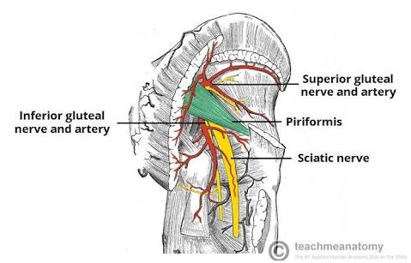
ANS: 3
BLOOD SUPPLY TO THIGH:
The main artery of the lower limb is the femoral artery. Perforating branches consist of three or four arteries that perforate the adductor magnus, contributing to the supply of the muscles in the medial and posterior thigh.

ARTERIES OF THE GLUTEAL REGION:
The superior gluteal artery is the largest branch of the internal iliac artery and arises from its posterior division. It has superficial and deep branches which supply the gluteus maximus, gluteus medius, gluteus minimus and tensor fasciate latae muscles.
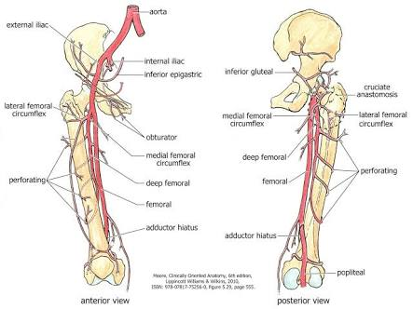
Q 4: Describe anatomical course, motor and sensory function of Sciatic Nerve
ANS: 4 ANATOMICAL COURSE:
The sciatic nerve starts in the lower spine in the lower spine and follows a long path through the buttock down the back of the thigh and leg and finally ends in the foot.
MOTOR FUNCTION:
Innervates the muscles of the posterior thigh (biceps femoris, semimembranosus and semitendinosus ) and the hamstring portion of the adductor mangus indirectly innervates (via its terminal branches) all muscles of the leg and foot.
SENSORY FUNCTION:
The sciatic nerve supplies sensation to the skin of the foot, as well as the entire lower leg except for its inner side.
Q 5: Enumerate Muscles of the medial compartment of thigh, what is tarsal tunnel syndrome?
ANS: 5
MUSCLES OF MEDIAL COMPARTMENT OF THE THIGH:
. GRACILIS
. OBTURATOR EXTERNUS
. ADDUCTOR BREVIS
. ADDUCTOR LONGUS
. ADDUCTOR MAGNUS
TARSAL TUNNEL SYNDROME:
Tarsal tunnel syndrome is a compression, or squeezing, on the posterior tibial nerve that produces symptoms anywhere along the path of the nerve running from the inside of the ankle into the foot.

