Name: Jamal Atif
ID: 7480
Final Term Paper
Q1: Point out slums in Peshawar. What steps would you recommend to improve the livelihood of people living in these slums? While suggesting slum improvements keep the current economic and political situation of the government in mind as well as pay careful attention to the context.
Introduction:
Urban slums are present in most of the major cities in Pakistan. These urban slums have desperate living conditions. For example, In Karachi (being the largest city in Pakistan) about half of the residents of the city live in the urban slums. The living conditions in these slums are miserable. The various problems include poor sanitation, waste disposal and lack of safe drinking water. About one fourth of the city residents have no water supply facility. These poor water, sanitation and hygiene spread many diseases including Hepatitis A, Hepatitis E, Typhoid, Cholera and polio.
Peshawar City is the largest city of KPK. Peshawar city district is also the most urbanized district of Khyber Pakhtunkhwa province. Being as a major business center, most of the people from the surrounding districts are shifting for jobs, education and health.
The heavy shift has got negative impacts on environmental resources such as soil, water, and agriculture. The land prices are increasing and it is not possible for a common person to afford accommodation. In early eighties University town, Hayatabad town was planned with the idea to accommodate the major migrant to the city district, but was not sufficient .Many housing schemes have been announced recently but they are either expensive or not convenient which has led people to search for cheap lands to accommodate in the surrounding. This has created extra burden on the environmental resources and also contributing to various environmental problem in the surrounding. Low income families have accommodated their selves in the surrounding areas of the city in the form of slums which has resulted in a lot of complications for the citizens of Peshawar as well as the people living in the slums as well.
These include:
- Shaheedabad/Subhanabad:
Shaheedabad and Subhanabad are located in Northern part of Peshawar City at 71.5083°E, 34.0232°N. These settlements are surrounded by agricultural land from all sides except in the East where a Christian Colony shares the boundary with Subhanabad. One metalled and two unmetalled roads connect these settlements with Tehkal area in the South and are situated at a distance of 1 kilometre. In the North, the slum is connected to Warsak Road at a distance of 3 kilometres. In the East an unmetalled road connects it to the Canal Road 1 kilometre away from the Subhanabad.
ShaheedAbad was developed in the 1970s by the locals who developed their agriculture land in the surrounding area. The slum is divided into two main Mohallas namely; Shaheedabad and Subhanabad. Majority of the slum property is privately owned, with the exception of 400 acres adjoining land that is owned by the Pakistan Armed Forces. This proximity has an adverse effect on the transport infrastructure, as the Military discourages the development of the road connecting the area to the city. Currently, there are about 2,500 to 3,000 households located in the slum, with an average household size of 10 members.

- Tajabad:

Tajabad – Lane 10 (Miangano Mohallah) falls in Town III. It is located in southern part of Peshawar city at longitude 71.4692°E and latitude 33.988°N, and at an elevation of 1,255 feet from mean sea level. A metalled Road (Achini Payan Road) connects it to the Peshawar Ring Road which is located at a distance of 1 kilometre in the South. In the North this area is connected with Canal Road and G. T. Road. Since its Eastern and South-Eastern parts are surrounded by the agricultural land, it can be easily categorized as the urban-rural fringe.
The area of Tajabad is planned according to streets/lanes where each major lane is considered a mohalla; there are a total of 18 major lanes in Tajabad. The socio-economic and living conditions vary from lane to lane. Lane 10, also known as the Miangano Mohallah, is a slum and consists of about 2,000 housing units with an average household size of 8 persons.

- Gujjar Camp:
Gujjar camp is located at 71.4715°E, 34.0093°N near Peshawar University. In West it is bounded by the Kabul river tributary. The slum is not directly accessible through a road. The nearest transport terminal is available at a distance of 1.5 kilometers on Palosi road in the East through the University of Peshawar campus, and another access is situated 1 kilometer away towards the South on Canal Road and is accessible through congested streets. The nearby slum of Gujjar Camp is Tajabad.
Gujjar camp is a haphazard settlement of mud houses built across the slum with no proper planned streets or mohallas. All the inhabitants are Afghan refugees who settled in this area in 1980s’ after fleeing the Soviet War in Afghanistan. Currently, there are about 400 to 500 houses in the slum, with an average household size of 11 members.

- Changarabad:

Changarabad is located at 71.5907°E, 34.0185°N at an elevation of 1,045 feet from mean sea level in the middle of the Peshawar city. This area is restricted by the railway line in the South and an irrigation canal in the East. The Pakistan Railway’s residential colony is located in the West. According to the community, the first residents of Changarabad reported settling in the area in 1960. The slum is a haphazard settlement without any properly planned streets or mohallas. Due to its location near the railway lines, 60% of the land is owned by Pakistan Railways, while the remaining 40% is privately owned. Currently there are an estimated 1,200 households established in the slum, with an average household size of 8.25 members. Almost 75% of the inhabitants are home owners and the remaining are tenants paying monthly rent.

How we can improve:
The following steps should be taken to improve the livelihood of the people living in those slums;
- Drainage System
- Garbage Collection and Disposal
- Sanitation and Human Excreta Management
- Water, Sanitation and Hygiene
- Health
- Utilities
- Roads and Transportation
- Availability of Open Spaces and Recreational Facilities
- Status of Socio-Economic Conditions
- Education
- Employment
The government should ponder on these key factors for the betterment of the people living in the slums and the surrounding areas of these slums to mitigate potential problems in the future.

Q2: Explain the structure and pattern of Islamabad Master Plan. Also mention what could have been done during the planning stage to make this master plan better or mention what was done wrong while planning Islamabad by criticizing it?

Introduction:
Islamabad is a major city of Pakistan, and Is Federally Administered as part of the Islamabad Capital Territory. Built as a planned city In the 1960s to replace Karachi as Pakistan's capital, Islamabad is known for Its high standards of living, safety, and abundant greenery. With a population of 2006,572 as per the 2017 census, Islamabad Is the 6th largest city of Pakistan, while the greater Islamabad Rawalpindi metropolitan area is the country’s third largest conurbation with population exceeding four million. The city is the political seat of Pakistan and local government setup is run by the Islamabad Metropolitan Corporation, supported by the Capital Development Authority (CDA).
Master Plan:
First Master Plan for Islamabad was prepared in 1960, prepared by Greek firm Doxiadis associates, divides the city into eight zones, Including administrative, diplomatic enclave, residential areas, educational sectors, Industrial sectors, commercial areas, and rural and green areas. Currently the Capital consists of 906 Sq. KM, in which the urban area consists of 220.15 Sq. KM and rural area Is 466.20 Sq.KM respectively having an overall density of 2,207 persons/Sq.
Structure and Pattern:
The Capital Republic (Determination of Area) Ordinance was promulgated and the specified area in the schedule measuring 350 square miles(906 sq. Km) or there about within the district of Rawalpindi in the province of Punjab at the site selected for the capital of Pakistan was declared the area of the Capital of the Republic. Thus the area of Rawalpindi and Rawalpindi Cantonment was detached from the Master Plan of Islamabad.
As per Master Plan the area of Islamabad was planned in a grid Iron pattern and the area was divided into modular square called sector. Each sector was a self-sustainable community measuring 4 Sq.Km(2X2).The Central Business District (CBD) of the city, called Blue Area, was planned in a linear pattern to grow along with growth of the city. Further area was allocated for Diplomatic Enclave, Admin Sector, Public Building Area, Special Institutions, Mauve Area, Light Industries etc. The National Park Area was reserved for recreation, agriculture, R&D Institution etc.
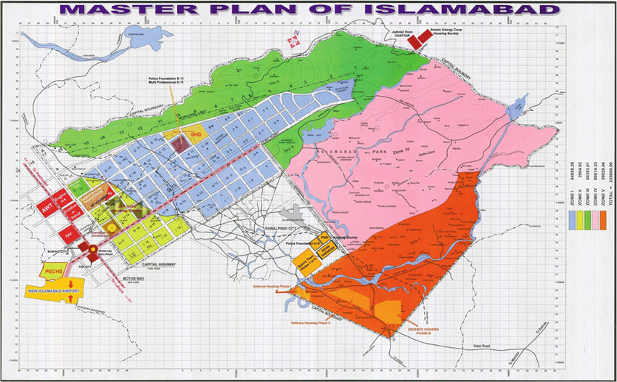
Drawbacks:
The Islamabad Master Plan, being no exception to master plans elsewhere, has resulted in contrived urban development and stifling of economic activities. The land and building regulations are too rigid and have resulted in over-regulating Islamabad, limiting both social and economic potential of the city. The present population Is growing at the rate of 4.91% which is expected to touch 4 million by 2030 and with that the boundary of the city v4I1 fall short of providing shelter to every inhabitant. If the current practices are continued then the future of the capital is quite bleak. At present the trend is towards keeping the population density low with big residential units in the capital, which requires using more and for construction purposes yet not every Inhabitant can either afford or even need such units. What is needed in this time and age, is paradigm shift towards high density, towards small yet spacious residential units and high density commercial and office buildings. There is a ' dire need to update master plan of Islamabad and revision of building Bylaws on urgent basis. The Islamabad master plan was supposed to be revised after every 20 years, but previous Governments failed to make revision that resulted in poor and haphazard construction and development.
At present, Islamabad, particularly its rural area, is dotted with unauthorized constructions and a lot of encroachment. The requirements of the city's population have multiplied over the years specifically with regard to education, health; the environment infrastructure and water.

Q3: Which Land use model best represents Peshawar (i.e. Concentric Zone Model, Sector Model or Multiple Nuclei Model). After identifying Model Type, mark (sketch) all the zones (i.e. CBD, Residential, Industrial etc.) on the map as discussed in the model. Additionally, explain the form of Peshawar city.
Peshawar has became a Multiple Nuclei Model , with time the old CBD of inner city has been supplemented with Saddar Bazaar and now the University road. The city has seen a hike in population due to rural to urban migration with people fleeing conflicts in the war torn province, with this increase the city’s structure has also changed alot. Even smaller commercial centers are emerging as prominent hubs. The industrial zones are in the western end of the city (Hayatabad industrial area) and within the southern Boundary (kohat road industrial complex) the residential sectors are scattered throughout the city and even intermingling with the industrial and commercial zones.
The city is an example of linear urban form, as the city dwells around the GT road. The new ring road has provided new arteries to the city and seeing rapid development along it.
The figure shows the model which suits the model of Peshawar. 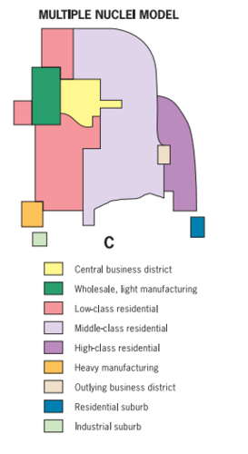
The Central Business District of Peshawar:
For the selection of CBD of Peshawar all parameters i.e. land values, rent values, volume of retail sale, intensity and density of retailing, pedestrian flow and vehicular flow are compared and area where these values are in highest number is selected.
The Saddar Bazaar is the CBD of Peshawar. The Saddar Bazaar has the largest commercial area,CB uses units, retail density, retail volume of sale, vehicular and pedestrian flow, rent values and land values.
Industrial Zone:
The western end of the city is the Industrial zone of Peshawar in which all the industries are located. It is located in Hayatabad and is known as the Industrial estate.
Residential Zone:
Hayatabad is an upscale suburb on the western outskirts of Peshawar the capital of the KPK province of Pakistan. It borders the now defunct Tribal Areas and is close to Torkham, which is the major border crossing point between Pakistan and Afghanistan. The suburb is home to several of Peshawar's educational and health institutions. Hayatabad is named after Hayat Sherpao.
Hayatabad is the residential zone of Peshawar. In this zone all the houses are located with some recreational places like Bagh-e-Naran and Tatara Park.
