**NAME: ABDUL MATEEN KHAN**

**ID: 14452**

**SUBJECT: SOFTWARE ENGINEERING**

**LECTURER: GHASSAN SIR**

**BSSE-4 SECTION A**

**QUESTION 1:** The pizza ordering system.

The pizza ordering system allows the user of a web browser to order pizza for home delivery. To place an order a shpper searches to find items t purchase , adds items one at a time to a shopping cart and possibly searches again for items.

When all items have been choosen the shopper provides a delivery address. If not paying with cashthe shopper also provides credit card information.

Develop a use case diagram for a use case fr placing an order, PlaceOrder. The use case should show a relationship to two previously specified use casses , IdentifyCustomer, which allows a user to register and log in , and PayByCredit, which modelscredit card payment.

**ANSWER:**

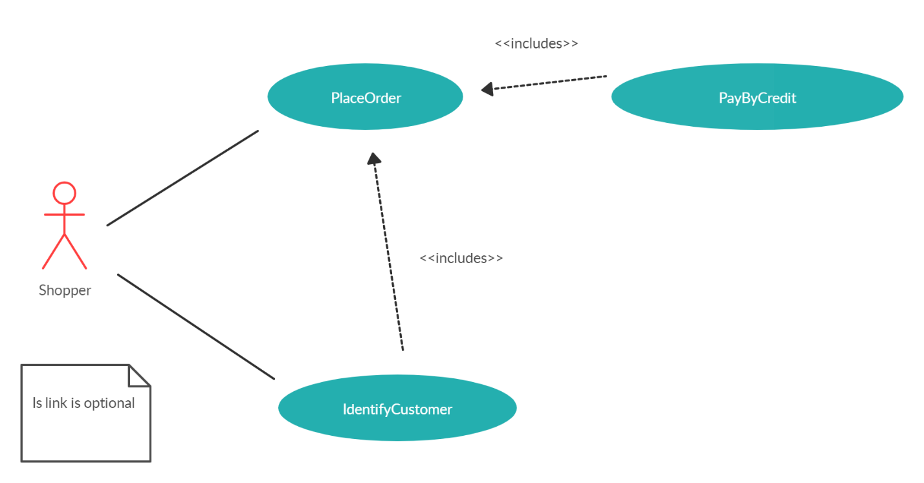

**QUESTION 2:** Suggest how an engineer responsible for drawing up a system requirements specification might keep track of the relationships between functional and non-functional requirements.

**ANSWER:** The engineer need to make documents for the system requirement. For the non-functional requirements the engineer should use the natural language because the non-functional is for the user only and does not comes from the software development, non-functional can be anything such as performance, Reliability, Availability, Maintainability etc. For functional the engineer should use more structural language rather than the natural language because the functional requirements are for the developer and comes from the software department, each functional requirement can be mapped to a specific performance requirement. It is easier to keep track of the relationship between functional and performance requirement since performance requirement is an extension of functional requirement which precise the same with a mathematical number. The engineer should be careful that the functional and non-functional requirements do not conflict with one another.

**QUESTION 3:** To reduce costs and the environmental impact of commuting, your company decides to close a number of offices and to provide support for staff to work from home. However, the senior management who introduce the policy are unaware that software is developed using agile methods, which rely on close team working and pair programming. Discuss the difficulties that this new policy might cause and how you might get around these problems?

**ANSWER:** If the company decided to close down a number of offices that were specialized in using agile methods they may face a multitude of difficulties. When a company is driven by a close team and is divided they will be unable to have daily meetings, which can cause issues with communication, programming in pairs would not be possible, a communication gab would be created, productivity will slow down due to communication issues, and detecting errors would be quite difficult. These problems can be avoided by creating merging offices together so pair programming and daily communication can be established. If that is not possible, a communication platform consisting of webcams, desktop viewing software, and microphones should be created to allow better communication.

Project managers who don’t have experience of agile methods may be reluctant to accept the risk of a new approach, as they do not know how this will affect their particular projects.



**ANSWER:** Ambiguities and omissions include:

a)     Can a customer buy several tickets for the same destination together or must they be bought one at a time?

b)     Can customers cancel a request if a mistake has been made?

c)     How should the system respond if an invalid card is input?

d)     What happens if customers try to put their card in before selecting a destination (as they would in ATM machines)?

e)     Must the user press the start button again if they wish to buy another ticket to a different destination?

f)      Should the system only sell tickets between the station where the machine is situated and direct connections or should it include all possible destinations?

**QUESTION 5:** Use your knowledge of how an ATM is used Develop a set of use cases that could serve as basic for understanding the req for an ATM system?

**ANSWER:**

* The customer first insert the card.
* Then enter the pin.
* Perform transaction.
* Withdraw the cash.
* Exit.
* Change the code if he want to.

DIAGRAM

* 