Name: Ibne Amin
ID NO: 15830
Deprtment: BS,SE2
Assignment: Programming
Section: A

package TicTacToe.

import javax.swing.JFrame;
import javax.swing.JOptionPane;

public class TicTacToe_s extends javax.swing.JFrame {

private String startgame ="X";
private int xCount = 0;
private int oCount = 0;

public TicTacToe_s() {
initComponents();
setSize(1200,600);
setLocationRelativeTo(null);
}
private void gameScore()
{
jlblPlayerX.setText(string.valueOf(xcount));
jlblPlayerO.setText(string.valueOf(ocount));
}

private void choose_a_player()
{
if (startGame.equalsIgnorCase("X"))
{
startGame ="o";
}
else
{
startGame="X";
}

}

@SuppressWarnings("unchecked")
private void initComponents() {

jPanel1 = new javax.swing.JPanel();
jLabel1 = new javax.swing.JLabel();
jPanel3 = new javax.swing.JPanel();
jPanel2 = new javax.swing.JPanel();
jButton1 = new javax.swing.JButton();
jPanel4 = new javax.swing.JPanel();
jButton2 = new javax.swing.JButton();
jPanel5 = new javax.swing.JPanel();
jButton3 = new javax.swing.JButton();
jPanel6 = new javax.swing.JPanel();
jLabel2 = new javax.swing.JLabel();
jPanel7 = new javax.swing.JPanel();
jlblPlayerX = new javax.swing.JLabel();
jPanel9 = new javax.swing.JPanel();
jButton4 = new javax.swing.JButton();
jPanel10 = new javax.swing.JPanel();
jButton5 = new javax.swing.JButton();
jPanel11 = new javax.swing.JPanel();
jButton6 = new javax.swing.JButton();
jPanel12 = new javax.swing.JPanel();
jLabel3 = new javax.swing.JLabel();
jPanel13 = new javax.swing.JPanel();
jlblPlayerO = new javax.swing.JLabel();
jPanel15 = new javax.swing.JPanel();
jButton7 = new javax.swing.JButton();
jPanel16 = new javax.swing.JPanel();
jButton8 = new javax.swing.JButton();
jPanel17 = new javax.swing.JPanel();
jButton9 = new javax.swing.JButton();
jPanel18 = new javax.swing.JPanel();
jbtnReset = new javax.swing.JButton();
jPanel19 = new javax.swing.JPanel();
jbtnExit = new javax.swing.JButton();

setDefaultCloseOperation(javax.swing.WindowConstants.EXIT_ON_CLOSE);
setTitle("TicTacToeGame");

jPanel1.setBackground(new java.awt.Color(204, 204, 204));
jPanel1.setBorder(javax.swing.BorderFactory.createLineBorder(new java.awt.Color(0, 0, 0), 2));
jPanel1.setLayout(new java.awt.BorderLayout());

jLabel1.setFont(new java.awt.Font("Tahoma", 3, 48)); // NOI18N
jLabel1.setHorizontalAlignment(javax.swing.SwingConstants.CENTER);
jLabel1.setText("Tic Tac Toe Game By Ibne Amin");
jPanel1.add(jLabel1, java.awt.BorderLayout.PAGE_START);

jPanel3.setBorder(javax.swing.BorderFactory.createLineBorder(new java.awt.Color(0, 0, 0), 2));
jPanel3.setLayout(new java.awt.GridLayout(3, 5, 2, 2));

jPanel2.setBackground(new java.awt.Color(255, 255, 255));
jPanel2.setBorder(javax.swing.BorderFactory.createLineBorder(new java.awt.Color(0, 0, 0), 2));
jPanel2.setLayout(new java.awt.BorderLayout());

jButton1.setFont(new java.awt.Font("Tahoma", 3, 48)); // NOI18N
jButton1.addActionListener(new java.awt.event.ActionListener() {
public void actionPerformed(java.awt.event.ActionEvent evt) {
jButton1ActionPerformed(evt);
}
});
jPanel2.add(jButton1, java.awt.BorderLayout.CENTER);

jPanel3.add(jPanel2);

jPanel4.setBackground(new java.awt.Color(255, 255, 255));
jPanel4.setBorder(javax.swing.BorderFactory.createLineBorder(new java.awt.Color(0, 0, 0), 2));
jPanel4.setLayout(new java.awt.BorderLayout());

jButton2.setFont(new java.awt.Font("Tahoma", 3, 48)); // NOI18N
jPanel4.add(jButton2, java.awt.BorderLayout.CENTER);

jPanel3.add(jPanel4);

jPanel5.setBackground(new java.awt.Color(255, 255, 255));
jPanel5.setBorder(javax.swing.BorderFactory.createLineBorder(new java.awt.Color(0, 0, 0), 2));
jPanel5.setLayout(new java.awt.BorderLayout());

jButton3.setFont(new java.awt.Font("Tahoma", 3, 48)); // NOI18N
jPanel5.add(jButton3, java.awt.BorderLayout.CENTER);

jPanel3.add(jPanel5);

jPanel6.setBackground(new java.awt.Color(255, 255, 255));
jPanel6.setBorder(javax.swing.BorderFactory.createLineBorder(new java.awt.Color(0, 0, 0), 2));
jPanel6.setLayout(new java.awt.BorderLayout());

jLabel2.setFont(new java.awt.Font("Tahoma", 1, 24)); // NOI18N
jLabel2.setText("player X:");
jPanel6.add(jLabel2, java.awt.BorderLayout.CENTER);

jPanel3.add(jPanel6);

jPanel7.setBackground(new java.awt.Color(255, 255, 255));
jPanel7.setBorder(javax.swing.BorderFactory.createLineBorder(new java.awt.Color(0, 0, 0), 2));

jlblPlayerX.setFont(new java.awt.Font("Tahoma", 1, 24)); // NOI18N
jlblPlayerX.setHorizontalAlignment(javax.swing.SwingConstants.CENTER);
jlblPlayerX.setText("jLabel4");

javax.swing.GroupLayout jPanel7Layout = new javax.swing.GroupLayout(jPanel7);
jPanel7.setLayout(jPanel7Layout);
jPanel7Layout.setHorizontalGroup(
jPanel7Layout.createParallelGroup(javax.swing.GroupLayout.Alignment.LEADING)
.addComponent(jlblPlayerX, javax.swing.GroupLayout.Alignment.TRAILING, javax.swing.GroupLayout.DEFAULT_SIZE, 232, Short.MAX_VALUE)
);
jPanel7Layout.setVerticalGroup(
jPanel7Layout.createParallelGroup(javax.swing.GroupLayout.Alignment.LEADING)
.addComponent(jlblPlayerX, javax.swing.GroupLayout.DEFAULT_SIZE, 172, Short.MAX_VALUE)
);

jPanel3.add(jPanel7);

jPanel9.setBackground(new java.awt.Color(255, 255, 255));
jPanel9.setBorder(javax.swing.BorderFactory.createLineBorder(new java.awt.Color(0, 0, 0), 2));
jPanel9.setLayout(new java.awt.BorderLayout());

jButton4.setFont(new java.awt.Font("Tahoma", 3, 48)); // NOI18N
jPanel9.add(jButton4, java.awt.BorderLayout.CENTER);

jPanel3.add(jPanel9);

jPanel10.setBackground(new java.awt.Color(255, 255, 255));
jPanel10.setBorder(javax.swing.BorderFactory.createLineBorder(new java.awt.Color(0, 0, 0), 2));
jPanel10.setLayout(new java.awt.BorderLayout());

jButton5.setFont(new java.awt.Font("Tahoma", 3, 48)); // NOI18N
jPanel10.add(jButton5, java.awt.BorderLayout.CENTER);

jPanel3.add(jPanel10);

jPanel11.setBackground(new java.awt.Color(255, 255, 255));
jPanel11.setBorder(javax.swing.BorderFactory.createLineBorder(new java.awt.Color(0, 0, 0), 2));
jPanel11.setLayout(new java.awt.BorderLayout());

jButton6.setFont(new java.awt.Font("Tahoma", 3, 48)); // NOI18N
jPanel11.add(jButton6, java.awt.BorderLayout.CENTER);

jPanel3.add(jPanel11);

jPanel12.setBackground(new java.awt.Color(255, 255, 255));
jPanel12.setBorder(javax.swing.BorderFactory.createLineBorder(new java.awt.Color(0, 0, 0), 2));
jPanel12.setLayout(new java.awt.BorderLayout());

jLabel3.setFont(new java.awt.Font("Tahoma", 1, 24)); // NOI18N
jLabel3.setText("player O:");
jPanel12.add(jLabel3, java.awt.BorderLayout.CENTER);

jPanel3.add(jPanel12);

jPanel13.setBackground(new java.awt.Color(255, 255, 255));
jPanel13.setBorder(javax.swing.BorderFactory.createLineBorder(new java.awt.Color(0, 0, 0), 2));

jlblPlayerO.setFont(new java.awt.Font("Tahoma", 1, 24)); // NOI18N
jlblPlayerO.setHorizontalAlignment(javax.swing.SwingConstants.CENTER);
jlblPlayerO.setText("jLabel5");

javax.swing.GroupLayout jPanel13Layout = new javax.swing.GroupLayout(jPanel13);
jPanel13.setLayout(jPanel13Layout);
jPanel13Layout.setHorizontalGroup(
jPanel13Layout.createParallelGroup(javax.swing.GroupLayout.Alignment.LEADING)
.addComponent(jlblPlayerO, javax.swing.GroupLayout.Alignment.TRAILING, javax.swing.GroupLayout.DEFAULT_SIZE, 232, Short.MAX_VALUE)
);
jPanel13Layout.setVerticalGroup(
jPanel13Layout.createParallelGroup(javax.swing.GroupLayout.Alignment.LEADING)
.addComponent(jlblPlayerO, javax.swing.GroupLayout.DEFAULT_SIZE, 172, Short.MAX_VALUE)
);

jPanel3.add(jPanel13);

jPanel15.setBackground(new java.awt.Color(255, 255, 255));
jPanel15.setBorder(javax.swing.BorderFactory.createLineBorder(new java.awt.Color(0, 0, 0), 2));
jPanel15.setLayout(new java.awt.BorderLayout());

jButton7.setFont(new java.awt.Font("Tahoma", 3, 48)); // NOI18N
jPanel15.add(jButton7, java.awt.BorderLayout.CENTER);

jPanel3.add(jPanel15);

jPanel16.setBackground(new java.awt.Color(255, 255, 255));
jPanel16.setBorder(javax.swing.BorderFactory.createLineBorder(new java.awt.Color(0, 0, 0), 2));
jPanel16.setLayout(new java.awt.BorderLayout());

jButton8.setFont(new java.awt.Font("Tahoma", 3, 48)); // NOI18N
jPanel16.add(jButton8, java.awt.BorderLayout.CENTER);

jPanel3.add(jPanel16);

jPanel17.setBackground(new java.awt.Color(255, 255, 255));
jPanel17.setBorder(javax.swing.BorderFactory.createLineBorder(new java.awt.Color(0, 0, 0), 2));
jPanel17.setLayout(new java.awt.BorderLayout());

jButton9.setFont(new java.awt.Font("Tahoma", 3, 48)); // NOI18N
jPanel17.add(jButton9, java.awt.BorderLayout.CENTER);

jPanel3.add(jPanel17);

jPanel18.setBackground(new java.awt.Color(255, 255, 255));
jPanel18.setBorder(javax.swing.BorderFactory.createLineBorder(new java.awt.Color(0, 0, 0), 2));
jPanel18.setLayout(new java.awt.BorderLayout());

jbtnReset.setFont(new java.awt.Font("Tahoma", 1, 36)); // NOI18N
jbtnReset.setText("Reset");
jbtnReset.addActionListener(new java.awt.event.ActionListener() {
public void actionPerformed(java.awt.event.ActionEvent evt) {
jbtnResetActionPerformed(evt);
}
});
jPanel18.add(jbtnReset, java.awt.BorderLayout.CENTER);

jPanel3.add(jPanel18);

jPanel19.setBackground(new java.awt.Color(255, 255, 255));
jPanel19.setBorder(javax.swing.BorderFactory.createLineBorder(new java.awt.Color(0, 0, 0), 2));
jPanel19.setLayout(new java.awt.BorderLayout());

jbtnExit.setFont(new java.awt.Font("Tahoma", 1, 36)); // NOI18N
jbtnExit.setText("Exit");
jbtnExit.addActionListener(new java.awt.event.ActionListener() {
public void actionPerformed(java.awt.event.ActionEvent evt) {
jbtnExitActionPerformed(evt);
}
});
jPanel19.add(jbtnExit, java.awt.BorderLayout.CENTER);

jPanel3.add(jPanel19);

jPanel1.add(jPanel3, java.awt.BorderLayout.CENTER);

getContentPane().add(jPanel1, java.awt.BorderLayout.CENTER);

pack();
setLocationRelativeTo(null);
}
private JFrame frame;
private void jbtnExitActionPerformed(java.awt.event.ActionEvent evt) {
frame = new JFrame("Exit");
if(JOptionPane.showConfirmDialog(frame,"Confirm if you want to Exit","Tic Tac Toe",
JOptionPane.YES_NO_OPTION) == JOptionPane.YES_NO_OPTION);
{
system.exit(0);
}
}

private void jbtnResetActionPerformed(java.awt.event.ActionEvent evt) {

}
}

private void jButton1ActionPerformed(java.awt.event.ActionEvent evt) {

jButton1.setText(startgame);

if (startGame.equalsIgnorCase("X"))
{
jButton1.setForegound(color.GREEN);
}
else
{
jButton1.setForegound(color.BLUE);
}

choose_a_player();

}

public static void main(String args[]) {
try {
for (javax.swing.UIManager.LookAndFeelInfo info : javax.swing.UIManager.getInstalledLookAndFeels()) {
if ("Nimbus".equals(info.getName())) {
javax.swing.UIManager.setLookAndFeel(info.getClassName());
break;
}
}
} catch (ClassNotFoundException ex) {
java.util.logging.Logger.getLogger(TicTacToe_s.class.getName()).log(java.util.logging.Level.SEVERE, null, ex);
} catch (InstantiationException ex) {
java.util.logging.Logger.getLogger(TicTacToe_s.class.getName()).log(java.util.logging.Level.SEVERE, null, ex);
} catch (IllegalAccessException ex) {
java.util.logging.Logger.getLogger(TicTacToe_s.class.getName()).log(java.util.logging.Level.SEVERE, null, ex);
} catch (javax.swing.UnsupportedLookAndFeelException ex) {
java.util.logging.Logger.getLogger(TicTacToe_s.class.getName()).log(java.util.logging.Level.SEVERE, null, ex);
}
//</editor-fold>

/* Create and display the form */
java.awt.EventQueue.invokeLater(new Runnable() {
public void run() {
new TicTacToe_s().setVisible(true);
}
});
}

private javax.swing.JButton jButton1;
private javax.swing.JButton jButton2;
private javax.swing.JButton jButton3;
private javax.swing.JButton jButton4;
private javax.swing.JButton jButton5;
private javax.swing.JButton jButton6;
private javax.swing.JButton jButton7;
private javax.swing.JButton jButton8;
private javax.swing.JButton jButton9;
private javax.swing.JLabel jLabel1;
private javax.swing.JLabel jLabel2;
private javax.swing.JLabel jLabel3;
private javax.swing.JPanel jPanel1;
private javax.swing.JPanel jPanel10;
private javax.swing.JPanel jPanel11;
private javax.swing.JPanel jPanel12;
private javax.swing.JPanel jPanel13;
private javax.swing.JPanel jPanel15;
private javax.swing.JPanel jPanel16;
private javax.swing.JPanel jPanel17;
private javax.swing.JPanel jPanel18;
private javax.swing.JPanel jPanel19;
private javax.swing.JPanel jPanel2;
private javax.swing.JPanel jPanel3;
private javax.swing.JPanel jPanel4;
private javax.swing.JPanel jPanel5;
private javax.swing.JPanel jPanel6;
private javax.swing.JPanel jPanel7;
private javax.swing.JPanel jPanel9;
private javax.swing.JButton jbtnExit;
private javax.swing.JButton jbtnReset;
private javax.swing.JLabel jlblPlayerO;
private javax.swing.JLabel jlblPlayerX;
}
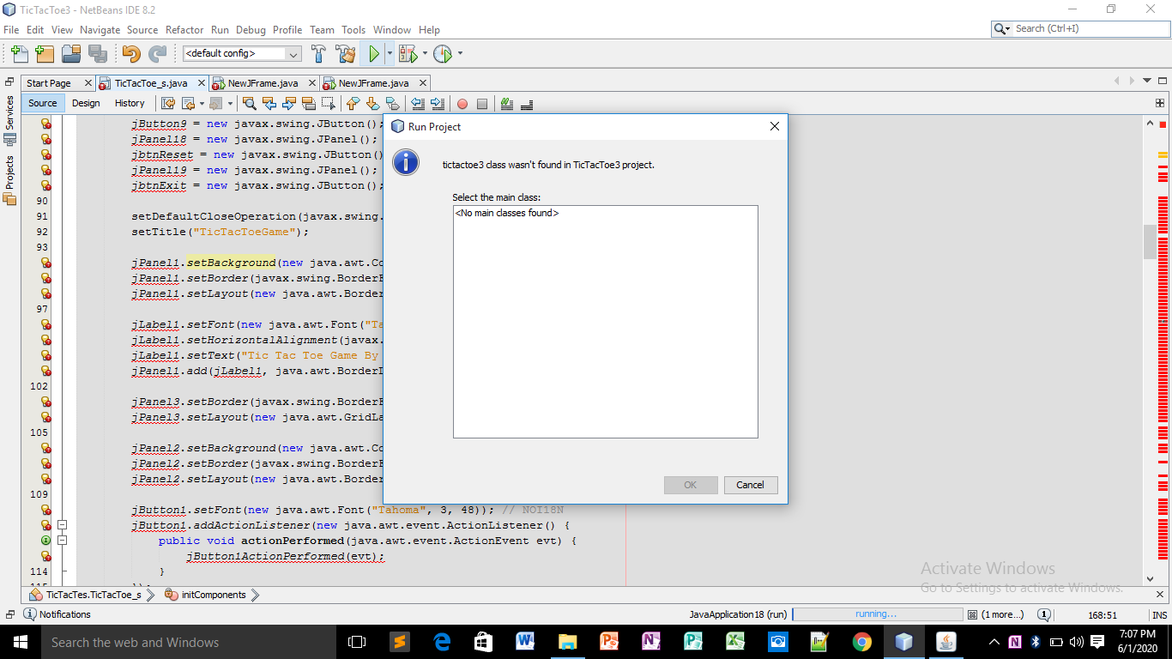

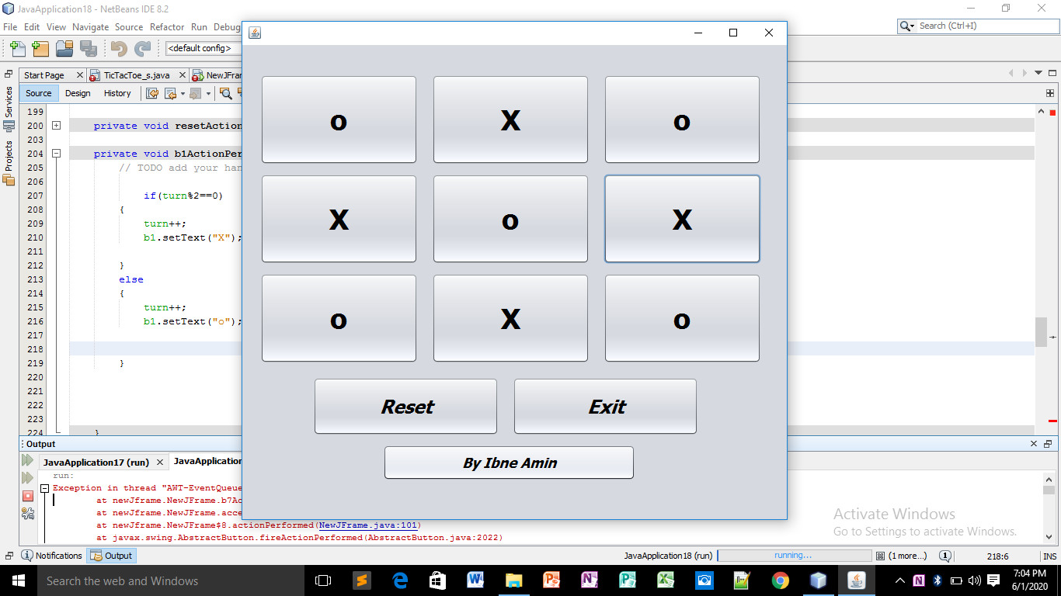

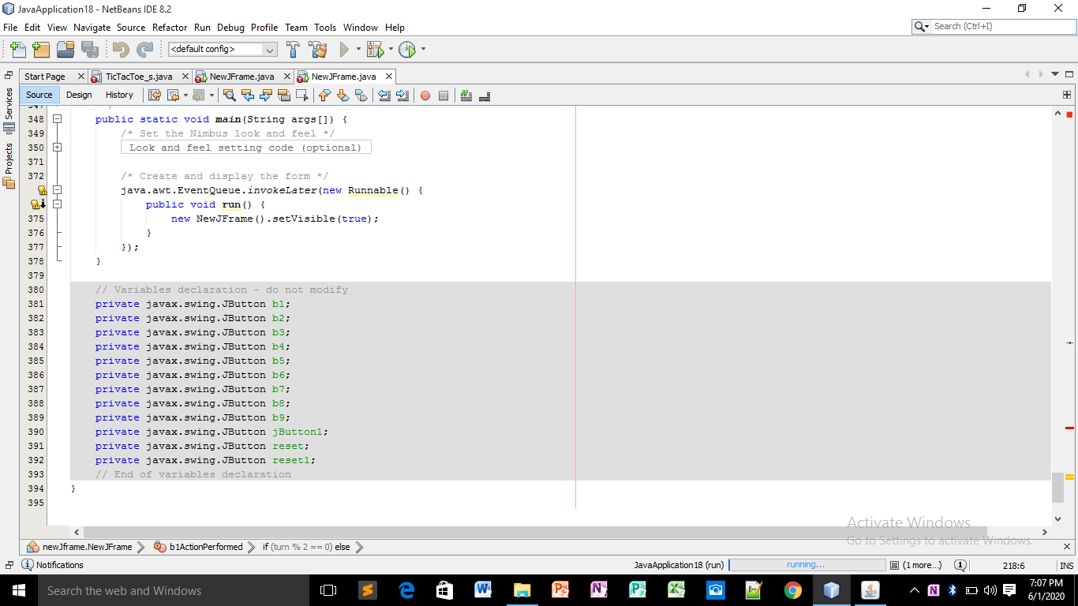

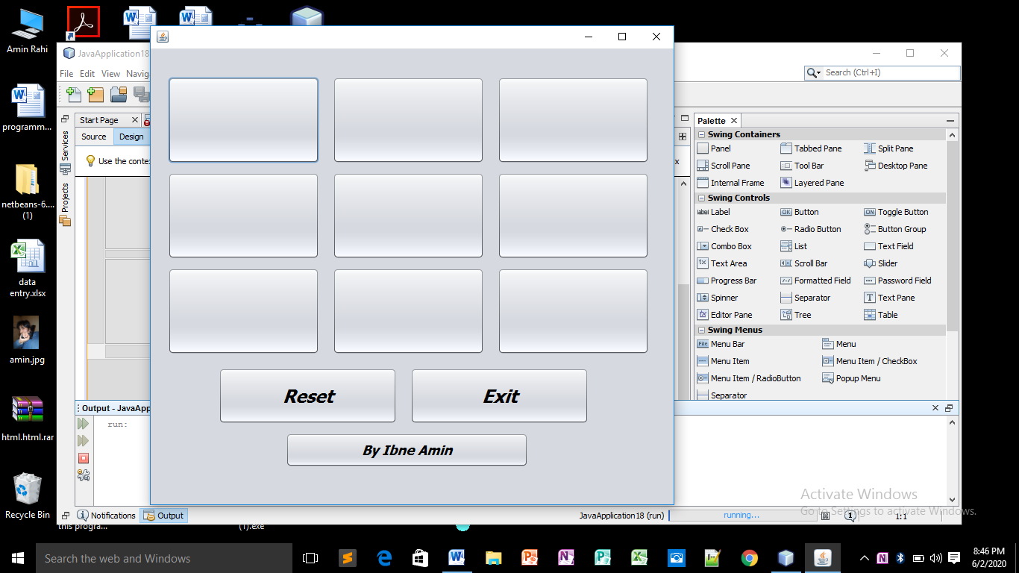

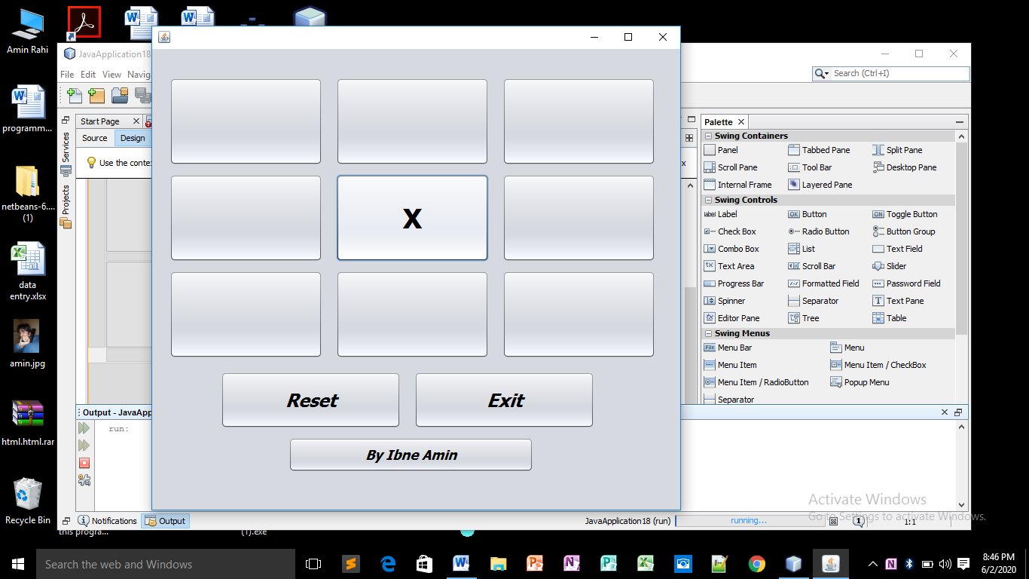
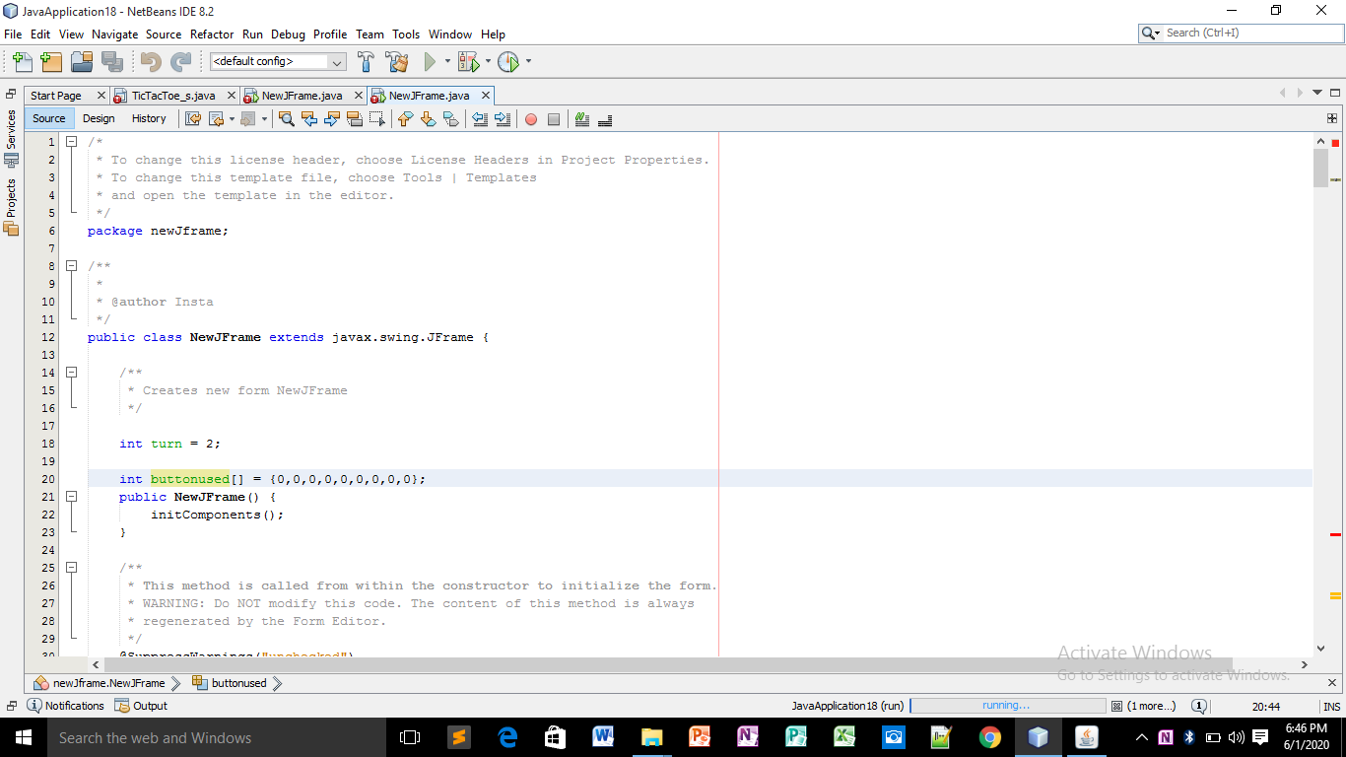
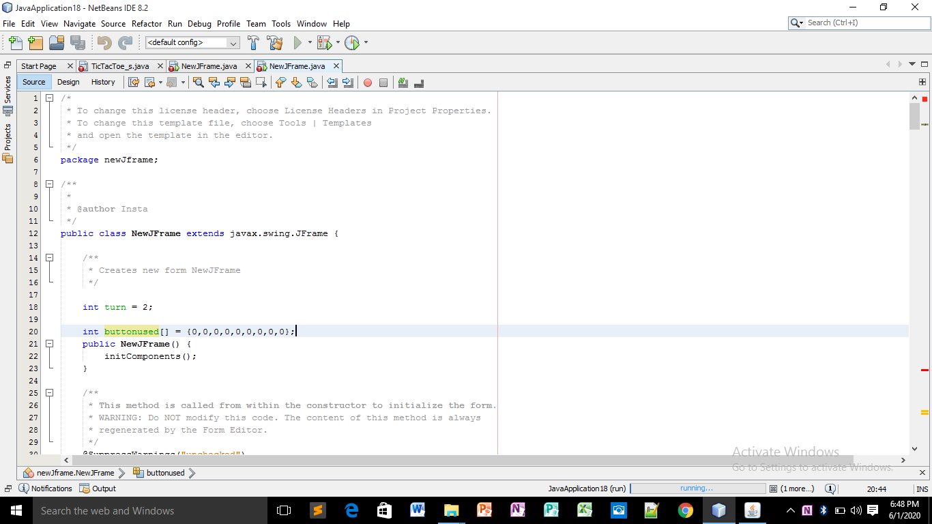
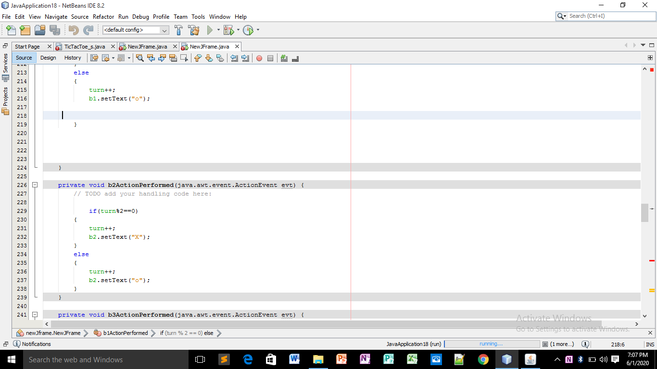
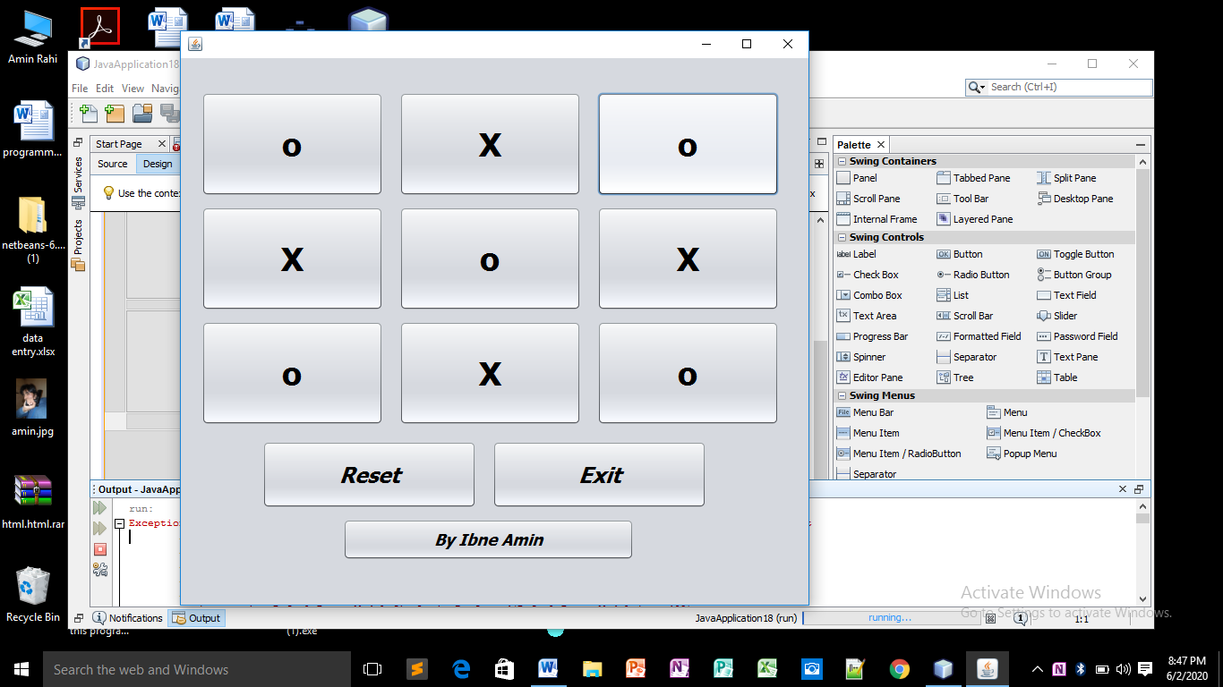

Explination:
This is the codding and some photos of my project which is name is Tic Tac Toe Game.
I made this Game The Tic Tac Toe Game in java IDE Netbeans.
First of all I made a project in Netbeans and I give it class name, project name etc.
When the project successful I made a JFrame in the project. and then I add some buttons which is used in the TIC TAC TOE GAME.after adding the buttons I adjust the size of the buttons and hidden the names of the buttons and change variable names which is used in codding for selecting the button.and Adding two buttons one for exit and one for reset the game.

