Name : Muhammad Qasim
ID : 16270
Depart: Radiology 2nd semester, Section B
Assignment : Physiology Viva

Q no 1.
- Write a note on CARDIOVASCULAR SYSTEM.
Ans:
CARDIOVASCULAR SYSTEM
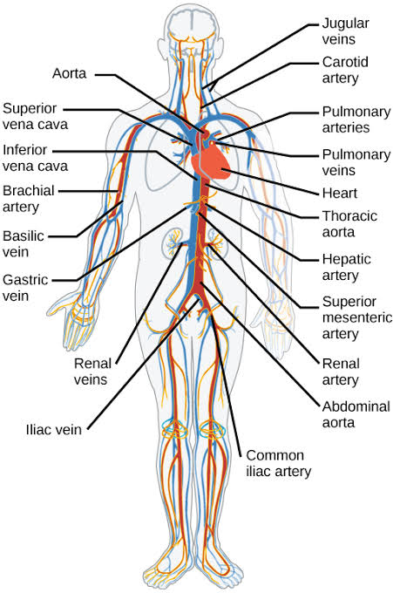
The Cardiovascular System, also called the Circulatory System OR the Vascular System, is an organ system that permits blood to circulate and transport nutrients (Such as Amino acids and Electrolytes), oxygen, carbon dioxide, hormones, and Blood cells to and from the cells in the body to provide nourishment and help in fighting diseases, stabilize temperature and pH, and maintain homeostasis.
Cardiovascular consists of the following organs:
- Made up of heart, blood, blood vessels
- Blood vessels include:
- Arteries= carry oxygen rich blood away from heart, to body
- Veins= carry oxygen poor blood to heart, away from body
- Capillaries= smallest vessels allow for exchange of oxygen and carbon dioxide to cells.

PHYSIOLOGY OF CARDIAC MUSCLES
- The heart is composed of three major types of cardiac muscles:
- Atrial Muscles
- Ventricular Muscles
- Specialized Excitatory and Conductive Muscle Fibers.

- The atrial and ventricular types of muscles contract in much the same way as skeletal muscle, expect that the duration of contraction is much longer.

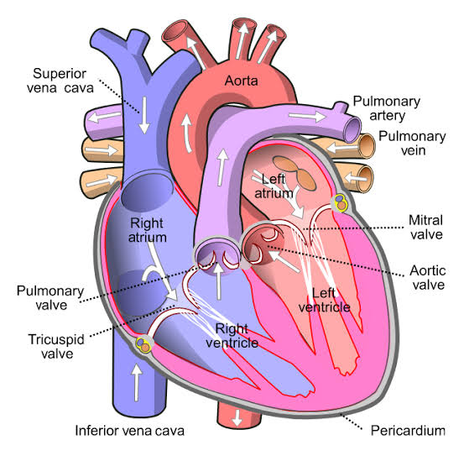
- The specialized excitatory and conductive fibers exhibit either automatic rhythmical electrical discharge in the form of action potentials that controls the rhythmical beating of the heart.
PHYSIOLOGIC ANATOMY OF CARDIAC MUSCLE
- Striated in the same manner as in Skeletal Muscles.
- But cardiac muscles is quite different from Skeletal Muscles.
- Intercalated Discs: The dark areas crossing the cardiac muscle fibers.
- Cardiac Cells are so interconnected that when one of these cells become excited, the action potential spreads to all of them, from cell to cell throughout the Latticework interconnections.
ACTION POTENTIAL IN CARDIAC MUSCLE
- Two types of channels in cardiac muscles:
- Fast Sodium Channel as those in skeletal muscles
- Slow Calcium Channels

DURATION OF CONTRACTION
- Cardiac muscle begin to contract a few milliseconds after the action potential begins and continue to contract until a few milliseconds after the action potential ends.
Therefor, the duration of contraction of cardiac muscle is mainly a function of the duration of the action potential.
- It’s about 0.2 seconds in atrial muscle and 0.3 seconds in ventricular muscle.

CARDIAC CYCLE
- The Cardiac Cycle: the cardiac events that occur from the beginning of one heartbeat to the beginning of the next.
- Cycle is initiated by spontaneous action potential in the Sinus Node. >> SA> rapidly through both atria and then through the A-V bundle into the ventricles.
Diastole and Systole
- Diastole: period of the relaxation during which the heart fills with blood. Followed by..
- Systole: period of contraction.
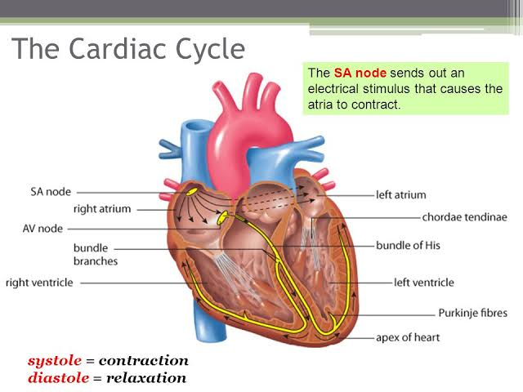
- The total duration of the cardiac cycle (including systole and diastole) is the reciprocal of the heart rate. If the heart rate is 72 beats/min, the duration of the cardiac cycle is 1/72 beats/min.

- What are the Symptoms of High and low Blood Pressure?

SYMPTOMPS OF HIGH BLOOD PRESSURE
Symptoms of high Blood Pressure are the following:
- Severe headaches
- Nosebleed
- Fatigue OR Confusion
- Vision problem
- Chest pain
- Difficulty in Breathing
- Irregular heartbeat
- Blood in the urine
SYMPTOMS OF LOW BLOOD PRESSURE
Symptoms of Low Blood Pressure are the following:
- Dizziness OR light headedness
- Nausea
- Fainting (syncope)
- Dehydration and Unusual thirst
- Dehydration can sometimes cause blood pressure to drop. However, dehydration does not always cause Low Blood Pressure
- Lack of Concentration
- Blurred vision
- Cold, Clammy, Pale skin

- What is the Treatment of High and Low Blood Pressure?
TREATMENT OF HIGH BLOOD PRESSURE
Treatment of High Blood Pressure are as follow:
- Changing lifestyle can go a long way toward controlling high blood pressure.
- Eating a healthy diet with less salt.
- Getting regular physical activity.
- Lose weight if you are over weight
- Quite smoking
- Cut back on Caffeine
- Reduce your stress.

TREATMENT OF LOW BLOOD PRESSURE
Treatment of Low Blood Pressure are as follow:
- Use more salt. Experts usually recommend limiting salt in your diet because Sodium can rise blood Pressure. So use more salt to rise low BP.
- Drink more water. Fluids increase blood volume and help prevent dehydration, both of which are important in treating Low BP.
- Wear compression stockings…
- Medications.

