NAME = IRSHAD WALI
ID = 13940
SUBJECT = BUSINESS MATHS
INSTRUCTOR = SIR LIAQUAT ALI
Q1 MCQS
ANSWER:
- E
- B
- D
- E
- D
- E
- E
- E
- A
- E
Q2A
Answer: Cost price= $4.5
Mark up= 26% = 0.26
Selling price = ( markup x product cost +product cost)
Selling Price = (0.26 x 4.5) + 4.5
Selling Price = $ 5.67
Selling price as a percent of cost price = 5.67/4.5 x 100 = 126% of cost price
Markup = profit/ cost x 100 = 1.17/4.5 x 100 = 26%

Q2b
Answer: solved by another app because here not that much habitual to use it and draw the formula accurately.

Attached the picture down here
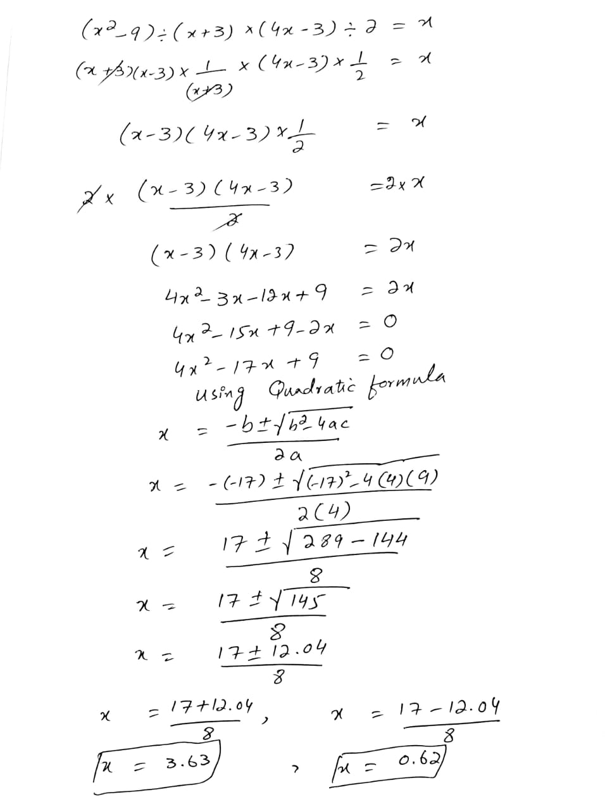
Q3a
Answer: Let x be the age of the girl and y be the age of her brother
So x+y= 60----------------(1)
then
x-2 = 3(y-2)
x-2= 3y-6
x-2+6-3y =0
x+4-3y=0
x-3y=- 4----------(2)
adding both
x+y=60
x-3y=-4
4y=64
Y=64/4
Y=16
Put y in equation 1
X+y=60
X+16=60
X=60-16
X=44 Answer
Age of the girl 44 and her brother 16

Q3b Selling price =18.75
Cost =15
A) Mark up based on cost?
b) Present mark up based on cost ?
Answer: (18.75-15)/15
A) = 0.25
b) = 0.25x100= 25%

Q4a
Answer: List price = 150
Trade discount = 20%=0.2
Find the net cost?
Net Cost = L (1-0.2)
Net cost = 150(1-0.8)
Net Cost = 120
Q4b
Answer: Let X be the cost of heating purposes
Y be the cost of electricity Then
x+y=1080----------(1)
x=3y-------------(2)
Putting equation 2 in 1
Y+3y=1080 =>4y = 1080
Y=270
X=810

Q5 A
Answer : Let 1 man alone can finish the work in X days and 1 boy alone can finish it in Y.
Then
1 man's 1 days work = 1/X
And,
1 boy's 1 day's work = 1/Y
(4 men's 1 day's work )+(6 boys 1 day's work )= 1/5
=> 4/X + 6/Y = 1/5
=> 4U + 6V = 1/5 [ Where 1/X = U and 1/Y =V]
=> 4U + 6V = 1/5 --------(1)
Again
( 3 men's 1 day's work ) + ( 4 boys 1 day's work ) = 1/7
=> 3/X + 4/Y = 1/7
=> 3U + 4V = 1/7 -------(2)
On multiplying (1) by 3 and ,(2) by 4 we get,
12U + 18V = 3/5 --------(3)
And,
12U + 16 V = 4/7 --------(4)
Subtracting (3) and (4) we get,
2V = ( 3/5 - 4/7)
2V = 1/35
V = 1/35 ×2
V = 1/70
1/Y = V
1/Y = 1/70
Y = 70 days
Putting V = 1/70 in equation (1) we get,
4U + 6V = 1/5
4U = ( 1/5 - 6V )
4U = ( 1/5 - 6/70 )
4U = ( 14 - 6 /70)
4U = ( 8/70)
U = 8/70 × 1/4
U = 1/35
1/X = U
1/X = 1/35
X = 35 days
So it means that 1 man alone can finish the work in 70 days and 1boy alone will take 35 days .
Q5 b
Answer: List price = 150
Trade discount = 20%=0.2
Find the net cost?
Net Cost = L (1-0.2)
Net cost = 150(1-0.8)
Net Cost = 120

