IQRA NATIONAL UNIVERSITY
DEPARTMENT OF ALLIED HEALTH SCIENCES
Final-Term Examination 2020
Course Title: ,Medical microbiologyDT 4th Instructor: Muhammad sohail
Time: 6 hours Total Marks: 50

Name: Muhammad Anas Azeem ID 14580

Q1. What do you know about parasites explain endo and ecto parasites in details
Q2. Explain protozoa, its characteristics and morphology, also classify protozoa on the basis of motility and reproduction into its types
Q3. Write down names of organelles and its functions present in paramecium and euglena
Q4. What is antibiotic resistance? Explain the mechanism of bacterial resistance. Its causes and solutions to the problem
Q5. Explain the mechanism of bacterial pathogenicity. Write down at least two bacterial diseases in detail.
Answer Section
Q1. What do you know about parasites explain endo and ecto parasites in details ?
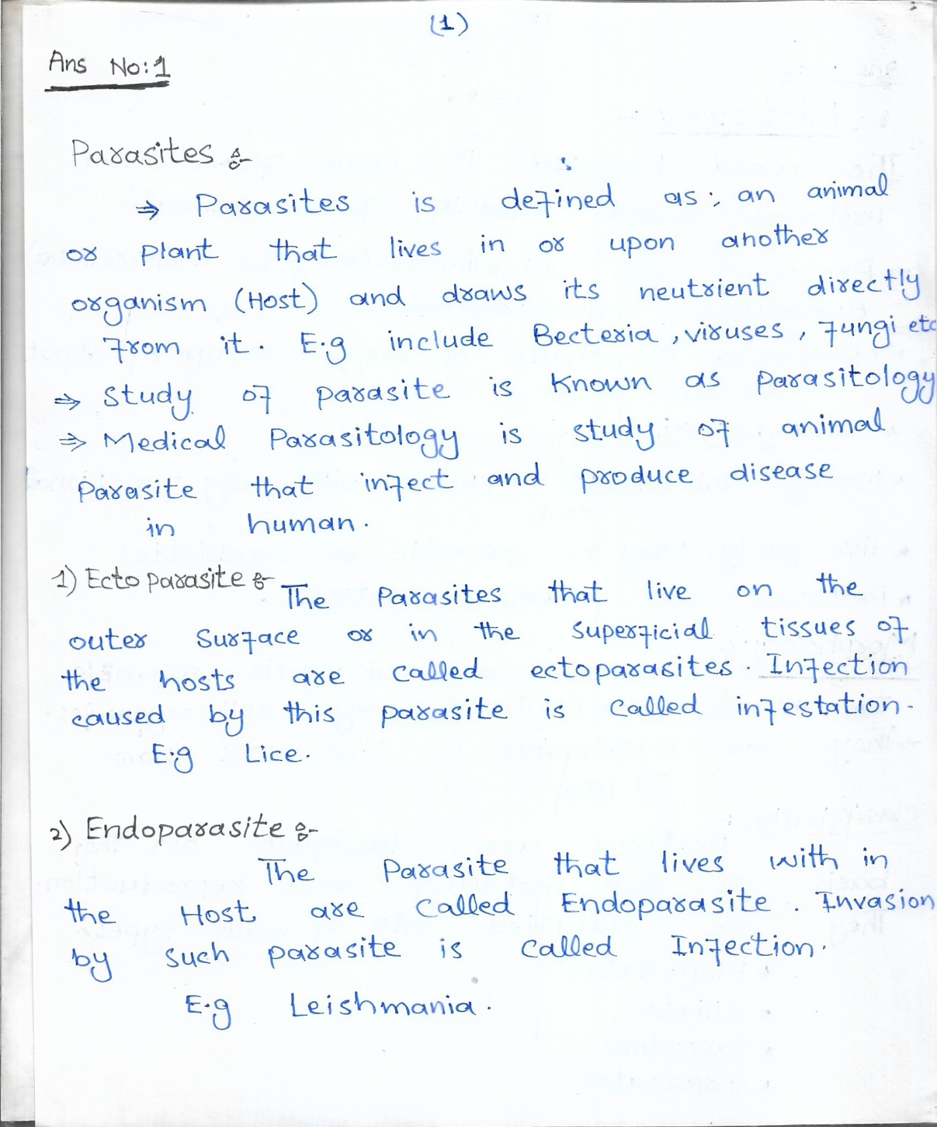
Q2. Explain protozoa, its characteristics and morphology, also classify protozoa on the basis of motility and reproduction into its types ?
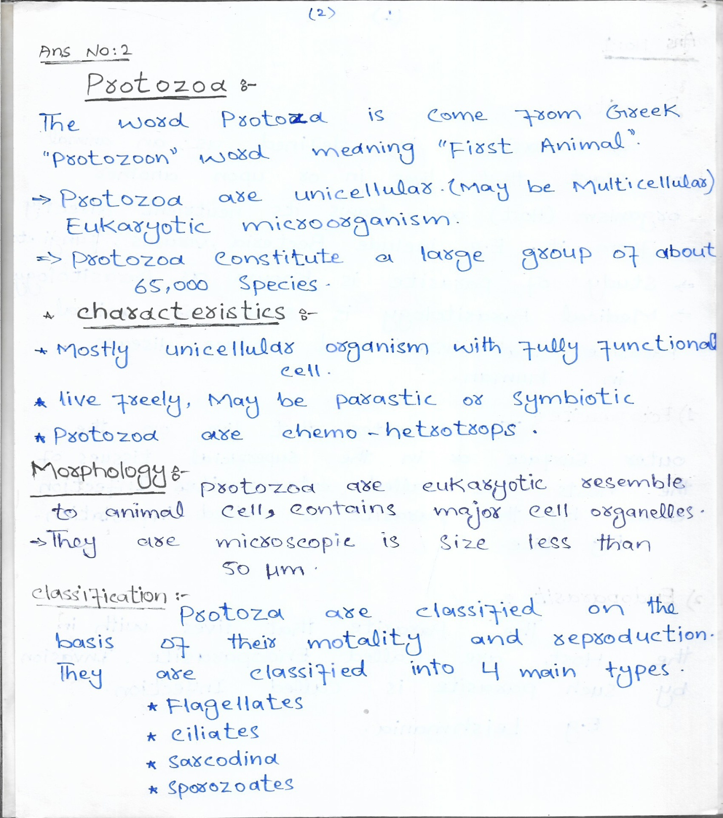

Q3. Write down names of organelles and its functions present in paramecium and euglena ?
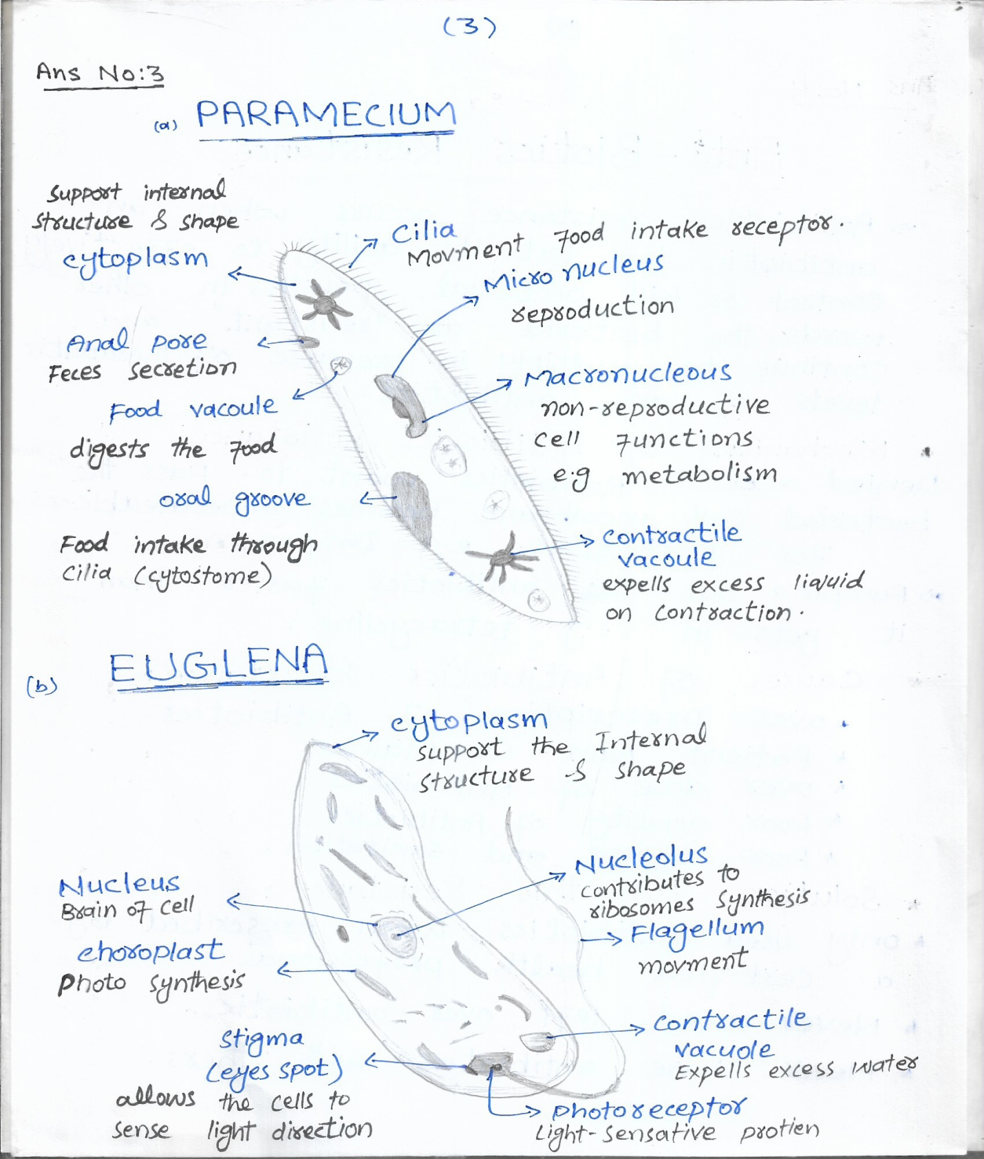
Q4. What is antibiotic resistance? Explain the mechanism of bacterial resistance. Its causes and solutions to the problem ?
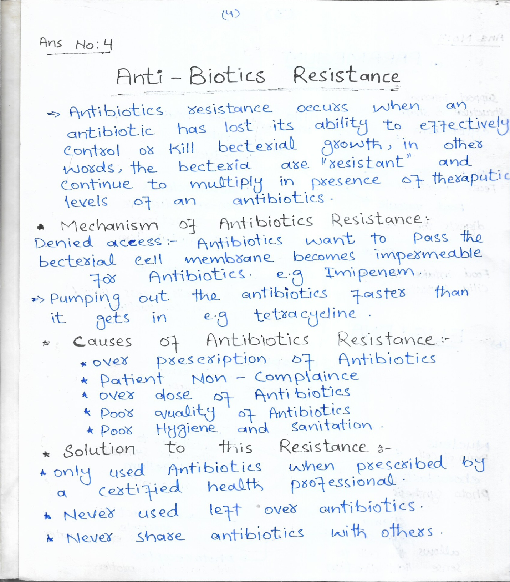

Q5. Explain the mechanism of bacterial pathogenicity. Write down at least two bacterial diseases in detail. ?
